VICTORIAN CIVIL AND ADMINISTRATIVE TRIBUNAL
planning and environment LIST | vcat reference No. P695/2021  Permit Application no.TPA/51893
CATCHWORDS
Section 77 of the Planning and Environment Act 1987; Monash Planning Scheme; General Residential Zone 6; Multiple dwellings; Policy; Neighbourhood Character; Internal Amenity

Applicant | Chin Pang Yu

Responsible Authority | Monash City Council

SUBJECT LAND | 76 Kanooka Grove  CLAYTON VIC 3168

HEARING TYPE | Hearing

DATE OF HEARING | 29 October 2021

DATE OF ORDER | 7 February 2022

CITATION | Yu v Monash CC [2022] VCAT 150

Order
- Pursuant to clause 64 of Schedule 1 of the Victorian Civil and Administrative Tribunal Act 1998, the permit application is amended by substituting for the permit application plans, the following plans filed with the Tribunal:
- Prepared by: | Bonacci Design
- Drawing numbers: | TP-2 to TP-6 inclusive all Rev C
- Dated: | 8 September 2021

Permit granted
- In application P695/2021 the decision of the responsible authority is set aside.
- In planning permit application TPA/51893 a permit is granted and directed to be issued for the land at 76 Kanooka Grove CLAYTON VIC 3168 in accordance with the endorsed plans and the conditions set out in Appendix A. The permit allows the construction of three dwellings on a lot.

Katherine Paterson
Member

Appearances
For applicant | Mr Simon Skinner, Town Planner
For responsible authority | Ms Sally Moser, Town Planner

Information
Description of proposal | Construction of three double storey dwellings on the site. Dwellings 1 and 3 will contain three bedrooms, and dwelling 2 will contain two bedrooms, with living rooms of all three dwellings provided at the ground floor. A single garage has been provided for each dwelling, with a tandem space for dwellings one and three. Access to the garages is provided by two separate crossovers.
Nature of proceeding | Application under section 77 of the Planning and Environment Act 1987 – to review the refusal to grant a permit.
Planning scheme | Monash Planning Scheme
Zone and overlays | General Residential Zone Schedule 6
Permit requirements | Clause 32.08-6 – Construction of two or more dwellings on a lot.
Land description | The subject site has an area of 697 square metres and currently contains a single storey weatherboard dwelling and associated outbuildings and garden.
Tribunal inspection | 25 October 2021

Reasons

What is this proceeding about?
- Chin Pang Yu wishes to construct three dwellings on land at 76 Kanooka Grove, Clayton. Following Monash City Council’s decision to refuse the application for a planning permit, he has requested that the Tribunal review this matter.
- Whilst agreeing that this site, which is located within the Monash National Employment and Innovation Cluster, was suitable for development of medium density housing, Monash City Council submits that the design of the proposed development fails to respect the preferred neighbourhood character of the area and will result in a poor level of internal amenity for the future occupants of the dwellings. I will consider each issue in turn.

Does the proposal respect the preferred character of the area?
- The purposes of the General Residential Zone Schedule 6 (GRZ6) include:
- To encourage development that respects the neighbourhood character of the area.
- To encourage a diversity of housing types and housing growth particularly in locations offering good access to services and transport.
- The schedule to GRZ6 contains the following neighbourhood objectives:
- To facilitate housing diversity in the form of units, townhouses and apartment developments of high quality design and finish.
- To provide an interface between the Clayton Activity Centre, the Monash Employment and Innovation Cluster, the housing growth area and the lower scale surrounding garden city suburban areas.
- To encourage development that respects sensitive residential interfaces and minimises building mass and visual bulk in the streetscape through landscaping in the front setback and breaks and recesses in the built form.
- To promote the preferred garden city character by minimising hard paving throughout the site by limiting the length and width of accessways and limiting paving within open space areas.
- To ensure developments are constructed within an open garden setting through the retention and planting of vegetation, including canopy trees.
- Council submitted that the proposed design failed to meet the character objectives due to the proposed “boundary to boundary” arrangement for dwelling 3, proposed 5.14 metre wall to the street, lack of response to the slope of the site resulting in high walls along the driveway and use of two crossovers to Kanooka Grove. I will consider each in turn.

Boundary walls for dwelling 3
- As can be seen from the extract provided below of the proposed plans, the application proposes to construct four separate walls on boundaries:
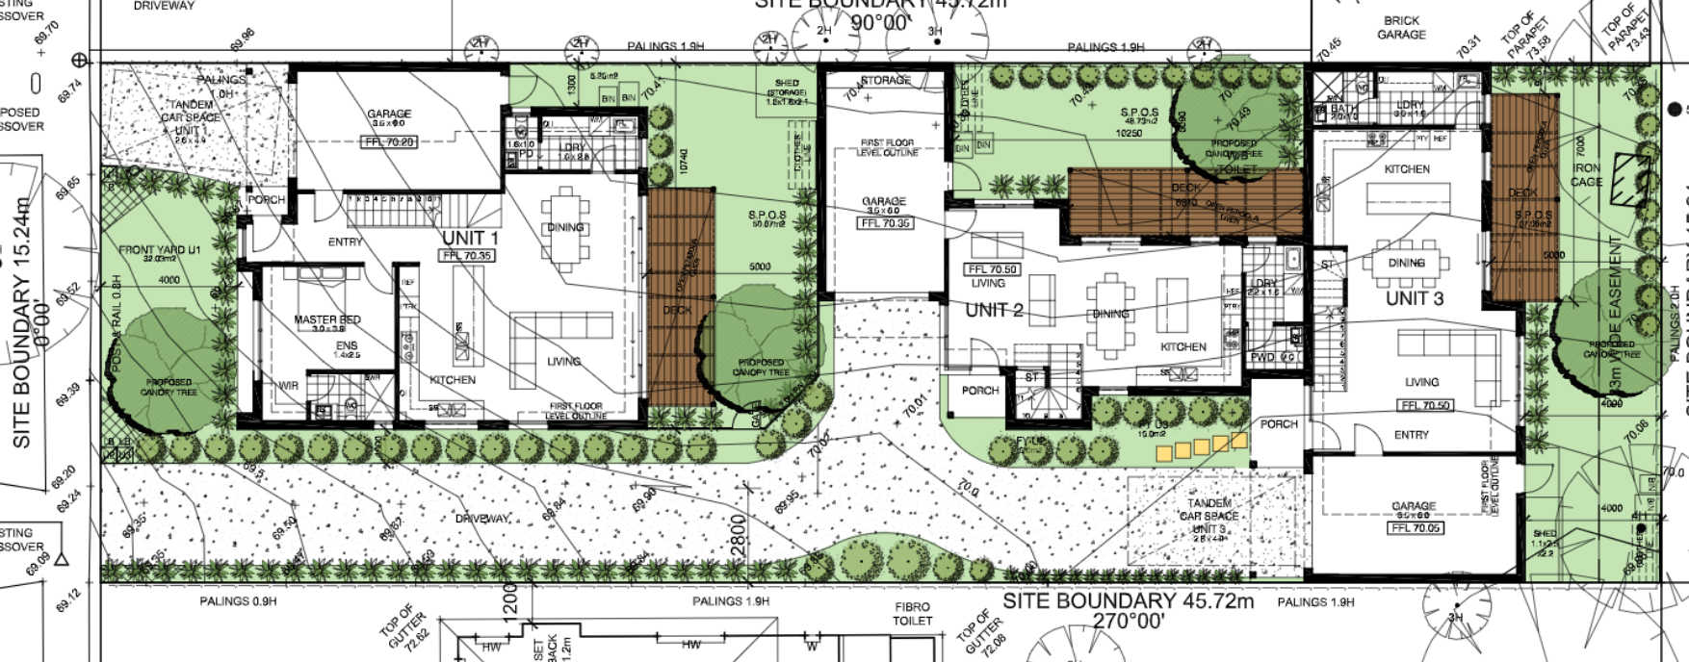
- Clause 55.04-2 contains the following objective for walls on boundaries:
To ensure that the location, length and height of a wall on a boundary respects the existing or preferred neighbourhood character and limits the impact on the amenity of existing dwellings.
- Whilst the schedule to the GRZ6 has amended the requirements of Clause 55 for rear setbacks, it has not amended the requirements of Standard B17 for side setbacks, or Standard B18 for walls on boundary. It was common ground the length and height of the walls was generally consistent with the requirements of Standard B18.
- Clause 22.01 contains the residential development and character policy, which has divided the municipality into various character areas, with the subject site included within the Monash National Employment Cluster and Clayton Activity Centre – Housing Diversity Area. Clause 22.01-3 contains the following policy guidance when considering walls on boundary within Monash:
- Ensure walls on boundaries are consistent with neighbourhood character, including spacing between dwellings and the character of open vegetated backyards.
- Limit the length of walls on boundaries to ensure landscaping space is provided around buildings, and the amenity of adjoining properties is not adversely impacted.
- Clause 22.01 contains the following preferred character statement for the Monash National Employment Cluster and Clayton Activity Centre – Housing Diversity Area:
The Clayton Activity Centre and the cluster more broadly are expected to experience major redevelopment, as one of the key areas for employment growth within Melbourne. As such, the core of the activity centre and the cluster are anticipated to accommodate growth and more diverse housing needs. This area also forms an interface to the surrounding garden city suburbs. New development should provide a transition between these areas.
New housing will generally comprise multi dwelling developments such as units and, where appropriate, low rise apartments. Front and rear setbacks will be less than those preferred in the garden city areas, however will still provide the opportunity for landscaping. Landscaping and open space within developments will remain an important feature for this character area. Canopy trees within developments and separation between buildings will provide visual and environmental amenity for occupants and the residents of existing dwellings. New developments will be designed and constructed to a high standard, ensuring they provide a positive architectural impact.
- As can be seen from the above Nearmap image, the subject site is located within an area of Clayton that is undergoing significant change, reflecting the policy settings for this site, and its location within the Monash National Employment and Innovation Cluster and Activity Centre.
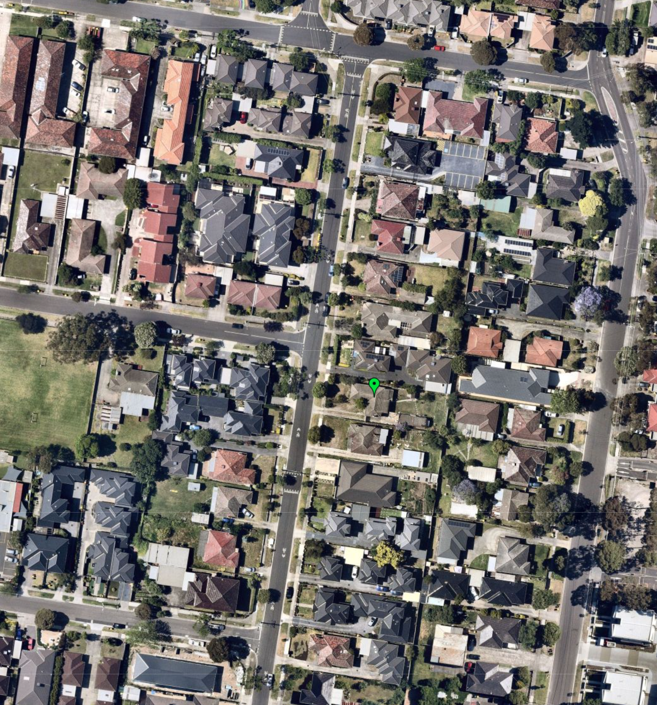
- Many of the newer developments within the area contain walls on one or both side boundaries. The Monash Planning Scheme does not discourage the use of boundary walls in this location, rather the focus is on ensuring that the front and side setbacks provided in a development is sufficient to provide landscaping. I will consider this aspect of the proposal next.

Landscaping
- The schedule to the GRZ6 states that new development should provide or retain the following landscaping:
- At least one canopy tree, plus one canopy tree per 5 metres of site width;
- A mixture of vegetation including indigenous species;
- Vegetation in the front, side and rear setbacks; and
- Vegetation on both sides of accessways.
- A canopy tree should reach a mature height at least equal to the maximum building height of the new development.
- The site has a width of 15.24 metres, which equates to a requirement of a minimum of four canopy trees for this site, one of which should reach a height of 8.34 metres
- The applicant submitted a landscape plan that was prepared by Habitat landscape and environmental design consultants, an extract of which is provided below:
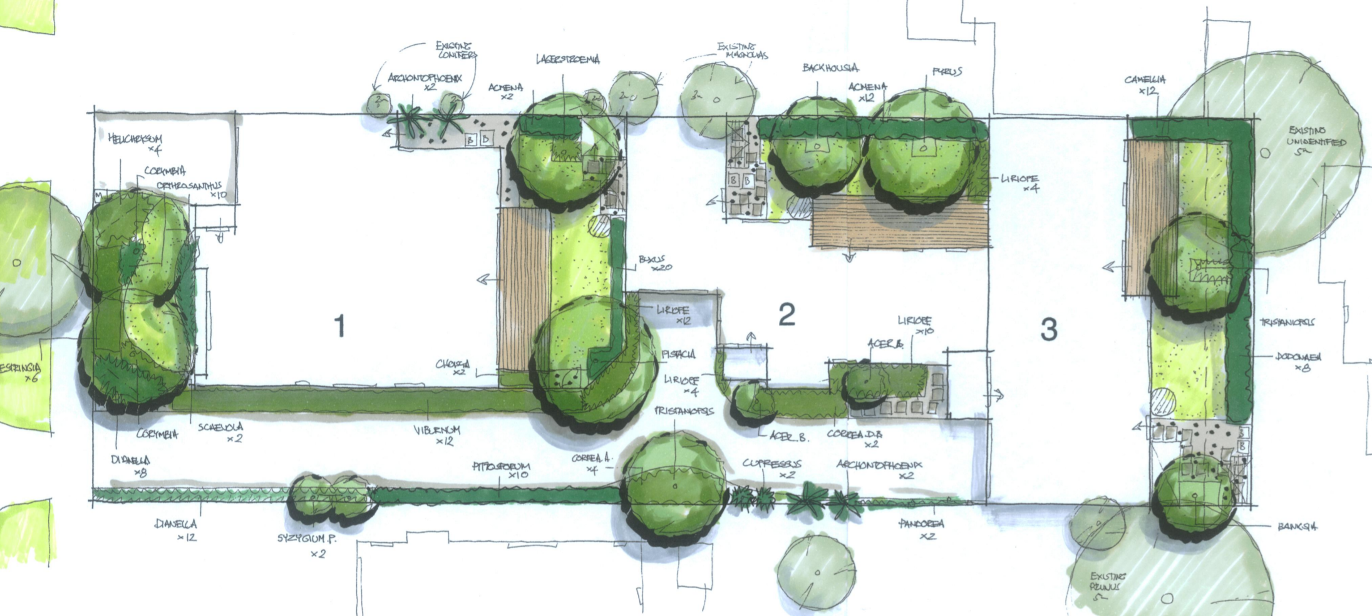
- The landscape plan indicates that there is sufficient space for the planting of nine canopy trees, including three with a height of nine metres, being two Dwarf Lemon Scented Gums and one Chinese Pistachio. I am satisfied based on this plan, that despite the walls on boundaries, the site has the capacity to accommodate landscaping in accordance with the requirements of the schedule to the GRZ6. I have required the endorsement, implementation and maintenance of the plan as conditions of permit.

Visual Bulk
- Council was concerned that the design of the built form would present as overly bulky when viewed from the streetscape and the internal driveway. Whilst the development has been provided with a front setback of four metres in accordance with the requirements of the schedule to the GRZ6, due to the 5.1 metre height of the balcony, the application is seeking a variation to standard B6 of Clause 55.03-1 (street setback). The objective of the standard is:
To ensure that the setbacks of buildings from a street respect the existing or preferred neighbourhood character and make efficient use of the site.
- Kanooka Grove is a wide street, and in a location where planning policy is calling for more robust built forms. I am satisfied that the two-storey form, despite the use of some sheer wall and cantilevered elements, will be a comfortable fit within the streetscape.
- With respect to the view of the built form when viewed from the internal driveway, this view will be largely viewed from the private realm by the occupiers of dwellings two and three and the adjoining properties. I am satisfied that the appearance from the driveway is acceptable, despite its height which rises to accommodate the slope of the site.
- The development may have an impact on the amenity of adjoining properties through visual bulk. I have provided an enlarged aerial view of the adjoining properties below, again taken from Nearmap:
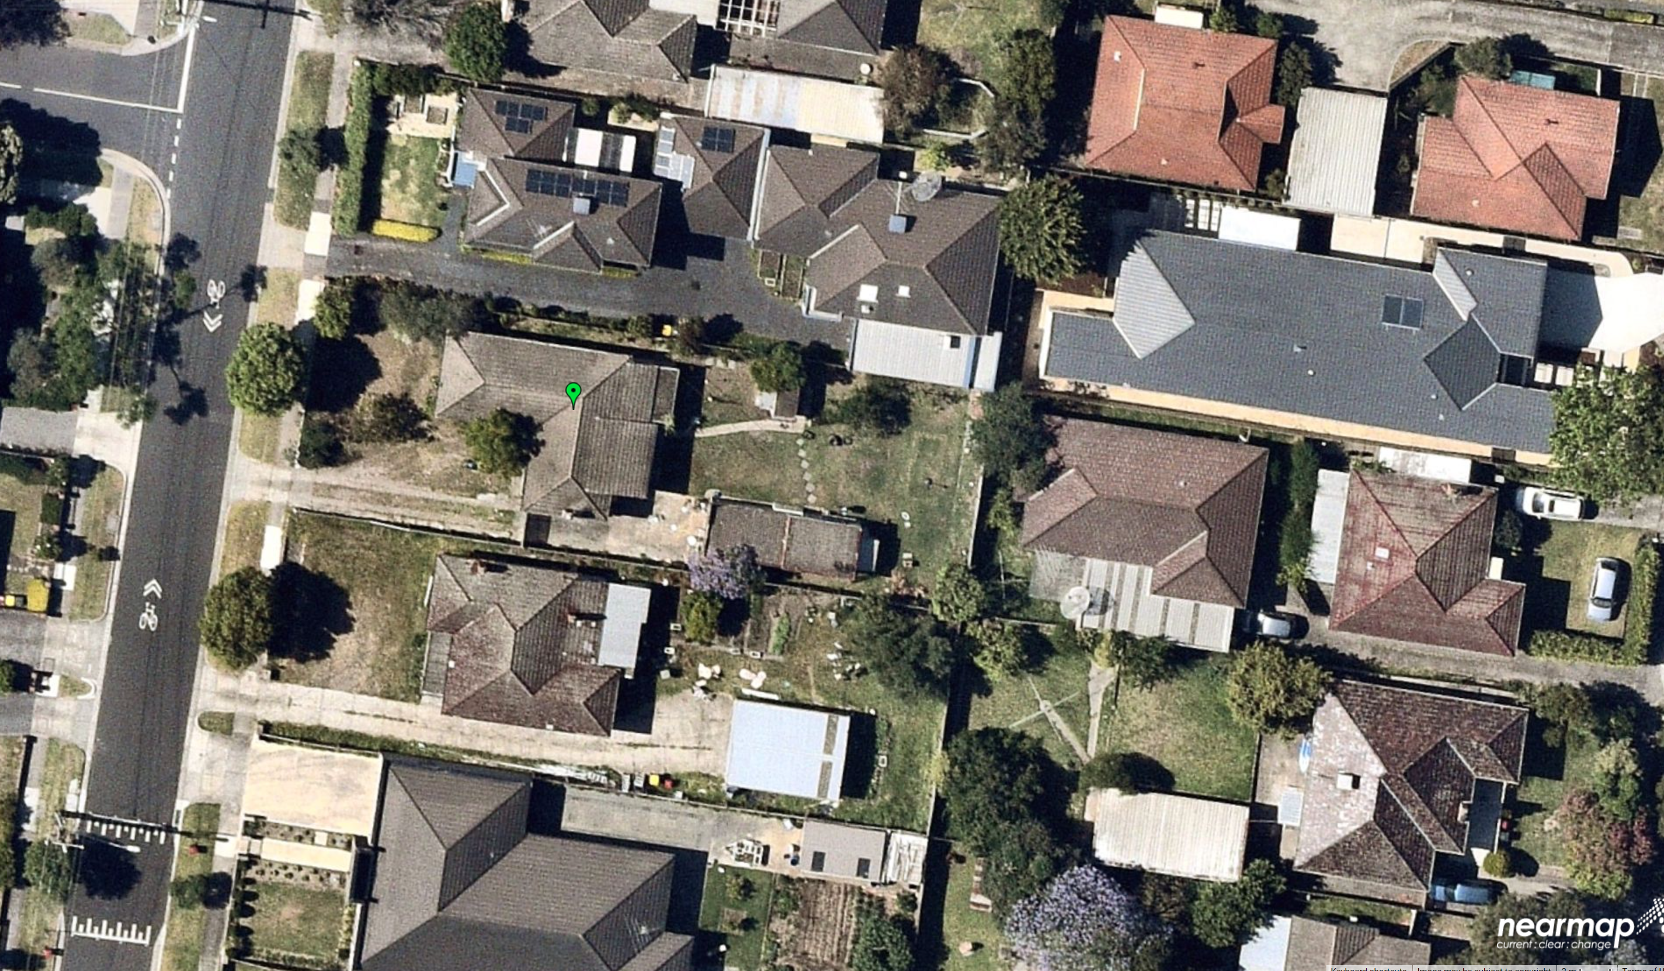
- To the north of the site is a driveway for a medium density development, which includes a garage on the boundary. I am satisfied that the amenity of these properties are unlikely to be affected by the development.
- The secluded private open space of the property to the east at 54A Browns Road, is located adjacent to the eastern boundary of the site. The development has sought to respond to this space by providing a greater setback to the principal area of secluded space, located adjacent to the south eastern corner of the site. I am satisfied that this response ensures that the development will not appear overlay bulky when viewed from this location. The landscape plan shows the planting of a 2.5 metre hedge as well as two canopy trees reaching a height of 5 and 8 metres, which will further assist in softening the impact of the development when viewed from this location.
- The property to the south of the site, has a large area of secluded private open space. Whilst dwelling two and three will be visible from this location, I am satisfied that the setbacks of the development are sufficient to prevent unreasonable visual bulk when viewed from this location. The landscape plan shows the planting of 5 metre Pencil Pines and 7 metre Bangalow Palms in this location which will further soften the impact of the development when viewed from this space.
- I am therefore satisfied that the proposal will not have an unreasonable impact on the streetscape or neighbouring properties through visual bulk.

Crossovers
- The objective of Clause 55.03-9 is to ensure the number and design of vehicle crossovers respects the neighbourhood character.
- Clause 22.01-3 has the following design objectives for crossovers:
- Locate and minimise vehicle crossovers to prevent traffic disruption, and preserve nature strips and street trees.
- Maximise landscaping in front setback areas by minimising the number of crossovers.
- The application proposes the use of two crossovers, with a combined width of 6 metres, which complies with Standard B14. As stated earlier, the two crossovers allow the planting of landscaping in accordance with the schedule of the GRZ6.
- In terms of impacts on the provision of on street parking, there is currently 10.1 metres between two crossovers for the subject site and the adjoining property to the north. The application will reduce this length to 8.6 metres. Using the design car space length of 6.7 metres provided for parallel parking at Clause 52.06-9 as a guide, both the existing and proposed scenario would allow the parking of one vehicle between the two crossovers. I am therefore satisfied that the proposal will not result in a loss of an on street parking space.
- Furthermore, I note that a number of the developments within Kanooka Grove have been constructed with two crossovers, and I am satisfied that the proposed use of two crossovers will be a comfortable fit within this streetscape.

Does the proposal result in a poor level of amenity for future occupants?
- Council was critical of the parking arrangements for dwelling 3, which they submitted obscured the entry for dwelling 3. They were also critical of the use of an obscured window to the dining room for dwelling 2. I have provided an extract of the plans showing the arrangement below:
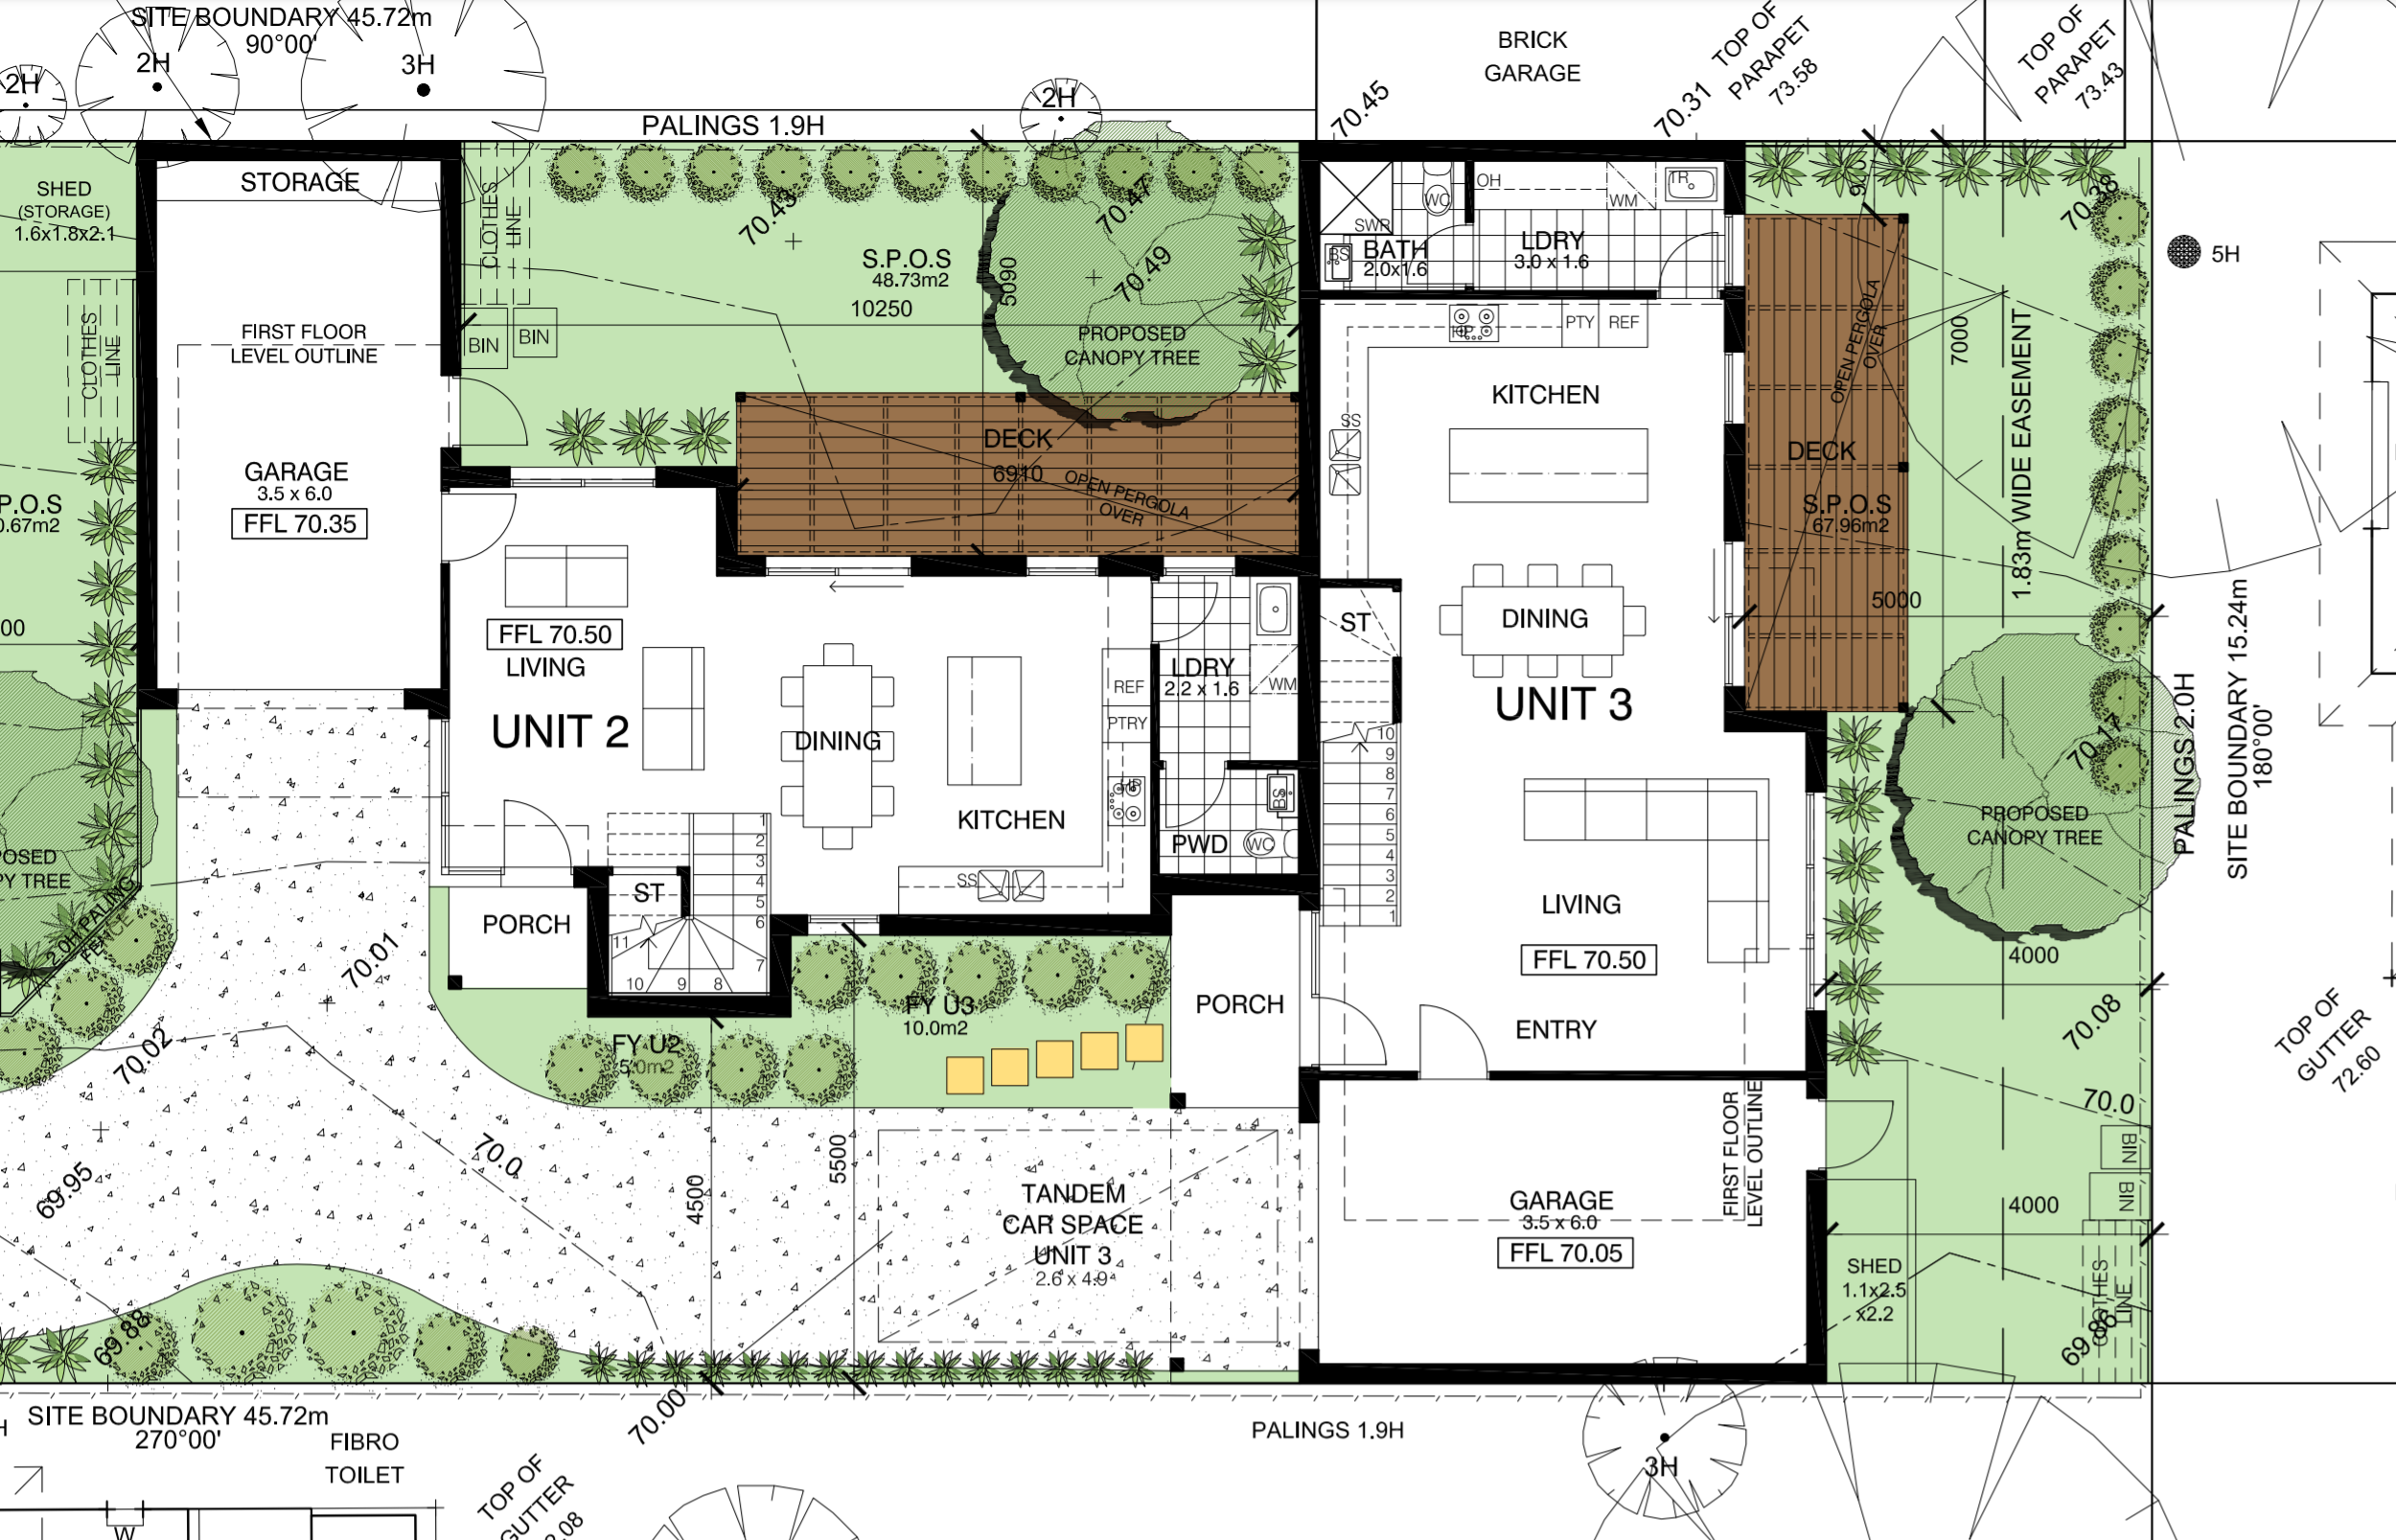
- The tandem car parking space for dwelling three is located in front of the garage. When a car is parked in this space, it will partially obscure the entry to dwelling three. Obscured glazing is proposed to the dining room window for dwelling two to provide additional privacy for the dwelling.
- Whilst the arrangement is not ideal, I am satisfied that it is acceptable. The entries to dwellings 2 and 3 will be easily identifiable for visitors entering the site, and the window for dwelling two’s dining room will not be the sole source of light or outlook to this room. The window is set back 2.5 metres from the driveway, and as such its location meets the requirements of Standard B15 of Clause 55.03-10.
- I did consider whether the obscured glazing to the window should be replaced to provide additional passive surveillance to the driveway, however as an outlook to the driveway is possible from the south facing living room windows of the dwelling, I do not consider this to be necessary.

What conditions are appropriate?
- Draft conditions were discussed at the hearing, and any changes to those conditions reflects those discussions as well as further consideration by the Tribunal.
- I have deleted condition 1(g) as I find that this is unnecessary. Each accessway serves less than 3 car parking spaces and pursuant to Clause 52.06-9 a vehicle does not need to exit the site in a forward direction in these circumstances. I have included the Tribunal’s standard expiry condition, with time limits of 3 and 5 years in recognition of the delays caused through the Covid-19 pandemic.

Conclusion
- For the reasons given above, the decision of the responsible authority is set aside. A permit is granted subject to conditions.

Katherine Paterson
Member

Appendix A – Permit Conditions

Permit Application No | TPA/51893
Land | 76 Kanooka Grove  CLAYTON VIC 3168 «SiteAddress»

What the permit allowS
The permit allows the construction of three dwellings on a lot in accordance with the endorsed plans.

Conditions

Amended Plans Required
- Before the development commences, amended plans to the satisfaction of the Responsible Authority must be submitted to and approved by the Responsible Authority. The plans must be drawn to scale and dimensioned. When the plans are endorsed they will then form part of the Permit. The plans must be generally in accordance with plans prepared by Bonacci Design, dated September 2021, Revision C, but modified to show:
- The location and design of any proposed electricity supply meter boxes. The electricity supply meter boxes must be located at or behind the setback alignment of buildings on the site, or in compliance with Council’s “Guide to Electricity Supply Meter Boxes in Monash”.
- A corner splay or area at least 50 per cent clear of visual obstructions extending at least 2 metres along the frontage road from the edge of an exit lane and 2.5 metres along the exit lane from the frontage, to provide a clear view of pedestrians on the footpath of the frontage road. The area clear of visual obstructions may include an adjacent entry or exit lane where more than one lane is provided, or adjacent landscaped areas, provided the landscaping in those areas is less than 900mm in height.
- Landscape plans in accordance with Condition 3 of this Permit.

Layout not to be Altered
- The development as shown on the endorsed plans must not be altered without the prior written consent of the Responsible Authority.

Landscape
- Concurrent with the endorsement of any plans requested pursuant to Condition 1, a landscape plan prepared by a Landscape Architect or a suitably qualified or experienced landscape designer, drawn to scale and dimensioned must be submitted to and approved by the Responsible Authority. The Landscape Plan must be generally in accordance with the plan prepared by Habitat Landscape and environmental design consultants dated October 2021.

Sustainable Design Assessment (ESD Requirement)
- Concurrent with the endorsement of plans requested pursuant to Condition 1, a Sustainable Design Assessment (in accordance with Clause 22.13) to the satisfaction of the Responsible Authority must be submitted to and approved by the Responsible Authority. Upon approval the Sustainable Design Assessment will be endorsed as part of the planning permit and the development must incorporate the sustainable design initiatives outlined in the Sustainable Design Assessment to the satisfaction of the Responsible Authority.

Tree Protection
- Before any development (including demolition) starts on the land, a tree protection fence must be erected around all trees that are to be retained, or are located within or adjacent to any works area (including trees on adjacent land). The tree protection fence must remain in place until all construction is completed on the land, except with the prior written consent of the Responsible Authority.
- No building material, demolition material, excavation or earthworks shall be stored or stockpiled within the Tree Protection Zone (TPZ) of any tree to be retained during the demolition, excavation and construction period of the development hereby permitted without the prior written consent of the Responsible Authority.
- No excavation less than 2.9 metres from the naturestrip street tree. This tree must be protected by temporary rectangular wire fencing as per Australian Standards, erected prior to commencement of works until completion. Fence must extent out to at least distances given.

Landscaping Prior to Occupation
- Before the occupation of any of the buildings allowed by this permit, landscaping works as shown on the endorsed plans must be completed to the satisfaction of the Responsible Authority and thereafter maintained to the satisfaction of the Responsible Authority.

Drainage
- The site must be drained to the satisfaction of the Responsible Authority.
- A plan detailing the drainage works must be submitted to the Engineering Division prior to the commencement of works for approval. The plans are to show sufficient information to determine that the drainage works will meet all drainage requirements of this permit.
- Stormwater discharge is to be detained on site to the predevelopment level of peak stormwater discharge. Approval of any detention system is required by the City of Monash prior to works commencing; or any alternate system.
- No polluted and/or sediment laden runoff is to be discharged directly or indirectly into Council's drains or watercourses during and after development, to the satisfaction of the Responsible Authority.
- The full cost of reinstatement of any Council assets damaged as a result of demolition, building or construction works, must be met by the permit applicant or any other person responsible for such damage, to the satisfaction of the Responsible Authority.

Vehicle Crossovers
- All disused or redundant vehicle crossovers must be removed and the area reinstated with footpath, naturestrip, kerb and channel to the satisfaction of the Responsible Authority.
- Any new vehicle crossover or modification to an existing vehicle crossover must be constructed to the satisfaction of the Responsible Authority.

Urban Design
- The walls on the boundary of adjoining properties shall be cleaned and finished in a manner to the satisfaction of the Responsible Authority.

Satisfactory Continuation and Completion
- Once the development has started it must be continued and completed to the satisfaction of the Responsible Authority.

Expiry of permit for development
- This permit as it relates to development (buildings and works) will expire if one of the following circumstances applies:
  - The development is not started within three (3) years of the issue date of this permit.
  - The development is not completed within five (5) years of the issue date of this permit.
In accordance with section 69 of the Planning and Environment Act 1987, an application may be submitted to the responsible authority for an extension of the periods referred to in this condition.
– End of conditions –

The submissions of the parties, any supporting exhibits given at the hearing and the statements of grounds filed have all been considered in the determination of the proceeding. In accordance with the practice of the Tribunal, not all of this material will be cited or referred to in these reasons.
Extract from Plan prepared by Bonacci design (Drawing No. TP-2 Rev C dated 8 September 2021)
Nearmap http://maps.au.nearmap.com/ image dated 23 December 2021 retrieved 7 February 2022.
This clause was recently amended by VC 199 to the Monash planning Scheme on 3 February 2022. As the amendment did not alter the dimensions of car parking spaces specified in the clause, I was satisfied that I did not need to hear further submissions on this provision from the parties prior to making a decision on this application.
Extract of Plans prepared by Bonacci Design Drawing No. TP-3 Rev C dated 8 September 2021

