VICTORIAN CIVIL AND ADMINISTRATIVE TRIBUNAL
planning and environment LIST | vcat reference No. P11063/2021  Permit Application no. TPA/52204
CATCHWORDS
Application under section 77 of the Planning and Environment Act 1987. Monash Planning Scheme. Residential Growth Zone, Schedule 3. Six attached dwellings. Response to context. Private open space.

Applicant | Thomas Clayton Pty Ltd

Responsible Authority | Monash City Council
SUBJECT LAND | 6 Thomas Street  CLAYTON VIC 3168
HEARING TYPE | Hearing
DATE OF HEARING | 10 December 2021
DATE OF ORDER | 17 February 2022
CITATION | Thomas Clayton Pty Ltd v Monash CC [2022] VCAT 171

Order

- Pursuant to clause 64 of Schedule 1 of the Victorian Civil and Administrative Tribunal Act 1998, the application is amended by:
  - substituting the following plans for the application plans:
    - Prepared by: Bello Design Group
    - Drawing Numbers: TP 01 – TP 09 (inclusive)
    - Dated: 22 October 2021
  - Amending the description of the permit application to include a reduction in the required car parking.
- In application P11063/2021, the decision of the responsible authority is affirmed.
- In planning permit, application TPA/52204, no permit is granted.

Cindy Wilson
Member

Appearances
For applicant | Mr Daniel Bowden, town planner of SongBowden Planning Pty Ltd  Mr Bowden called the following witness:  - Mr Damien Hancox, traffic engineer of TTM Consulting (Vic) Pty Ltd
For responsible authority | Mr Peter English, town planner of Peter English & Associates Pty Ltd

Information
Description of proposal | The construction of six attached dwellings and reduction in the required number of car spaces by one space.
Nature of proceeding | Application under section 77 of the Planning and Environment Act 1987 – to review the refusal to grant a permit.
Planning scheme | Monash Planning Scheme
Zone and overlays | Residential Growth Zone, Schedule 3  No overlays
Permit requirements | Clause 32.07-5 A permit is required to construct two or more dwellings on a lot.  Clause 52.06-3 A permit is required to reduce the standard car parking requirement.
Land description | The review site is located on the eastern side of Thomas Street, Clayton. It comprises two parcels of land with a total area of 704 square metres.
Tribunal inspection | An inspection of the site and surrounds was undertaken prior to the hearing.

Reasons

- Monash City Council has refused an application for the construction of six dwellings at 6 Thomas Street, Clayton. The applicant seeks a review of that decision.
- Having inspected the site and surrounds, heard the submissions and evidence, considered the material provided including photos and plans and had regard to the Monash Planning Scheme, I have decided to affirm the decision of Council and direct that no permit issue.
- Despite support for increased dwelling density and diversity in this location, I find the proposal fails to appropriately respond to context and landscaping directions in the Planning Scheme and results in a poor standard of private open space.

What is proposed?
- Six attached dwellings are proposed. Dwelling 1, setback 4 metres from the street, is three storey with a single garage, bedroom, ensuite, and storage area at ground level, open plan kitchen/living room at first floor with a balcony facing the street and two bedrooms and ensuites at the second floor.
- Dwellings 2, 3, 4 and 5 are each three storey and have similar layouts. At ground level there is a single car space, powder room, study and an external area of private open space with storage area. At first floor each dwelling is provided with an open plan kitchen/living room with a north facing balcony of 12 square metres. The second floor layout includes two bedrooms and two ensuites. The car accommodation for dwelling 4 is an undercroft car space with the other dwellings having single garages.
- Dwelling 6, at the rear of the property is two storey with an open plan kitchen/living room at ground floor with access to ground level open space at the rear extending north to the right of way. A single carport is proposed on the south side of the site at the termination of the shared driveway. At first floor there are two bedrooms, two ensuites and a retreat area.
- Figure 1 shows the ground level proposed.
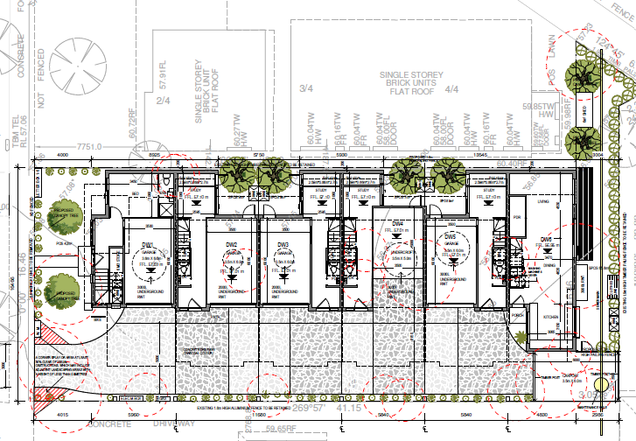
Figure 1: Ground floor plan Source: TP 03 Bello Design Group dated 22 October 2021
- Elevations show a flat roof design with varied external materials including face brickwork in a dark colour, sections of dark and light rendered cladding and a section of feature cladding facing the street in grey with vertical lines.
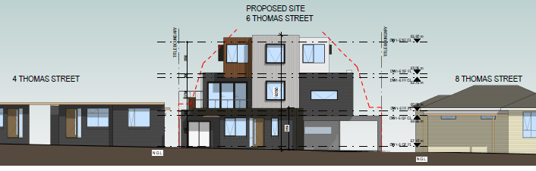
Figure 2: Front elevation Source: TP 06 Bello Design Group dated 22 October 2021

What is the physical context?
- The review site is located on the east side of Thomas Street between Haughton Avenue and Jean Avenue, Clayton. Irregular in shape, it comprises two parcels of land with a total area of 704 square metres. The larger parcel is rectangular with a frontage of 16.46 metres and depth of 38.1 metres. The smaller parcel is to the rear of the site and comprises a strip of land 3.05 metres wide that extends from the southern side of the lot to connect with an unmade right of way north of 4 Thomas Avenue. A wider area providing a splay is adjacent to the right of way. The configuration is shown in figure 3 below.
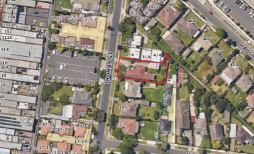
Figure 3: Aerial photo of site and surrounds Source: Council delegate report dated 16 January 2021
- To the north of the review site there is a medium density development comprising four single storey dwellings with the right of way adjoining its the northern boundary. Further north, on the corner of Haughton Road, is another single storey medium density development with the railway line and Clayton station on the opposite side of Haughton Road.
- To the south is a single storey timber dwelling with a pitched tiled roof. Further south there are two brick detached single storey dwellings, one of which is on the corner of Jean Avenue.
- To the rear is the rear single storey dwelling and private open space of a dual occupancy at 1 Jean Avenue.
- Opposite the review site, on the west side of Thomas Street, is a public car park provided for the Clayton shopping centre which extends either side of Clayton Road, further west. North of the car park there is a single storey medium density development and south of the car park is a single storey detached house. Elsewhere in Thomas Street, there are older style detached dwellings and some contemporary double storey multi dwelling developments at 17-19 and 21 Thomas Street. A permit has been granted for five three storey dwellings at 25 Thomas Street. Another public car park is located on the north west corner of Thomas Street and Centre Road.
- The nearby Clayton shopping centre provides a range of services and businesses, the Monash medical centre is approximately 900 metres to the north and Monash University is approximately 2.5 kms to the north. In addition to the nearby Clayton railway station, the site is well served by bus services.

What is the Planning Scheme context?
- The review site is within the Residential Growth Zone, Schedule 3 (RGZ3). The purpose of the RGZ, in addition to supporting increased density and diversity of housing, seeks to implement policy and ensure residential development achieves design objectives specified in the schedule to the zone. Pursuant to clause 32.07-5 a development must meet the requirements of clause 55.
- Schedule 3 to the RGZ applies to the Clayton Major Activity Centre and Monash National Employment and Innovation Cluster and includes the following design objectives:
To facilitate housing growth in the form of apartment developments of a high quality design and finish.
To ensure developments are constructed within an open garden setting through the retention and planting of vegetation, including canopy trees.
To ensure that the height, scale and form of development respects any sensitive residential interfaces and minimises the appearance of visual bulk.
- The Schedule varies standards relating to front setback, landscaping, side and rear setbacks, private open space and front fence height. Decision guidelines refer to whether the development contains elements of the ‘garden city’ character and specifically requires consideration of whether the proposal (as relevant):
Includes well located open space, primarily unencumbered by easements, to provide for large tree planting and a mixture of indigenous and exotic vegetation in front, side and rear setbacks.
Provides vegetation in the front setback that softens the appearance of built form and contributes to the public realm.
Sites buildings to minimise the need to remove of significant trees, and protects significant trees on the site and adjoining properties.
Maximises planting opportunities adjacent to the street by excluding hard paving such as car parking, turning circles and wide driveways, and minimising basement car parking, within the front setback.
Minimises hard paving throughout the site including limiting driveway lengths and widths, providing landscaping on both sides of driveways, and restricting the extent of paving within open space areas.
Where vehicle crossovers are located and whether they are minimised in number to prevent traffic disruption, and preserve nature strips and street trees.
Include significant breaks and recesses in building massing, is designed to avoid large block like structures dominating the streetscape.
Whether the development uses robust and low maintenance materials and finishes that complement the neighbourhood, withstand weathering and create minimal adverse impacts (for instance, safe walking surfaces and limited reflective materials).
Whether the development minimises the impact to neighbouring properties, through suitable setbacks from adjacent secluded private open space to enable the provision of screening trees, and scaling down of building form to the adjoining properties in the General Residential Zone, where applicable.
- A permit is required under clause 52.06-3 to reduce the number of car spaces required under clause 52.06-5 by one resident space.
- Decision guidelines at clause 65 are relevant as are the provisions of clause 71.02-3 to deliver integrated decision making.
- The Planning Policy Framework (PPF) supports increased dwelling density and greater dwelling diversity adjacent to activity centres and close to public transport. Such locations are supported for the ability to provide people with the option to meet most of their everyday needs within a 20 minute walk, cycle or local public transport trip from their home. There are objectives that seek development to respond and contribute positively to context, provide for safety, respect existing neighbourhood character or contribute to preferred neighbourhood character and achieve environmentally sustainable outcomes.
- The Municipal Strategic Statement (MSS) identifies the importance of the garden city character in Monash and the need for additional and more diverse dwellings to accommodate population growth and changing household sizes. There is a commitment to managing residential growth to ensure it is directed to activity centres that are well serviced and the Monash National Employment Cluster is identified as a significant opportunity to increase residential densities.
- Council says the land is shown on the Residential development framework map in the MSS within three overlapping categories being: Category 1 Activity and Neighbourhood Centres; Category 2 Accessible Areas; and Category 3 Residential Land in the Monash National Employment Cluster.
- The Applicant submits the review site is correctly located only in Category 1 Activity and Neighbourhood Centres, representing the category of highest change and including only a small section of land surrounding train stations and designated activity centres. The Applicant refers to the Monash Housing Strategy which provides built form guidance for this category and includes it in the group of categories with future development potential where:
… substantial change is expected to occur and where new development outcomes should be guided by structure planning and design guidelines that promote a preferred future built form appropriate to the context.
- I agree with Council that Map 3 in clause 21.04-1, reproduced in Figure 4 below, (which appears to be the same in the Housing Strategy) shows three overlapping categories applicable to the land.
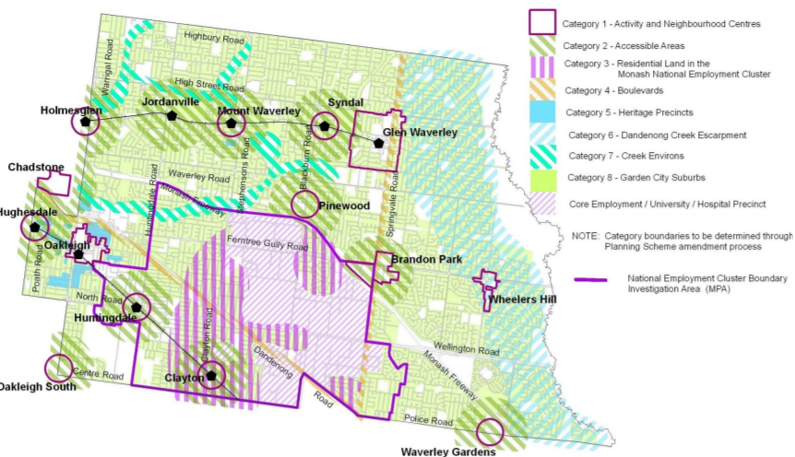
Figure 4: Map 3 -Residential development framework plan Source: Clause 21.04-1 Monash Planning Scheme
- All three categories are designated as suitable for housing growth, more intensive form of development and substantial change.
- Under clause 22.02 the site is within a character type referred to as Housing Growth Area – Clayton Activity Centre and Monash National Employment Cluster where the preferred character is:
The scale of new residential development will generally comprise larger footprint apartment development of a high-quality design and finish. Some infill town house and unit development will also occur. Where possible on larger sites, developments will be multi-level, and set in open gardens.
Although setbacks from all boundaries will be less than is common in other parts of Monash, the developments will ensure the incorporation of well-maintained landscaping to address the garden city character, albeit in a more urban form.
- Both parties referred to the Clayton Activity Centre Precinct Plan (Clayton PP) which provides a framework to guide future land use and built form changes within the centre. In the Clayton PP, the east side of Thomas Street is situated in Precinct 3: Surrounding Residential with a preferred height of six storeys. Neither party relied on the Clayton PP in submissions, other than to provide an understanding of Council’s strategic expectations for the area.
- The Clayton PP has been adopted by Council. However, no Planning Scheme Amendment to implement the Clayton PP has been prepared, authorised, exhibited, considered by a Panel or determined by the Minister for Planning. In these circumstances the weight I give the Clayton PP is very limited.

Does the proposal respond acceptably to the planning and physical context?
- There is no dispute that the review site is within an area earmarked for substantial built form change. The current zoning supports four storey development and strategic planning in the form of the adopted Clayton PP anticipates six storeys. The locational advantages of the site to support increased dwelling numbers and additional dwelling diversity are many. These include excellent access to public transport, shops, services, a major medical precinct and proximity to Monash University.
- It is an area where new building form is not expected to respect the existing neighbourhood character. Instead housing growth is to be facilitated and development is anticipated to comprise larger footprint apartment buildings with some infill town house and unit developments. Setbacks to boundaries are anticipated to be less than is common in other parts of Monash but well maintained landscaping is to be provided to address the garden city character, albeit in a more urban form. Concurrently there are design objectives that seek development to be within an open garden setting and to provide a height, scale and form that respects any sensitive residential interfaces and minimises the appearance of visual bulk. A development is expected to respond to site context and there are clause 55 objectives relating to amenity and site layout that are to be met.
- Although the proposal includes some positive features, there are a number of elements that I find unsatisfactory and in combination they lead me to conclude the proposal does not respond acceptably to the outcomes sought.
- To the north of the review site there are three single storey dwellings within approximately 1 metre of the common boundary with four habitable room windows facing that setback.
- At ground level the development presents with significant boundary construction on the north side. The length of wall is 21.5 metres while standard B18 requires 17 metres. In some circumstances this failure to meet the standard for walls on boundaries would be acceptable, especially in an area where substantial change is sought, but I consider the impacts on the amenity of the existing dwellings to the north is unacceptable.
- The placement of the boundary construction is within approximately 1 metre of several habitable room windows of the single storey dwellings at 3/4 and 4/4 Thomas Street. The wall height is 3.1 metres but allowing for the balcony balustrades above (noting they are setback 800mm with the ‘shelf’ extension to within 400mm) the height reaches approximately 4.5 metres. This is a poor response to the outlook and daylight access to existing habitable room windows. With a wall height of greater than 3 metres, albeit marginally, the daylight standard is not met. If the balustrades are considered as part of the wall height, the non-compliance is more significant.
- The balustrades and screens to the first floor north facing balconies do not comply with the side setback standard. It is my opinion that these structures would create unacceptable visual bulk when viewed from the habitable room windows of the dwellings to the north, an outcome inconsistent with the design objective in Schedule 3 that seeks to ensure that the height, scale and form of development respects any sensitive residential interfaces and minimises the appearance of visual bulk.
- I am concerned about the impact on equitable development opportunities of the property to the north due to the layout that incorporates first floor balconies to within 800mm of the common boundary and the privacy shelfs to within 400mm. Any future development of the adjoining property will have to respond to protect the amenity of these balconies from overlooking, shadow and daylight and with such limited setbacks this will create unreasonable constraints. The layout of the first floor with the adjoining development to the north is shown in figure 5 below.
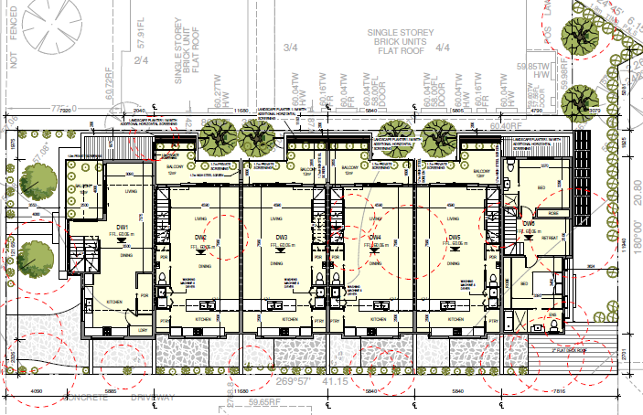
Figure 5: First floor plan Source: TP 04 Bello Design Group dated 22 October 2021
- I accept the Applicant’s submission that balustrade/screen is not a wall as referred to in clause 55 standards, but I agree with Council that such a structure, in this proposal, has a similar impact in terms of daylight and appearance. At the hearing, the Applicant made some suggestions about how the balcony layout/balustrade height could be modified to achieve compliance. I have considered those suggestions, but I am not persuaded that such changes would address my concerns about impact to the north and provide balcony spaces with acceptable amenity for future residents.
- The four ground level courtyards on the north side are between 7 and 9 square metres but only half of that area is clear to the sky due to the overhang of the first floor. The landscape plan shows a capital pear in each of these spaces. I agree with Council the viability and capacity of the trees to reach mature height in this space, which is also to provide for bin storage and other services, is questionable. This limits the opportunity to achieve the tree planting to side boundaries referred to in the Schedule 3 decision guidelines.
- The opportunity for landscaping to the southern side of the site cannot be said to contribute to the garden city character. It comprises a landscape strip along the southern side of the driveway of 0.5 metre width. The landscape plan shows six gantry posts, letter boxes, gas and electricity services in that area and the planting is limited to creepers and ground covers. It was the evidence of Mr Hancox that there is no opportunity for wider sections of landscaping along the southern side of the driveway and still provide appropriate vehicle access. This layout results in limited landscaping opportunity and fails to respond to the Schedule 3 decision guidelines that call for minimising hard paving throughout the site and providing landscaping on both sides of driveways. There is no open space at the termination of the driveway that would allow planting that would contribute to the garden setting sought under Schedule 3.
- There is a north facing window within 3 metres of the common boundary in the dwelling to the south at 8 Thomas Street. The proposal does not meet the standard for north facing windows with the first floor setback 2.3 metres in lieu of 2.8 metres and the upper level setback 4.2 metres in lieu of 5.2 metres. This is poor outcome for the amenity of the adjoining dwelling.
- Site coverage of 66.6% is proposed. The standard of 60% specified in clause 55 is not varied in Schedule 3 to the RGZ. I agree with the Applicant that in an area where more intense development is sought, variation to this standard may be acceptable and not be detrimental to the design outcome. However, in this proposal I consider the failings of the design to acceptably respond to the adjoining properties and to provide an acceptable contribution to the open garden setting sought in the RGZ is connected to the relatively high site cover.
- The Applicant referred to the findings in Domus Design Pty Ltd v Glen Eira CC that applying a ‘minimal change’ type analysis rather than an ‘activity centre’ analysis is potentially fruitless when the site context is likely to change. I agree in this case that the impetus for growth applies to the adjoining sites and nearby land that are also in the RGZ3 and subject to the same policy settings and therefore can reasonably be expected to redevelop over time. I do not reject the proposal for a poor response to existing neighbourhood character and I accept that amenity expectations in this context must be tempered. However, this does not mean that amenity impacts are to be ignored nor that design objectives and decision guidelines in a schedule applied to the area are not relevant. I find in this proposal the design has failed to respond to the reasonable amenity expectations for existing dwellings to the north and south and to provide the landscape setting sought in the RGZ3 for the reasons I have set out.
- A number of Tribunal decisions relating to developments in the RGZ3 were referred to by the Applicant to support the submission that the proposal is an acceptable response to the planning context. I have read the cases referred to and these do not change my view about the proposal before me, noting that each case turns on its individual merits having regard to context and design. For example, in the case of GNL Developments Pty Ltd v Monash CC the Tribunal approved a development of six dwellings, five three storey and one two storey, at 9 Myriong Street, Clayton. Although the layout is similar to the proposal before me, the following features in the 9 Myriong Street development create differences:
  - The design includes an area of communal open space at the end of the driveway and two sections of wider landscaping strip along the driveway. The landscape plan shows two small trees in the wider landscape strip and a larger canopy tree at the termination of the shared driveway. This layout responds to the RGZ3 call for landscaping on both sides of the driveway and for contribution to the garden setting.
  - The extent of boundary construction complies with the relevant standard and walls on boundary are not proposed within 1 metre of habitable room windows. Rather, for the most part, the sections of wall on boundary face a driveway or existing boundary construction limiting amenity impacts to adjoining dwellings.
  - The first floor generally aligns with, or is recessed, from the ground floor rather than including cantilevered elements over private open spaces.
  - First floor balcony screens are not within 1.5 metres of habitable rooms windows.
  - Site coverage of 61.2% is proposed compared with 65.3%.

Private open space
- Council criticised the proposal for providing secluded private open space in the form of balconies, arguing that the varied standard in the RGZ3 provides a clear preference for ground level open space. The amenity of the balconies is also criticised for the extent of screening proposed.
- Encouraging well designed housing that achieves a high level of internal and external amenity is a strategy in the PPF. The MSS includes a strategy to ensure that development provides a high level of amenity for occupants and clause 55 includes objectives and standards that relate to on-site amenity including the provision of private open space.
- The RGZ3 varies standard B28 to require:
An area of 40 square metres, with one part of the private open space at the side or the rear of the dwelling or residential building with a minimum area of 35 square metres, a minimum width of 3 metres and convenient access from a living room.
- There is no variation to the remainder of standard B28 that allows for the provision of private open space in the form of a balcony or roof top area as an alternative to ground level space.
- I do not share Council’s view that there is a clear preference for ground floor private open space. In my view the varied standard relating to private open space at ground level does not translate to a preference for avoiding balconies.
- Ground level open space provided for dwelling 6 meets the varied standard and is acceptable.
- The balconies provided for the other five dwellings exceed the floor space specified in standard B28, have northern aspect and, in the case of dwelling 1, has a good outlook. I am however, concerned about the amenity of dwellings 2, 3, 4 and 5. This concern arises from the primary outlook from the living room of each of these dwellings is to the section of the balcony with 1.7 metre high obscure screening. This will provide poor outlook and amenity for the future residents. My concern about this matter is exacerbated given the south facing windows of the open plan living room/kitchen area at first floor for these dwellings are of obscured glazing further compromising outlook. The balcony spaces for these four dwellings are very different in terms of amenity compared to the five dwellings approved by the Tribunal at 25 Thomas Street in Papermite Pty Ltd v Monash CC [2019] VCAT 1954, where two dwellings have unscreened balconies and three dwellings have ground level secluded private open space.

Other matters
- Although I have refused this application for the reasons set out, for completeness I make the following findings on other aspects of the proposal.
- Although I have criticised the design response to the north and south, I do not oppose the concept of the built form extending deep into the site. In the RGZ3 where increased dwelling intensity is sought I consider such development is supported, subject to an acceptable response to sensitive residential interfaces context. The design guidelines in the RGZ3 refer to proposals which include significant breaks in building mass to ensure the presentation to the street is not a block like structure. There is no similar reference to achieving those significant breaks to side interfaces.
- The front setback at a minimum of 4 metres and the 3 metre setback to the rear appropriately meet the varied standards in RGZ3. I consider the shrouds proposed to upper level bedroom windows is a positive approach to protect privacy whilst allowing outlook and light to the rooms.
- A statement of grounds raised concerns about inadequate parking and submitted that the proposal will result in excessive parking in Jean Avenue given there are restrictions in Thomas Avenue. Council oppose the reduction of one car space sought by the application.
- The proposal provides one car space per dwelling. This meets the requirements of the Planning Scheme for all but dwelling 1. This dwelling contains three bedrooms and attracts a requirement for two car spaces. I am satisfied it is reasonable to allow the waiver of one car space having regard to the following matters:
  - The Australian Bureau of Statistics data (2016 census) provided by Mr Hancox show that 70% of three bedroom dwellings in the Clayton postcode have 0 or 1 vehicle. This suggests a relatively high demand for three bedroom dwellings with only one car space.
  - The proximity of the site to a train station and multiple bus routes is excellent.
  - The accessibility of the site to shops, services and employment within walking distance makes trips without a car convenient.
  - The proximity of the site to major employment opportunities at Monash medical centre within walking distance and Monash University within a bicycle or bus trip.
  - There is support in policy for promoting more sustainable transport patterns and minimising trips by motor vehicles, including through demand management.
  - There are permit parking restrictions in Thomas Street and based on Mr Hancox’s evidence Council’s parking permit policy would not allocate parking permits to this development as of right.
  - There are 4 hour limits on parking on one side of Jean Avenue with unrestricted parking on the other side. If overflow long term parking is, or becomes, an issue in Jean Avenue, Council can manage this with further restrictions to limit unreasonable impact on amenity of residential areas.
- The car parking layout includes an ‘undercroft’ car space for dwelling 4. This space is 3.5 x 5 metres and is enclosed on three sides but has no door. The shorter length of this car spaces is required to provide a turning area for the car using the carport for dwelling 6.
- It is Mr Hancox’s evidence that the undercroft car space meets the length requirements for a car space at clause 52.06-9. In answer to a question about the precision that would be required for parking in this space without projecting into the driveway, Mr Hancox said a car would need to be within 100mm of the end wall. He said this is acceptable since most cars have sensor beepers that allow precision parking and if the car projected into the driveway by 0.5 metres, there would still be room for a turning area but with corrective manoeuvres.
- I note that for a car space in a garage or carport, a length of 6 metres is required. It is unclear to me what makes the ‘undercroft’ car space subject to a different requirement given it is enclosed by walls on three sides. I accept that a projection from the end of the car space would not necessarily prevent the vehicle from car space 6 achieving a turn with corrective manoeuvres but this would depend on the extent of that projection. I consider any future proposal for the site should achieve a layout that avoids a car space that is so constrained and relies on such precision parking.

Conclusion
- For the reasons set out, I set aside the decision of Council and direct that no permit issue.

Cindy Wilson
Member

The submissions and evidence of the parties, any supporting exhibits given at the hearing, and the statements of grounds filed; have all been considered in the determination of the proceeding. In accordance with the practice of the Tribunal, not all of this material will be cited or referred to in these reasons.
At the direction of the Tribunal in Papermite Pty Ltd v Monash CC [2019] VCAT 1954
Including at clauses 11.01-1R, 11.03-1S, 16.01-1S, 16.01-1R and 18.02-3S.
At clause 15.01-4R.
Including at clauses 15.01-1S, 15.01-2S, 15.01-5S, 15.02-1S.
Noting the officer report on the permit application referred to the review site as included only in Category 3 – Residential Land in the National Employment Cluster.
Page 67 Monash Housing Strategy 2014, Final Report 28 October 2014 Planisphere adopted by Council in 2014.
At Figure 6A page 77.
On 28 January 2020.
(Red Dot) [2006] VCAT 452 [41] that references a quote from an earlier decision Domus Design Pty Ltd v Glen Eira CC [2001] VCAT 2330
At clause 16.01-1S
At clause 55.05-4.
From a person who elected not to be a party to the proceeding.
At clauses 18.02-3S, 18.02-4S and 21.12-3.

