VICTORIAN CIVIL AND ADMINISTRATIVE TRIBUNAL
planning and environment LIST | vcat reference No. P221/2021  Permit Application no. TPA/51717
CATCHWORDS
Section 77 of the Planning & Environment Act 1987; Monash Planning Scheme; Residential 1 Zone; multiple dwellings; Policy; Neighbourhood Character; Parking

Applicant | Kamrun and Awlad Hossain

Responsible Authority | Monash City Council
Referral Authority | Department of Transport
SUBJECT LAND | 517 High Street Road  MOUNT WAVERLEY VIC 3149
HEARING TYPE | Hearing
DATE OF HEARING | 1 September 2021
DATE OF ORDER | 1 November 2021
CITATION | Hossain v Monash CC [2021] VCAT 1231

Order

Permit granted
- In application P221/2021 the decision of the responsible authority is set aside.
- In planning permit application TPA/51717 a permit is granted and directed to be issued for the land at 517 High Street Road Mount Waverley in accordance with the endorsed plans and the conditions set out in Appendix A. The permit allows:
- The construction of four dwellings on the land; and
- The alteration of access to a road in a road zone category 1.

Katherine Paterson
Member

Appearances
For applicant | Mr Andrew Grey, Town Planner
For responsible authority | Mr David de Giovanni, Town Planner
For referral authority | No appearance

Information
Description of proposal | The construction of four attached dwellings on the land. Dwellings one to three will be triple storey in height, with dwelling four to be double storey. Dwellings one and four will contain four bedrooms with a study, with dwellings two and three containing two bedrooms. A double garage has been provided for each dwelling at ground level, accessed via a common driveway to High Street Road. The dwellings will appear as a single three storey building when viewed from High Street Road.
Nature of proceeding | Application under section 77 of the Planning and Environment Act 1987 – to review the refusal to grant a permit.
Planning scheme | Monash Planning Scheme
Zone and overlays | General Residential Zone Schedule 3, Vegetation Protection Overlay Schedule 1. High Street Road is included within a Road Zone Category 1.
Permit requirements | Clause 32.08-6 – Construction of two or more dwellings on a lot;  Clause 52.29-2 – To create or alter access to a road in a road zone category 1.
Land description | The site has an area of 766 square metres and currently contains a single storey brick dwelling, with vehicle access to High Street Road.
Tribunal inspection | 6 October 2021

Reasons

What is this proceeding about?
- Kamrun and Awlad Hossain wish to construct four dwellings on land at 517 High Street Road Mount Waverley. Following Monash City Council’s decision to refuse an application for a planning permit for the development, they have requested that the Tribunal review this matter.
- Monash City Council determined to refuse the application on a number of grounds but are primarily concerned that a three storey development is inconsistent with the policy directions for this site and the neighbourhood character of the area, the proposal will provide a poor level of internal amenity for the future occupants of the dwellings, and the car parking access arrangements are unacceptable.

What are the key issues?
- Having considered all the submissions and evidence and inspected the subject land and its locality I am of the opinion that the key issues in this proceeding are:
- Is a three storey development consistent with planning policy expectations for this site?
- Is the proposal respectful of the neighbourhood character?
- Will the proposal provide an acceptable level of internal amenity for the future occupants of the dwellings?
- Does the proposal provide adequate car parking?

Is a three storey development consistent with planning policy expectations for this site?
- Clause 11.01-1R of the Monash Planning Scheme seeks to create mixed-use neighbourhoods at varying densities, including through the development of urban-renewal precincts, that offer more choice in housing, create jobs and opportunities for local businesses and deliver better access to services and facilities. To that end, Clause 16.01-1R seeks to facilitate increased housing in established areas to create a city of 20 minute neighbourhoods close to existing services, jobs and public transport.
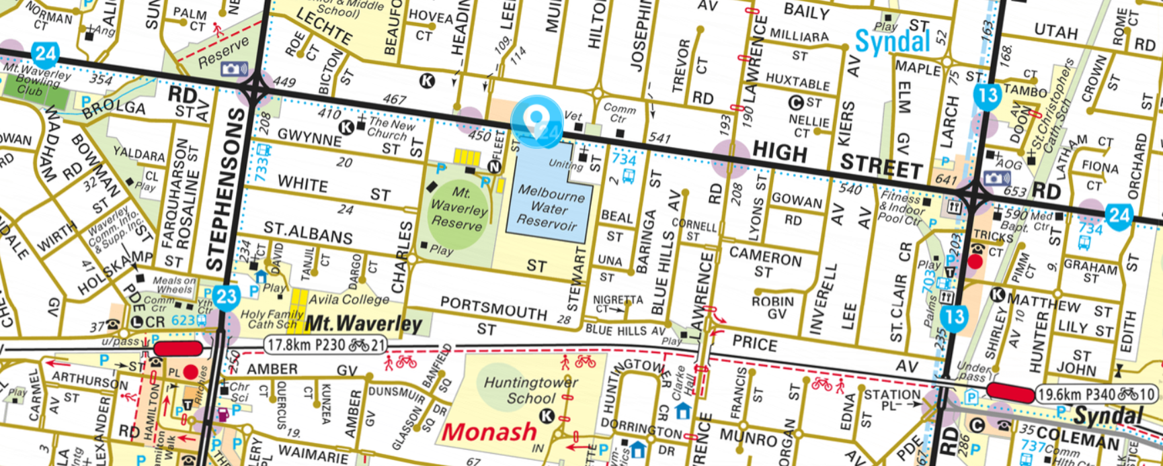
- As can be seen from the above map from Melways Online, the subject site is located approximately 50 metres from a small group of shops located on High Street Road, 900 metres (a ten minute walk) from the Syndal Neighbourhood Activity Centre which includes the Syndal train station and 1 kilometre (a 13 minute walk) from the Mount Waverley Major activity centre, which includes a supermarket and train station. In addition to the Mount Waverley and Syndal train stations, there are a number of bus routes that operate in the area, including a service along High Street Road, linking the site with Glen Iris and Glen Waverley, with the nearest stop outside of the subject site. It is a site that I find is strongly supported by the planning policy framework for more intensive housing forms.

Local Planning Policy
- Clause 21.01-1 states that the population of Monash is expected to grow by over 26,000 to over 215,000 by 2031. The rising population has resulted in an increase in the number of households, and it is estimated that this will drive demand for at least 10,000 new dwellings for the municipality over the period of 2016-2031.
- To guide the provision of additional housing, clause 21.04-1 divides the municipality into various change areas, with the subject site located within Category 8: Garden City Suburbs, which is identified for incremental change.
- Clause 22.01-4 divides Monash into various character precincts, with the subject site included within the Garden City Suburbs (Northern Precinct). The preferred character statement for the precinct includes the following:
Although there will be changes to some of the houses within this area, including the development of well-designed and sensitive unit development and, on suitable sites, some apartment development, these will take place within a pleasant leafy framework of well-vegetated front and rear gardens and large canopy trees.
- This statement indicates that on some sites, robust forms, even apartment developments will be considered suitable. This is reflected in the inclusion of the site within a General Residential Zone Schedule 3 (GRZ3), which allows for three storey forms. The subject site is located on a road within the Road Zone Category 1, within an easy walking distance of three activity centres. It also adjoins an existing three storey apartment building and is located opposite a Melbourne Water reservoir. I find that this is a site which can comfortably accommodate more robust forms of housing, including three storey forms.

Is the proposal respectful of the neighbourhood character?
- Clause 55.02-1 seeks to ensure the design of medium density housing either respects the existing character of the area or contributes towards a preferred character.
- The GRZ3 contains the following Neighbourhood Character Objectives:
- To support new development that contributes to the preferred garden city character through well landscaped and spacious gardens that include canopy trees.
- To promote the preferred garden city character by minimising hard paving throughout the site by limiting the length and width of accessways and limiting paving within open space areas.
- To support new development that minimises building mass and visual bulk in the streetscape through generous front and side setbacks, landscaping in the front setback and breaks and recesses in the built form.
- To support new development that locates garages and carports behind the front walls of buildings.
- The schedule to the zone varies the standard Clause 55 requirements for front, side and rear setbacks, provision of private open space, landscaping and front fences, which seek to achieve design outcomes which are consistent with the character objectives.
- Council submitted that whilst the proposal is setback in accordance with the zone requirements, the lack of recession at upper levels will mean that it will read as ‘top-heavy’ with its height and scale out of character with the prevailing height of buildings, being one to two stories in scale, with the notable exception of the three storey apartment building which adjoins the site.
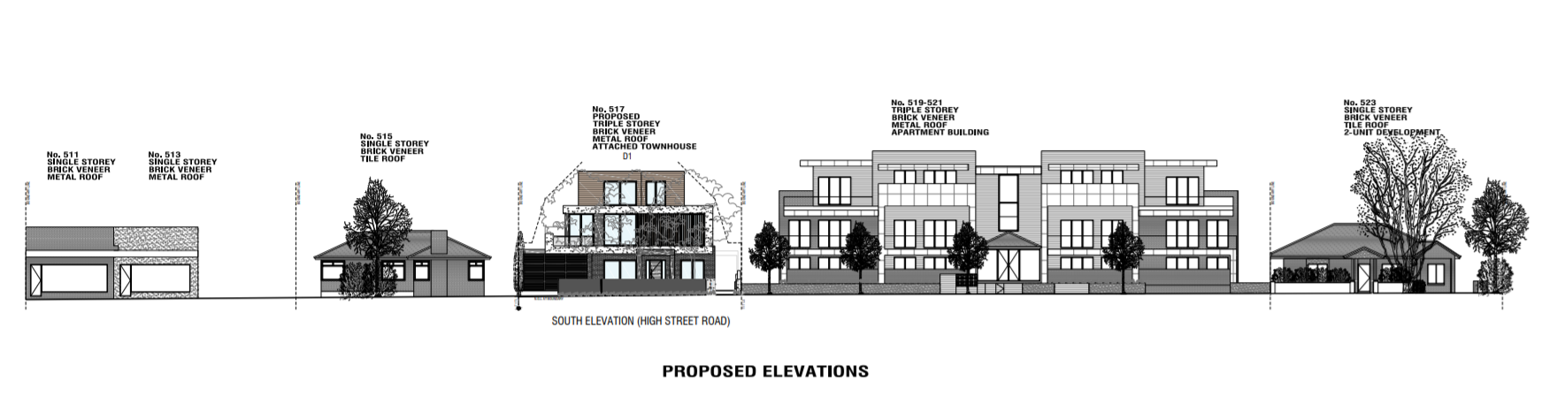
- I disagree. As can been seen from the above streetscape elevation, the design is a departure from the original housing stock; but will provide a transition from the significantly more robust three storey apartment building and borrows elements of the commercial buildings provided within the small activity centre.
- Whilst the front façade of the building will present as a sheer three storey building to the public realm, as indicated above, I find that this site, due to its proximity to the commercial buildings and its location on High Street Road, a four-lane main road, is one which may comfortably absorb robust forms.
- Although accepting that the landscape plan provides the amount of planting required by the schedule to the GRZ3, Council submitted that the landscaping plan demonstrated that the proposed site setbacks were inadequate as they are insufficient to accommodate canopy trees, as desired by Clause 22.01.
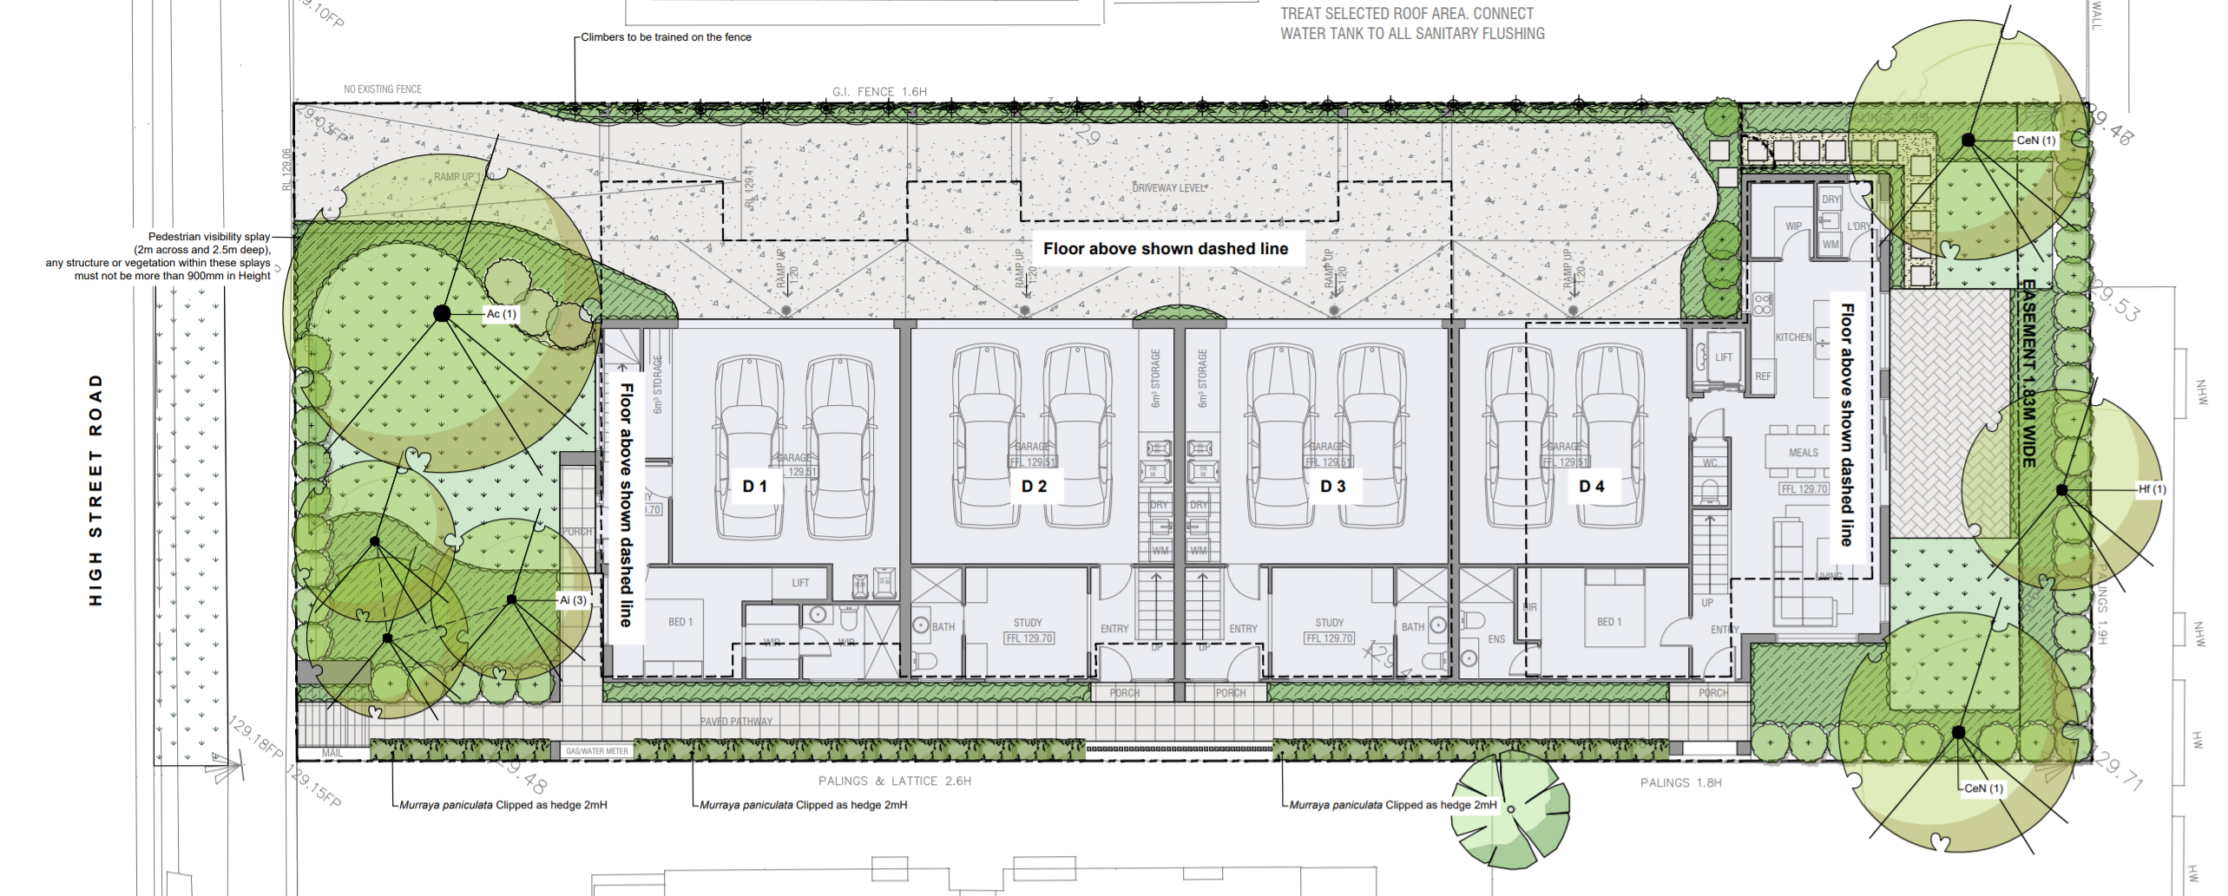
- The landscape plan, prepared by John Patrick Landscape Architects, indicates that the setback to the eastern boundary, which adjoins the apartment building, is sufficient to accommodate a two metre Orange Jasmine hedge, but the western boundary is only sufficient to accommodate a Star Jasmine Climber.
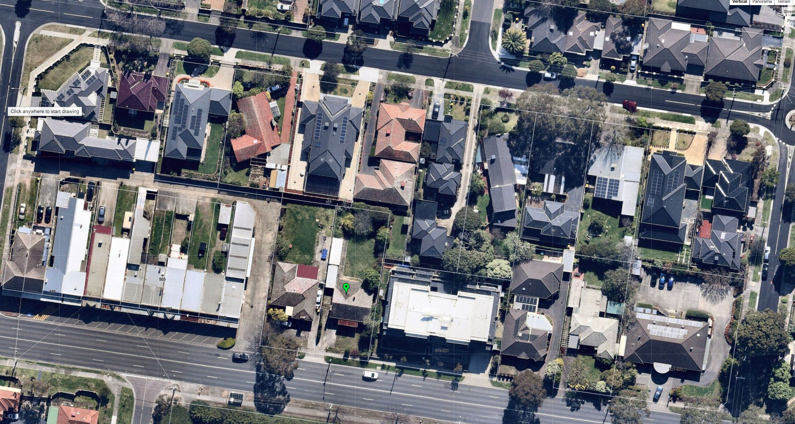
- As can be seen in the above Nearmap image, landscaping within the vicinity of the subject site could be characterised by canopy tree planting in both the front and rear setbacks, with very limited planting, if any along the side boundaries. I find that the landscape plan prepared by Mr Patrick is generally consistent with this landscaped character of the area.
- I have required the landscape plan to be endorsed, implemented, and maintained as a condition of permit.
- I therefore find that the proposed development is an acceptable response to the preferred neighbourhood character of the area.

Will the proposal provide an acceptable level of internal amenity for the future occupants of the dwellings?
- Council submitted that the proposal would provide a poor level of internal amenity due to the use of balconies, and the use of screening to prevent overlooking of the adjoining properties. I will consider each in turn.

Balconies
- The schedule to the GRZ3, whilst varying the requirements for Standard B28, does make provision for balconies, requiring these to be a minimum of 10 square meters with a width of two square metres. These have been provided for dwellings one, two and three at the first floor level of the proposed dwellings.
- Council submits that the choice to use balconies for large three and four bedroom dwellings is inappropriate, as dwellings are likely to be used as family homes and these spaces will be inadequate to meet the recreational needs of the residents. I disagree.
- Whilst they are large homes, the larger balconies are generous and will provide a sufficient space to provide room for outdoor dining, particularly as they are immediately adjoin the living rooms of each dwelling.
- The subject site is located 180 metres from the Mount Waverley reserve which includes a playground, sporting facilities including a tennis club and a football oval, and a dog off lease area. Whilst I acknowledge that residents of these dwellings will need to cross High Street Road to access the reserve, this is easily done utilising the existing pedestrian crossings withing High Street Road. I find that the reserve is located a convenient distance from the site and will be sufficient to meet any additional recreational needs the residents of the dwellings may have such as the ability for kids to kick a football or have an area to play. I therefore find that the provision of balconies for the development is acceptable.

Screening
- The application plans indicate the use of a mixture of screens, highlight windows and opaque glazing to prevent the overlooking of adjoining properties. Whilst these design treatments will protect the amenity of surrounding properties, I agree with Council that screening methods have the potential to significantly affect the internal amenity of dwellings. Therefore, they need to be applied with caution. I will consider each interface in turn.

Western
- Adjoining the site to the west is a single storey brick dwelling, which contains a series of habitable room windows located 2.63 metres from the boundary, and a large area of secluded private open space to the rear of the site.
- At the ground level, dwelling four has a kitchen window with an outlook towards the west, located approximately 8.8 metres from the boundary. Standard B22 of Clause 55.04-6 does not require the window to be treated provided there is a visual barrier of at least 1.8 metres high, which is typically the paling fence. The plans indicate that both a 1.6 metre and a 1.95 metre fence will be used along the boundary, however the exact location of the fences is not clearly shown on the plans. To ensure that the fence prevents overlooking of the window, I have required the taller fence to extend from the rear (northern) boundary a minimum distance of 17.52 metres towards the frontage of the site.
- At the first floor level, overlooking is possible from a series of windows and balconies for each dwelling.
- For dwelling four, there are two west facing windows which may overlook the secluded private open space of the dwelling at 515 High Street Road. The bedroom two window for dwelling four is proposed to be a highlight window, which I find to be acceptable. Bedroom three is currently shown as not treated. However, based on a site line diagram, I am satisfied that the taller boundary fence in this location will be sufficient to prevent unreasonable overlooking of the adjoining property. I have therefore not required this window to be screened.
- The first floor balcony to dwelling three has been treated to prevent overlooking through the use of a screen to its western edge, but no measures has been to the northern side of the balcony. I am concerned that overlooking of the adjoining property is possible from the northern façade. To improve the amenity of the adjoining properties this could be easily addressed through the use of an alternative measure such as a fin extending along the western edge of the balcony to prevent oblique views from the northern end of the balcony. This would have the added benefit of ensuring that this balcony still has an outlook towards the north. I have required this as a condition of permit. A similar issue exists for the balcony for dwelling two, and so I have required a similar treatment to this space.
- The first-floor kitchen windows to dwellings two and three have a sill height of approximately 1.1 metres above the floor level. These windows will provide the only clear outlook from the living and dining room areas of the dwellings, with a secondary outlook provided via the windows to the stairwell. I am not satisfied that the sill height of the kitchen window is sufficient to prevent the overlooking of the neighbouring habitable room windows or secluded private open space. However, I also note that the screening of these windows will have a significant impact on the internal amenity of the dwellings. I have therefore required a sight line diagram to demonstrate that the proposed sill height is sufficient to prevent the unreasonable overlooking of the adjoining property. If the window does need to be treated, this could be done by either raising the sill of the window to 1.7 metres in height or treated with an alternative method to prevent overlooking of the adjoining property but still enable an outlook from these windows. I have required this as a condition of permit. I recognise that this requirement may affect the internal amenity of the living rooms of these dwellings, however I find that due to their size and configuration, as well as access to daylight and views through windows to the balconies and stairwells, the amenity of these spaces will remain acceptable, even if the kitchen windows do require some additional measures to prevent overlooking.
- A highlight western living room window has been used to prevent overlooking to dwelling 1 as well as screening applied to the balcony. As these spaces also have the benefit of windows which directly face the street, I find that this is satisfactory, and I have not required any changes to this arrangement.
- At the third storey, the bedroom windows have been treated to prevent overlooking of the adjoining property through screens or highlight windows. As these windows are to bedrooms, I find that this approach is acceptable and I have not required any changes to this level.

Eastern
- To the east, the site adjoins a three storey apartment building at 519-521 High Street Road, the secluded private open space for a dwelling at 2/54 Lechte Road and further to the east the dwelling at 3/56 Lechte Road.
- At the hearing, the Tribunal was provided with a copy of the endorsed plans for the apartment building at 519-521 High Street Road. These plans indicate that at ground level the site adjoins the ‘side yard’ for two apartments. There is only one habitable window at ground level with an outlook towards the subject site, being the window to Bedroom 2 of apartment 1. At the first-floor level, there is the bedroom 2 window to dwelling 10, and at the second floor level windows to the living areas of dwellings 19 and 22. The windows to the first and second floor windows have been treated to prevent overlooking of the subject site.
- Overlooking from the ground floor windows will be prevented by the 2.6 metre fence on the boundary.
- The first floor and second floor bedroom windows have the potential to overlook the secluded private open space of dwellings 1 and 9/519-521 High Street Road, 2/54 Lechte Road and 3/56 Lechte Road. This impact has been addressed through the use of screens which I find to be acceptable, particularly as they are to bedrooms, and will not have an unreasonable impact on the internal amenity of these spaces.

Northern
- The first-floor windows at the northern façade have been treated to prevent overlooking through the use of screens. This may have an impact on the liveability of the dwelling, particularly to the first-floor retreat area. The rear boundary is treated with a 1.9 metre fence which may be sufficient to prevent the overlooking of the secluded private open space of the adjoining dwelling from the first-floor habitable room windows of dwelling four. I therefore have required the provision of a sight light diagram to demonstrate the overlooking from the windows, and if screening is required, the provision of alternative screening methods to these windows which enable an outlook for the occupants of the dwellings, whilst ensuring that the amenity of the adjoining dwelling at 2/54 Lechte Road is protected.

Conclusion on overlooking
- Whilst reverse living dwellings are a legitimate housing design, they may result in a poor level of amenity, particularly when there is a need to provide screening to living room windows to prevent the overlooking of adjoining properties. In this case, whilst there is a need for a significant amount screening measures, with the changes I have made I am satisfied that all living rooms will have an outlook. Any compromise in the internal amenity needs to be offset by the benefits of the location which include the proximity to activity centres and recreation reserves which will ass

Does the proposal provide adequate car parking?
- The Department of Transport, in a statement of grounds submitted in response to the VCAT Amended Plans (Version B dated 21/07/21)
It is noted that there has been a reduction in width of the driveway entrance and number of dwellings is reduced from 5 to 4. The driveway entrance is now made aligned with the existing crossover. No modification is proposed to the existing crossover.
The Department is generally supportive of the amendment but is concerned that the proposed accessway width looks tight and vehicles need to perform at least 2 corrective movements to turn around and exit in forward direction as shown in the submitted swept path diagrams. Consequently, vehicles might choose to reverse out because it is more convenient to do so, particularly vehicles from Dwelling 1 which is closest to the road. Drivers’ behaviour cannot be controlled via condition of permit, so the Department must ensure that sufficient turnaround space is provided onsite.
In light of the above, the Department keeps its position previously stated in its original response to VCAT dated 29/04/2021 that it does not wish to contest the Application for Review, nor take party at the hearing. However, it would require a new set of conditions as below:
1. Unless otherwise agreed in writing by the Head, Transport for Victoria, prior to the endorsement of plans, amended plans must be submitted to and approved by the Head, Transport for Victoria. When approved, the amended plans must be endorsed by the Responsible Authority and will form part of the permit. The plans must be drawn to scale with dimensions and generally in accordance with the submitted plan but revised to show:
a. Accessway being modified to allow sufficient turnaround space for all vehicles parked in the garages to enter and exit in a forward direction, with no more than one corrective movement (demonstrated by B85 swept path diagrams).
2. All vehicles must enter and exit the site in a forward direction at all times.
- The garden area on the amended plans is shown to 35%. Whilst the Tribunal could have imposed the conditions as suggested by VicRoads, the Tribunal was concerned that the changes required would reduce the amount of garden area to be less than the mandatory requirement.
- This concern was discussed at the hearing, and Mr Gray provided a sketch plan which indicated how the accessway could be widened without affecting garden area. My order of 2 September required the circulation of a revised plan, with revised traffic swept diagrams, and provided an opportunity for the parties to respond to the revised layout.
- The plans which were submitted in response to the Tribunal’s order widened the access way to 5.8 metres, by reducing the width of the ground floor bedrooms and studies. Importantly the overall footprint of the dwellings has not altered, and garden area remains at 35%,
- The plans were accompanied by a memorandum of opinion prepared by Traffix Group dated September 2021. The memorandum included swept path diagrams which indicate that with this change, vehicles can enter and exit the site with one corrective manoeuvre required for vehicles to reverse into the garage space.
- In response to the amended plans, the Department of Transport advised that they now only sought one condition on the permit, being that vehicles must enter and exit the site in a forward direction at all times.
- Monash City Council provided the following response to the amended plans:
Following on from the Tribunal’s order dated 2 September 2021 and the circulation of amended documents by the permit applicant, the amended plans and traffic report have been forwarded to Council’s traffic engineers who offer the following comment:
“We accept the provided swept path diagram indicating the requirement of one corrective movement for vehicles to access the garages and exit the site in a forward direction. Swept path analysis are done on a desktop screen with a software where every manoeuvre is done precisely and efficiently to ensure the maximum usage of every inch of the provided space. However, in reality motorists have different level of driving skills, especially when reversing out of a parking space and not every inch of the provided space will be utilised as efficiently as proposed in the swept path diagrams. This will lead to motorists requiring multiple corrective movements to access the garage or exit the site in a forward direction. Thus, we believe driveways should be designed to accommodate vehicles to be able to access the garages or exit the site in a forward direction without a single corrective movement”.
Adding to this, in Council’s view, the fact that every car space (all eight) necessitate a correcting movement for vehicles to enter in a forward manner is indicative of a parking layout that is marginal, and designed to the absolute minimums. In Council’s view a better outcome is required for a site with a frontage to a Road Zone, Category 1.
On this basis, Council opposes the revised car parking arrangement.
- I disagree with Council’s assessment of the revised plans. Whilst the swept path diagrams indicate that a corrective manoeuvre is required enter the garages, this can comfortably occur on the site and is consistent with the Australian Standards for long term resident parking. I am therefore satisfied that the change significantly improves the access and egress to the site, ensuring that a vehicle may enter and exit the site in a safe and convenient manner. I have therefore required the submission of amended plans generally in accordance with these plans as a condition of permit, noting that the garden area has not been altered by the revised access arrangements.

What conditions are appropriate?
- Draft conditions were circulated by the responsible authority, however due to time constraints the permit applicant did not have an opportunity to comment on these conditions. For this reason, my order of the 2 October provided an opportunity to the permit applicant to respond to the draft conditions.
- I have had regard to those comments in my consideration of the conditions, as well as further consideration by the Tribunal.

Conclusion
- For the reasons given above, the decision of the responsible authority is set aside. A permit is granted subject to conditions.

Katherine Paterson
Member

Appendix A – Permit Conditions

Permit Application No: | TPA/51717
Land: | 517 High Street Road  MOUNT WAVERLEY VIC 3149

What the permit allows
In accordance with the endorsed plans:
- The construction of four dwellings on the land; and
- The alteration of access to a road in a road zone category 1.

Conditions:

- Before the development starts, two copies of amended plans drawn to scale and dimensioned, must be submitted to and approved by the Responsible Authority. When approved the plans will then form part of the permit. The plans must be generally in accordance with the plans prepared by Planning and Design, dated 21.07.21 (drawing Numbers SC, dr, TP01 to TP07 inclusive, SE, SD01 to SD04 inclusive all Rev B) but modified to show:
- The 1.95 metre paling fence along the western boundary to extend from the rear (northern) boundary a minimum distance of 17.52 metres towards the frontage of the site.
- The northern side of the balcony to dwellings two and three treated to prevent overlooking of the secluded private open space of 515 High Street Road. An alternative method such as a fin, blade, or extension of the screen provided to the western edge of the balconies should be used to ensure that the balcony retains an outlook to the north. A sightline diagram must be provided which demonstrates that the method used is sufficient to prevent unreasonable overlooking of the neighbouring secluded private open space within 9 metres of the balcony.
- A sight line diagram to demonstrate that the sill height to the kitchen windows of dwellings two and three is sufficient to prevent the unreasonable overlooking of the habitable room windows and secluded private open space of the property at 515 High Street Road. If the window does need to be treated, this may be done by raising the sill of the window to 1.7 metres in height or treated with an alternative method to prevent overlooking of the adjoining property but still enable an outlook from these windows, such as fins, blades, louvre screen, or raising the height of the boundary fence. If an alternative method is used, a sight line diagram must be provided which demonstrates the method used will prevent the unreasonable overlooking of the adjoining property.
- The provision of a sight light diagram to demonstrate the overlooking from the first floor northern habitable windows towards dwelling four to the property at 2/54 Lechte Road, within 9 metres of the window. If screening is required to prevent the unreasonable overlooking of secluded private open space and habitable room windows of /54 Lechte Road, this should be achieved using alternative screening methods to these windows which enable an outlook for the occupants of the dwellings, whilst ensuring that the amenity of the adjoining dwelling at 2/54 Lechte Road is protected. A sight line diagram must be provided which demonstrates that the method used achieves this outcome.
- An increase in the width to the access way to 5.8 metres with the subsequential changes generally in accordance with the plans prepared by Planning and Design Pty Ltd, Drawing Numbers TP01-TP03 inclusive all Revision C dated 2 September 2021.
- The location of the cantilever support arms on all floor plans and elevations.
- The height of the cantilever support arms.
- Clarification on the plans as to the purpose of the 7.8m dimension on the east elevation (between dwellings 2 and 3) and whether this correlates to an angle in the wall above or similar. If so, this detail is to be clarified on plan.
- The setback between dwellings 1 and 2 (second level).
- Clarification on the plans that the 1.7m screening to the balconies is obscure glazing or screening with a maximum of 25% transparent.
- The provision of additional bins to the garages of dwellings 1, 2 and 3 (recycle and FOGO).
- Any changes recommended in the Sustainable Design Assessment (SDA) report required by Condition 6 of this permit;
- Mail boxes not exceeding 1.2 metres in height.
- A combined electricity meter box located behind the front setback area.
- A Landscape Plan accordance with condition 3 of this Permit and to incorporate the above required changes.
- The development as shown on the endorsed plans must not be altered without the written consent of the Responsible Authority.
- Concurrent with the endorsement of any plans requested pursuant to Condition 1, a landscape plan prepared by a Landscape Architect or a suitably qualified or experienced landscape designer, drawn to scale and dimensioned must be submitted to and approved by the Responsible Authority. The Landscape Plan must be generally in accordance with the plan prepared by John Patrick Landscape Architects dated 22 July 2021 (Landscape Plan for VCAT) but amended to show modifications required under Condition 1.
When approved the plan will be endorsed and will then form part of the permit.
- Before the occupation of the buildings allowed by this permit, landscaping works as shown on the endorsed plans must be completed to the satisfaction of the Responsible Authority and then maintained to the satisfaction of the Responsible Authority.
- Concurrent with the endorsement of plans requested pursuant to Condition 1, a Sustainable Design Assessment (in accordance with Clause 22.13) to the satisfaction of the Responsible Authority must be submitted to and approved by the Responsible Authority. Upon approval the Sustainable Design Assessment will be endorsed as part of the planning permit and the development must incorporate the sustainable design initiatives outlined in the Sustainable Design Assessment to the satisfaction of the Responsible Authority.
- All stormwater collected on the site from all hard surface areas must not be allowed to flow uncontrolled into adjoining properties or the road reserve.
- The private on-site drainage system must prevent stormwater discharge from the/each driveway over the footpath and into the road reserve. The internal drainage system may include either:
- a trench grate (minimum internal width of 150 mm) located within the property boundary and not the back of footpath; and/or
- shaping the internal driveway so that stormwater is collected in grated pits within the property; and or
- another Council approved equivalent.
- All stormwater collected on the site is to be detained on site to the predevelopment level of peak stormwater discharge. The design of any internal detention system is to be approved by Council’s Engineering Department prior to drainage works commencing.
- The nominated point of stormwater connection for the site is to the south-west corner of the property where the entire site's stormwater must be collected and free drained via a pipe to the 300mm Council drain in the naturestrip via a 900mm x 600mm junction pit to be constructed to Council standards. (A new pit is to be constructed to Council standards if a pit does not exist, is in poor condition or is not a Council standard pit).
- All new vehicle crossings must be a minimum of 3.0 metres in width and constructed in accordance with Council standards.
- All new vehicle crossings are to be no closer than 1.0 metre, measured to the edge of any power pole, drainage or service pit, or other services. Approval from affected service authorities is required as part of the vehicle crossing application process.
- All vehicle crossings within 1.50 metres of an adjoining crossing shall be converted to a double crossing in accordance with Council standards.
- Any works within the road reserve must ensure the footpath and naturestrip are to be reinstated to Council standards.
- Engineering permits must be obtained for new or altered vehicle crossings and new connections to Council pits and these works are to be inspected by Council's Engineering Department. A refundable security deposit of $3,500 is to be paid prior to the drainage works commencing.
- Once the development has started it must be continued, completed and then be maintained to the satisfaction of the Responsible Authority.

Head, Transport for Victoria
- Vehicles must enter and exit the site in a forward direction at all times.

Expiry
- The permit for development will expire in accordance with section 68 of the Planning and Environment Act 1987, if one of the following circumstances applies:
- The development is not started before 2 years from the date of issue.
- The development is not completed before 4 years from the date of issue.
In accordance with section 69 of the Planning and Environment Act 1987, the responsible authority may extend the periods referred to if a request is made in writing before the permit expires, or within six months of the permit expiry date, where the development allowed by the permit has not yet started; or within 12 months of the permit expiry date, where the development has lawfully started before the permit expires.

- End of conditions -

The submissions and evidence of the parties, any supporting exhibits given at the hearing, and the statements of grounds filed; have all been considered in the determination of the proceeding. In accordance with the practice of the Tribunal, not all of this material will be cited or referred to in these reasons.
https://online.melway.com.au/melway/
As identified at Clause 21.01-3 of the Monash Planning Scheme
As identified in Plan Melbourne 2017-2050
http://maps.au.nearmap.com/ dated 1 September 2021, retrieved 20 October 2021

