VICTORIAN CIVIL AND ADMINISTRATIVE TRIBUNAL
planning and environment LIST | vcat reference No. P664/2021  Permit Application no. TPA/51741
CATCHWORDS
Application under section 77 of the Planning and Environment Act 1987 to review refusal to grant a permit; Monash Planning Scheme; General Residential Zone 3 – Garden City Suburbs; three double storey dwellings; neighbourhood character; Garden City Character; solar access; tree protection and parking access

Applicant | Josephine Lardieri

Responsible Authority | Monash City Council
Respondent | Cassandra Kurtlu
SUBJECT LAND | 36 Macrina Street  OAKLEIGH EAST VIC 3166
HEARING TYPE | Hearing
DATE OF HEARING | 10 November 2021
DATE OF ORDER | 15 December 2021
CITATION | Lardieri v Monash CC [2021] VCAT 1513

Order
- In application P664/2021 the decision of the responsible authority is affirmed.
- In planning permit application TPA/51741 no permit is granted.

Christopher Harty
Member

Appearances
For Josephine Lardieri | Mr Daniel Bowden, Town Planner from SongBowden Planning Pty Ltd
For Monash City Council | Mr Gareth Gale, Town Planner from Gareth Gale Consulting Pty Ltd
For Cassandra Kurtlu | No appearance

Information
Description of proposal | Three double storey dwellings on a lot. Dwellings 1 and 2 are a side-by-side arrangement fronting the street with Dwelling 3 positioned behind.
Nature of proceeding | Application under section 77 of the Planning and Environment Act 1987 – to review the refusal to grant a permit.
Planning scheme | Monash Planning Scheme
Zone and overlays | General Residential Zone Schedule 3 – Garden City Suburbs (GRZ3)  No overlays
Permit requirements | Clause 32.08-6 – to construct two or more dwellings on a lot.
Relevant scheme policies and provisions | Clauses 11, 15, 16, 21.01, 21.04, 22.01, 32.08, 52.06, 55, 65 and 71.02
Land description | The site is located on the east side of Macrina Street in Oakleigh East, south of Nonna Street. It is regular in shape with a frontage width of 16.76 metres and depth of 46.43 metres with an overall area of 778 square metres. The site currently contains a single storey detached weatherboard dwelling. The site has a drainage and sewerage easement across the rear of 1.83 metres in width.  The surrounding area is residential in nature with a predominantly single storey detached built form with tiled, hipped pitched roof forms and some more recently constructed two-storey medium density development. To both the north and south, the lots have each been developed with two tandem arranged single storey villa units. To the east is the backyard area of a single storey detached dwelling. Adjoining to the rear (eastern) boundary of the site are located two large canopy trees. To the west across the road are single storey detached dwellings.
Tribunal inspection | 7 December 2021 unaccompanied

Reasons

What is this proceeding about?
- Josephine Lardieri (applicant) seeks to construct three (3) double storey dwellings at 36 Macrina Street, Oakleigh East (site). Monash City Council (Council) determined on 10 March 2021 to refuse to grant a permit. The applicant has lodged a review of Council’s decision.
- The applicant wishes to develop the site with two dwellings facing the street in a side-by-side arrangement and a third dwelling to the rear of the site. Dwellings 1 and 3 will have a crossover and driveway located along the northern side boundary of the site providing vehicular access to double garages for each dwelling. Dwelling 2 is located to the south and will have a separate crossover and shorter driveway to access a single garage with a tandem visitor car parking space. The double garage for Dwelling 1 is to be positioned adjoining the western wall of Dwelling 3 and behind the private open space area of Dwelling 2 (refer to Figures 1 to 3).
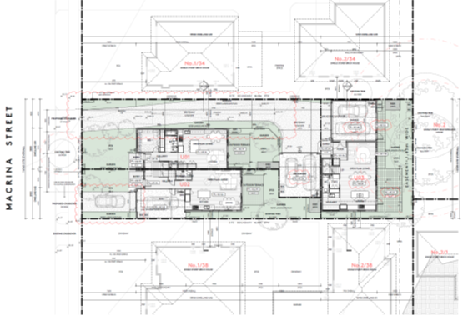

Figure 1: Ground floor plan

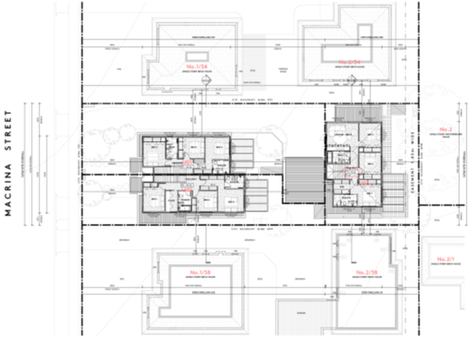

Figure 2: First floor plan
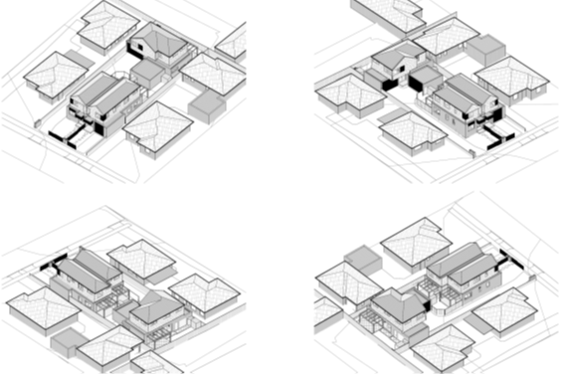

Figure 3: Perspective images of the proposal
- Council considered that the proposal would not:
- respect the preferred neighbourhood character of the area with a top-heavy bulky design with limited articulation or appropriate roof forms;
- provide sufficient space for vehicle manoeuvring associated with parking at the rear that enables vehicles to exit the site in a forward direction;
- provide for the rear dwelling to have good integration with the street;
- provide adequate solar access to Dwellings 2 and 3; and
- provide sufficient protection of adjoining canopy trees located to the rear of the site.
- The respondent (objector) supports Council’s position raising concerns that the development is an overdevelopment of the site.
- The applicant says the proposal is an acceptable design response as it achieves urban consolidation, will sit comfortably within the street, and will respect the amenity of the adjoining properties.

what are the key issues?
- The issues raised within the context of this review relate generally to the proposal’s design response to neighbourhood character. There are also issues around solar access, poor sense of address for the rear dwelling, tree protection and parking access. Having heard the submissions and inspected the site and locality, the key issues arising from this proposal are:
- Is the proposal respectful of neighbourhood character?
- Is the detailed design acceptable?
- Whether parking access is acceptable?
- Whether tree protection is adequate?
- I must decide whether the proposal will produce an acceptable outcome having regard to the relevant policies and provisions in the Monash Planning Scheme (planning scheme). Net community benefit is central in reaching a conclusion. Clause 71.02 - Integrated Decision Making of the planning scheme requires the decision-maker to integrate the range of policies relevant to the issues to be determined and balance conflicting objectives in favour of net community benefit and sustainable development.
- With this proposed development I must decide whether a permit should be granted and, if so, what conditions should be applied.
- Having considered all submissions presented with regards to the applicable policies and provisions of the planning scheme, I find the proposal does not represent an acceptable outcome.
- The design of the proposal is at odds with neighbourhood character, offers poor provision of solar access for two of the three dwellings, does not provide easy and efficient parking access and has uncertainty regarding tree protection. Individually, these issues may not be a problem, but together in a cumulative sense, they represent an outcome that is not acceptable.
- I have decided to affirm the decision of Council and that no permit is granted. My reasons follow.

Is the proposal respectful of neighbourhood character?
- The site is located within a residential area that is experiencing change. The character of built form in Macrina Street is evolving with newer multi-unit developments providing a significant contribution to the character of the area. Residential housing in the area is mixed, which is reflected in the character of the neighbourhood, with the range of eras within which housing has developed from post-war to more recent contemporary built form designs.
- Although the character is mixed, Council correctly pointed out that the features that make up the character of the area retain some consistency through design features, including hipped roof form, recessed upper floor levels from both the front and sides and clear articulation across building façades. Council says that, although there is a difference between newer built form compared to the older housing form, the newer designs have been sympathetic to the older character, using these design features.
- The applicant says the proposal’s design of a gable roof form unashamedly offers a modern 2022 design feature that is different to the 1990s design found in the area. The character of the area is sufficiently varied to be able to accommodate the proposal’s contemporary design. It reflects the intensity of development that has occurred elsewhere in Macrina Street and in other local streets including Inga Street and Dorothea Mackellar Avenue.
- Council has undertaken significant strategic work through Amendment C125 Parts 1 and 2, which implements the Monash Housing Strategy, 2014. The site was rezoned under Amendment C125 Part 2 on 14 November 2019 from the previous General Residential Zone Schedule 2 – Monash Residential Areas (GRZ2) to the General Residential Zone Schedule 3 – Garden City Suburbs (GRZ3). The GRZ3 affects the majority of the residential areas located away from major arterial roads such as the Princes Highway (Dandenong Road) where the GRZ2 still prevails.
- The GRZ encourages a diversity of housing types and housing growth particularly in locations offering good access to services and transport. It also encourages development that respects the neighbourhood character of the area.
- Neighbourhood character and Garden City Character go hand in hand under the planning scheme with a strong theme resonating with how new residential development is considered. Erosion of the Garden City Character through loss of significant vegetation and tree canopy and inappropriate redevelopment of residential areas is a key concern identified in the planning scheme.
- The planning scheme recognises that new development should provide suitable setbacks, appropriate site coverage and site permeability and sufficient open space areas to allow for tree retention and new planting to support the Garden City Character.
- Relevantly, under Clause 21.04 – Residential Development, the site is located within the residential character area of Category 8 relating to Garden City Suburbs. These areas are recognised under the policy as suitable for incremental change. Policy under Clause 21.04-3 seeks to encourage the provision of a variety of housing types and sizes that will accommodate a diversity of future housing needs and preferences that complement and enhance the Garden City Character.
- Under Clause 22.01 – Residential Development and Character Policy, the site is located within the residential character type of Garden City Suburbs: Northern Areas. The preferred neighbourhood character for this type refers to anticipating unit development that is responsive to the existing garden character of the area with built form secondary in visual significance to the landscape when viewed from the street. It refers to key features such as generous and consistent street setbacks, new development complementing established buildings through consistent siting, articulated façades and use of materials. New development is to consider energy efficiency and long expanses of blank walls are to be avoided.
- Both Council and the applicant recognise that change is happening in the area with numerous older and newer style medium density housing developments. There is a mixture of both single and double storey built forms. There are also numerous examples of the same layout as that proposed found in the area with two side-by-side double storey dwellings facing the street and a third double storey dwelling at the rear.
- The main concern with Council was the top-heavy nature of the proposal and lack of articulation. The proposal includes a pitched gable roof form with the gable end fronting the street and presenting a two-storey façade (refer to Figures 4 and 5). While I accept that the ground floor façade facing the street will have acceptable articulation provided by the combination of slight variation in setbacks and entry doors with porches, it is the upper level that presents as a less articulated design. Admittedly the central punch-through windows and timber features to the upper-level bedroom windows assists with providing some visual variation of form. However, the limited recession of around 700mm from the ground floor façade and the general overall lack of articulation of the upper façade walls, compounded by the use of lighter colours, makes the built form stand out as not complementary of the materials, colours and form found in the neighbourhood. I find it is inconsistent with what the preferred neighbourhood character seeks with respect to articulated façades.
- I note the existing dwelling on the site has a gable roof form with the gable ends facing side boundaries and assisted with eaves that introduce shadow to the wall. This is something that could have assisted with breaking up the sheer wall form of the proposal.
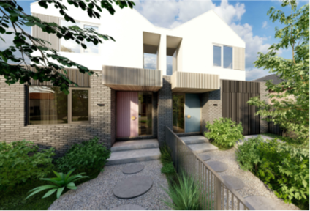

Figure 4: Perspective of the front façade
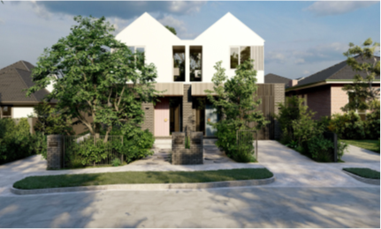

Figure 5: Perspective of streetscape view
- I am comfortable with setbacks from the street. They are generous and do allow space for landscaping including the planting of canopy trees.
- The minimal recessed upper levels along the driveway of Dwelling 1 of around 500mm along a length of around 12.05 metres also presents as a stark built form, particularly from oblique views from the street and down the driveway itself. These detract from respecting built form character in the neighbourhood where upper levels of double storey medium density housing have provided more recognisable upper-level recession in form.
- Generally, the design is respectful with the above exceptions.

Is the detailed design acceptable?
- Council was concerned with the poor visibility from the street of the entry to Dwelling 3 at the rear, saying one would need to walk about halfway down the driveway before seeing or recognising the dwelling entry. Council says the sense of address is unacceptable.
- The applicant says the entry to most rear dwellings are at best difficult to visually see from the street. I agree. Entries to rear dwellings are, by design, obscured from the street by the front dwellings. This is not fatal to a tandem style of design. There are other means of discerning the presence of a rear dwelling and its entry including letterboxes and the like. I note the cantilevered design over the entry porch area of Dwelling 3 and the variation in the use of materials and colours, which assists in identifying the entry to Dwelling 3 (refer to Figure 6).
- I do not consider the integration with the street of the rear dwelling a fatal flaw in the proposal.
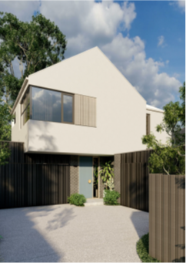

Figure 6: Perspective image of the front of Dwelling 3 at the rear of the site.
- A more significant flaw with the design is solar access. The placement of the driveway along the northern boundary of the site results in Dwelling 3 at the rear having its garage located on the northern boundary effectively preventing any northern solar access to habitable living rooms at the ground floor level. Similarly, with the side-by-side typology on an east-west oriented lot, Dwelling 2 is located on the southern side attached at both ground floor and first floor levels with Dwelling 1, compromising any opportunity for northern solar access.
- Generally, one could accept such a situation if it was the only dwelling foregoing solar access from a northern orientation. However, in this case, two out of the three dwellings will experience poor solar access.
- These design issues combine to produce an outcome which fails policy under Clause 15.02-1S – Energy and resource efficiency that seeks to encourage development that is energy efficient, supports a cooler environment and minimises greenhouse gas emissions. It also fails the requirements under Clause 55.03-5 – Energy efficiency objectives that seek to achieve energy efficient dwellings and development that is orientated and has a layout that makes appropriate use of daylight and solar energy.
- The proposal relies on solar access from the east and the west for the living areas of Dwellings 2 and 3. I accept that the upper-level bedrooms of Dwelling 3 will have reasonable solar access. However, the reliance on solar access from either the east or west is insufficient for the living areas of these dwellings.
- The proposal has not provided for realistic or reasonable solar access, particularly for Dwellings 2 and 3 because of the limitations associated with a side-by-side built form typology and orientation associated with a garage on the north side of Dwelling 3.
- Generally, daylight may be available but solar access will be limited. I find that where effects of climate change are becoming a serious issue, together with the need to encourage energy efficiency, to allow development that is clearly not a form of sustainable development fails to satisfy a key policy under Clause 71.02 of the planning scheme. I am required to determine and balance conflicting objectives in favour of not only net community benefit but also sustainable development for the benefit of present and future generations. I find the proposal does not achieve these aspirations.
- There was discussion during the hearing about flipping the design to have the driveway run along the southern boundary. I consider this would be an improvement because it would free up the northern façade of Dwelling 3 from the constraints of the proposed location of its garage. However, I understand the applicant’s desire to avoid impacting existing north facing habitable room windows of the dwelling located to the south at 2/38 Macrina Street. My response to that issue would be that to overcome such constraints, appropriate setbacks from the southern boundary could be applied to avoid creating any loss of solar access to the adjoining dwelling.

Whether parking access is acceptable?
- The proposal provides a driveway along the northern boundary leading to a vehicle manoeuvring area at the rear of the site of nearly 35 metres in length that sandwiches between the two garages servicing Dwellings 1 and 3. Council says the area between these two garages is too tight to allow vehicles accessing the garages to manoeuvre without excessive corrective movements to be able to conveniently exit the site in a forward direction. The applicant says the area is useable and submitted engineering swept path diagrams showing a four-point turn manoeuvre is possible to allow vehicles to access and leave the site in a forward direction. The applicant says having to engage in corrective manoeuvres is allowed under Clause 52.06 and is a common occurrence with medium density housing developments.
- I accept that having to undertake corrective manoeuvres to enter or exit a site in a forward direction is sometimes necessary. I do not accept the extent of corrective manoeuvring that would be required for the proposal.
- I agree with Council that forcing future occupants of the proposal to undertake four corrective turning movements to be able to exit the garages and site in a forward direction is asking too much and is likely to be viewed as an inconvenience, resulting in drivers simply reversing the length of the driveway to leave the site. This is inconsistent with Clause 52.06-9 – Design standards for car parking which asks for accessways serving four or more car spaces to be designed so that cars can exit the site in a forward direction. It is also inconsistent with the objective of Clause 52.06 to ensure that the design and location of car parking is of a high standard, creates a safe environment for users and enables easy and efficient use.
- The applicant suggested the garage for Dwelling 1 could be pushed back one (1) metre towards the southern boundary, however this raises potential uncertainty regarding the extent of improvement in lessening corrective turning movements and its effects on meeting garden area requirements under the zone. Council’s engineers suggested moving the garage for Dwelling 1 two (2) metres to the south and the garage for Dwelling 3 one (1) metre to the east to allow what Council considers to be a more appropriate outcome.
- I find that additional room for manoeuvring is required but not to the extent that eliminates all-together corrective movements. One corrective movement would be an acceptable outcome. Unfortunately, I am not satisfied that I can require such a change by way of conditions when other changes are required which, in my view, culminates in a need for a fresh design approach.

Whether tree protection is adequate?
- At the rear of the site, on adjoining land at 2 Nonna Street, are two large canopy trees comprising Gympie Messmate (Eucalyptus cloeziana) with heights of around 22 metres and canopy widths of 14 and 16 metres respectively. They have Tree Protection Zones (TPZ) of 9.6 and 10.8 metres respectively.
- The proposed location of Dwelling 3 is set back five (5) metres from the eastern rear boundary. This results in encroachment of the TPZs of the trees by 9.3% and 9.5% respectively. These levels of encroachment are within the general 10% level of encroachment considered acceptable under AS 4970-2009 – Protection of trees on development sites. However, it is also proposed to have an area of paving within the private open space area of Dwelling 3 within the setback area of five (5) metres, which proposes an additional area of encroachment of the TPZs of the trees of 10.2% and 5.1% respectively.
- The amended plans have sought to alleviate the extent of encroachment by proposing at grade construction of the outdoor terrace paving with the additional careful siting and excavation of any foundation holes. A water tank and storage shed would also be required to be re-located.
- Generally, I would anticipate that paving at grade without excavation that would disturb tree roots would be an acceptable measure to minimise adverse impacts on the TPZs of the to trees. This would include supervision of works by an arborist. However, given my other concerns with this proposal and potentially the need for changes to siting and design, I consider the uncertainty of protecting these neighbouring trees would need further consideration. This is particularly highlighted given the Garden City Character policies and emphasis on protecting existing canopy trees as part of the policy direction to maintain the Garden City Character in the area.

Conclusion
- I acknowledge the site has potential for accommodating incremental change with replacing one dwelling with three. Attention to the Garden City Character is appropriate and the concept of the design is one that has already commonly occurred in the area.
- However, many of those other existing similar design typologies have their driveways along the southern boundary resulting in better solar access outcomes. They also reflect articulated front façades and a hipped roof form with recessed upper levels, which the proposal does not all-together respect. Whilst the application of a gable roof form is not completely at odds with the character of the neighbourhood, I find the details of treatments culminate in a form that does not achieve an acceptable level of respect. It is a matter that requires a reconsideration of the siting and design to achieve an acceptable outcome.
- For the reasons given above, the decision of the responsible authority is affirmed. No permit is granted.

Christopher Harty
Member

The statement of grounds lodged by Ms Kurtlu have been considered by the Tribunal.
The submissions of the parties, any supporting exhibits given at the hearing, and the statements of grounds filed; have all been considered in the determination of the proceeding. In accordance with the practice of the Tribunal, not all of this material will be cited or referred to in these reasons.
The Monash Housing Strategy, 2014 is a background document under Clause 21.04-4 and a Policy Reference document under Clause 22.01-6.
Refer to Maintaining the Garden City Character under Clause 21.01-2.
For example, where gable roof forms do occur, such as with the existing dwelling on the site, the use of eaves assists with forming shadow effects and variation.

