VICTORIAN CIVIL AND ADMINISTRATIVE TRIBUNAL
planning and environment LIST | vcat reference Nos. P1651/2020 and P95/2021  Permit Application no. TPA/51359
CATCHWORDS
Sections 82 and 80 of the Planning and Environment Act 1987; Monash Planning Scheme, Neighbourhood Residential Zone Schedule 4, Vegetation Protection Overlay Schedule 1, Construction of five dwellings, Planning Policy, Neighbourhood Character; Design; Traffic; Internal Amenity; External Amenity

ApplicantS

P1651/2020 | Elizabeth and Miklos Tuz, Ying Li, Kwok Hong Yip, Les and Lily McNamara, Brian and Jenny Menzies, Melinda Tuz

P95/2021 | Oorja Developers Pty Ltd

responsible authority | Monash City Council
RespondentS

P1651/2020 | Oorja Developers Pty Ltd

P95/2021 | Elizabeth and Miklos Tuz, Ying Li, Kwok Hong Yip, Les and Lily McNamara, Brian and Jenny Menzies, Melinda Tuz

SUBJECT LAND | 3 Wesley Court Wheelers Hill

HEARING TYPE | Hearing
DATE OF HEARING | 16 August 2021

DATE OF ORDER | 15 September 2021

CITATION | Tuz v Monash CC [2021] VCAT 1057

Order
- In applications P1651/2020 and P95/2021the decision of the responsible authority is set aside.
- In planning permit application TPA/51359 no permit is granted.

Katherine Paterson
Member

Appearances
For Elizabeth and Miklos Tuz, Ying Li, Kwok Hong Yip, Les and Lily McNamara, Brian and Jenny Menzies, Melinda Tuz | Ms Elizabeth Tuz and Ms Melinda Tuz in person.
For Oorja Developers Pty Ltd | Mr Panos Nickas, Solicitor, Nickas Legal Pty Ltd
For Monash City Council | Mr David De Giovanni, town planner, DD planning.

Information
Description of proposal | Construction of five dwellings on the land. Each dwelling will be two stories in height and contain four bedrooms with a double garage. Dwellings 2 to 5 will be accessed via a central driveway with dwelling 1 accessed via a separate crossover. Twenty-five trees are proposed to be removed to accommodate the development. The architectural style of the development is contemporary with pitched roof forms and a variety of materials and finishes used.
Nature of proceeding | Application P1651/2020  Application under section 82 of the Planning and Environment Act 1987 – to review the decision to grant a permit.  Application P95/2021  Application under section 80 of the Planning and Environment Act 1987 – to review conditions 1(d) and 1(e) contained in decision to grant a permit
Planning scheme | Monash Planning Scheme
Zone and overlays | Neighbourhood Residential Zone Schedule 4, Vegetation Protection Overlay Schedule 1.
Permit requirements | Clause 32.09-6 – Construct two or more dwellings on a lot  Clause 42.02-2 – Remove vegetation, Trees 18, 21, 29, 33, 36 and 37
Land description | The subject site has an area of 874 square metres and is irregular in shape. It is currently occupied by a single storey detached dwelling and associated outbuildings and a large amount of canopy trees.
Tribunal inspection | Due to the current Covid-19 restrictions, a site inspection could not be held. The Tribunal has relied on the photographs tendered at the hearing, Google and Nearmap images, and real estate pages to gain an understanding of the site and surrounds.

Reasons

What is this proceeding about?
- Oorja Developers Pty Ltd wish to construct five dwellings on land at 3 Wesley Court Wheelers Hill. A number of nearby residents oppose the proposal, and following the decision of Monash City Council to grant a planning permit for the development they have applied to the Tribunal for review of this matter.
- They submit that Wesley Court was never designed to accommodate a large number of dwellings, and that the addition of five dwellings to the court will impact the wellbeing of current residents and permanently diminish the amenity, liveability, and character of the court and the surrounding area.
- The permit applicant has also requested a review of conditions 1(d) and 1(e) of the notice of decision granted by the permit applicant which seek to increase the first floor setbacks of the built form to the property at 2 Wesley Court.

What are the key issues?
- Having considered all the submissions I am of the opinion that the key issues in this proceeding are:
- Does planning policy support the construction of five dwellings on the site?
- Is the proposal respectful of the neighbourhood character?
- Is the loss of vegetation acceptable?
- Does the proposal create unacceptable amenity impacts?
- Will the proposal generate unreasonable parking and traffic impacts?

Summary of findings
- I have decided to refuse to grant a planning permit for this proposal as whilst planning policy supports the development of townhouses on the site the design fails to respond to the preferred neighbourhood character and will not enable the planting of canopy trees as desired by the Neighbourhood Residential Zone Schedule 4.
My reasons follow.

Does planning policy support the construction of five dwellings on the site?
- Clause 11.01-1R of the Monash Planning Scheme seeks to create mixed-use neighbourhoods at varying densities, including through the development of urban-renewal precincts, that offer more choice in housing, create jobs and opportunities for local businesses and deliver better access to services and facilities. Clause 15.01-4 R seeks to create a city of 20 minute neighbourhoods, that give people the ability to meet most of their everyday needs within a 20 minute walk, cycle or local public transport trip from their home. To that end, clause 16.01-1S includes the following strategies:
- Increase the proportion of housing in designated locations in established urban areas (including under-utilised urban land) and reduce the share of new dwellings in greenfield, fringe and dispersed development areas.
- Encourage higher density housing development on sites that are well located in relation to jobs, services and public transport.
- Identify opportunities for increased residential densities to help consolidate urban areas.
- Facilitate diverse housing that offers choice and meets changing household needs by widening housing diversity through a mix of housing types.
- Encourage the development of well-designed housing that: -
- Provides a high level of internal and external amenity.
- Incorporates universal design and adaptable internal dwelling design.
- Support opportunities for a range of income groups to choose housing in well-serviced locations.
- Plan for growth areas to provide for a mix of housing types through a variety of lot sizes, including higher housing densities in and around activity centres.
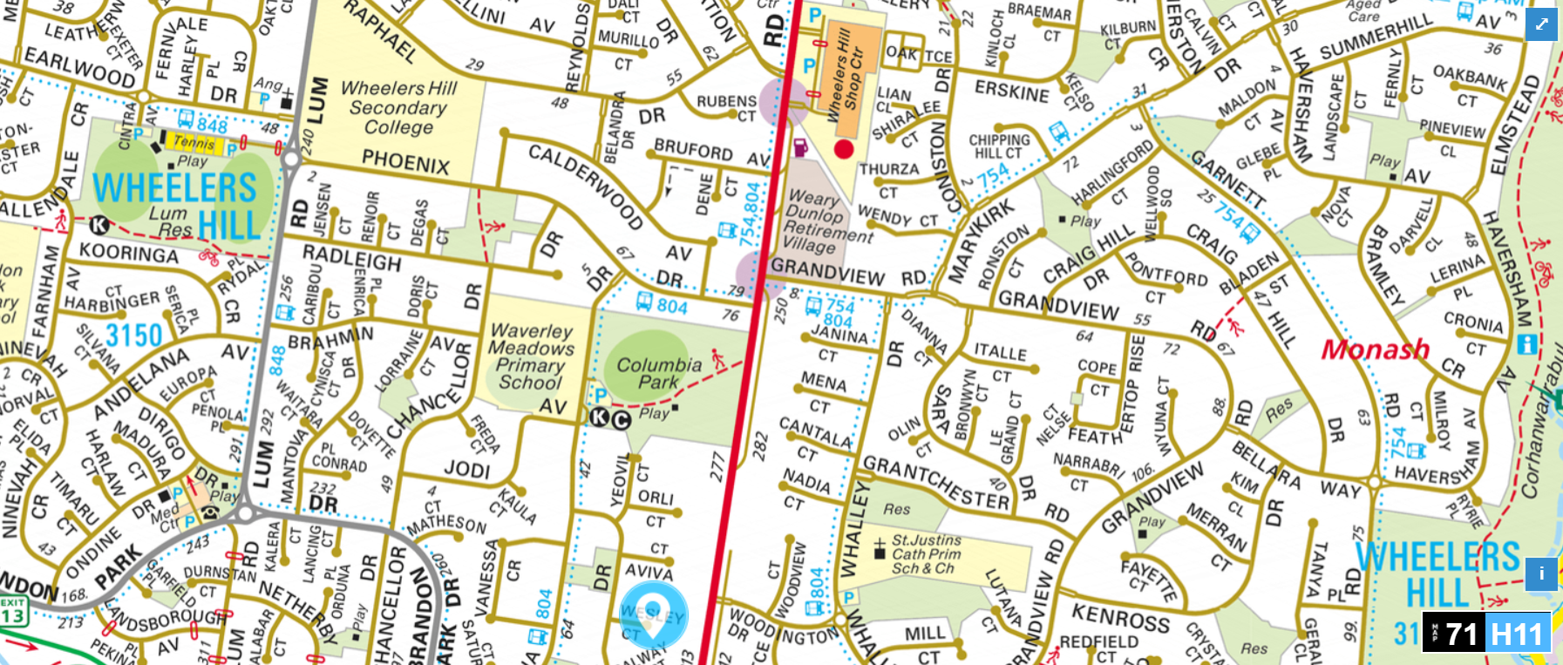
- As can be seen from the above extract from Melways Online, the subject site is located approximately 1.3 kilometres (a sixteen minute walk) from the Wheelers Hill Shopping Centre, which includes a supermarket. Nearby public transport is in the form of buses, with the nearest bus service linking the site with Dandenong and Chadstone, with stops at the Oakleigh and Dandenong Train station. The nearest bus stop is located 450 metres away in Columbia Drive. I find that this is a site which is supported by the planning policy framework for additional housing.

Local Planning Policy Framework
- Clause 21.01 states that the City of Monash had an estimated 189,000 residents in 2016 which is expected to increase by over 26,000 to over 215,000 by 2031. It is estimated that this will drive demand for at least 10,000 new dwellings over the period 2016-2031. To guide the location and scale of new development, Clause 21.04 of the planning scheme has divided the municipality into various housing categories, with the subject site included within Category 8 Garden City Suburbs. Clause 21.04-1 states that these areas are suitable for incremental change. Monash Housing Strategy, which was prepared by Planisphere in October 2014 and a reference document at Clause 21.04-4 provides the following rationale for sites that were to be included within the Incremental Change Areas.
This step involved analysing the balance of Monash’s residential areas, where ‘Garden City’ character will remain an important guide to residential development outcomes. These are areas where neighbourhood amenity and character are a priority and which have reasonable access to activity centres and public transport nodes, but which are beyond easy walking distance of these facilities.
- The strategy goes on to define the anticipated built form outcomes for the incremental areas as follows:
Predominantly conventional detached houses, units and townhouses reflecting the existing scale and neighbourhood character. On larger lots, in suitable locations, lower to medium scale apartment developments may be appropriate, subject to careful design and the provision of substantial landscaped setbacks.
- As such I find that whilst the development of townhouses on this site is generally consistent with the outcomes anticipated by planning policy for this site, the design and scale of the development must be consistent with the neighbourhood character of the area and not have an unreasonable impact on the amenity of the surrounding properties. I turn to these aspects of the proposal next.

Is the proposal respectful of the neighbourhood character?
- The subject site is included within the Neighbourhood Residential Zone Schedule 4, the purposes of which include:
- To implement the Municipal Planning Strategy and the Planning Policy Framework.
- To recognise areas of predominantly single and double storey residential development.
- To manage and ensure that development respects the identified neighbourhood character, heritage, environmental or landscape characteristics.
- Clause 55.02 requires the design of medium density housing to either respect the existing character or contribute towards a preferred neighbourhood character. The schedule to the NRZ4 contains the following neighbourhood character objectives:
- To ensure new development maintains the important view lines to the Dandenong Ranges, along the streets and between buildings.
- To ensure development is defined by its spacious and generous garden settings, tall canopy trees and consistent built form and setbacks.
- To encourage open gardens to the street, and the planting and retention of significant trees.
- The neighbourhood character policy at Clause 22.01 has divided the municipality into various character precincts, with the subject site included within the ‘Dandenong Valley Escarpment Area’ which has the following preferred character statement:
The neighbourhood character of this area will evolve within a landscape that has a large number of native trees spread throughout both the public and private realm. This provides an overhead canopy which unifies the diverse built-form of some neighbourhoods and provides a strong relationship with the semi-natural landscape of the Dandenong Valley. An important characteristic of the area is the view lines to the Dandenong Ranges, along streets and between buildings. New dwellings, or additions to dwellings, will seek to maintain these views.
Building scale, height and bulk will continue to enhance and reinforce the existing landscape and built form character and will generally be similar within neighbourhoods. Large scale contrasts between buildings will be discouraged except where existing trees and shrubs soften the junction between buildings or where there is a graduated change in scale.
Garages will be incorporated into the dwelling design so as not to dominate the facade of the building. New developments will typically be sited to address the street, be well designed, energy efficient and sustainable.
Front setbacks will be generous to enable the development and maintenance of significant native tree canopy and understorey vegetation. There may be variation at a neighbourhood level but there will be consistency within individual streets.
Dwellings will be designed to sympathetically integrate with any existing native trees and shrubs on or adjacent to the development site and to the topography. Facades will be articulated with recesses, openings and balconies. Robust and low maintenance materials and finishes that blend with the surrounding natural environment will be used. Long expanses of blank wall will be avoided, particularly when adjacent to public parks, reserves and other open space areas.
Existing trees will be retained where possible and landscaping will reduce the dominance of buildings and provide filtered views of the architecture. Most gardens will be open to the street with no walls or fences, allowing the soft naturalistic qualities of neighbourhoods to be retained. Large walls and fences will be discouraged except where they are already a visually dominant streetscape element. Gardens will be predominantly planted with native vegetation to contribute to the existing natural setting.
The soft quality of the street will be maintained by ensuring that there is only one single crossover per lot frontage.
- Unfortunately, due to the current Covid 19 restrictions, the Tribunal was unable to inspect the site in person. As such, as explained at the hearing my assessment of the existing character is based on the photographs and submissions provided to the Tribunal at the hearing, as well as other tools available to the Tribunal. Based on these documents, the Tribunal finds that built form in the area consists of one and two storey brick detached dwellings, constructed in a variety of styles, but all with pitched concrete tiled roofs. What is apparent in the streetscape is the presence of tall canopy trees, which are located within mature gardens. These are a defining characteristic of the streetscape of Wesley Court. Based on Google street view images, views of the Dandenong Ranges, which are located generally to the west of the site, do not appear to be readily available from the street, although I note the submissions which indicate that views are accessible from within the property of 2 Wesley Court and may be apparent from the other neighbouring properties.
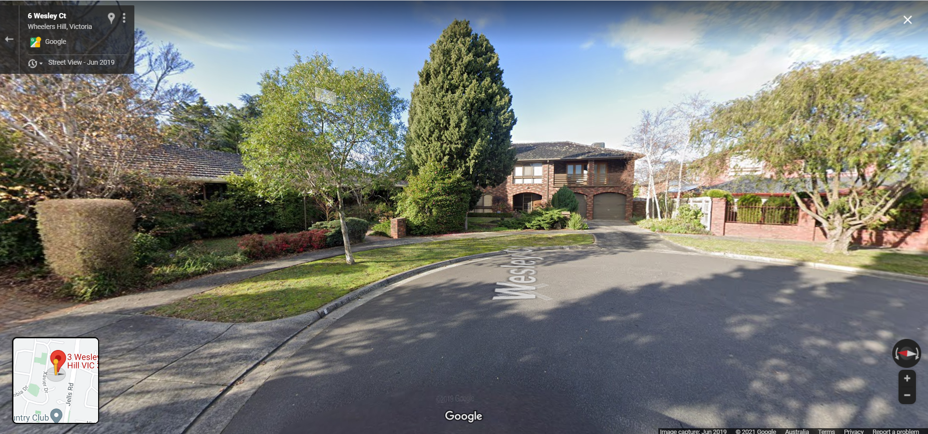
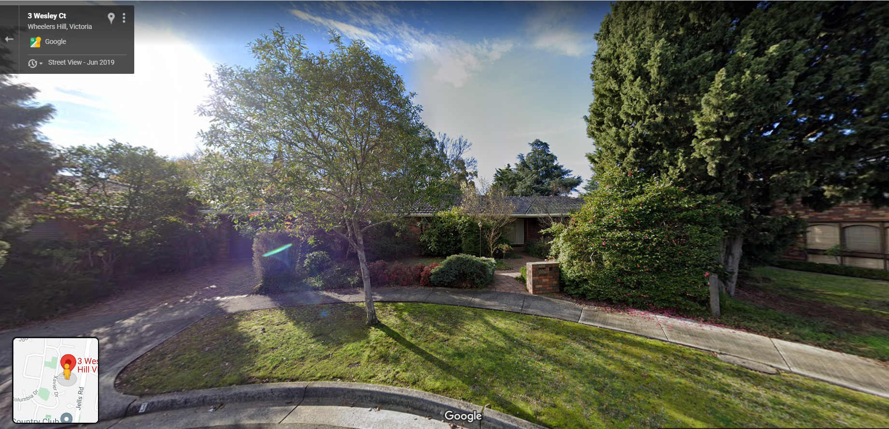
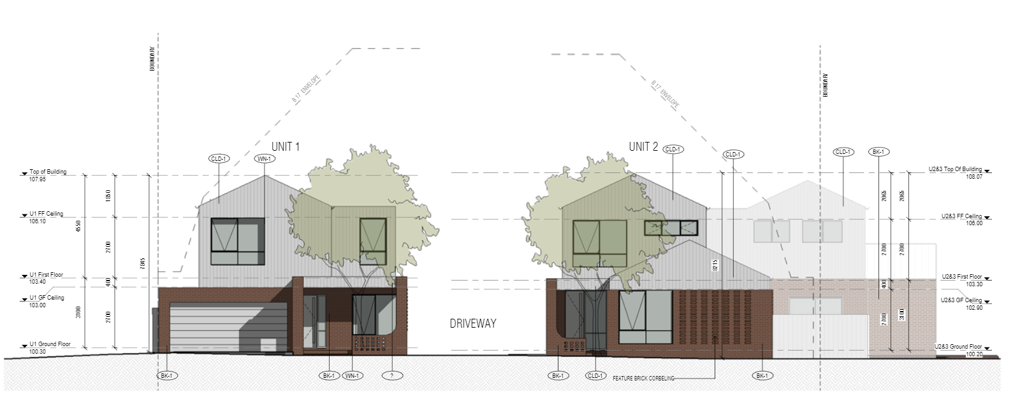
- As the above extract from the advertised plan indicates, the application proposes to introduce five dwellings into this streetscape, constructed in a variety of materials, including face brick work and cement sheet cladding. The application proposes the construction of two crossovers, one to access the driveway for dwelling 1, and the other to provide access to the remaining dwellings.
- The residents submit that the proposal is inconsistent with the character of the area due to the number of dwellings, its site coverage, the proposal to create two crossovers to access the development, and location of the garage for dwelling 1, as well as the proposed setbacks of the development. They were also critical of the overall design of the dwellings submitting:
Some aspects of the design have an ultra-modern look which is a distinct departure from the majority of nearby dwellings. The cladding proposed for the 2nd level of each unit makes it look as if a shed is sitting on top of the 1st level and with the cladding proposed to be “white or similar”, its colour will only amplify its presence rather than allow it to blend into both the surrounding built environment and the natural landscape. Other aspects of the design such as the curved motif applied to entry ways have a decidedly 70’s feel. Add in the unattractive feature brick walls and it makes for a mishmash of styles that will not blend harmoniously with the surrounding dwellings. It feels very much as if a few design elements found on properties in the area have been cobbled together to satisfy Council’s requirement to ‘respect the character of surrounding development’.
- I agree. I find that there are many aspects of the design that are a departure from the existing and preferred character of the area. Whilst this may have been acceptable in an area where significant change is anticipated, in this case the site has been included within a NRZ4 which places greater emphasis on neighbourhood character. This proposal seeks a departure from the preferred character of the area in terms of roof form, presence of double garage doors within the street, and extensive use of cement sheet cladding at the upper levels.
- The landscape plan indicates that the proposed layout will enable the planting of seven canopy trees on the site, as well as the retention of tree 42, which is a four metre flowering gum shown on the architectural plans as to be removed and replaced. The trees to be planted include a 12 metre Black wattle, 8 metre Light wattles and 5 metre red leaved willow myrtles.
- Mr Nickas submitted that the level of canopy tree planting shown on the plans was consistent with the requirements of the NRZ4, if the triangular portion of the land was excluded from the calculation of site width. I disagree with this assessment. This section of land is of sufficient area to accommodate a dwelling and clearly forms part of the site. As such I have calculated the site width based on the actual width of the site, which is 52 metres (using the figures provided on the plan). This equates to a requirement of a minimum canopy trees on the site, all capable of reaching a height of 8.4 metres, being the maximum building height of the built form. The failure of the proposal to provide this level of canopy tree planting is a key failing of the design and an indication that this proposal has failed to respond to the preferred character of the area, which places emphasis on retention and planting of canopy trees to reflect the character of the Dandenong Valley Escarpment.

Is the loss of vegetation acceptable?
- The subject site is included within a Vegetation Protection Overlay Schedule 1 (VPO1), the objective of which is:
To conserve significant treed environments and ensure that new development complements the Garden City Character of the neighbourhood.
- The arborist report which accompanied the application, assessed 43 trees located on the site and surrounding properties, 20 of which require a planning permit to be removed under the provisions of VPO1. The application seeks to remove six of these trees being trees 18, 21, 29, 33, 36 and 37.
- Turning now to the trees to be removed. All six trees have been given a tree retention value rating of either low, or low to moderate, and I am satisfied that their removal is acceptable, provided they are replaced with suitable trees. The trees to be removed have canopies which range in height from 12 to 23 metres, and I find that it is desirable from a character perspective that at least some taller canopy trees are provided to replace the species that is lost. Again, as the design does not enable this to occur, it is an indication that the design fails to respond to the preferred character of the area.
- I am also concerned that the design will have an adverse impact on the health and viability of the Golden Cypress located in 2 Wesley Court. This tree was not assessed by the arborist due to its setback from the property boundary. I find that this was an oversight as given the size of the tree the development does have the potential to have an impact on the health and viability of the tree. I note that the setbacks required by Council would have provided additional physical separation between the tree and the proposed built form. Any future development should be accompanied by a report which provides an assessment of the likely impact on the health and viability of this tree. These concerns could have been addressed via a revised arborist report which I would have required as a permit condition had I been of a mind to grant a planning permit for the development.
- There was also concern that the loss of trees may have an impact on the ecological values of the area, however no evidence was provided to the Tribunal as to what the actual impact would be and as such, I have not had regard to these impacts in my decision.
Does the proposal create unacceptable amenity impacts?
- Concern was raised that the proposed development would unreasonably affect the amenity through visual bulk, overlooking, overshadowing and loss of light. I will consider each in turn.

Visual Bulk
- The visual impact of a development is usually most felt within the secluded private open space of adjoining residential properties.
- Both Ms Tuz and Mr De Giovanni submitted that the proposal, in its advertised form would unreasonably affect the amenity of the adjoining properties through visual bulk. Conditions 1(d) and 1(e) seek to resolve this issue for the interface with 2 Wesley Court, by requiring an increase in setback to the first floor western wall of dwelling 1. Prior to the hearing, the applicant circulated an alternative design, known as Revision D which also seeks to resolve this issue for 2 Wesley Court.
- I find that the setbacks, as shown on the revision D drawings submitted prior to the hearing would be sufficient to reduce the visual bulk impacts of the proposal when viewed from 2 Wesley Court, and I would have required the changes shown as a condition of permit, had I been of a mind to grant a planning permit. I am satisfied that the setbacks of the built form to the other adjoining residential properties are sufficient to mitigate any unreasonable visual bulk from adjoining properties.

Overlooking
- The plans indicate that all first floor habitable room windows that have an outlook to adjoining properties are proposed to be treated to prevent overlooking of adjoining properties through the use of obscure glazing to a sill height of 1.7 metres. Whilst this complies with Standard B22 of clause 55.04-6, it will conversely have a significant impact on the internal amenity of the proposed dwellings. Some windows appear to have been treated unnecessarily and for others alternative treatments could have been used such as blades or fins which prevent downward views whilst still enabling some outlook for the dwelling. I would encourage any redesign to consider the use of screening treatments in a more nuanced manner.

Overshadowing
- The shadow diagrams submitted with the application indicate that the proposal will cast additional shadow in the adjoining properties, however the amount of shadow cast is considerably less than that allowed under standard B21 of clause 55.04-5. I am therefore satisfied that the proposal will not unreasonably affect the amenity of adjoining properties through overshadowing.

Loss of light
- The plans indicate that the proposed built form will be set back a considerable distance from any neighbouring habitable room window which directly faces the subject site. As these setbacks exceed the requirements of Standard B19 and Standard B20, I am satisfied that the proposed development would not result in any unreasonable loss of light to adjoining properties.
Will the proposal generate unreasonable parking and traffic impacts?
- There were several criticisms of the proposed development, including the provision of parking, the impact of the development on traffic volumes within the street, the provision for waste services, and the choice to use two crossovers. I will consider each in turn.

Provision of parking
- The application provides two spaces per dwelling and a visitor parking space which is consistent with the requirements of Clause 52.06. I have not refused this application on the basis of its parking provision.

Crossovers and access
- The application proposes the use of two crossovers, an existing crossover will be used to access dwelling 1 and another to provide access to the other dwellings. Clause 21.01-3 of the scheme outlines the Council’s vehicle crossing policy which is to:
- Locate and minimise vehicle crossovers to prevent traffic disruption, and preserve nature strips and street trees.
- Maximise landscaping in front setback areas by minimising the number of crossovers
- From a character perspective, I find that the use of two driveways has limited the ability of the front setback to be landscaped as desired by the NRZ4 and VPO that applies to the land. In terms of traffic disruption, I note that the proposal was accompanied by a traffic engineering report prepared by TTM, which states that the location of the new crossover is acceptable from a traffic engineering perspective. The officer’s report indicates that Council’s traffic engineers were supportive of the application subject to conditions requiring the following:
- The minimum distance is to be 5.5m measured in between the turning points of the proposed vehicle crossings.
- Driveway to have an internal radius of at least 4 metres at changes of direction or intersection.
- On-site visitor parking spaces are required to be clearly marked
- In order to enable vehicles from unit 3 and unit 4 to be able to exit in a forward direction, the sections of the driveway at the change in direction north of unit 3 and unit 4 carpark spaces are to have 4m internal radius. This will affect unit 3’s and unit 4’s porch locations.
- The maximum grade within a parking module measured parallel to the angle of parking is to be 1 in 20. Measured in any other direction is to be 1 in 16.
- These requirements were included on the Notice of Decision which was not disputed by the permit applicant and I am satisfied that the proposed crossovers are acceptable from a traffic engineering perspective.

Traffic volumes
- The TTM report does not provide an assessment of the existing traffic volumes in Wesley Court, or an assessment of the predicted traffic volumes as a result of the development.
- However, using the design standards for streets and roads provided at Clause 56.06-8 of the scheme, I find that the street would meet the definition of an Access Place- Level 1 which has a design capacity of between 1000 and 2000 vehicle movements per day. Applying a rate of 10 vehicle movements per day per dwelling, the existing traffic within Wesley Court would be approximately 70 vehicle movements per day, with 7 expected during peak hours. The proposed development would increase the traffic volumes to 110 vehicle movements per day, with 11 vehicle movements during the peak hours, or one vehicle every five minutes. I find that the increase in traffic volumes will be comfortably absorbed within the existing road network, and will not have an adverse impact on the amenity of the street.

Waste
- Concern was raised that the rubbish collection for the development would have an adverse impact on the amenity of Wesley Court. Condition 10 of the Notice of Decision requires the preparation of a Waste Management Plan. This could result in several scenarios including private collection, the use of shared bins, or simply utilising Council’s usual services. All options are considered acceptable by the Tribunal. I have not refused this application on the basis of waste collection.

Conclusion
- For the reasons given above, the decision of the responsible authority is set aside. No permit is granted.

Katherine Paterson
Member

The submissions and evidence of the parties, any supporting exhibits given at the hearing and the statements of grounds filed have all been considered in the determination of the proceeding. In accordance with the practice of the Tribunal, not all of this material will be cited or referred to in these reasons.
https://online.melway.com.au/melway/ retrieved 30 August 2021
The centre is identified as a Neighbourhood Activity Centre at Clause 21.01-3 of the scheme
Clause 22.04-1
Google Maps https://www.google.com/maps/@-37.9185346,145.1856374,3a,75y,85.11h,85.26t/data=!3m6!1e1!3m4!1sWuPasanc8kkODnX95NefkA!2e0!7i16384!8i8192 images dated June 2019, retrieved 30 August 2021.
Drawing TP06.1 prepared by R Architecture dated 22 May 2020.

