VICTORIAN CIVIL AND ADMINISTRATIVE TRIBUNAL
planning and environment LIST | vcat reference No. P11705/2021  Permit Application no. TPA/52018/A

Applicant | Aristidis Karabatos

Responsible Authority | Monash City Council
SUBJECT LAND | 1685 Dandenong Road,  OAKLEIGH EAST VIC 3166
HEARING TYPE | Hearing
DATE OF HEARING | 27 January 2022
DATE OF ORDER | 27 January 2022

Order

Permit amended
- In application P11705/2021 the decision of the responsible authority is set aside.
- Planning permit TPA/52018/A is amended and an amended permit is directed to be issued for the land at 1685 Dandenong Road, Oakleigh East. The permit is amended as follows.
  - What the permit allows is amended to read as follows:
- Alterations and additions to the existing dwelling on a lot less than 500 square metres and construction of a front fence
- Conditions in the permit are amended as follows:
  - A new condition is included as follows:
1. Within three (3) months of this permit being amended, plans drawn to scale and correctly dimensioned must be submitted to the satisfaction of and approved by the responsible authority. When approved, the plans will be endorsed and then form part of the Permit. The plans must be generally in accordance with the plans lodged with the amendment application (prepared by Karabatos Architecture, numbered TP00 to TP21 inclusive, labelled Revision E and dated 08/08/2021) but modified to show:
a) The title boundary clearly shown, labelled and marked in red on all relevant plans including along the entire Bowmans Parade frontage on Drawing No’s TP10 (Ground Floor Plan) and TP17 (Landscaping Plan).
b) The notations regarding “Existing Fence Line (Green Line)” deleted from all relevant plans including Drawing No’s TP09, TP10, TP10, TP11 and TP17 and replaced with a notation stating “Proposed Fence Line (Green Line)”.
c) All proposed fencing must not extend beyond the existing title boundaries.
d) The outer section of splayed fencing located at the corner of Dandenong Road and Bowmans Parade (shown as having a height of 1.0 metre) reduced to a maximum height of 0.9 metres.
e) The inner section of splayed fence at the corner of Dandenong Road and Bowmans Parade increased in setback from the existing concrete paved splay so as to be parallel and at least 3.0 metres to this concrete splay.
f) Landscaping shown in the area between the inner and outer splay fencing. This should include details of the pedestrian path and planting either side of this path.
g) The inner section of splayed fencing located in proximity to the corner of Dandenong Road and Bowmans Parade (which contains the new pedestrian gate), as well as fencing to both Dandenong Road and Bowmans Parade reduced to a maximum height of 2.0 metres.
h) All new fencing to the streets to be painted in Dulux Windspray, or similar colour.
i) All relevant plans updated as required to satisfy condition parts 1a) to 1i) inclusive including the floor plans, elevations, fence elevations and landscaping plan.
- Conditions in the permit are renumbered accordingly. This includes that the previously numbered condition 1 becomes condition 2, with other subsequent numbers also renumbered accordingly.

Alison Glynn
Member

Appearances
For Aristidis Karabatos | Sarah Varney, barrister.
For Monash City Council | Ms Adrianne Kellock, town planner of Kellock Town Planning Pty Ltd.

Information
Description of proposal | Amendment to an existing permit. The amendment refused relates to the construction of a 2.1 metre high timber paling front and side street boundary fence and vehicle gates to an existing dwelling.
Nature of proceeding | Application under section 77 of the Planning and Environment Act 1987 – to review the refusal to grant a permit.
Planning scheme | Monash Planning Scheme
Zone and overlays | General Residential Zone – Schedule 2 (GRZ2)

Remarks

- Oral reasons for this decision were given at the conclusion of the hearing.
- In the oral reasons given I advised I would include as part of remarks, a copy of a diagram clarifying the intent of the amended fence splay setback in the new condition 1. This is provided in figure 1 below.

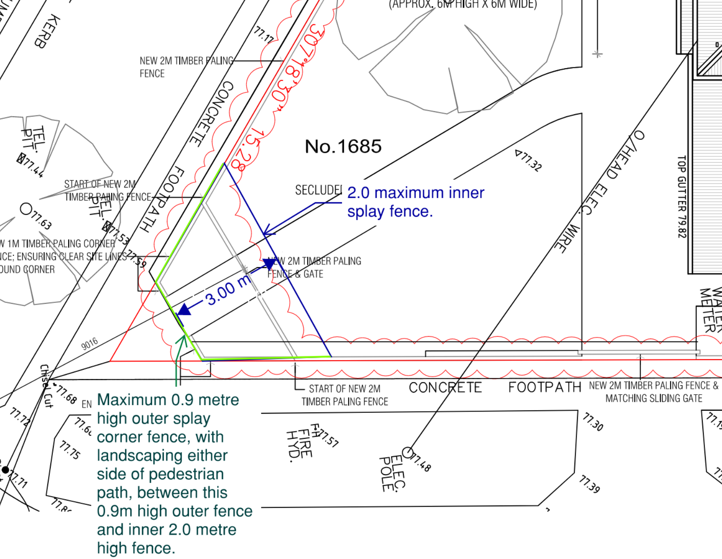
Figure 1

Alison Glynn
Member

