VICTORIAN CIVIL AND ADMINISTRATIVE TRIBUNAL
planning and environment LIST | vcat reference No. P659/2020  Permit Application no.TPA/51039
CATCHWORDS
Section 79 of the Planning and Environment Act 1987; Monash Planning Scheme; medium density development; external amenity impacts; visual bulk and scale of development; overshadowing; over-looking; repeat appeal
Applicant | Kostas Damaskos

Responsible Authority | Monash City Council
Respondents | Barbara Susan Williams, Irina Tourovsky & Others
Referral Authorities | Melbourne Water
 | The Head, Transport for Victoria

SUBJECT LAND | 140 Ferntree Gully Road  OAKLEIGH EAST VIC 3166

HEARING TYPE | Hearing

DATE OF HEARING | 10 March 2021 and 26 April 2021
date of interim orderS | 26 April 2021, 25 January 2022, 8 February 2022
date of site inspection | 9 December 2021

DATE OF ORDER | 28 February 2022

CITATION | Damaskos v Monash CC [2022] VCAT 37

order

Permit granted
- In application P659/2020 the decision of the responsible authority is set aside.
- In planning permit application TPA/51039 a permit is granted and directed to be issued for the land at 140 Ferntree Gully Road OAKLEIGH EAST VIC 3166 in accordance with the endorsed plans and the conditions set out in Appendix A. The permit allows:
- Construction of three dwellings on land in the General Residential Zone (Schedule 3) and Special Building Overlay
- Alteration of access to a road in a Transport Zone 2.

Carol Daicic
Senior Member

Appearances
For Kostas Damaskos | Daniel Bowden of Song Bowden Pty Ltd
For Monash City Council | Adrienne Kellock of Kellock Town Planning Pty Ltd
For Melbourne Water | No appearance
The Head, Transport for Victoria | No appearance
For Barbara Susan Williams, Irina Tourovsky & Others | Barbara Susan Williams

Information
Description of proposal |  | Construction of three (3) dwellings, buildings and works in land in a General Residential Zone – Schedule 3 and Special Building Overlay (SBO) and alternation of access to a road in a Transport 2 Zone.
Nature of proceeding |  | Application under section 79 of the Planning and Environment Act 1987 – to review the failure to grant a permit within the prescribed time.
Planning scheme |  | Monash Planning Scheme
Zone and overlays |  | General Residential Zone – Schedule 3 (GRZ3)  Special Building Overlay (SBO)
Permit requirements |  | Clause 32.08-6:  - To construct two or more dwellings on a lot.  - To construct or extend a front fence within 3 metres of the street if it exceeds the maximum height specified in clause 55.06-2.  Clause 44.05-2: To construct a building or to construct or carry out works including a fence.  Clause 52.29: Land adjacent to a Transport 2 Zone
Other requirements |  | Clause 52.06: car parking
Clause 32.08-6: stipulates that a development must meet the requirements of clause 55 (two or more dwellings on a lot and residential buildings)
Clause 65: decision guidelines
Tribunal inspection |  | A site inspection was conducted after the hearing in December 2021.
Land description | The subject land is located on the south side of Ferntree Gully Road. The total area of the subject land is approximately 1086 sqm. It is irregular in shape with an angled rear boundary. The frontage is approximately 18.29m, the eastern boundary is 64.54m long and the western boundary is 54.26m long. From front to rear there is slope of over 7 metres and a fall by approximately less than one metre from east to west.  The subject land contains a single storey brick dwelling with a pitched roof. There is a 1.9m fence running across the frontage comprising a low brick wall with timber pickets above. The rear yard contains a double garage and a shed.  Vegetation is largely confined to low level planting within the front setback and the rear yard has been cleared of vegetation.  Ferntree Gully Road is a road in a Transport 2 Zone. Vehicle access is provided via a single width crossover located towards the eastern end of the frontage of the subject land.  Abutting the subject land to the east is a property with five dwellings comprising the original dwelling fronting Ferntree Gully Road and four newer double storey dwellings fronting Highland Avenue. To the west, the adjoining property contains four double storey dwellings, two of which front Ferntree Gully Road and two of which are located to the rear. Vehicle access to those properties is provided via two crossovers at either end of the frontage. The rear abuttal to the subject land is to FE Hunt Reserve, which forms part of a Melbourne Water Floodplain.  Nearby residential development comprises a mix of original modest single storey brick and weatherboard dwellings, along with a number of multi-unit developments and large single dwellings. The subject land is located approximately 2.2 kilometres north-east of Oakleigh activity centre and 1.8 kilometres north-west of Monash University. It is conveniently located near various services and facilities including public transport, a local shopping strip and a primary school.

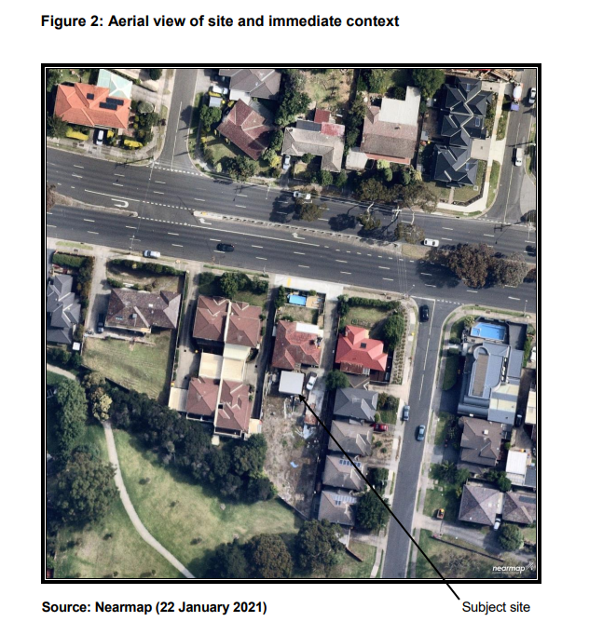
Figure: Council submission at page 9

Reasons

What is this proceeding about?
- Kostas Damaskos wishes to develop the subject land for three dwellings, comprising retention of the existing dwelling at the front of the subject land and construction of two new dwellings at the rear.
- He has filed an application for review in VCAT pursuant to section 79 of the Planning and Environment Act 1987 (Vic) because the Monash City Council (council) failed to make a decision with respect to his planning permit application within the prescribed time.
- The permit application originally sought approval for the construction of four dwellings (with the existing dwelling to be demolished). However, notice of an amended proposal was filed prior to the commencement of the hearing proposing a three dwelling development and amended plans were substituted for the application plans.
- The council and the objectors submit that the proposal fails to provide a suitable response to the site context and the preferred character of the neighbourhood. They submit that potential impacts on neighbouring properties have not been satisfactorily addressed. Further, they submit that the design fails to satisfy the objectives of schedule 3 to the General Residential Zone (GRZ3) and will provide a poor level of amenity for future occupants. They submit that the need to provide substantial living areas at basement level, within a flood plain, indicates a compromised design. They ask the Tribunal to direct no permit to issue.
- The planning history of the subject land includes:
  - the previous approval in a lapsed planning permit for a similar three dwelling proposal; and
  - a previous application for a four dwelling proposal that was refused by the Tribunal in application P1353/2018.

PROPOSAL
- The proposal comprises:
  - the retention of the existing dwelling (containing two bedrooms and a study) and double garage;
  - construction of a new elevated decking area to the rear of the existing dwelling of approximately 16 sqm with external stairs accessing the garage;
  - retention of the existing front fence;
  - two new dwellings to the rear with a maximum height of approximately 8 metres in a ‘side by side’ arrangement containing:
    - a large basement level comprising a rumpus area connecting to a terrace, laundry and powder room;
    - a ground level comprising a double garage and an open plan kitchen / living / meals area with sliding doors to access either a covered area at the rear (dwelling 2) or an outdoor area with a pergola (dwelling 3). Dwelling 3 also has a master bedroom with ensuite on this level;
    - a first floor level that contains bedrooms (4 bedrooms for dwelling 2 and 3 for dwelling 3), amenities and a south facing balcony (which is accessible from one or more of the bedrooms).
  - the new dwellings are contemporary in style and contain a low pitched roof;
- secluded private open space for all three dwellings located to the rear (south). The existing dwelling is also provided with private open space in the front setback;
- the development has a site coverage of approximately 40 per cent and permeable surface area of 41% respectively;
- compliance with the mandatory garden area requirement of 35%;
- vehicle access to all three dwellings via the existing crossover on Ferntree Gully Road.
- Extracts of the permit application plans are set out below:

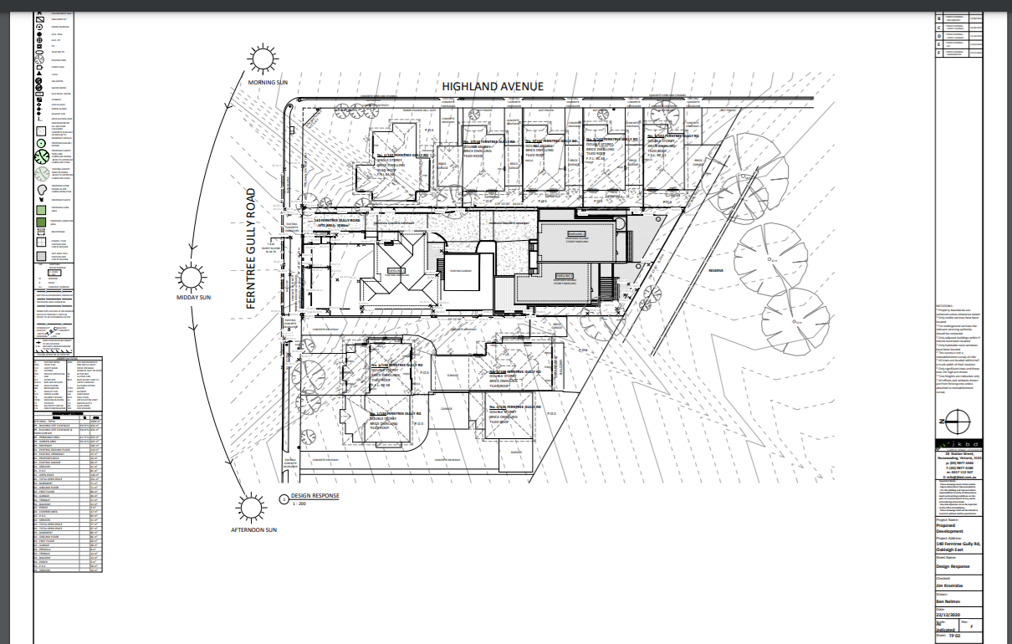
Subject land
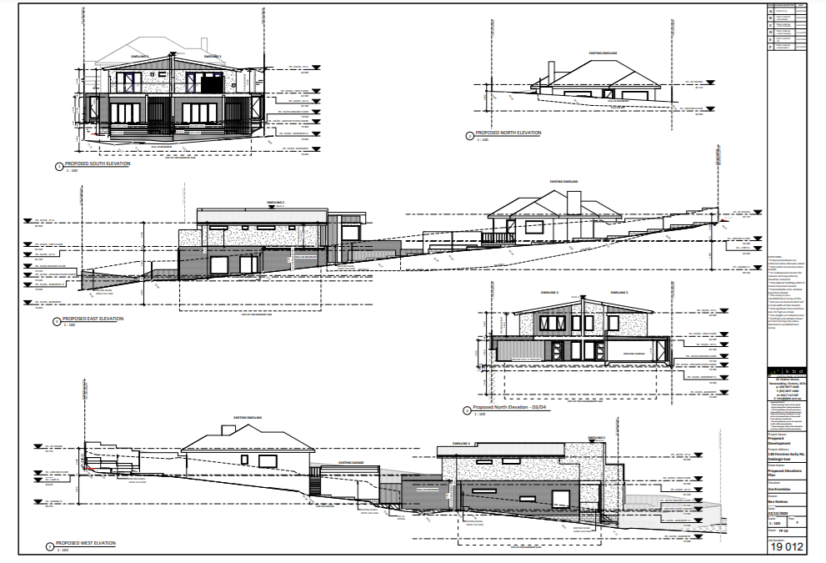

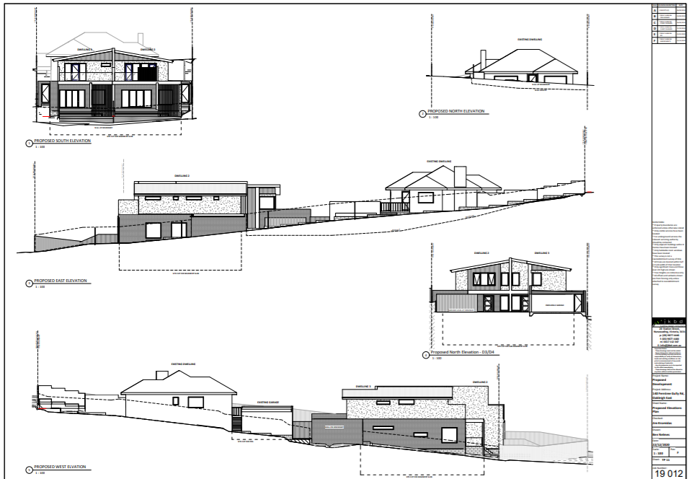

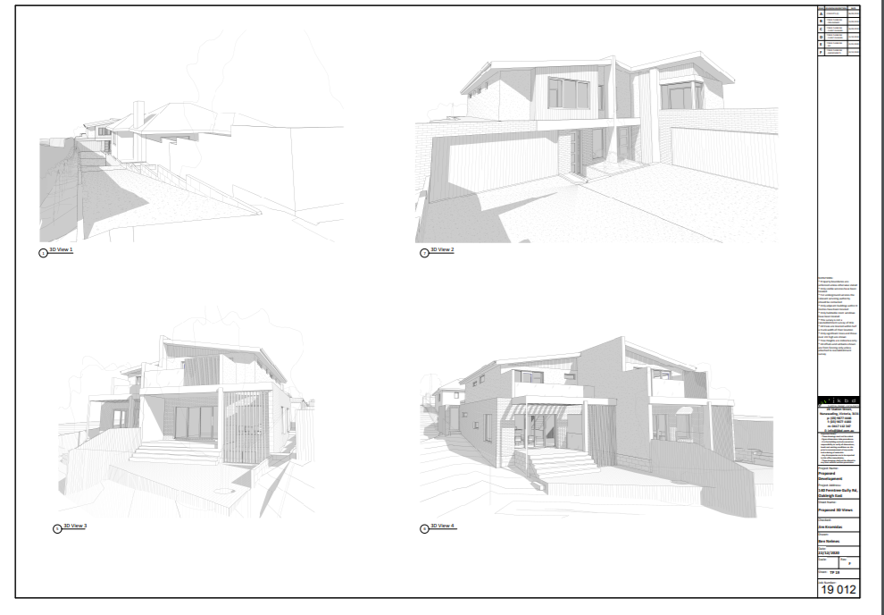
Figures: Extracts from the amended plans

- With respect to some of the quantitative aspects of the proposal:
  - The existing dwelling is set back 11 metres, in excess of the 7.6 metres Rescode standard.
  - The site coverage is 39.6%.
  - Site permeability is 42%.
  - The garden area requirement is met at 39.134%.
  - The maximum building height is approximately 7.9 metres, below the 12m requirement under the GRZ3.

COUNCIL’S FORMAL POSITION
- The council’s formal position is that it opposes the proposal based on the amended plans on the following basis:
            - The proposal does not meet the objectives of Clause 15 Built Environment and Heritage, Clause 21.04 Residential Development, Clause 22.01 Residential Development and Character Policy and is inconsistent with the design objectives of the General Residential Zone, Schedule 3, in terms of building bulk and massing and insufficient landscaping opportunities.
            - The proposal will adversely impact the amenity of adjoining properties by way of overshadowing and unreasonable visual bulk.
            - The proposal will result in poor internal amenity for future residents.
            - The proposal does not adequately satisfy the objectives and design standards of Clause 55 of the Monash Planning Scheme with regard to neighbourhood character, site layout and building massing, landscaping, private open space provision, sense of address and detailed design.
            - The proposal does not respond to the concerns raised by VCAT in Application P1353/2018 (and) will result in a poor quality design outcome.

OBJECTORS
- The respondents object to the proposal as set out in the amended statement of grounds filed by Barbara Williams dated 24 February 2021. Their issues can be summarised as follows:
  - the proposal represents a potential traffic hazard from cars reversing out of the driveway of Ferntree Gully Road, particularly from dwelling 3 due to the small size of both new garages proposed;
  - the dwellings are small in perimeter but contain three levels and 4 bedrooms;
  - the subterranean nature of the proposal is contrary to the types of built form experienced by the neighbourhood of over-development;
  - the proposed dwellings appear as bulky and out of character to the site context;
  - car parking is inadequate given the two nearby halls used for fencing and scouts;
  - there should be no additional overshadowing in backyards to units 3 and 4 of 142 Ferntree Gully Road which have backyards 3 metres wide;
  - lack of evidence and assurance that the excavation and the building underground of dwelling 2 will not compromise the structural integrity of units at 142 Ferntree Gully Road; and
  - uncertainty about Melbourne Water condition 1(e) (with reference to the need for retaining walls).

What are the key issues?
- The key issues in this matter are:
  - Does the proposal appropriately respond to its planning policy context?
  - Does the proposal respond to its physical context?
  - Does the proposal provide an acceptable level of external amenity for neighbouring properties?
  - Does the proposal provide an acceptable level of internal amenity for its occupants?
  - Does this proposal address the issues raised by the Tribunal in the previous proposal in P1353/2018?

Procedural issues & rulings

Amended plans
- The application originally lodged by Kostas Damaskos sought approval for the construction of four new dwellings, including the demolition of the existing house.
- However, Kostas Damaskos circulated amended plans prepared by JKBD, Building Design Consultants (Job No 19092) Drawing Nos. TP 01 - TP 19 (all Revision F) dated 22 December 2020 dated 22 December 2020 on 25 January 2021 in accordance with VCAT Practice Note PNPE9 (Amendment of Plans and Applications).
- In summary the changes are as follows:
  - reduction in the number of dwellings from 4 to 3.
  - the reduction is achieved by deleting dwellings 1 and 2 from the previous proposal and replacing it with the existing dwelling that is now proposed to be retained.
  - previous dwellings 3 and 4 are renumbered as dwellings 2 and 3. No changes are proposed to their layout.
  - the existing driveway and garage for the existing dwelling are to be retained and incorporated into the revised scheme. A new deck to the south of the existing dwelling is proposed to facilitate connection between the dwelling at the garage.
  - the existing conditions at the street frontage such as the fence and layout of the north facing open space area, located in the front setback are to be maintained.
  - the eastern boundary fence detail has been updated to reflect the new 2 metre high fence that has been installed.
- There being no opposition by any party, I formally substituted the amended plans for the application plans at the commencement of the hearing.

Parties to proceeding
- Barbara Williams confirmed that the owners of unit 1/142 Ferntree Gully Road and unit 3/142 Ferntree Gully Road are no longer joint parties to the joint statement of grounds following the circulation of amended plans.
- I removed the relevant persons as joint parties to the proceeding in my earlier procedural order following the first day of the hearing.

Covid-19 pandemic
- The Tribunal records that the Covid-19 pandemic has caused disruption to Tribunal services.
- In particular, the Tribunal was unable to undertake an unaccompanied site inspection until December 2021 primarily due to State Government restrictions relating to movement during lockdown periods. The parties were informed of the delay.

post hearing AMENDMENTS
- The parties were given an opportunity to make submissions regarding any planning scheme amendments since the last day of the hearing including VC205 and VC199 to the Monash Planning Scheme.
- No party made any submissions of substance by the deadlines specified in the Tribunal Orders dated 25 January 2022 or 8 February 2022.

Does the proposal appropriately respond to its strategic planning context?
Zone and overlay controls
- Since the proposal in P1353/2018 was considered, the schedule to the General Residential Zone that applies to the subject land has changed.
- Pursuant to amendment C125 (part 2) – approved in November 2019 – the subject land was rezoned from General Residential Zone – Schedule 2 (GRZ2) to General Residential Zone – Schedule 3 (GRZ3).
- The subject land is now included in the GRZ3 and Special Building Overlay (SBO). It also abuts a Transport Zone 2 being Ferntree Gully Road.
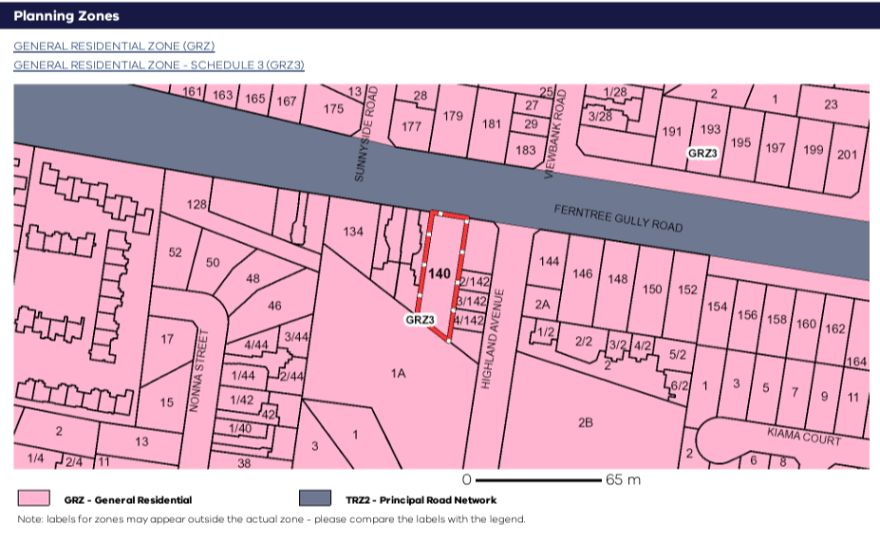
Figure: Extract Zoning Map

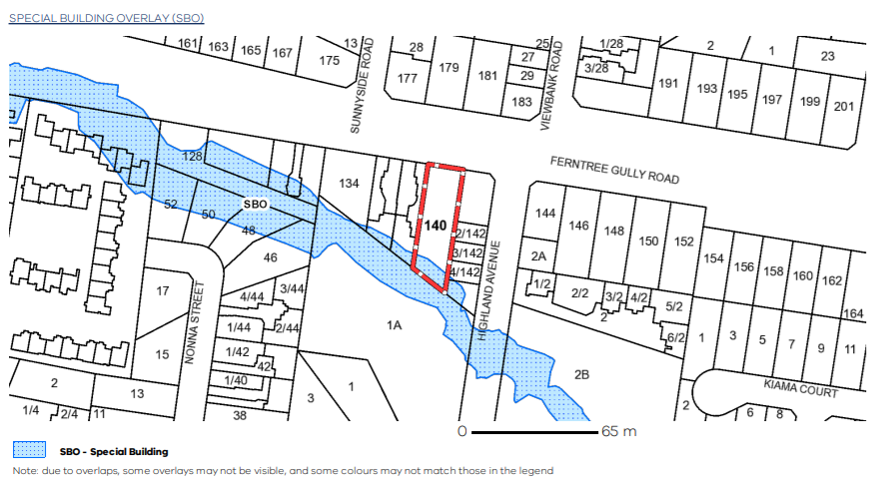
Figure: Extract of Special Building Overlay

- The purposes of the GRZ are:
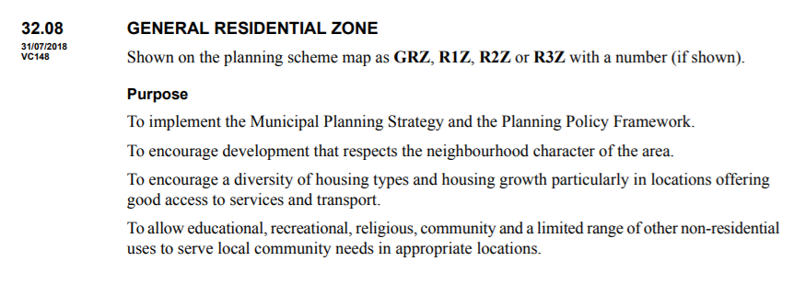
- Clause 32.08-1 states that 32.08-1 a schedule to this zone may contain neighbourhood character objectives to be achieved for the area. Clause 1.0 of the GRZ3 contains the following neighbourhood character objectives:
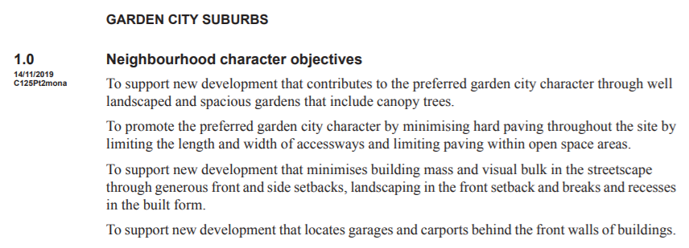
- The decision guidelines for residential development at clause 32.08-13 of the GRZ state:
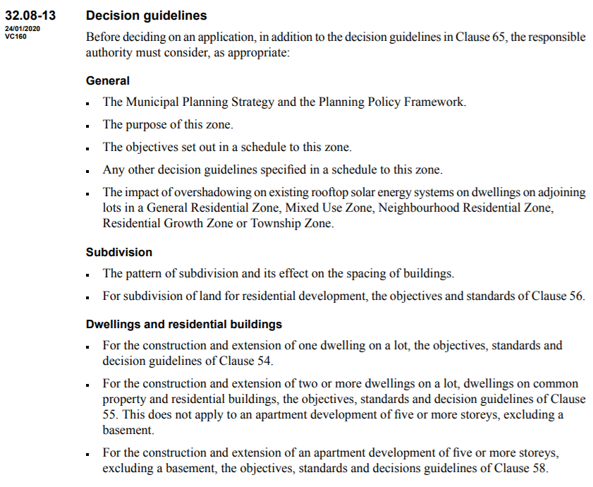
- Clause 7.0 of GRZ3 contains the following additional decision guidelines to be considered with respect to a proposal:
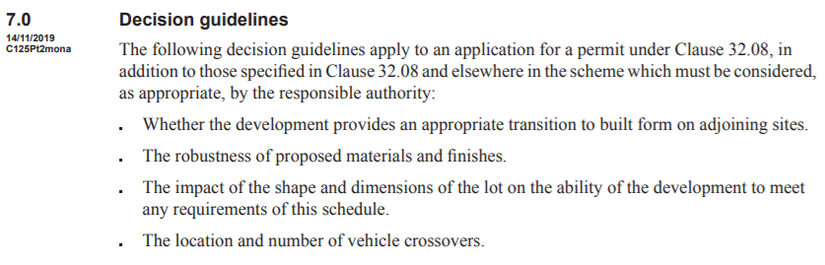
- Clause 32.08-7 states that a schedule may specify the requirements of various standards of clause 55 of the planning scheme. Clause 4.0 of schedule 3 contains the following clause 55 requirements:
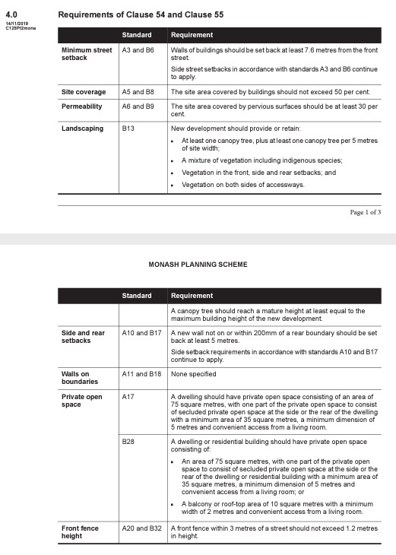

- The purpose of the SBO set out in clause 44.05 of the planning scheme is:

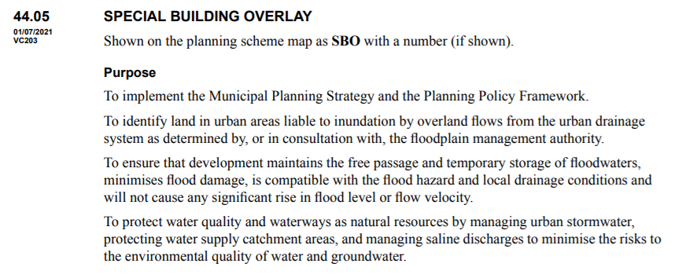

- The decision guidelines at clause 44.05-7 provide:

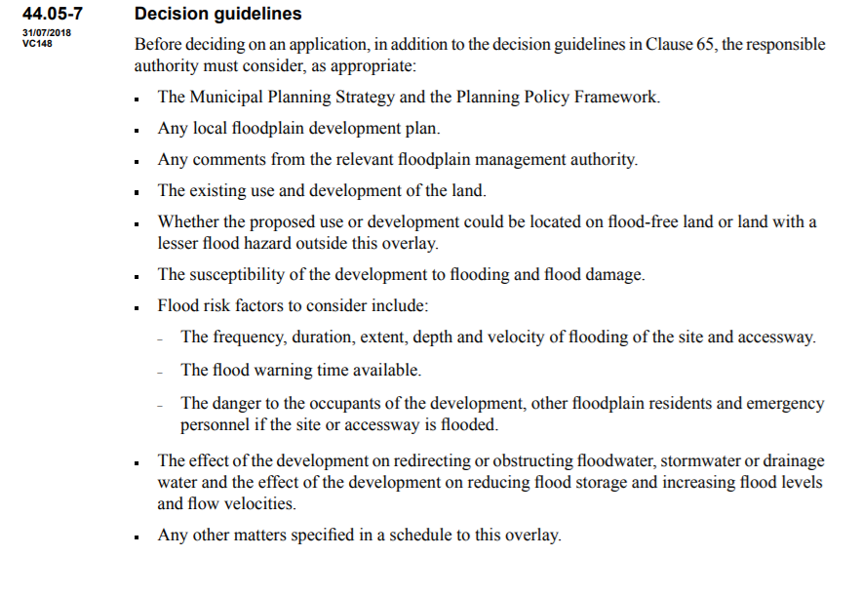
Clause 52.29 permit trigger
- Clause 52.29 was amended pursuant to VC199 on 20 January 2022 and provides amongst other things:
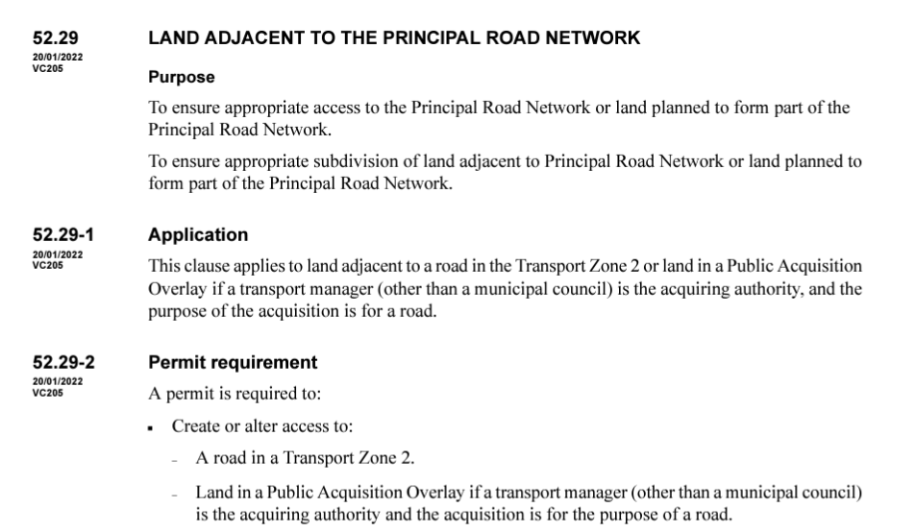

- With respect to third party rights, clause 52.29-5 provides:
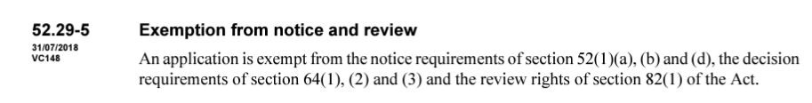

- At clause 52.29-6, the decision guidelines are specified below:
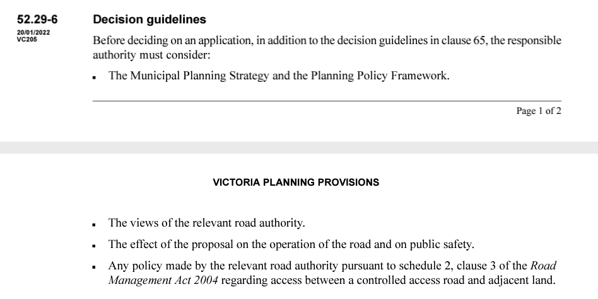

Planning policy context
- It is common ground that the following key clauses of the Planning Policy Framework are of particular relevance to the permit application:
  - Clause 11 (settlement)
  - Clause 11.01-11R1 (settlement – Metropolitan Melbourne)
  - Clause 15 (Built Environment and Heritage)
  - Clause 15.01-2S (Building Design)
  - Clause 16 (Housing)
  - Clause 16.01-1S (Housing Supply)
  - Clause 16.01-1R (Housing Supply – Metropolitan Melbourne)
  - Clause 16.01-2S (Housing Affordability).
- The Tribunal is familiar with the key objectives of these clauses and I do not repeat them here.
- The Local Planning Policy Framework has changed since the proceeding in P1353/2018.
- Relevantly, Amendment C125 (Part 2) to the planning scheme was approved on 14 November 2019. This amendment updated clause 21.04 (Residential Development) and clause 22.01 (Residential Development and Character Policy) to reflect the objectives, directions and actions of the Monash Housing Strategy 2014 and introduced new character areas with preferred character statements. The provisions are extensive and so I have referenced them directly from the planning scheme for ease of reference rather than attempt to paraphrase them.
- The ‘Garden City Character’ is identified as a core value held by the community and council. Relevantly, the following sections of the local planning policy framework are in dispute in this proceeding.
- Clause 21.04 (Residential Development) provides the residential development framework and translates the overall aims of the Monash Housing Strategy 2014 into a location plan that broadly identifies the preferred location for different types of housing.
- According to Map 3 – Residential Development Framework Map contained in clause 21.04, the subject site is located within a Category 8 – Garden City Suburbs area. It is close to the edge of an area identified as Category 3 – Residential Land in the Monash National Employment Cluster.
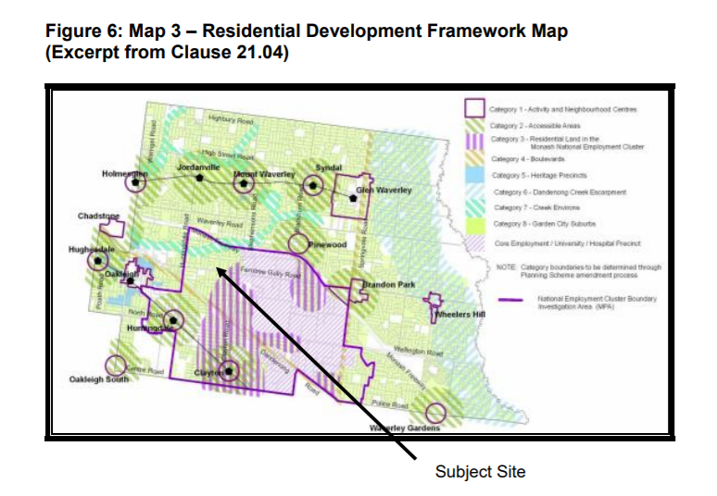
Figure: Residential Development Framework Map (clause 21.04) planning scheme

- The Monash Housing Strategy 2014 sets out the following future character for Category 8 (garden city suburbs) areas:

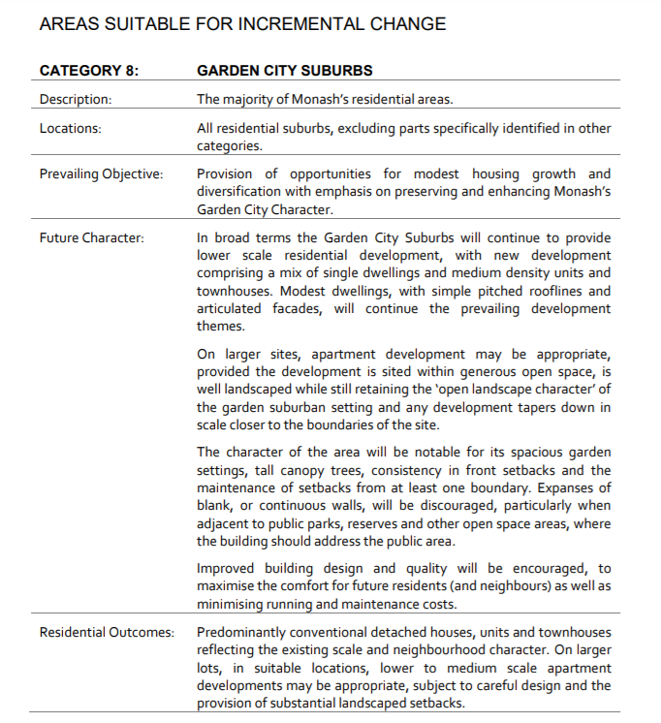
Extract: Monash Housing Strategy 2014 at page 86.

- The objectives and strategies of clause 21.04 include: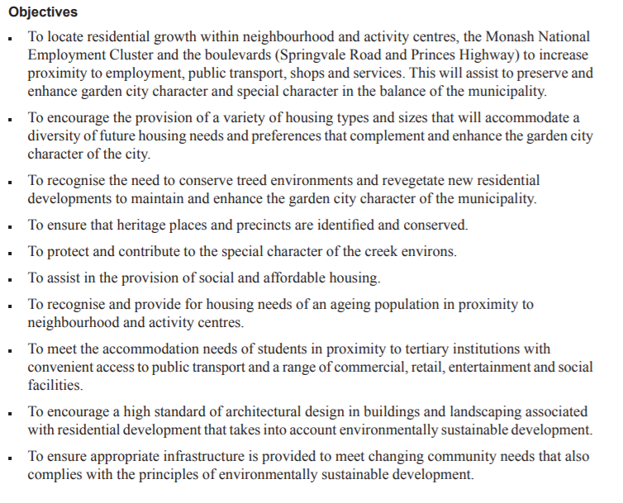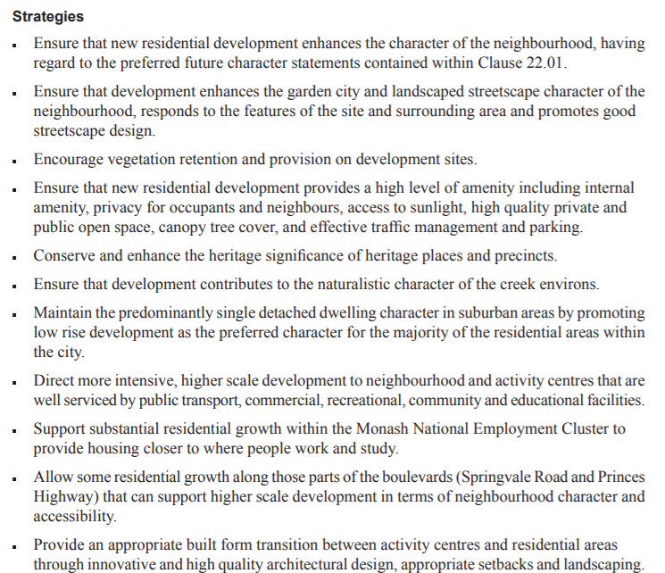
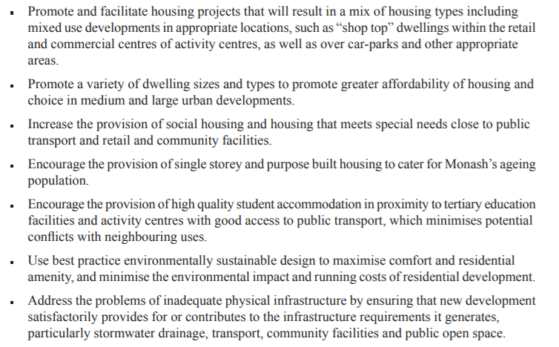
- Clause 22.01 (Residential Development and Character Policy) contains the following objectives:
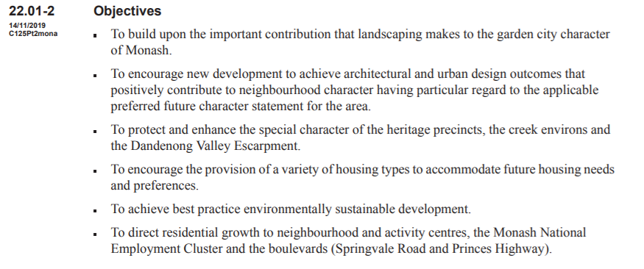
- Clause 22.01- 4 contains Map 1 which sets out the residential character areas. The subject land is contained in ‘Garden City Suburbs Northern Areas’.

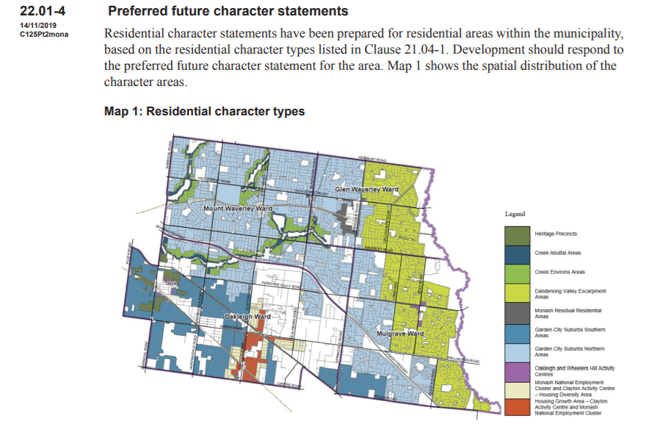
Figure: Map 1 in Clause 22.01-4

- Clause 22.01-5 provides:
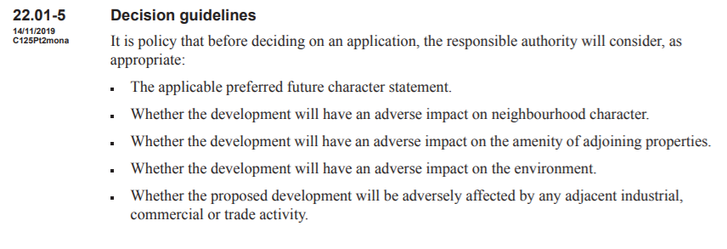
- The preferred character statement for the Garden City Suburbs Northern Areas is:
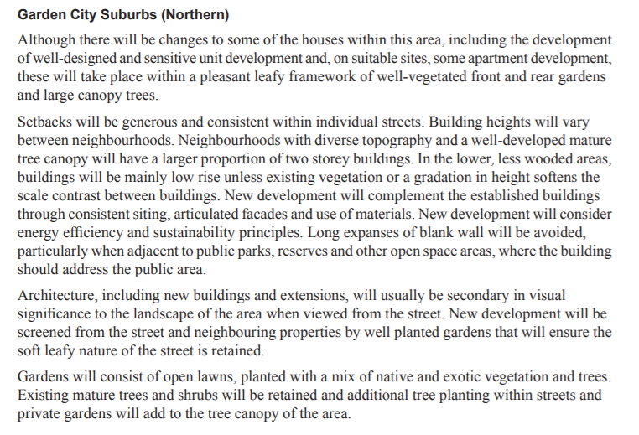
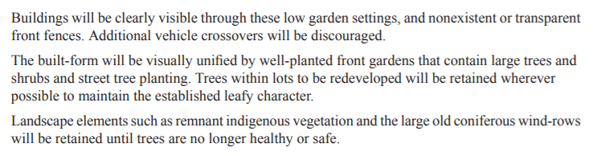

- The policy also contains broad design guidance regarding various key design principles including:
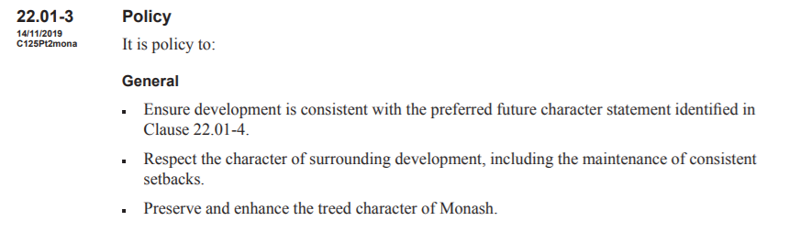
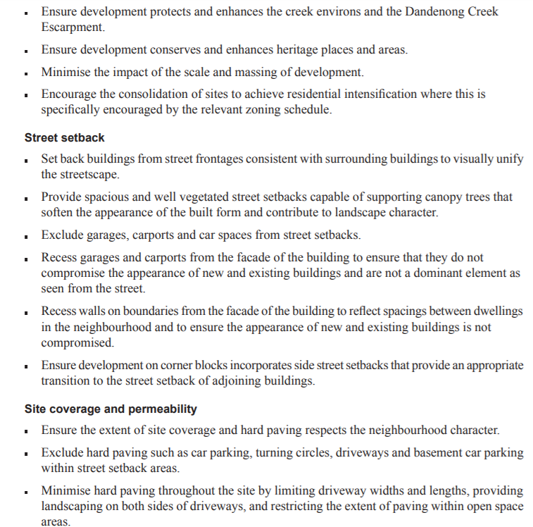
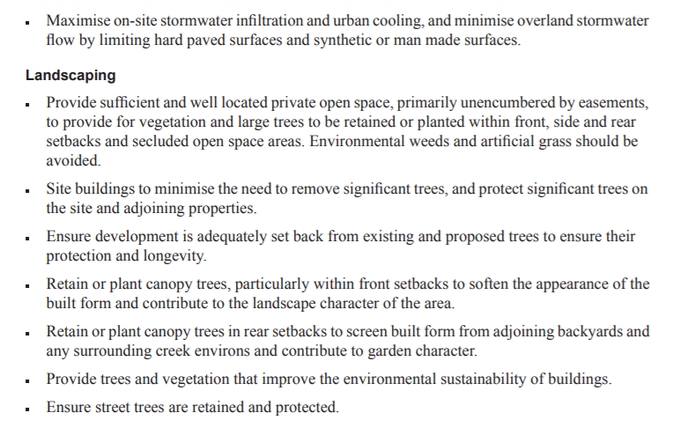
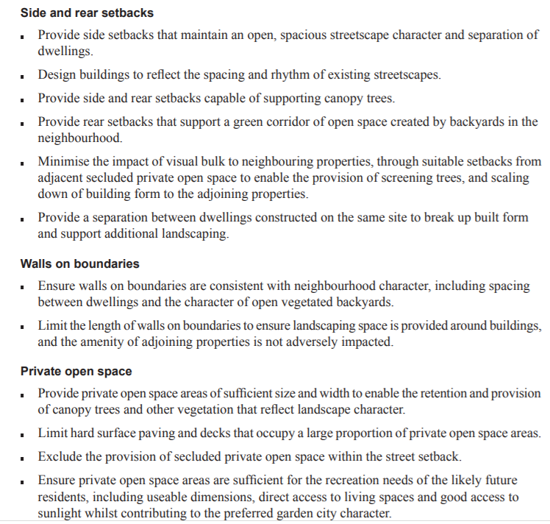
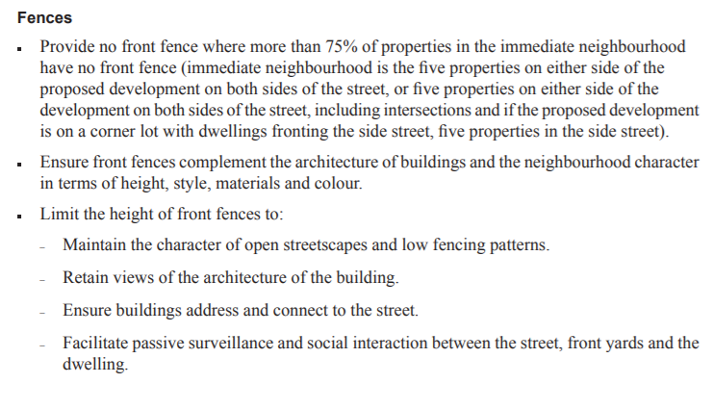

Consideration
- The council submits that whilst the proposal satisfies urban consolidation and housing choice objectives, it fails to provide a suitable design response to the site context and the preferred character of the neighbourhood in terms of building bulk and massing and landscaping opportunities.
- In this regard, the council submits that the permit application fails to strike an appropriate balance between certain objectives in clauses 15, 21.04, 22.01 and GRZ3, namely:
To achieve architectural and urban design outcomes that contribute positively to local context and enhance the public realm. (Clause 15.01-2S)
To encourage the provision of a variety of housing types and sizes that will accommodate a diversity of future housing needs and preferences that complement and enhance the garden city character of the city.
To recognise the need to conserve treed environments and revegetate new residential developments to maintain and enhance the garden city character of the municipality. (Clause 21.04)
To build upon the important contribution that landscaping makes to the Garden City Character of Monash.
To encourage new development to achieve architectural and urban design outcomes that positively contribute to neighbourhood character having particular regard to the desired future character statement for the applicable residential Character Type. (Clause 22.01)
To support new development that contributes to the preferred garden city character through well landscaped and spacious gardens that include canopy trees.
To promote the preferred garden city character by minimising hard paving throughout the site by limiting the length and width of accessways and limiting paving within open space areas.
To support new development that minimises building mass and visual bulk in the streetscape through generous front and side setbacks, landscaping in the front setback and breaks and recesses in the built form. (Schedule 3 to the General Residential Zone)

Tribunal findings
- The garden city suburbs northern area is a broad area with numerous aspirational statements to reconcile.
- I prefer the submissions made by Kostas Damaskos having regard to the subject land and its planning policy context that:
  - The allotment size at 1086 square metres is a large parcel of land located within a robust main road context.
  - The GRZ3 anticipates heights of 3 storeys and up to 12 metres on sloping sites and the zone purposes promote diversity in well located areas.
  - The subject land is well located with respect to public transport with a bus stop at the site’s frontage. In addition, the proximity of local shops, schools and parkland provides all the ingredients of a 20 minute neighbourhood.
  - There are no heritage, neighbourhood character or vegetation controls that constrain the development potential of the subject land.
  - The redevelopment of the subject land for townhouses is supported on all levels of policy based on the above considerations.
  - The subject land is located within the National Employment Cluster Boundary investigation area as identified in the council’s housing study.
  - The subject land is located within an established residential neighbourhood which is characterised by medium density development that has consistently continued to form part of the character of the area, in particular over the past 20 years. I observed on my site inspection the presence of other sites under construction which suggest this trend will continue at least in the short term.
  - By virtue of the proximity to facilities, the application of the GRZ combined with the applicable State and Local Policy Framework that promotes such locations to achieve increased population for the municipality of Monash, such development will continue in these areas.
  - The third level of dwellings 2 and 3 have a sub-terranean component and as such do not present as a third storey proposal and are arguably less imposing of developments on neighbouring properties.
- Having regard to the purposes of the GRZ, I find that the subject land is well suited for redevelopment and medium density development. Land in the GRZ contemplates development of up to three storeys and 12m in height on sloping sites. The maximum height of the new dwellings is 7.96 metres and does not exceed three storeys.
- The proposal is supported by clause 15 which promotes responsive urban design which includes landscaping. Clause 16 of the planning scheme seeks, amongst other things, to realise opportunities for increased residential densities to help consolidate urban areas reflected in Plan Melbourne and encourages housing diversity. Clause 16.01-2 has an objective to locate a substantial proportion of new housing in or close to activity centres and in urban renewal precincts and sites that offer good access to services and public transport. Similar local policy objectives are contained in local planning policy supporting housing diversity to meet the needs of a growing population and that there are increased housing opportunities close to activity centres (refer to clause 21.04).
- Whilst there is clear policy support for redevelopment of the subject land, a key consideration in the policy framework is how the proposal responds to neighbourhood character. I find that the built form as it relates to its neighbours is an appropriate fit in this location where large and modern townhouses and apartments of a two and three storey scale prevail. This was observed on my site inspection and in the aerial photographs and photos tendered at the hearing which evidenced the concept of multi dwellings on such allotments as commonplace. In fact, it is a definable feature in this location. This is discussed further below.

does the proposal respond to its physical planning context?
- The subject land is located on the south side of Ferntree Gully Road and has a rear abuttal to FE Hunt Reserve, which forms part of a Melbourne Water floodplain.
- Ferntree Gully Road is a Category 1 (main road) that runs in an approximate east-west direction. In the vicinity of the subject land, Ferntree Gully Road is a divided road that contains three traffic lanes in each direction. The west bound section of the road that is located in proximity to the subject land also contains a right turn lane.

- The subject land is located:
  - approximately 2.2 kilometres north-east of the Oakleigh activity centre;
  - approximately 1.8 kilometres north-west of Monash University; and
  - within convenient walking distance to various services and facilities including public transport, a local shopping strip (containing an IGA supermarket), Amsleigh Park Primary School and parks.
- Key features of surrounding properties are set out below:
- East: this property known as 142 Ferntree Gully Road contains five dwellings comprising the original dwelling fronting Ferntree Gully Road and four newer double storey dwellings fronting Highland Avenue. Vehicle access for all five dwellings is provided from Highland Avenue. The rear of each double storey dwelling is elevated substantially above natural ground level. These dwellings contain elevated ground floor habitable room windows and decking areas that face the subject land.
- West: this property contains four double storey dwellings two of which front Ferntree Gully Road and two of which are located to the rear. Vehicle access is provided via two crossovers, which are located either end of the frontage.
- South: is the FE Hunt Reserve which forms part of a Melbourne Water floodplain. It comprises two parts, which are located to the east and west of Highland Avenue. The western component, part of which is located alongside the subject land, is relatively open and it contains:
  - Scattered vegetation;
  - A single storey building that is well setback form the subject land (occupied by the Victorian Rovers);
  - A pedestrian path that provides access to Ferntree Gully Road (to the west of No 130 Ferntree Gully Road).
- North: The two properties at 179 and 181 Ferntree Gully Road each contain a single dwelling.
- Nearby residential development comprises a mix of original modest single storey brick and weatherboard dwellings, along with a number of more recently constructed multi-unit developments and large single dwellings. Double storey dwellings are evident in the area.
- A number of properties have a rear abuttal to FE Hunt Reserve and have been redeveloped with either unit developments ( for example, 130 and 132 Ferntree Gully Road and 44 Nonna Street) or large single dwellings (such as 46 Nonna Street).
- The Tribunal directed that issue of a multi-unit development in proximity to the subject land at 48 - 52 Nonna Street for eleven double storey dwellings over basement car parking in August 2016.
- The aerial view annotated in the council’s submission provides a closer overview of the subject land and wider context:
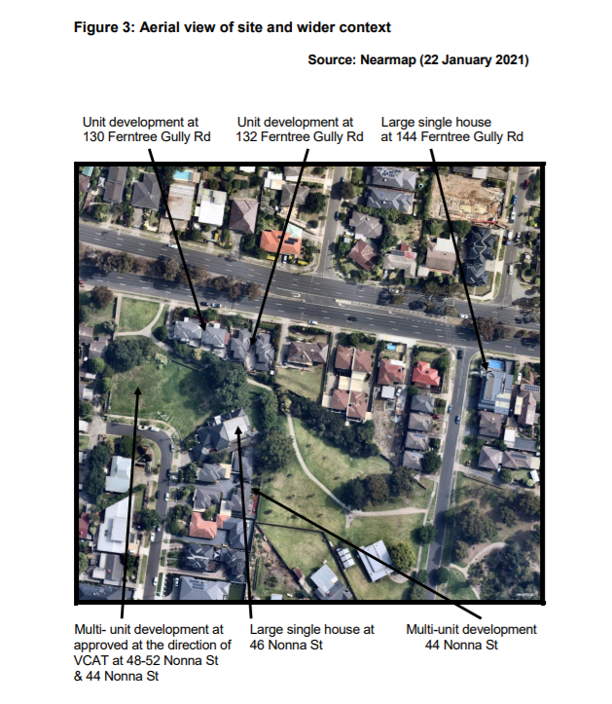

Tribunal finding
- I prefer the submissions made by Kostas Damaskos and I find that the proposal responds to its physical context and is suitable for medium density development because:
  - The subject land is a large allotment at 1086 square metres. This is a large allotment in the context of the surrounding area.
  - The subject land has an abuttal to parkland at the rear of the site.
  - The subject land is well located in an established residential area with convenient access to a wide range of services and facilities, as well as public transport.
  - The location of the subject land on a main road provides a robust built form response in distinction to those streets located further away from Ferntree Gully Road.
  - The subject land is not affected by any neighbourhood character or heritage overlays, which arguably provides greater opportunity for a range of architectural styles.
  - There are no existing street trees, electricity poles, drainage pits or the like located in front of the subject land to restrict convenient access to / from Ferntree Gully Road.
  - Infill developments including modern and contemporary double and triple storey dwellings on single and consolidated lots are evident within the immediate residential context.
  - No easements affect the subject land.
  - The proposal fits into the area which has the following characteristics:
    - A built form dominated by medium density development.
    - Large buildings are commonplace, in particular elevated dwellings as a result of the fall of the land.
    - A busy main road environment.
    - Abuttal to the reserve to the rear providing outlook, access and amenity.
    - A variety of housing styles and types. Whilst original dwellings from the 1950s and 1960s are found, replacement developments comprising single dwellings and a range of medium density developments of a significant scale are a readily identifiable feature. Medium density development is a well-established feature in this location.
    - Low/medium level mature vegetation.
    - A range of dwelling setbacks including building along the boundary. A feature is development that occurs deep into allotments often at a significant scale.
    - Open space generally located to the rear of dwellings, often in a courtyard form, influenced by the fall of the land.
    - A range of front fence treatments and parking arrangements as they present to the streetscape.

does the proposal provide an acceptable level of external amentity for neighbouring properties?
- The requirements under clause 55.02 – 55.06 of the planning scheme with respect to external amenity impacts are discussed in turn below.

Clause 55.02 – Neighbourhood character response
- Clause 55.02 relates to neighbourhood character and infrastructure.
- Clause 55.02-1 provides:
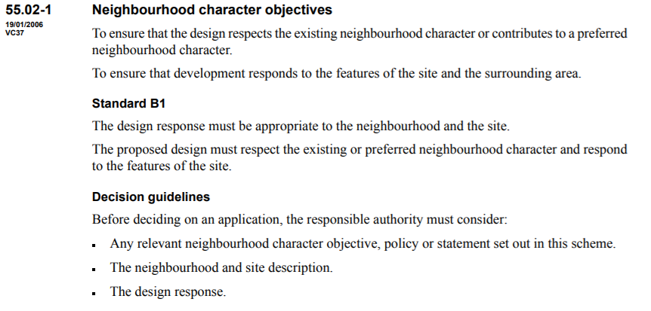

Council and objectors’ submissions
- The council submits that it recognises that the built form character of the area surrounding the subject land is changing with original modest single storey dwellings being gradually replaced with new large single dwellings and unit developments. However, the neighbourhood character objectives of clause 55 seek to encourage site responsive design that is compatible with the preferred character of the neighbourhood.
- The council submits that the proposal fails to satisfy the objectives of the council’s neighbourhood character policy at clause 22.01 as it does not respect the existing and preferred character of the area. In particular, it submits that:
- The proposal fails to satisfactorily integrate with the pattern of development in the area due to the bulk, mass, scale and height of the rear two dwellings and the retention of the high front fencing.
- The development will be overly prominent when viewed from the adjoining public reserve to the rear due to the height, mass and attached form of the two dwellings and the slope of the subject land.
- The attached form of the rear two dwellings is excessively prominent when comparison is given to development on neighbouring properties. The three storey height (recognising that part of the lower level is below the existing ground level) exacerbates this issue.
- The level of building bulk associated with the attached form of the two rear dwellings exceeds that of neighbouring developments.
- The intense level of development and footprint at the rear half of the site is unbalanced and seems to indicate a temporary response.
- The temporary response of the existing dwelling, including the high front fencing and synthetic grass within the setback is unacceptable.

Kostas Damaskos’s submissions
- Kostas Damaskos submits that the retention of the existing dwelling should be seen as a positive aspect of the proposal. He says that it represents the most effective way to respond positively to the planning controls and policy framework that focus on such items as streetscape character, building spacing, visual bulk and landscaping. The retention of the ‘status quo’ at the street frontage is said to be a key component of the acceptability of the proposal.
- Kostas Damaskos rejects the criticism by the council of this proposal being a temporary response to the development of the subject land. He says that the existing dwelling is in good condition and its location is said to be conducive to incorporation into the proposed scheme. Not only will the new development be limited in its views from the street frontage, the proposal provides opportunity for improvements in landscaping along the common driveway. There are examples of other properties with swimming pools in the front setback in the nearby vicinity.
- Further, Kostas Damaskos submits that any concern regarding the character impacts at the rear of the subject land and the three storey scale should be dismissed. Whilst containing three levels, the presentation of dwellings 2 and 3 are of low two-storey scale dwellings given the sub-terrain element, where heights have been kept to a minimum at 7.96 metres and the need to account for Melbourne Water constraints.
- The GRZ anticipates heights up to 12 metres, noting that despite containing three levels, the overall maximum height of 7.96 metres is not only well below that height, but dwellings 2 and 3 sit well below heights found in nearby properties.
- The proposal is said to be consistent with the backyard character of neighbouring properties in the surrounding area, particularly those facing FE Hunt Reserve.
- Since the previous application, Kostas Damaskos submits that a new side fence has been constructed along the boundary with the townhouses at 142 Ferntree Gully Road to the east and this needs to be taken into account as part of the existing conditions of the proposal.
- With respect to the suitability of the built form, Kostas Damaskos submits that the siting of the upper levels and the impacts onto surrounding dwellings in both character and amenity terms are acceptable given the character of this location is made up of equally robust forms deep into allotments in combination with the high level of compliance with the amenity standards of Rescode. Kostas Damaskos submits that the existing character is mixed and evolving with the onset of large developments. For example, the Tribunal recently approved a development of 11 double storey dwellings over basement car park containing 24 spaces at 48-52 Nonna Street, Oakleigh. In that case, the Tribunal stated:
I consider that the development is of appropriate scale and form to existing dwellings in the locality. The newer individual dwellings or medium density developments are increasingly double or triple storey and are replacing the original, mostly modestly sized, single storey dwellings.
- The plans for 48-52 Nonna Street development evidence three storey townhouse forms, scaled at approximately 11metres in height with some examples of external stairs to private open spaces.
- Kostas Damaskos submits that there are other nearby properties which interface with FE Hunt Reserve and there are many examples of significant multi-storey development. Those interfaces display a presence of water tanks and carparking structures exist above the height of rear balconies without any significant landscaping. Kostas Damaskos admits that some of these developments existed before the planning scheme requirement for a 5 metre rear setback.
- Kostas Damaskos submits that the proposal at approximately 8 metres in height will be the lowest development to present to FT Hunt Reserve when compared to other developments in the vicinity of the subject land.

Tribunal findings
- The local area in which the subject land is situated is clearly evolving. Medium density housing is well-established in the surrounding context. The character of this location displays:
  - Ferntree Gully Road is a busy 6 lane highway;
  - Fall of land is significant and influences built form;
  - The reserve to the rear of the subject land provides outlook and amenity;
  - Varied subdivision pattern exists with a range of allotment sizes;
  - Large allotments with orientation onto the reserve contain substantial built form that borrows on the landscape quality of the reserve;
  - Medium density at the same scale and density as the proposal is an established feature in the area;
  - There is an emerging character that is replacing the traditional housing stock with large single dwellings and equally large multi-unit developments at two and three storey scale;
  - Multi-unit developments are often large dwellings with a range of architectural styles add further diversity in the precinct; and
  - As a result of such development, features such as building scale, height, crossovers and landscaping has altered from the more traditional single dwellings.
- The Tribunal has previously said that there is nothing inherently unacceptable about development at the rear of infill sites such as is proposed here, provided that the proposed form and scale of buildings is respectful of the sensitive nature of back-yard amenity.
- In this case, a key feature of the backyard character in this location is large dwellings with elevated floor levels that extend deep into the site to address the reserve at the rear. This design feature is not limited to those allotments with a frontage to the busy main road context.
- I find the front set back responds to the garden city concept, noting that this front set back remains unchanged from existing conditions. I consider this is a relatively generous front setback and will be supplemented by the rear deck area providing improved amenity for the occupants of the existing dwelling. The retention of the existing fence and vegetation to the street frontage in this main road context does not in my view detract from the strength of the proposal. Further, the proposed layout provides for landscaping opportunities throughout the subject land to meet the varied standard B13 of clause 55 of the planning scheme.

Clause 55.03 – Site layout and building massing

Overview
- Clause 55.03 contains various objectives with respect to street setback objective (clause 55.03-1), building height objectives (clause 55.03-2), site coverage objective (clause 55.03-3), permeability and stormwater management objectives (clause 55.03-4), energy efficiency objectives (clause 55.03-5), open space objective (clause 55.03-6), safety objective (clause 55.03-7), landscaping objectives (clause 55.03-8), access objective (clause 55.03-9) and parking location objectives (clause 55.03-10).
- The council and the objectors are critical about the extent of availability of areas for landscaping with respect to site layout under clause 55.03.
- In this regard clause 55.03-8 provides:

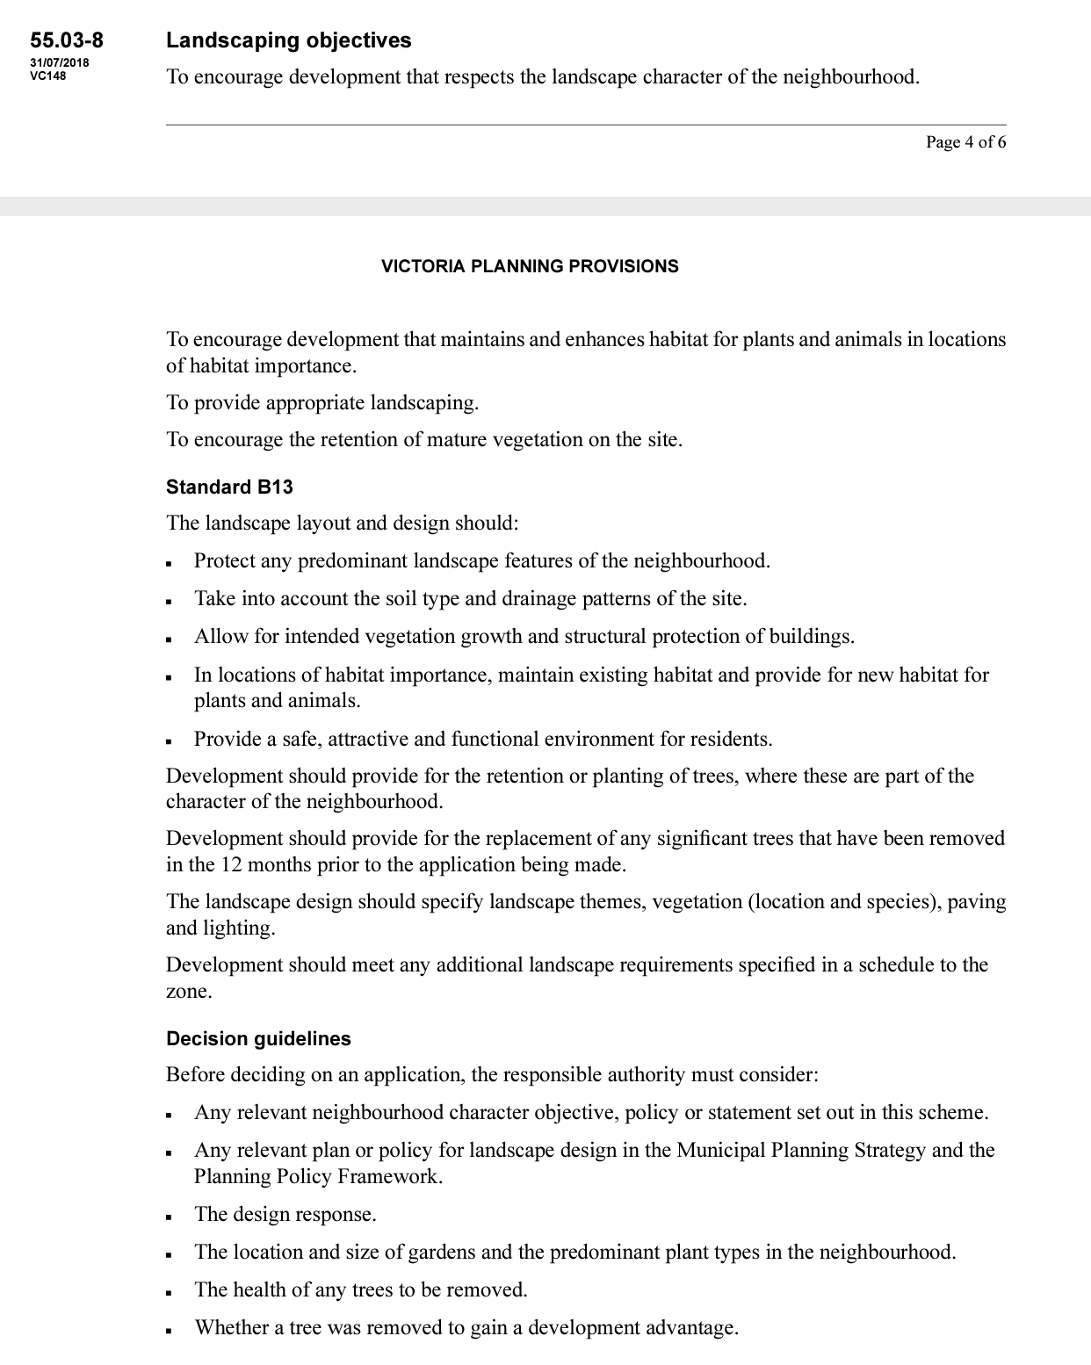

- The GRZ3 varies standard B13 as follows:

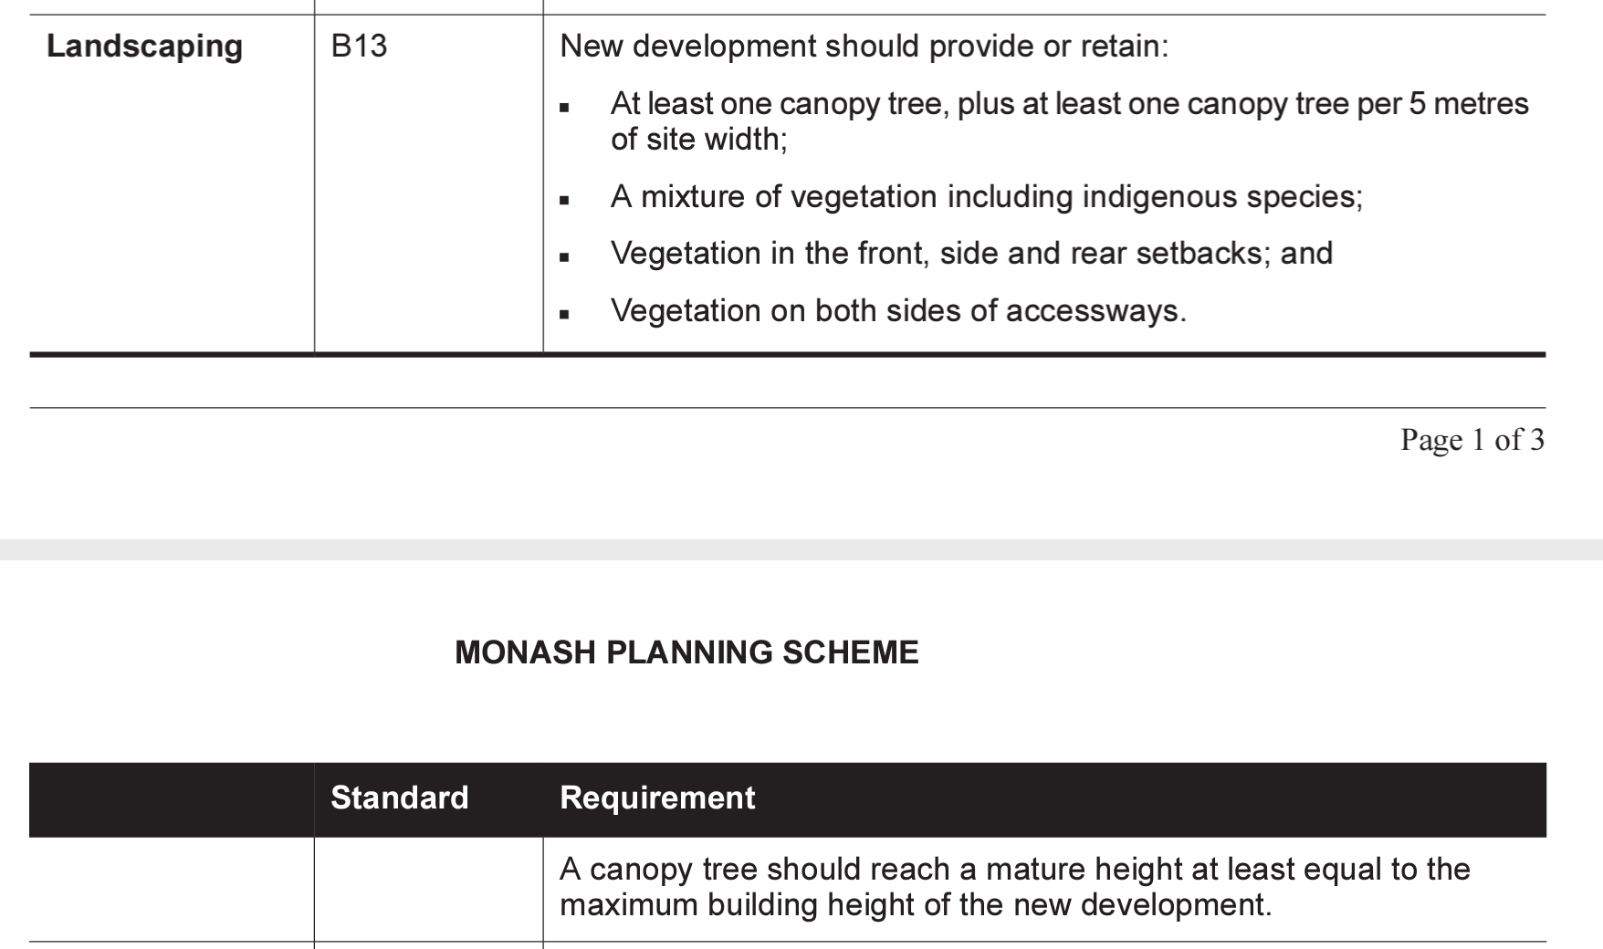

Council and objectors’ submissions
- The council submits that the proposal fails to satisfy key objectives of clause 55.03 because:
  - The layout provides insufficient space for appropriate landscaping in the front setback towards the front of the subject land but instead proposes a combination of paving and synthetic grass.
  - Opportunities for canopy planting towards the rear of the subject land are severely constrained due to minimal setbacks of the two new dwellings.
- The basement extends across the majority of the width of the rear part of the subject land, with side setbacks between approximately 1.3 to 1.6 metres. Furthermore, dwelling 2’s garage is located abutting the side boundary and the 1.3 metre side setback contains a 900mm wide path and a retaining wall. This layout means that there are no real opportunities to provide any planting to soften the development when viewed from the adjoining dwellings at 3/142 and 4/142 Ferntree Gully Road.
- The design involves a common ‘gun barrel’ driveway running along the eastern boundary without variation and a relatively minimal landscape strip that narrows to approximately 500mm alongside dwellings 2/142 and 3/142 Ferntree Gully Road. This planting strip offers limited space for meaningful landscaping.
- The majority of the secluded private open space (SPOS) provided for dwellings 2 and 3 are oriented to the south.
- Both dwellings 2 and 3 contain minimal north facing windows.
- The main living rooms of dwellings 2 and 3 are located at basement level with south facing windows and will be affected by the overhang of the ground floor area. The design is relying on a void to provide light to these rooms, however, with the required changes imposed by the conditions of Melbourne Water, access to quality light will be further diminished as ‘All doors, windows, vents and openings to the basement rumpus and ancillary rooms of Dwellings 2 & 3 must be bunded and floor protected to a minimum 300mm above the applicable flood level, as per finished dwelling floor heights’.
- The main living room of the existing dwelling contains a habitable room that is setback less than the required 1.5 metres from the shared driveway. TP-07 shows the layout of existing dwelling as fairly close to the driveway.

Kostas Damaskos’s submissions
- Kostas Damaskos submits that the proposal is appropriately oriented on the north / south allotment and has the benefit of a rear abuttal to parkland.
- Given the rear setback, Kostas Damaskos contends that there is excellent landscaping opportunities at the rear.

Tribunal findings
- Having regard to the siting and setbacks including the rear, I consider there is sufficient opportunity for landscaping required to meet to the objectives of clause 55.03-8. Landscaping requirements are provided for in the permit conditions.
- Compliance with standard B29 is discussed later in these reasons.

Clause 55.04 – Amenity Impacts

Overview
- Clause 55.04 contains objectives with respect to side and rear setbacks (clause 55.04-1), walls on boundaries objective (clause 55.04-2); daylight to existing windows objective (clause 55.04-3); north-facing windows objective (clause 55.04-4); overshadowing open space objective (standard B21) (clause 55.04-5); overlooking objective (standard B22) (clause 55.04-6); internal views objective (clause 55.04-7) and noise impacts objectives (clause 55.04-8).
- Any variations to the standards under these objectives are set out in the GRZ3.
- Overall, I am satisfied that the external amenity impacts of the proposal are acceptable.
- Set out below is a summary of the key issues discussed at the hearing with respect to external amenity.

Side and rear setbacks objective
- The council and objectors submits that the proposal fails to satisfy key objectives of clause 55.04 because the rear setback of the proposal does not satisfy one of the major requirements of GRZ3 to provide a 5 metre setback from the rear boundary to provide generous landscaping areas and reduce the impact of development by providing a landscaped separation between properties.
- In relation to the encroachment of the 5 metre setback by 17cm for dwelling 3 and 40 cm and dwelling 2, the objectors submit that there should be strict compliance with the 5 metre setback because this will change the neighbourhood character when viewed from FE Hunt reserve.
- Side boundary setbacks are relative minimal along the eastern and western side boundary resulting in adjoining properties being adversely affected by overshadowing.
- Clause 55.04-1 provides the side and rear set back objectives:
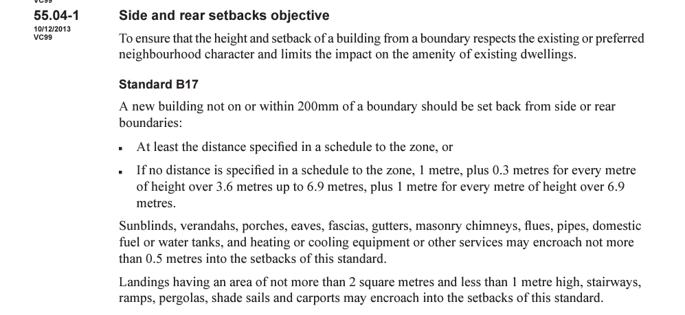

- The decision guidelines provide:
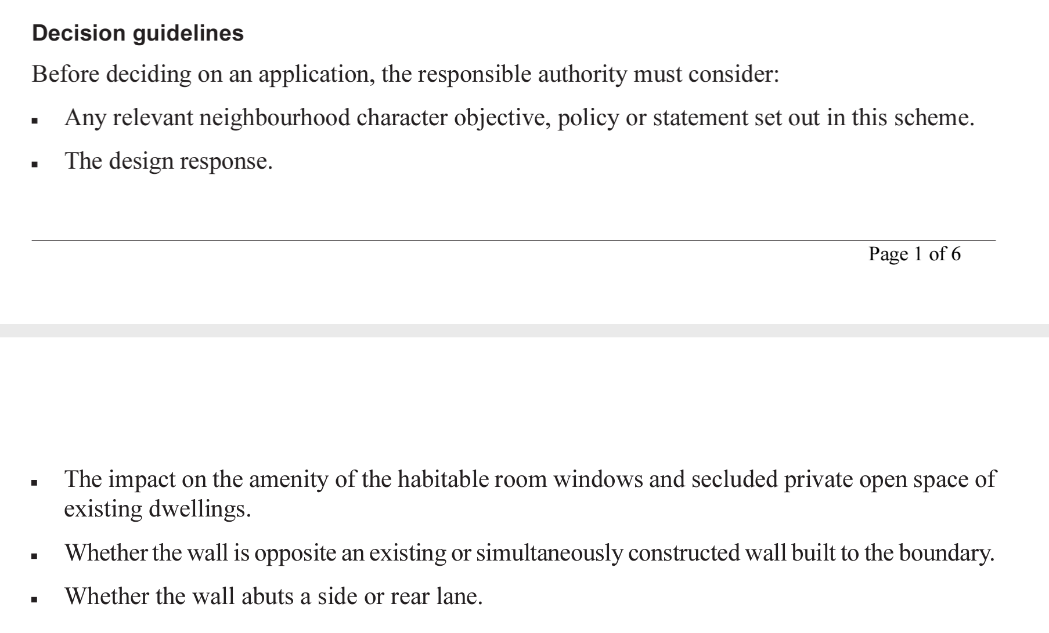
- Kostas Damaskos submits that the setback at the closest point is approximately 17 cm short at the western end at 4.83m. However, at the eastern end it is significantly in excess of the 5 metre rear setback control at 11.83 metres. There is a second encroachment of 40 cm for dwelling 2.

Tribunal finding
- Having regard to the relevant provisions, I am satisfied that the extent of side and rear setbacks are acceptable and the objective is met. This is particularly given the interface at the rear is to the public reserve and where there is extensive variable setback provided and the extent of any encroachment into the 5 metre set back requirement is consider minor.

Overshadowing
- With respect to the issues in dispute, clause 55.04-5 provides with respect to overshadowing:
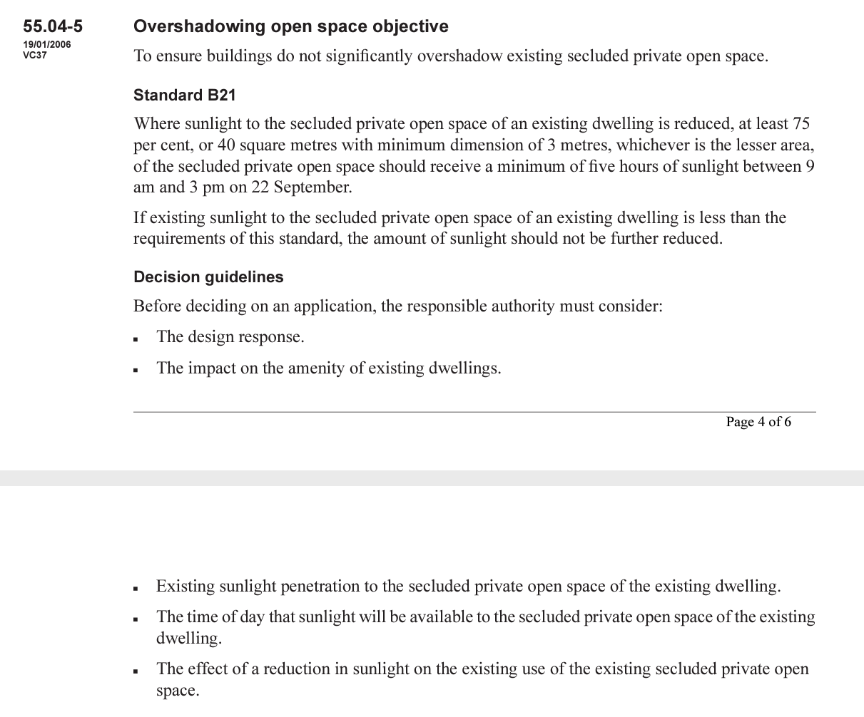
- The council and objectors submit that despite overshadowing being raised by the Tribunal in P1353/2018, the amended plans propose a very similar building envelope for the two rear dwellings, noting that since the previous hearing in P1353/2018, a new 2 metre high fence has been installed along the eastern boundary which has an impact on the exist of existing shadowing.
- The council accepts that it has not undertaken an analysis of the overshadowing impacts at each relevant hour. However, it was mindful of the Tribunal’s comments with respect to overshadowing regarding the previous application.
- The council maintains overshadowing is a concern generally given the criticisms raised in the officer report was based on the amended plans.
- The objectors submit that:
  - the additional overshadowing is unacceptable to the rear areas of units 3/142 and unit 4/142 Ferntree Gully Road. They submit that the proposal will overshadow the existing verandas and staircases at the rear of these properties. It is not clear if the shadow is covering the roof over the rear veranda or is at ground level; and
  - the new 2 metre fence was reluctantly accepted by the objectors to be built and as such should be considered as a temporary structure and not relevant to the overshadowing assessment. A lower fence is preferred for the future to allow for dappled light.
- With respect to overshadowing Kostas Damaskos submits:
  - the Tribunal in the previous decision did not find shadowing unacceptable, it simply shared concerns based on the information before it and Kostas Damaskos accepts a more resolved proposal was required;
  - neither the council nor the objectors provide any assessment about the extent of overshadowing;
  - the application plans have been altered in terms of wall heights, finished floor levels, setbacks and the boundary fence and this has altered the extent of overshadowing from the previous proposal and the advertised plans.
- Having regard to the assessment about shadowing, Kostas Damaskos submits that, according to the shadow diagrams, there is no additional impact to units 1, 2 and 5 /142 Ferntree Gully Road.
- For units 3/142 and 4/142 Ferntree Gully Road, the area of secluded private open space at ground level is less than 40 square metres respectively. Hence, standard B21 requires that solar access to these spaces should not be further reduced. The shadow diagrams at hourly intervals show that aside from a very small slither of additional shadow at 2pm at unit 4/142 Ferntree Gully Road, the proposal does not cast any additional shadow onto these adjoining properties to the east until 3pm, noting that the period of assessment under standard B21 is between 9am and 3pm at the equinox.
- Kostas Damaskos concedes the additional shadow cast into the secluded private open space areas at 3pm (equinox) is 4 sqm for unit 3/142 Ferntree Gully Road and 6 sqm for unit 4/142 Ferntree Gully Road (as shown in grey on the shadow diagrams).
- Kostas Damaskos submits that having regard to the decision guidelines, the loss of sunlight at the 3pm period will not unreasonably impact on the amenity of units 3 and 4/142 Ferntree Gully Road when the nature of these spaces and location of where the additional shadow occurs is properly understood. This is at the end of the assessment period and as shown on the remaining hourly intervals causes no material impact.
- Further, Kostas Damaskos submits that the previous Tribunal was less concerned with impacts in the very late afternoon than an impact occurring at 2pm or 1pm but was unable to make a proper assessment in the absence of a full set of shadow diagrams being provided between 9am and 3pm. The plans show, that at 1pm, there is no impact and at 2pm there is a minor slither of additional shadow.
- In response to the submissions made by the objectors about the additional overshadowing to the rear of units 3/142 and 4/142 Ferntree Gully Road, Kostas Damaskos contends that the shadow falls on the ground and not on the deck or stairway areas on those properties according to the shadow diagrams. The council agrees that the elevated nature of the verandas means that the shadows are unlikely to affect those raised areas and will fall at ground level.
- For completeness, I record that in relation to the 2 metre eastern boundary fence, Kostas Damaskos and the council concur that the overshadowing assessment should take into account the existing conditions (including the 2 metre eastern boundary fencing) in assessing the overshadowing impacts despite any future intention of the objectors for a lower fence in the future.

Tribunal finding
- Having regard to the submissions, I am generally content with the extent of overall overshadowing impacts of the proposal on adjoining properties.
- However, I am concerned that there will be additional overshadowing to the secluded private open spaces in units 3/142 and 4/142 Ferntree Gully Road from 3pm and a very minor slither of overshadowing to unit 4/142 Ferntree Gully Road from 2pm. These amount to non-compliance with standard B21.
- Whilst I consider that the extent of overshadowing in itself would not result in a planning permit being refused, this issue nevertheless weighs against the grant of a planning permit.
- Given that the only secluded private open space areas of the unitsat 142 Ferntree Gully Road face the review site, I consider that the proposed development should be altered to ensure that there is no additional shadow to these units at 3pm at the equinox to the satisfaction of the responsible authority. I have included a condition to this effect.

Overlooking
- With respect to the issues in dispute, clause 55.04-6 provides with respect to overlooking:

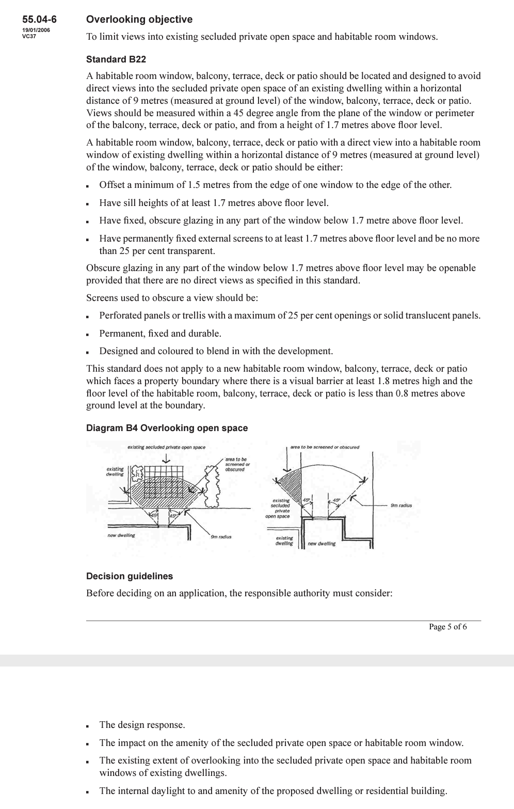
- The council submits that the proposal fails to satisfy key objectives of clause 55.04 because overlooking has been generally addressed with excessive use of extensive screening, which is suggestive of an unresponsive design. For example, in addition to the need to screen three windows at the upper floor level, the master bedroom of dwelling 3 at ground level is a highlight window and that window also seeks to minimise overlooking.
- Importantly, the council submits that there is large square window in the meals area of dwelling 3 that has the potential for overlooking because the finished floor levels are raised above natural ground level and therefore screening would be needed to comply with standard B22 and this is not currently shown.
- Also the council submits that the outdoor area of dwelling 3, where there is a pergola, has the potential to directly overlook the neighbouring property when looking at the west and south elevation in non-compliance with B22. The council admits that it is difficult to undertake this assessment without a cross-section to address the 9 metre requirement and so a planning permit condition is proposed to address this issue.
- Kostas Damaskos submits that with respect to daylight to windows, north facing windows and the like, no concerns have been raised by the council or objectors.
- Also, the concern raised by the council about excessive screening of overlooking is rejected by Kostas Damaskos. Kostas Damaskos submits that bedroom 2 is the only room facing west that has the highlight window and bedroom 1 on the other side.
- With respect to additional conditions proposed by the council at the hearing, Kostas Damaskos:
  - concedes that it is appropriate for additional screening of the meals area window of dwelling 3 to comply with standard B22.
  - does not consider that screening of the ground level deck of dwelling 3 is needed. This is based on the area of open space for the adjoining property is on the 45 degree angle under the tree and does not need to be screened based on the usability of that area of open space.

Tribunal findings
- I prefer the submissions made by Kostas Damaskos that the overlooking has generally been adequately addressed. Whilst there is the need for some screening to dwellings 2 and 3, I do not consider there is excessive screening as the council contends.
- That said, I consider there is a need for the additional conditions requested by the council at the hearing and in post hearing written submissions to address:
  - the additional screening of the window on the western elevation in the meals area of dwelling 3 in order to comply with standard B22; and
  - any necessary screening of the decked area at ground level for dwelling 3.

Clause 55.06 – Detailed design
- Clause 55.06 addresses detailed design and includes the design detail objective (clause 55.06-1) and front fences objective (clause 55.06-2).
- Clause 55.06-1 provides:
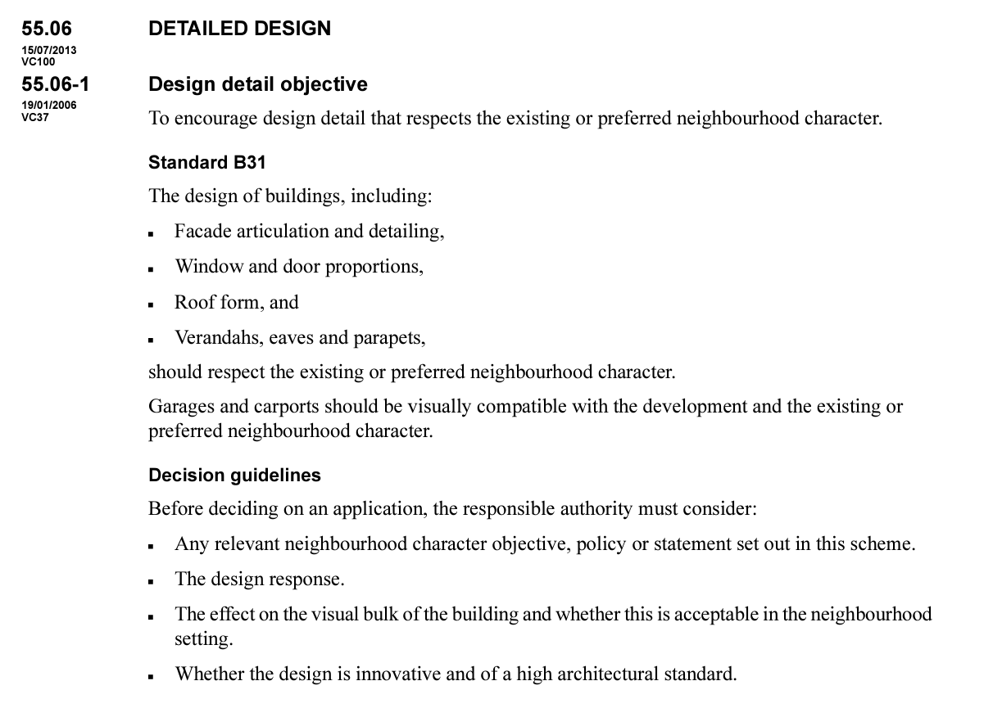

- Clause 55.06-2 provides:
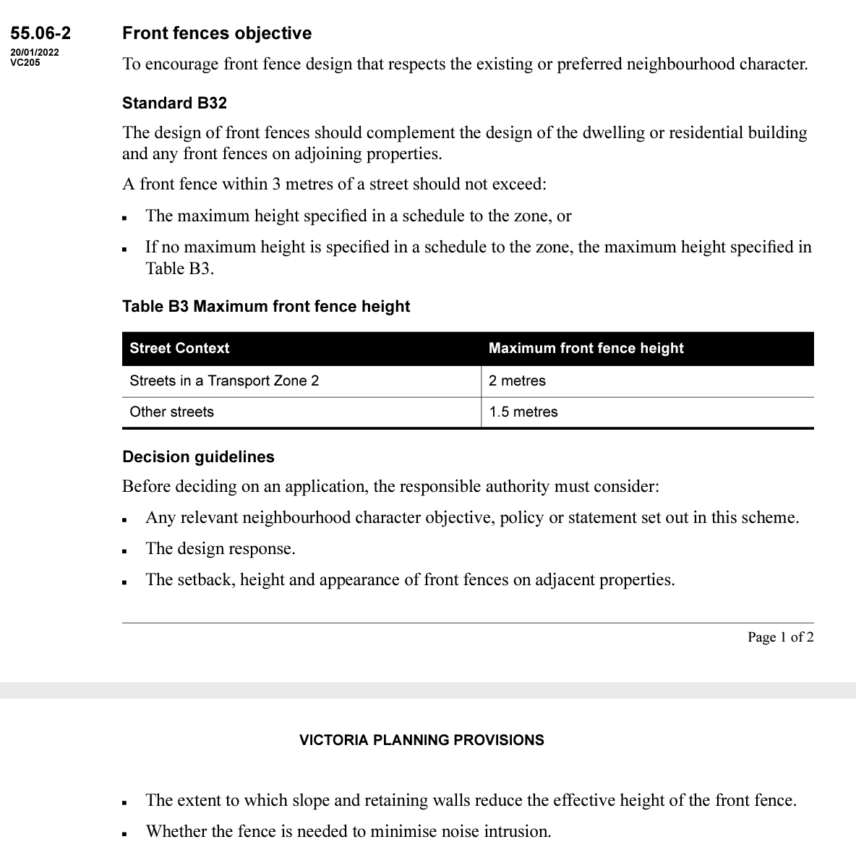
- The council submits that the proposal fails to satisfy key objectives of clause 55.06 because:
  - The design detail fails to respect the neighbourhood character having regard to the height, elongated building mass and inadequate first floor recession of the two new dwellings.
  - The retention of the existing high front fencing is not consistent with the preferred neighbourhood character and is not consistent with the design of the development as a whole in terms of building materials and style.
- Kostas Damaskos submits that the front fence is an existing condition and proposed condition 1(c) requiring that it be lowered should be deleted. Further, a change that has occurred since the previous application is the bus stop at the front of the subject land. There are litter, privacy and safety issues now associated with the bus stop and the front fence.
- Kostas Damaskos submits that the retention of the front fence is an acceptable outcome and should not be reduced in height given the safety and security issues that now exist. The objectors do not oppose the retention of the existing front fence.

Tribunal findings
- The matters about building design have been addressed earlier.
- Given the diverse neighbourhood character, main road and bus stop, I find the front fence is acceptable in this location. I will delete proposed condition 1(c) seeking to replace the existing fence to a maximum height of 1.2 metres.

does the proposal provide an acceptable level of internal amenity for future residents?
- Onsite amenity and facilities is addressed in the requirements of clause 55.05 and contain objectives with respect to accessibility (clause 55.05-1), dwelling entry (clause 55.05-2), daylight to new windows (clause 55.05-3), private open space (clause 55.05-4); solar access to open space (clause 55.05-5) and storage (clause 55.05-6).
- The focus of the submissions with respect to internal amenity are summarised below.

Council and objectors’ submissions
- The council submits that the proposal fails to satisfy key objectives of clause 55.05 because:
  - The largest living spaces in the two new dwellings are provided at basement level in an area affected by the SBO. The requirements of Melbourne Water have not been fully satisfied at this stage and will have further implications on the access to daylight for future occupants.
  - The outlook from the new dwellings is limited with minimal north facing windows.
  - The development relies on the provision of balconies and decks for private open space provision for the two new dwellings and the SPOS provided to the existing dwelling has no relationship with the living area.
  - Solar access to the SPOS provided for dwellings 2 and 3 is poor. The principal SPOS for each dwelling is at grade, on the southern side of the dwelling and does not satisfy the required setbacks of standard B29.
  - The existing front entry to dwelling 1 and proposed front entry to dwelling 3 are both obscure and provide a poor sense of address, particularly for dwelling 3 with imposing double storey blank walls, driveways, car parking and garage doors dominating. This issue was raised at the previous proceeding in P1353/2018.
  - External storage areas and clothes lines have not been provided.
- Further, the objectors submit that the bedrooms look small and will not provide an appropriate level of internal amenity for their future occupants.

Kostas Damaskos’s submissions
- Kostas Damaskos submits that:
  - The layout proposed is similar to the layout previously approved by the council and the deck that exists at the adjoining property to the west.
  - The open space for dwelling one remains the current arrangement of north facing open space. The front fence and vegetation are maintained, limiting streetscape impacts. The space will be supplemented by the addition of the rear deck.
  - The dwelling entry for dwellings 2 and 3 have been amended to provide a sense of identity, shelter, surveillance and improved landscaping opportunity.
  - With regard to north facing windows, the proposal has oriented itself on the north / south allotment that has the benefit of a rear abuttal to the parkland. This is said to be a key orientation away from the busy main road context (i.e. the six lane Ferntree Gully Road) and overlooking from adjoining dwellings.
  - No calculation is provided by the council regarding the concern that solar access to the private open space of units 2 and 3 on the amended plans do not comply with standard B29. Standard B29 requires the south facing wall to be setback from the southern boundary by 90% of its height, plus 2 metres to achieve compliance. The average wall height of dwellings 2 and 3 is 5.6m and 5.8m respectively. Accordingly, each dwelling requires a setback of 7.04m and 7.22m to achieve compliance. The average setback is calculated by Kostas Damaskos as 8.7m and 9.2m.
  - The bedrooms have a 3m x 3m dimension which is acceptable under the planning scheme.
  - The subterranean elements of dwellings 2 and 3 are a supplementary space and provide additional amenity for future occupants.
  - The council’s criticisms of technical compliance with Rescode standards are not supported by any proper assessment or analysis undertaken by the council.

Tribunal findings
- I prefer the submissions made by Kostas Damaskos and find that the proposal provides an acceptable level of internal amenity for future occupants.

has the proposal addressed the issues raised in application p1353/2018?
Background
- A previous proposal for four dwellings on the subject land lodged by Kostas Damaskos was refused by the Tribunal in November 2018. The Tribunal in that case handed down an oral decision and subsequently provided written reasons in a Tribunal Order dated 4 December 2018.
- In that proceeding, despite commenting that the subject land is suitable for medium density housing, the Tribunal found that the previous proposal was an overdevelopment of the subject land and a better resolved design was warranted. In addition to noting the need to comply with Melbourne Water requirements due to the existence of a Special Building Overlay (SBO), the key concerns with the previous proposal in P1353/2018 were the cumulative impacts of:
  - architectural design including the flat roof form;
  - high solid fencing;
  - dwelling entry;
  - private open space arrangements and solar access, particularly for dwellings 2 and 3;
  - the number of corrective vehicle manoeuvres required to enter and exit the subject land in a forward direction; and
  - overshadowing to adjoining properties.
- Given the brevity of the Tribunal’s reasons, they are worth repeating here in full:
REASONS
WHAT IS THIS PROCEEDING ABOUT?
      - Mr George Damaskos wishes to construct four dwellings on land at 140 Ferntree Gully Road, Oakleigh East. Following Council’s failure to determine the application within the prescribed time, he has requested that the Tribunal review this matter.
      - At the conclusion of the hearing I determined that a planning permit should not be granted for the development and gave oral reasons for my decision. Mr Bowden, on behalf of the permit applicant requested written reasons for my decision. What follows is an edited version of the transcript from the hearing.
      - Having heard from the parties I consider that I am in a position to make a decision on this application today.
      - Whilst I agree with the parties that this is a site that is suitable for medium density housing I have a number of concerns with this proposal before me which when combined indicated this development is an overdevelopment of the site. I’m not saying that you can’t put four dwellings on this site, but it needs to be a better resolved design.
      - First and foremost is the design choice to go with a flat roof versus the pitched roof form, which from the photographs that have been provided, whilst there are some examples where some elements of the flat roof form has been used, the overwhelming predominant form, as I have seen from aerial photographs as well as my understanding of what the character of Monash is, and what Oakleigh South is pitched tiled roof forms.
      - I appreciate that a pitched roof form would make it a taller built form and we will get back to what the implications of what that would mean.
      - It might be more appropriate to have some pitched roof form elements and some flat roof to mitigate some of those aspects.
      - Working through the site I am concerned about that the choice to use a solid 2 metre high front fence, I appreciate the use of recycled bricks and that’s quite a clever and innovative approach, but I think this solid fence in that area where there appears to be a mixture of fencing types, but predominately low scale or open style fences. There needs to be something a bit more resolved.
      - In terms of dwelling entry I share Council’s concerns with the entry arrangement, particularly for Dwelling 3, and somewhat for Dwellings 2 and 4, on slopping sites like this you often see where the basement has been introduced a separate pedestrian entrance at grade, and I consider that might have provided a better entry arrangement, but the entry arrangements that are before me I consider somewhat cumbersome and would not be particularly identifiable for visitors to the site.
      - This development is one of those classic occasions where a number of somewhat minor issues culminating in a proposal that is unacceptable.
      - With respect to the private open space arrangements, in terms of Dwelling 1 I consider it would achieve a reasonable recreational area to meet the needs of the occupants of the dwellings. I do have some concerns about the limited access to solar access, particularly to Dwelling 2 and 3, although Dwelling 2 space is somewhat benefitted by having that lower ground area, again it’s a further indication that a reduction in the overall scale of the dwellings is required.
      - In terms of access arrangements to the dwellings, I share Council’s concerns with the number of correcting manoeuvres required to enter and exit the site in a forward direction. As this is a site on Ferntree Gully Road, we do need to ensure cars can enter and entry (sic) the site in a forward direction. Whilst that can occur, the sheer number of corrective manoeuvres required indicates that this can’t occur in an easy or convenient manner.
      - In terms of overshadowing of the adjoining properties, I share the residents’ concerns with the amount of additional shadows cast, and particularly given that I don’t have details for 1pm and 2pm, its difficult to gain a full understanding of what the impact will be, and in some ways having an impact in the very late afternoon is perhaps not as significant as the impact occurring at 2pm or 1pm. I’m also concerned that the plans show that a 1.8 metre fence, rather than the existing situation which would mean that their [sic] currently experiencing a greater level of sunlight which would be taken away by this proposed development which I have concerns with.
      - Obviously, we are in an SBO and I appreciate that the concerns that were initially expressed from Melbourne Water have been addressed, but any future proposal obviously needs to be decided with those constraints in mind.
      - For those reasons the decision of the responsible authority will be affirmed and no permit will be issue.
What are the guiding principles for ‘repeat appeals’?
- The principles regarding repeat appeals are well established.
- The Supreme Court of Victoria recognised that repeat applications can come in many forms. Approval may be sought of the same use and development as was sought in a previous application. They may contain one or more correcting features or seek approval for a development entirely different from that for which approval weas sought in an earlier application.
- His Honour Garde J said in Zumpano:
29 …. Planning decisions in earlier applications affecting the subject or surrounding land are often relevant considerations in the assessment of a later application. They will almost certainly be relevant when the same use and development of the same land is sought in both the earlier and later applications. It is for the later decision-maker to determine what weight should be given to the earlier decision. Assessment of the significance of correcting features in the context of a proposed use and development is pre-eminently a planning and not a legal matter.
- Whilst the Tribunal is not bound by precedent, there needs to be reasonable grounds for a later appeal determination to depart from a Tribunal view on a very similar proposal earlier. The factors to justify a departure from an earlier determination could include:
  - significant changes in the application itself;
  - changes in the circumstances of the land and its surrounds;
  - changes in planning policy; and / or
  - changes in the interpretation of the facts or law relevant to the Tribunal’s consideration.
- The role of the Tribunal is not to determine if the proposal before it would have satisfied the earlier (and perhaps differently constituted) Tribunal, nor to summarily determine the matter solely by reference to the ‘Reichart’ principles. Rather, the role of the Tribunal is to still consider the new application before it on its merits but in doing so, to give great weight to the Tribunal’s decision on the earlier application having regard to the usual principles that have evolved for this purpose.

Submissions
- In this case, neither the responsible authority nor the respondents made detailed submissions about whether the proposal was a ‘correcting repeat appeal’ or a ‘classic repeat appeal’. Rather, whilst acknowledging that the reduction from four dwellings to three dwellings represents a far less intensive development in general terms, their submissions focussed on the fact that the two proposed dwellings at the rear contained a very similar building footprint to the previous proposal and therefore the problem identified at that time of the previous proceeding in P1353/2018 had not been addressed.
- In this regard, the council submits that changes to the two new dwellings at the rear are minimal when compared to the design previously considered by the Tribunal and the issues of concern raised by the Tribunal, including impact on adjoining properties, have not been satisfactorily addressed. The council expressed concern about:
  - The current proposal is an interim response that seeks to achieve approval for two new dwellings at the rear of the subject land.
  - There has been on attempt to improve the presentation and landscaping of the property to the street and the paving and synthetic grass to part of the frontage is contrary to the policy objectives of GRZ3 and the Residential Character Policy that encourage open and lands caped frontages.
  - The retention of the existing high fencing across the frontage and along the side return to the driveway completely closes the property and provides no real sense of address.
  - The proposal seeks to introduce paving and synthetic grass to be part of the frontage, which is considered contrary to the policy objectives of schedule 3 to the GRZ and those within the Residential Character Policy that encourage open and landscaped frontages.
- In addition the council submits that the proposal ignores the previous issue raised by the Tribunal with respect to the front fence:
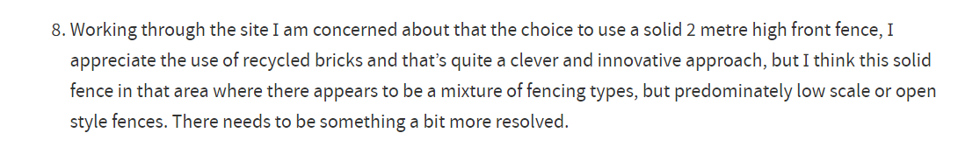
- The council submits it is concerns in relation to the two new dwellings at the rear of the subject land because:
  - Despite the introduction of a pitched roof, the building envelopes of both dwellings are very similar to those shown on the plans that VCAT refused.
  - The design fails to mitigate visual bulk impacts on adjoining properties due to the minimal side setbacks and lack of landscaping opportunities.
  - The setbacks from the rear boundary do not satisfy the requirements of GRZ3. The 5 metre minimum setback is sought to provide generous landscaping areas, to allow for the planting of canopy trees to protect ‘Monash’s garden city’ character and to assist in reducing the visual impact of development by providing a landscaped separation between properties.
  - Landscaping space within rear yards is very limited. The secluded open space of both dwellings contain large areas of decking that extend close to the rear boundary (2 metres for Dwelling 2 and 1.2 metres for dwelling 3).
  - The development will present as overly prominent when viewed from the adjoining reserve, as there is very limited space for landscaping to soften the visual impact of the built form.
  - Internal amenity is constrained because:
    - Secluded open space areas will be affected by overshadowing;
    - The dwellings have poor access to northern sunlight;
    - The largest living area (rumpus room) is at basement level and the changes required by Melbourne Water’s conditions are likely to have implications for the amount of light available to windows and doors within this level.
- The presentation of the driveway with the slope of the site and the need for retaining walls, running along almost the length of the eastern boundary will contribute to an undesirably dominant built form with insufficient areas available for suitable landscaping to soften the appearance of the development.
- The design does not provide for a sense of address and adequate entry to dwelling 3 despite this issue being raised by the Tribunal in P1353/2018:
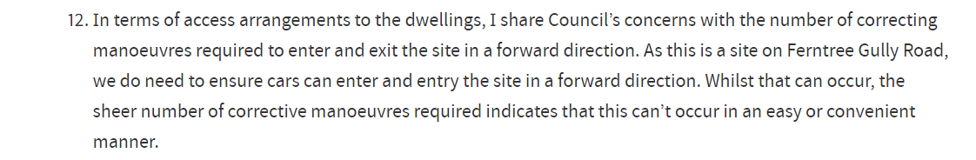
- Kostas Damaskos submits to the contrary that he has addressed the issues raised by the Tribunal in its previous decision, which he says in any event are minor items requiring correction. This is because:
  - the amended proposal in this proceeding now seeks to retain the existing dwelling at the front, in place of two new townhouses in the previous scheme;
  - the two proposed dwellings at the rear have a pitched roof which allows a reduction of overall height and wall heights;
  - the existing paling front fence is being retained in place of the solid 2 metre high brick fence in the previous proposal;
  - dwelling entries to the proposed new dwellings have been reconfigured;
  - private open space arrangements for the rear dwellings have been increased / improved;
  - concerns about vehicle manoeuvres required to enter and exit the subject land in a forward direction are alleviated;
  - overshadowing to adjoining properties is acceptable;
  - Melbourne Water requirements have been appropriately addressed in balancing issues such as visual bulk.
- In addition, Kostas Damaskos submits that the objectors previously did not take issue with a three dwelling proposal; rather they were concerned with a four dwelling proposal. He submits that what is now proposed is the same built form that was previously approved under the lapsed planning permit. Further, Kostas Damaskos submits that the proposal is for all intents and purposes the same application as was previously approved and unopposed by the objectors.
- Further, Kostas Damaskos submits that any suggestion of the application being an interim response should be dismissed. This is not the first time Kostas Damaskos has been comfortable with this scale and type of the proposal given the permit history.

Tribunal findings
- It is relevant to my considerations that the planning controls affecting the subject land have changed since the Tribunal’s decision is P1353/2018 with the approval of the Monash Housing Strategy 2014 and the application of the GRZ3 in place of the GRZ2.
- It is also relevant that I am now considering a three dwelling proposal rather than a four dwelling proposal.
- I accept the submissions made by Kostas Damaskos that the proposal has responded to the previous Tribunal decision in P1353/2018 because essentially cumulative impact of the ‘minor’ issues identified in the previous scheme have been addressed because:
  - With the retention of the existing dwelling setback 11 metres from the street frontage, the status quo with respect to the streetscape is maintained. In neighbourhood character terms, this means the streetscape effectively remains unchanged;
  - The existing dwelling is a preferred outcome to the original scheme to the extent that it allows for greater landscaping opportunity and vehicle turning as well as reducing the built form scale and as a result criticisms regarding visual bulk;
  - The flat roof approach has been replaced with a pitched roof to respond to the prevailing character. The low pitch is cognisant of the height of the dwellings. Whilst the overall height of the rear dwellings is higher than the original scheme as a result of the introduction of a pitched roof, the height at the east and west interface (i.e. the wall height) is lower. This is a positive improvement with respect to overshadowing;
  - Dwelling entries for dwellings 2 and 3 have been redesigned to provide an at grade pedestrian entrance with improved surveillance and circulation space, including the removal of the hidden entrance for dwelling 3. This includes two front doors, upper level windows and landscaping opportunities that have windows facing the common area. The is preferred to the previous layout approved by the council under the lapsed permit;
  - The council’s traffic engineer accepts the swept path analysis for the revised design;
  - Melbourne Water’s requirements continue to be met by the proposal; in fact the approval from the authority was first obtained over 6 years ago; and
  - Overshadowing of adjoining dwellings has been further reduced as a result of the changes to the dwellings at the rear. The plans now reference the new 2 metre fence and updated shadows at all intervals have now been provided (refer to discussion above).

are there any other issues?

Clause 52.29, traffic and visitor parking
- The existing crossover is not being altered. However, the council has assumed a permit trigger applies under clause 52.29 because there will be an increase in vehicle movements from the subject land. I have proceeded on this basis.
- With respect to the permit trigger under clause 52.29, I find that it is appropriate to adopt the requirement made by the Department of Transport as a determining referral authority on 20 January 2020 who advised it had no objection to the original plans subject to the following condition:
Vehicles must enter and exit the land in a forward direction at all times.
- I record that on 11 February 2021, the Department advised no further conditions were required and confirmed it was not intended to participate in the VCAT hearing. The council took no issue with this outcome.
- I allowed the parties to make further submissions with respect to amendment VC199. No party wished to make any further submissions in relation to the updated wording changes to clause 52.29 or this amendment.
- VicRoads and council’s traffic engineers are supportive of the vehicle turning circles contained in the swept path diagrams filed in support of the application subject to adjustments that can be addressed by way of condition.
- I prefer the submissions made by Kostas Damaskos that the garages meet the standard size required by the planning scheme in response to the submissions made by the objectors.
- The objectors are critical of the proposal because no visitor parking space is provided. I accept the submissions made by Kostas Damaskos that there is no permit trigger for the provision of visitor parking under the planning scheme.

Melbourne Water
- Melbourne Water is a determining referral authority and it does not object to the proposal subject to conditions. The council’s drainage engineers are also supportive of the proposal.
- Kostas Damaskos submits that the required levels of bunding to achieve compliance with Melbourne Water conditions are 79 AHD for dwelling 2 and 78.28 AHD for dwelling 3. Therefore, an additional 40 cm of soil is required to achieve compliance for dwelling 2 which has levels at 78.6 AHD. Kostas Damaskos accepts a permit condition to achieve compliance. The Melbourne Water conditions are included in the permit that I am directing to be issued by the council.

‘Interim’ or temporary proposal allegation
- The responsible authority and the respondents submit that the proposal appears to be masked as a staged proposal. They raise concerns that Kostas Damaskos will make a future application to redevelop the front portion of the subject land.
- I am unable to pre-empt any future applications that Kostas Damaskos may make. I must consider the proposal before me and determine whether it will produce an acceptable outcome. Any future applications must be considered on their own merits.

Construction matters
- To the extent the objectors complain about matters relating to excavation (including underground) and construction, these are matters to be considered at the detailed design stage and building permit application stage. Engineering plans will need to be prepared to the satisfaction of relevant authorities. These are not matters before me.
- However, Kostas Damaskos clarified that the retaining wall at the rear of the garage of unit 2 will be removed to accord with Melbourne Water requirements. This will be replaced with stepping-stones to the rear.

acceptable outcomes and Does the proposal achieve net community benefit?
- In considering the application before me, I am reminded by Kostas Damaskos of the comments by Justice Osborn in Rozen v Macedon Ranges SC & Anor [2010] VSC 583 that the planning scheme does not require an ideal outcome as a prerequisite to a permit. If it did, very few, if any, permits for development would ever be granted and there would be difficult differences of opinion as to whether the outcomes were in fact ideal. The Tribunal is entitled to grant a permit where it is satisfied that the permit will result in a reasonably acceptable outcome having regard to the matters relevant to its decision under the planning controls.
- Having considered all relevant matters, I find that the proposal will result in a net community benefit because:
  - The proposed development is site responsive.
  - The design of the proposed development is appropriate having regard to the character of the area.
  - The layout and design provides a high level of amenity for future residents which overall, satisfies the objectives and standards of Rescode.
  - The development is designed to ensure that the amenity of nearby residents is not unreasonably affected and to the extent there are concerns, they can be addressed by way of condition.
  - The proposal satisfies the urban consolidation objectives and makes effective use of the subject land. It will contribute towards diversity and affordability in accordance with council’s strategic directions.
  - The proposal has an acceptable level of compliance with Rescode and council’s local policies.

What conditions are appropriate?

Front fence
- Kostas Damaskos seeks the deletion of condition 1(c), requiring the reduction in the height of the front fence. The objectors do not oppose this for privacy reasons given the new bus stop. I consider this is a reasonable request and have deleted the council’s proposed condition requiring the replacement of the front fence with a lower fence.

Additional screening – dwelling 3
- I allowed the parties to file submissions after the hearing to address the concerns of the council regarding overlooking from dwelling 3 for:
(a) the screening of the large western meals area window at ground floor; and
(b) the western edge of the deck in the meals area.
- I have included the additional conditions provided by the council.

Overshadowing of units at 142 Ferntree Gully Road
- At the hearing, the objectors requested an additional condition requiring the alternation of the building so that there is no additional shadow at 3pm at the equinox to the existing secluded private open space to the units at 142 Ferntree Gully Road. This condition was opposed Kostas Damaskos given the additional overshadowing predominantly occurred at the end of the relevant period at 3pm at the equinox.
- Given the limited area of secluded private open space for these properties at 142 Ferntree Gully Road, I consider that the inclusion of a condition to effectively comply with standard B21 is appropriate to the satisfaction of the responsible authority.

Conclusion
- For the reasons given above, the decision of the responsible authority is set aside. A permit is granted subject to conditions.

Carol Daicic
Senior Member

Appendix A – Permit Conditions

Permit Application No | TPA/51039
Land | 140 Ferntree Gully Road  OAKLEIGH EAST VIC 3166

What the permit allowS
In accordance with the endorsed plans:
- Construction of three dwellings on land in the General Residential Zone - Schedule 3 and Special Building Overlay
- Alteration of access to a road in a Transport Zone 2.

Conditions

Amended Plans required:
- Before the development starts, plans drawn to scale and dimensioned must be submitted to and approved by the responsible authority. When approved, the plans will be endorsed and will then form part of the permit. The plans must be generally in accordance with the amended plans prepared by JKBD, Building Design Consultants (Job No 19092) Drawing Nos. TP 01 - TP 19 (all Revision F) dated 22 December 2020 and subject to the following changes:
  - All required changes to address Melbourne Water’s requirements.
  - Driveway ramp grades are to be redesigned in accordance with Design Standards for car parking set out in Clause 52.06-9 of the Monash Planning Scheme.
  - An elevation of the front fence showing materials of construction.
  - Storage Areas and clotheslines for all dwellings.
  - Revised landscaping plan to incorporate all changes required under Condition 4.
  - The location and design of any proposed electricity supply meter boxes. The electricity supply meter boxes must be located at a distance from the street which is at or behind the setback alignment of buildings on the site or in compliance with Council’s “Guide to Electricity Supply Meter Boxes in Monash”.
  - The development must be provided with a corner splay or area at least 50% clear of visual obstruction (or with a height of less than 1.2m) extending at least 2.0 metres long x 2.5 metres deep (within the property) on both sides of each vehicle crossing to provide a clear view of pedestrians on the footpath of the frontage road.
  - The west facing meals room window of Dwelling 3 screened in accordance with the requirements of Standard B22 of Clause 55 of the Monash Planning Scheme.
  - Screening of the western edge only of the section of Dwelling 3’s rear paved/decking area that has a FFL of 79.3 to AHD (and which is covered by a pergola) in accordance with the requirements of Standard B22 of Clause 55 of the Monash Planning Scheme, unless it is satisfactorily demonstrated (e.g. by cross-section or other diagrams) that no screening is required to satisfy Standard B22, to the satisfaction of the responsible authority.
  - The building to be altered to ensure no additional shadow to the existing secluded private open space areas of the units at 142 Ferntree Gully Road at 3pm at the equinox to the satisfaction of the responsible authority.

No Alteration or Changes
- The development as shown on the endorsed plans must not be altered without the prior written consent of the responsible authority.

Common Boundary Fences
- All common boundary fences are to be a minimum of 1.8 metres above the finished ground level to the satisfaction of the responsible authority. The fence heights must be measured above the highest point on the subject or adjoining site, within 3 metres of the fence line.

Landscaping
- Concurrent with the endorsement of the plans pursuant to Condition 1, a landscape plan prepared by a Landscape Architect or a suitably qualified or experienced landscape designer, drawn to scale and dimensioned must be submitted to and approved by the responsible authority prior to the commencement of any works. The plan must show the proposed landscape treatment of the site including:-
  - the location of all existing trees and other vegetation to be retained on site;
  - provision of canopy trees with spreading crowns located throughout the site including the major open space areas of the development;
  - planting to soften the appearance of hard surface areas such as driveways and other paved areas;
  - a schedule of all proposed trees, shrubs and ground cover, which will include the size of all plants (at planting and at maturity), their location, botanical names and the location of all areas to be covered by grass, lawn, mulch or other surface material;
  - the location and details of all fencing;
  - the extent of any cut, fill, embankments or retaining walls associated with the landscape treatment of the site; and
  - details of all proposed hard surface materials including pathways, patio or decked areas.
When approved the plan will be endorsed and will then form part of the permit.

Tree Protection
- Prior to the commencement of any works that are permitted by this permit, all trees that are to be retained, or are located within or adjacent to any works area, shall be marked and provided with a protective barricade and verified by an authorised officer of the responsible authority.
- No building material, demolition material or earthworks shall be stored or stockpiled under the canopy line of any tree to be retained during the construction period of the development hereby permitted

Landscaping Prior to Occupation
- Before the occupation of the buildings allowed by this permit, landscaping works as shown on the endorsed plans must be completed to the satisfaction of the responsible authority and then maintained to the satisfaction of the responsible authority.

Drainage
- All stormwater collected on the site from all hard surface areas must not be allowed to flow uncontrolled into adjoining properties or the road reserve.
- The nominated point of stormwater connection for the site is to the south-west corner of the property where the entire site's stormwater must be collected and free drained via a pipe to the Melbourne Water pit in the Council Reserve to Council and Melbourne Water standards. Note: If the point of connection cannot be located then notify Council's Engineering Department immediately.
- Permits must be obtained from Melbourne Water prior to connecting into Melbourne water pit. A copy of the Melbourne Water approval report is to be forwarded to Council for record keeping.
- An onsite detention system for storm events up to the 1% AEP event to be retained on site for the basement carpark. The detention system for the basement is to be separated from the detention system for the property, which is to be at ground level and discharge by gravity. A Licensed Surveyor or Civil Engineer (who is a Registered Building Practitioner) must certify that the stormwater detention system including all levels, pits, pipes and storage volumes is constructed in accordance with the approved plans. The certifier's registration number must be included on the certificate.

Vehicle Crossing
- Approval of each proposed crossing, and a permit for installation or modification of any vehicle crossing is required from Council’s Engineering Department.
- The existing crossing is of poor quality and is to be fully reconstructed to align with the proposed driveway. The footpath and nature strip are to be reinstated to the satisfaction of Council.
- Provide a corner splay or area at least 50% clear of visual obstructions (or with a height of less than 1.2 metres), which may include adjacent landscaping areas with a height of less than 0.9 metres, extending at least 2.0 metres long x 2.5 metres deep (within the property) both sides of the new vehicle crossing to provide a clear view of pedestrians on the footpath of the frontage road.

Urban Design
- The walls on the boundary of adjoining properties shall be cleaned and finished in a manner to the satisfaction of the responsible authority.

Completion of Buildings and Works
- Once the development has started it must be continued and completed to the satisfaction of the responsible authority.

Department of Transport Conditions (Ref PPR 31739/19)
- Vehicles must enter and exit the land in a forward direction at all times.

Melbourne Water Conditions (Ref MWA-1161479)
- Prior to the development plans being endorsed, amended plans must be submitted to Council and Melbourne Water addressing Melbourne Water's conditions. Site, ground floor and elevation plans must be submitted with ground and floor levels to Australian Height Datum (AHD) and must be amended to show:
  - The void to Dwelling 3 bunded and flood protected to 78.28m to AHD.
  - The void to Dwelling 2 bunded and flood protected to 79.00m to AHD.
  - All decking within the open spaces (including beneath the pergola/covered area) of Dwellings 2 & 3 open and unenclosed.
  - All fencing within the open space/southern setback of Dwellings 2 & 3 in an open style of construction.
  - Deletion of any retaining walls proposed within the side or rear setbacks of Dwellings 2 and 3.
- Dwelling 3 must be constructed with finished floor levels set no lower than 78.28 metres to Australian Height Datum (AHD), which is 300mm above the grading flood level of 77.98m to AHD.
- Dwelling 2 must be constructed with finished floor levels set no lower than 79.00m to AHD, which is 300mm above the grading flood level of 78.7m to AHD.
- Garage 2 must be constructed with finished floor levels set no lower than the grading flood level of 78.7m to AHD.
- Garage 3 must be constructed with finished floor levels set no lower than the grading flood level of 77.98m to AHD.
- Prior to the issue of an Occupancy Permit, a certified survey plan, showing finished floor levels (as constructed) reduced to the Australian Height Datum, must be submitted to Melbourne Water to demonstrate that the floor levels have been constructed in accordance with Melbourne Water's requirements.
- All doors, windows, vents and openings to the basement rumpus and ancillary rooms of Dwellings 2 and 3 must be bunded and flood protected to a minimum 300mm above the applicable flood level, as per finished dwelling floor heights above.
- The development must be set back a minimum of 1.2 metres from the southern property boundary, maintained at natural surface levels. No structures (i.e. no garages, sheds or water tanks), are permitted within this setback, apart from open style fencing.
- Prior to the issue of a Statement of Compliance, Melbourne Water requires evidence of the location of the stormwater connection (legal point of discharge). If a new stormwater connection is required, a separate application must be made and accepted to Melbourne Water.
- No fill is to be imported into the floodplain/overland flow path and no retaining walls are to be used in the development within the floodplain/overland flow path.
- The internal fences separating Dwellings 2 and 3 within the southern boundary setback must be of an open style of construction (50% open style) to allow for the passage of fast moving overland flows.
- Any proposed southern boundary fences must be open style or timber paling construction.
- Any proposed decking and steps within the private open space of Dwellings 2 and 3 must be located outside the southern setback and must be unenclosed, open underneath to allow for the passage of overland flows.

Permit Expiry
- This permit will expire in accordance with section 68 of the Planning and Environment Act 1987, if one of the following circumstances applies:
  - The development has not started before two (2) years from the date of issue.
  - The development is not completed before four (4) years from the date of issue.
In accordance with section 69 of the Planning and Environment Act 1987, the responsible authority may extend the periods referred to if a request is made in writing before the permit expires, or within six months of the permit expiry date, where the development allowed by the permit has not yet started; or within 12 months of the permit expiry date, where the development has lawfully started before the permit expires.

– End of conditions –

Section 4(2)(d) of the Victorian Civil and Administrative Tribunal Act 1998 states a failure to make a decision is deemed to be a decision to refuse to make the decision.
The council assessed the permit application on the basis that a planning permit is required under clause 52.29 to alter access to the formally worded ‘Road Zone – Category 1’ – refer to Council submissions at [5.3]. I have proceeded on this basis.
The timing of the unaccompanied site inspection was delayed due to the State Government restrictions imposed during the Covid-19 pandemic in 2021 prohibiting site inspections.
The submissions of the parties, any supporting exhibits given at the hearing and the statements of grounds filed have all been considered in the determination of the proceeding. In accordance with the practice of the Tribunal, not all of this material will be cited or referred to in these reasons.
Measured above natural ground level (NGL).
Council submissions at [1.4]
Barbara Williams confirmed on day 1 of the hearing that she speaks on behalf the following joint respondents: Irina Tourovsky, (owner of unit 2/142 Ferntree Gully Road), Lyn White (owner of unit 4/142 Ferntree Gully Road) and George Galanis and herself (owners of unit 5/142 Ferntree Gully Road). She no longer represents the owners of unit 1/142 or unit 3/142 Ferntree Gully Road respectively who she advised no longer wish to contest the application since the circulation of amended plans.
Source Council submission at page 35
Council submission at [8.5]
Council submission at [2.4]
Bologna v Monash CC [2016] VCAT 779 at [8]
Refer for example, to the decision in Withington v Bayside City Council [2005] VCAT 1278 at [45] to [46].
Proposed condition 7 required by Melbourne Water dated 03 February 2021.
Damaskos v Monash CC [2018] VCAT 1920
Zumpano v Banyule City Council [2016] VSC 420 at [26]
Zumpano v Banyule City Council [2016] VSC 420
K & B Reichert v City of Banyule & Ors [1996] VICCAT 44
Sprut Pty Ltd v Stonnington CC [2012] VCAT 1675
[2018] VCAT 1920 at [8]
At [171] – [177]

