VICTORIAN CIVIL AND ADMINISTRATIVE TRIBUNAL
planning and environment LIST | vcat reference No. P559/2021  Permit Application no. TPA/51560
CATCHWORDS
Planning and Environment Act 1987; Monash Planning Scheme; General Residential Zone; Clayton Activity Centre; Proposal for four, three storey dwellings; Access and car parking; Landscaping adequacy.

Applicant | Antonio Lucarelli

Responsible Authority | Monash City Council
Referral AuthoritIES | Vic Roads, Head Transport for Victoria  Melbourne Water
SUBJECT LAND | 1363 Centre Road and part of the land at 1361 and 1365 Centre Road  CLAYTON VIC 3168
HEARING TYPE | Hearing
DATE OF HEARING | 10 November 2021
DATE OF ORDER | 6 December 2021
CITATION | Lucarelli v Monash CC [2021] VCAT 1459

Order
- Pursuant to clause 64 of Schedule 1 of the Victorian Civil and Administrative Tribunal Act 1998 and section 127 of the Victorian Civil and Administrative Tribunal Act 1998, the permit application and application for review is amended as follows:
- The land to which the permit applies is to include Part 1361 and 1365 Centre Road,
- The application is amended to include the creation of easements pursuant to Clause 52.02 of the Monash Planning Scheme.
- Pursuant to clause 64 of Schedule 1 of the Victorian Civil and Administrative Tribunal Act 1998, the permit application is amended by substituting for the permit application plans, the following plans filed with the Tribunal:
- Prepared by: | Jesse Ant Architects
- Drawing numbers: | Revision B
- Dated: | 23 September 2021
- In application P559/2021 the decision of the responsible authority is set aside.
- In planning permit application TPA/51560 a permit is granted and directed to be issued for land at 1363 Centre Road, Clayton and part of the land at 1361 and 1365 Centre Road, Clayton in accordance with the endorsed plans and subject to the conditions set out in Appendix A to this order. The permit allows:
- The development of four (4) dwellings on land in the General Residential Zone and covered by the Special Building Overlay, to create easements and to alter access to a Road Zone, Category 1

Megan Carew
Member

Appearances
For applicant | Mr David D’ Giovanni, Town Planning Consultant
For responsible authority | Mr Andrew Clarke, Town Planning Consultant, Clarke Planning

Information
Description of proposal | Construction of four three-storey dwellings in two attached pairs.  Townhouses 1 and 2 are accessed via a common driveway from Centre Road. Townhouse 1 is designed in a reverse living layout and has a balcony facing the street. Townhouse 2 is attached to Townhouse 1 and has ground level open space.  Townhouses 3 and 4 are located to the rear of the site and are arranged in a side-by-side design. They are separately accessed from the rear laneway. To access the proposed garages, easements would need to be created over the adjoining properties at 1361 and 1365 Centre Road Clayton as shown on the plans.
Nature of proceeding | Application under section 79 of the Planning and Environment Act 1987 – to review the failure to grant a permit within the prescribed time.
Zone and overlays | General Residential Zone – Schedule 6 (GRZ6)  Special Building Overlay (SBO)  Abuts a Road Zone-Category 1.
Permit requirements | Clause 32.08-6- construction of two or more dwellings on a lot in GRZ6.  Clause 44.05-2-buildings and works in a SBO.  Clause 52.02- Creation of easements.  Clause 52.29- Access to a road in a Road Zone- Category 1.
Key scheme policies and provisions | Clauses 11, 15, 16, 18, 21, 22.01, 22.04, 22.05, 22.13, 32.08, 44.05, 52.02, 52.06, 52.29, 55, 65 and 71.02
Land description | The three properties forming the review site are located on the north side of Centre Road, which forms the municipal boundary.  The land at No. 1363 Centre Road has frontage to Centre Road of 18.9m and a total site area of 921.75m². It is occupied by a single storey dwelling. The site has access to a rear laneway that runs from Burton Avenue to the west and terminates to the east of the review site.
 | The proposal includes the creation of “splays” for access to garages over part of the rear of the adjoining properties at Nos. 1361 and 1365 Centre Road. No. 1361 Centre Road is located to the west and is presently occupied by a medical centre with car parking within the front setback and vacant land to the rear. To the east is No. 1365 Centre Road, a site occupied by a single storey dwelling. This site is subject to a current application for a three-level apartment style development.
Tribunal inspection | I inspected the review site and its environs following the hearing.

Figure 1 Site context

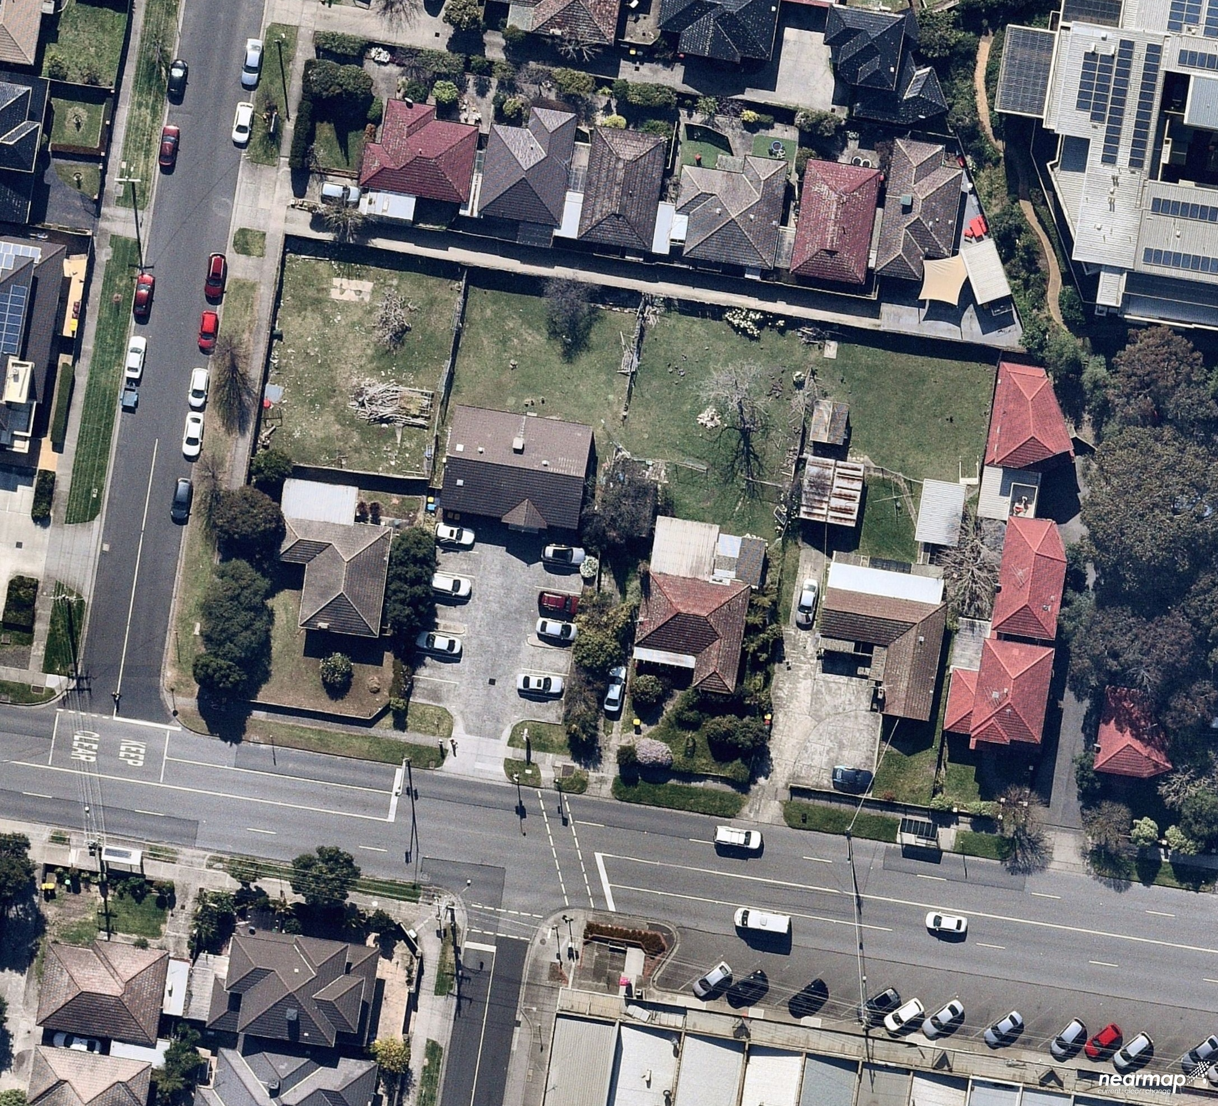
Reasons

What is this proceeding about?
- The applicant is seeking a review of Monash City Council’s failure to determine an application for four townhouses. The applicant says that the proposal as set out in the amended plans substituted at the hearing is an acceptable outcome in the context of the Monash Planning Scheme.
- The Council determined that it would have refused the permit application. It considered that the proposal had not responded to the preferred neighbourhood character, would not have an acceptable built form outcome and that vehicular movements in the laneway were unsatisfactory. In respect to the later, Council submitted that the tandem car parking arrangement for townhouses 3 and 4 had major shortcomings.
- The site is subject to the Special Building Overlay (SBO). Melbourne Water originally objected to the application, but following amended plans is now satisfied that the built form outcome is acceptable. Council considered that the need to achieve compliance with the SBO requirements had resulted in design constraints that had not been overcome in the amended plans.
- I must decide if a permit should be granted and if so, what conditions should apply. Having considered the planning policy framework, the purpose of the zone and the decision guidelines of the relevant clauses of the Monash Planning Scheme and the submissions of the parties, I have determined to set aside the decision of the responsible authority and grant a permit. My reasons follow.

PRELIMINARY MATTERS
- The application relies on the creation of carriageway easements over the rear corners of the properties at 1361 and 1365 Centre Road in favour of the site at 1363 Centre Road. The easements relate to splays providing access to the garages for townhouses 3 and 4. The Tribunal understands that these properties are in different ownership listed as Lucarelli Superannuation Pty Ltd controlled by the permit applicant. Copies of the titles provided at the hearing. The advertised and amended plans included reference to these splays.
- At the commencement of the hearing, the applicant sought leave to amend the application to include the creation of easements over these additional properties. Having heard from all the parties, I have determined to amend the application to include the additional land and creation of associated easements.

WHAT ARE MY FINDINGS?
- It was common ground that the site is a suitable candidate for some form of medium density housing. The zoning and applicable planning policies support increased housing densities in this location. Clause 21.04-1 includes the review site within the residential land within the Monash National Employment Cluster. It is also located within the Clayton Activity Centre and an accessible area.
- Council explained that broadly, the local policies seek to establish a garden city character. Clause 22.01 sets out residential development and neighbourhood character policy and notes that the City of Monash’s residential areas have a garden city character that is highly valued by the community. The review site is part of the Housing Diversity Area- Clayton Activity Centre and Monash National Employment Cluster:
The Clayton Activity Centre and the cluster more broadly are expected to experience major redevelopment, as one of the key areas for employment growth within Melbourne. As such, the core of the activity centre and the cluster are anticipated to accommodate growth and more diverse housing needs. This area also forms an interface to the surrounding garden city suburbs. New development should provide a transition between these areas.
New housing will generally comprise multi dwelling developments such as units and, where appropriate, low rise apartments. Front and rear setbacks will be less than those preferred in the garden city areas, however will still provide the opportunity for landscaping. Landscaping and open space within developments will remain an important feature for this character area. Canopy trees within developments and separation between buildings will provide visual and environmental amenity for occupants and the residents of existing dwellings. New developments will be designed and constructed to a high standard, ensuring they provide a positive architectural impact.
- This categorisation is reflected in the application of the site within the General Residential Zone – Schedule 6 that applies to sites within the Monash National Employment Cluster and Clayton Activity Centre. In this zone varied Clause 55 standards B6, B13, B17. B28 and B32 apply. The neighbourhood character objectives are currently set out in the schedule to the zone that include:
- To facilitate housing diversity in the form of units, townhouses and apartment developments of high quality design and finish.
- To provide an interface between the Clayton Activity Centre, the Monash Employment and Innovation Cluster, the housing growth area and the lower scale surrounding garden city suburban areas.
- To encourage development that respects sensitive residential interfaces and minimises building mass and visual bulk in the streetscape through landscaping in the front setback and breaks and recesses in the built form.
- To promote the preferred garden city character by minimising hard paving throughout the site by limiting the length and width of accessways and limiting paving within open space areas.
- To ensure developments are constructed within an open garden setting through the retention and planting of vegetation, including canopy trees.
As set out above, it is anticipated that the character of this area will see change, but that the preferred garden city character is still relevant. As the Tribunal set out in Chen v Monash [2021] VCAT 1207:
17 It is clear that change is expected in this location, including units, within a framework where the preferred future character involves opportunity for landscaping (as underpins the important Garden City policy theme) and ensures a positive architectural impact.
- The Clayton Activity Centre Precinct Plan was adopted by Council on 28 January 2020. It is not the subject of a present planning scheme amendment, but it is a document to which I can have regard pursuant to Section 60 of the Planning and Environment Act 1987. The review site is part of an area identified for residential intensification with a height of 3 storeys (where the frontage is less than 20m).
- Higher building height is contemplated within the adopted plan for larger sites. Council submitted that to best achieve the strategic aspirations for this site, whilst managing the constraints of the Special Building Overlay, the land owner is best exploring the consolidation of this site with one or both abutting allotments. This may be so, but the Tribunal is required to consider the application as put forward by the applicant and to determine if the proposal is acceptable.

NEIGHBOURHOOD CHARACTER
- The character of this area is mixed with older style housing stock interspersed with medium density housing and juxtaposed with uses such as the aged care facility and the strip commercial area opposite the review site. The impact of the main road location is keenly felt. There are pockets of the garden suburban character such as the large trees at 1367-1369 Centre Road identified by Council in its submission and on the bend of Burton Avenue.
- The review site will be one of the first properties to develop in this immediate area. There is also a concurrent application for a three-storey apartment building on land at 1365 Centre Road, Clayton. That application is to be considered separately by this Tribunal, although the required splays are included on those plans. The permit applicant also drew my attention to the recent approval of a contemporary three storey apartment building at 4 Burton Avenue to the north of the review site.
- Council submits that the proposal does not meet the preferred neighbourhood character for the area due to the minimal front setback, lack of opportunities throughout the site for landscaping and design detail. Council says that these issues arise from the site layout and need to respond to the SBO requirements.
- The applicant accepts that the SBO requirements for overland flow have narrowed the built form, but says that this has resulted in good side and rear setbacks so that the dwellings will sit comfortably on the site and create breathing space and landscaping.
- The site layout adopts two modules of townhouses with access from the rear laneway and pedestrian access/ address to Centre Road provided via a pedestrian pathway. Townhouse 1 fronts Centre Road, while Townhouse 2 has access from the common driveway (see Figure 2). The design creates some efficiencies, minimising the extent of driveway required and the site coverage is relatively modest and garden area (approximately 38%) is met. The two modules are separated by a break in building form at ground level that provides for access to the rear dwellings.
Figure 2 Proposed landscape plan
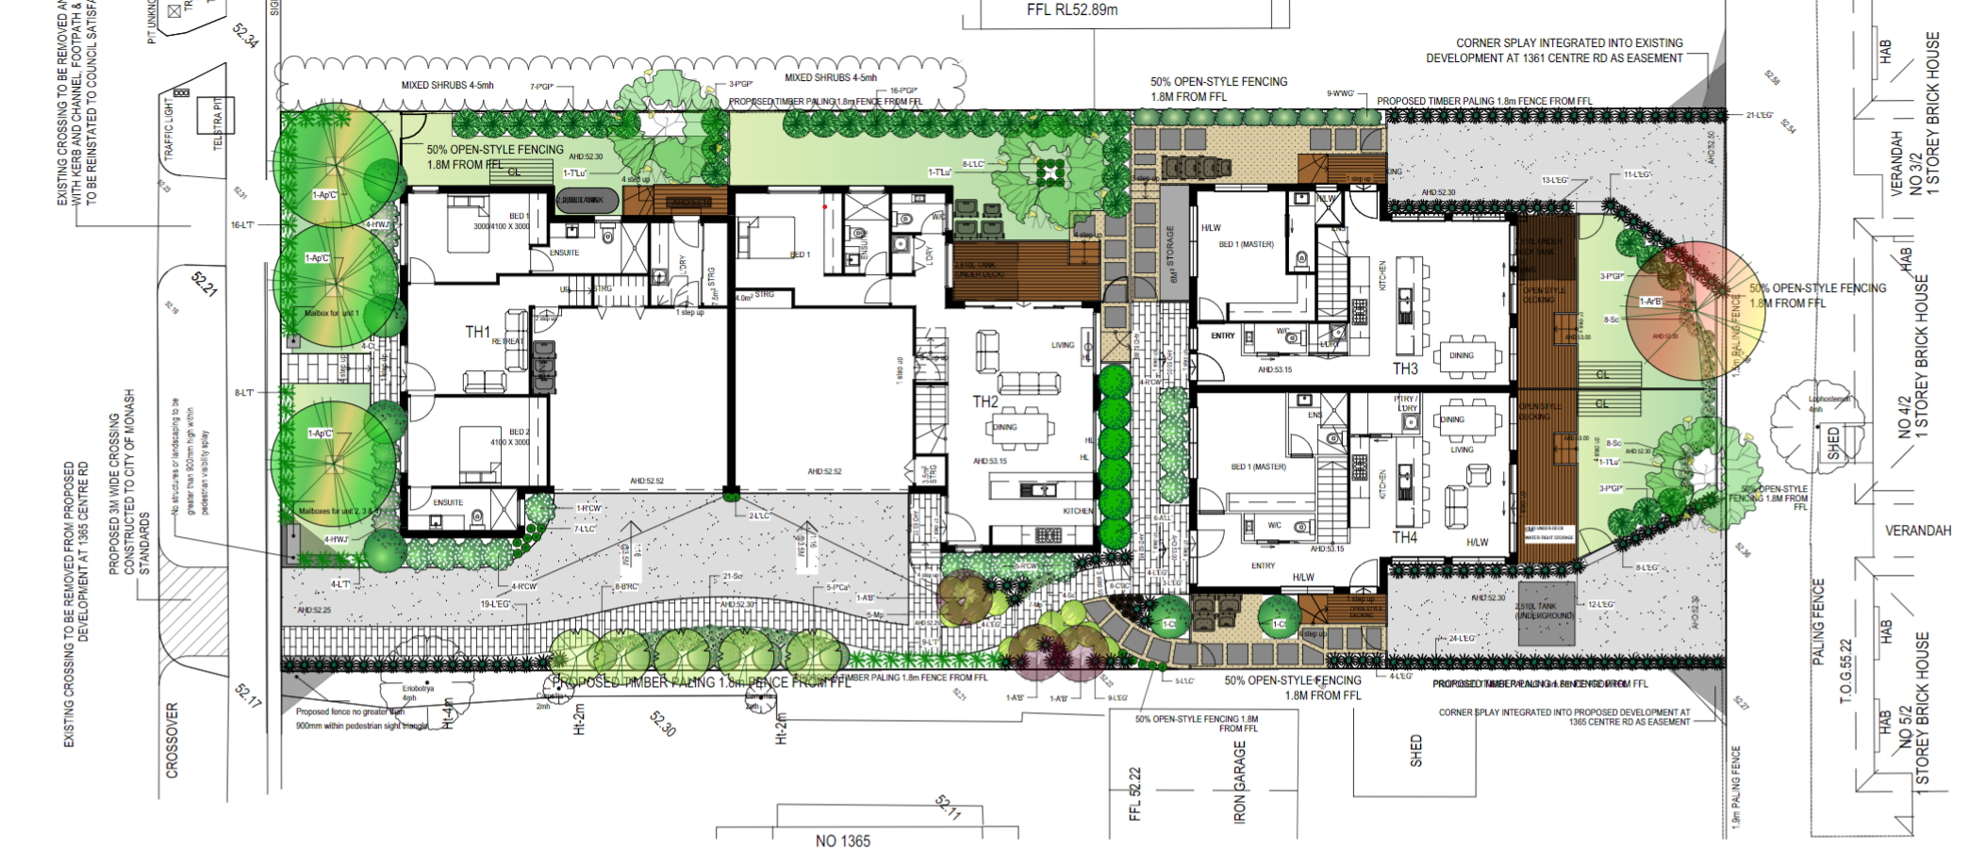

- I am satisfied that the two modules ensure that the development is broken up along the length of the block. Side setbacks are met for the front units, although there is some marginal non-compliance at the very top of the third level for the rear units. The upper levels are recessed and centralised with angled roof forms assisting in reducing visual bulk and creating additional interest. The varied rear setback standard of 4m is met with in the order of 6 metres provided (increasing at each level). This acts to reduce visual bulk to properties on the other side of the laneway with opportunities for landscaping.

Front setback
- Standard B6 is varied in the schedule to the zone to provide for a minimum 4m front setback. The Council says that while this is met the form of the proposed porch/ architectural element reduces the setback in an unacceptable way. Council says that:
It is not a case of simply deleting this framed element. This element is integral in breaking up what is otherwise a flat and bland ground level façade form. This framed element also adds the necessary depth to then allow the first floor balcony and its balustrade to be setback just 4.1m from the frontage. 110. If you remove this framed element, the ground level façade and first floor footprint and balcony present a bland and heavy form. 111. It is submitted this necessary architectural element unreasonably ‘borrows’ from the minimum front setback, and the resulting 3.0m wide landscape zone is insufficient to achieve meaningful canopy tree planting.
- I find that the proposal complies with the varied standard and that the porch/ framed element will not be visually dominant. While the space for landscaping is reduced, the intention shown on the draft landscape plan is for larger trees in the front setback that will have a canopy above the porch/ framing element. No front fence is proposed which will assist opportunities for landscaping. The landscaping is also capable of wrapping around the built form on the western side.

Landscaping
- Having considered the landscaping plan provided (Figure 2), I am satisfied that there is adequate room for canopy tree planting and that the varied Standard B13 can be met. Landscaping can be provided along the eastern boundary. While there is no room between the two modules, this is not required given the impetus for housing diversity in this area.
- I find that the opportunities for landscaping will provide an acceptable response that will be consistent with the outcomes sought by the planning scheme for the area. The plans show several trees of 8 metres rather than the 10m sought by Council. I find that the final species selection and location of plantings can be resolved through secondary consent.

Design Detail
- Council also submits that the materials proposed lack quality. The zone objectives seek high quality design and finish. I am satisfied that the final materials can be resolved through permit condition.
- Council identified an error in the materials schedule referring to ‘heka hood’ window elements while the elevations show this detail is not used anywhere. The applicant notes that this is an error resulting from the amended plans. I find that this can be addressed in the conditions.
- Council also expressed concern about the sense of address provided for Townhouse 3. I find that this is satisfactory and can be addressed by the use of wayfinding signage or identification at the end of the common accessway.

Amenity ConsiderAtions
- Council did not raise any concerns with overlooking, overshadowing or daylight to windows. Each of these aspects are in compliance with the relevant standards set out in Clause 55.
- Visual bulk is generally addressed, noting the generous rear setback, the medical centre to the west and the development site to the east. Even in the absence of an acceptable development on the land at 1365, the location of the vehicle access, garage and shed means that amenity impacts are limited to the existing dwelling.
- Levels of internal amenity are acceptable. Council questioned the non-compliance for Townhouses 3 and 4 at ground level for the dimension of private open space, but each of these units has an alternative first floor balcony.

CAR PARKING AND ACCESS
- The proposal provides two car spaces for each dwelling which complies with the requirements of Clause 52.06. Visitor parking is not provided for a development of this site, and management of the on-street-car parking resource in Burton Avenue is a matter for Council.
- Dwellings 1 and 2 have a standard access arrangement with a single crossover to Centre Road. This is supported by the road authority. At the hearing I expressed some concern about the accessibility of the northernmost car space in the garage for Townhouse 2 without impacting on landscaping. The applicant relies on the swept path analysis provided O’Brien Traffic dated 4 October 2021 that the spaces are acceptable. The garage arrangement for Dwelling 2 relies on the cars being parked in a particular way and the swept path movements come very close to the entry and steps. I consider that the garage opening should be widened /or the accessway modified to provide for more comfortable movements to this space.
- Council’s traffic engineers expressed concern about the proposed paving treatment to distinguish a pedestrian pathway within a shared zone. I find that this could be removed, and a consistent paving treatment provided without impacting on the functionality of this space.
- The vehicular access arrangements and car parking for the rear two units was more controversial. The statement of grounds received by the Tribunal were concerned about the use of the laneway, when historically this was not the case. I am satisfied that although access was not historically taken from the laneway, that this could have been used by a single dwelling on the review site. Several of the units at 2 Burton Avenue appear to be able to access the laneway including the rear unit. The addition of four vehicle spaces and associated movements with access to the laneway is acceptable in this context.
- The laneway is narrow, and manoeuvrability for the two tandem spaces relies on the splays to the adjoining properties. Council’s traffic engineers sought increased setbacks to achieve turning movements. Council submitted that:
The sub-standard rear car parking arrangement for dwellings 3 and 4, with this parking layout failing Clause 52.06-9, being tight, not easy and convenient to use, and in the inability to provide covered parking for what are 4 bedroom family sized dwellings.
- I do not share Council’s concerns about the proposed tandem arrangement Tandem arrangements are common in residential developments and are acceptable. However, both spaces are uncovered. As discussed at the hearing it would be possible to provide carport arrangements for the rear two units to comply with Clause 52.06 and that this was supported by Melbourne Water. I find that this is appropriate given the size and nature of these townhouses. There is sufficient width to provide the carports with little impact on the neighbouring properties.
- In respect to the accessibility of the spaces Council sought a minimum 4.8m wide access aisle width. The applicant relied on the swept path analysis provided in the advice from O’Brien Traffic dated 4 October 2021 which used the proposed splays rather than access aisle width to demonstrate compliance. I find that the proposed car parking will be acceptable. Residents will become familiar with the use of these spaces over time. The conditions will require the easements to be in place prior to the endorsement of plans.
- In considering the appropriateness of the easements, I have had regard to the impact on the potential future development of the adjoining lots and find that the impact is relatively minor and should not significantly impede outcomes consistent with the objectives for the area.

WHAT CONDITIONS ARE APPROPRIATE?
- In determining the conditions of permit, I have had regard to the draft conditions prepared by the responsible authority at the direction of the Tribunal, the submissions of the parties and my findings above.
- I have adjusted the Melbourne Water conditions to remove duplication.
- Council sought that if the laneway is to be used that it be constructed from Burton Avenue to the review site. The applicant considered that the nexus to the development was limited given that benefit of the works would be taken by the other properties that have access to the laneway.
- I agree with Council that it would be preferable for the laneway to be constructed for the amenity of all users. However, I find that the scale of the proposal before me (effectively two dwellings with access) does not justify the requirement to construct the whole of the laneway. I put to the parties the option of requiring construction of the portion of the laneway abutting the review site in the alternative. This was not supported by the Council due to a desire to see a consistent approach. Accordingly, I find that the laneway will be capable of serving the development as presently constructed as it does other properties with access to the laneway.

CONCLUSION
- For the reasons given above, the decision of the responsible authority is set aside. A permit is granted subject to conditions.

Megan Carew
Member

Appendix A – Permit Conditions

Permit Application No | TPA/51570
Land | 1363 Centre Road and part of the land at 1361 and 1365 Centre Road  CLAYTON VIC 3168

What the permit allowS
In accordance with the endorsed plans:
- The development of four (4) dwellings on land in the General Residential Zone and covered by the Special Building Overlay, to create easements and to alter access to a Road Zone, Category 1

Conditions
- Before the development starts, two copies of amended plans drawn to scale and dimensioned, must be submitted to and approved by the Responsible Authority. When approved the plans will then form part of the permit. The plans must be generally in accordance with the plans prepared by Jesse Ant Architects, VCAT Plans, Revision B, dated 23/09/21, but modified to show:
  - Noise attenuation measures to Townhouse 1’s windows.
  - The removal of the internal steps of Townhouse 1’s garage into the laundry or demonstrate that it does not impede parking.
  - The removal of the trough from Townhouse 1’s garage.
  - Bedrooms in Townhouse 2 to be labelled correctly.
  - A consistent paving treatment for the access from Centre Road.
  - A notation confirming of carriageway easement rights over the title of 1361 Centre Road, Clayton and 1365 Centre Road, Clayton in accordance with Condition 20.
  - An amended schedule of materials, finishes and colours including removal of the reference to the ‘heka wood’.
  - Modification of the opening of the garage to Townhouse 2 or redesign of the entry to improve access to the northern car space in this garage.
  - The provision of single carports for Townhouse 3 and 4. The carports are to be designed in accordance with Melbourne Water Condition 9 to take into account the cantilever above and daylight access to the living room windows.
  - The requirements of Melbourne Water in Condition 8.
- The development as shown on the endorsed plans must not be altered without the written consent of the Responsible Authority.

Department of Transport (Conditions 3 to 7)
- Prior to the occupation of the development, a sealed access crossover at least 3.5 metres wide at the property boundary, with the edges of the crossover angled at 60 degrees to the road reserve boundary, at least for the first 3 metres from the edge of the road with 3.0 metre radial turnouts must be constructed to the satisfaction of the Responsible Authority and at no cost to Head, Transport for Victoria.
- Prior to the occupation of the development, all disused or redundant vehicle crossings must be removed, and the area reinstated to the satisfaction of the Responsible Authority and at no cost to Head, Transport for Victoria.
- Prior to the occupation of the development hereby approved, the access crossover and associated works must be completed and available for use to the satisfaction of the Responsible Authority.
- Vehicles must enter and exit the land in a forward direction at all times.
- The level of the footpaths must not be lowered or altered in any way to facilitate access to the site.

Melbourne Water (Conditions 8 to 18)
- Prior to the development plans being endorsed, amended plans must be submitted to Council and Melbourne Water addressing Melbourne Water's conditions. Plans must be submitted with surface and floor levels to Australian Height Datum (AHD) and must show:
  - Finished floor levels of the garage to Townhouse 1 must be set no lower than 52.70 metres to AHD.
  - Finished floor levels of the garage to Townhouse 2 must be set no lower than 52.75 metres to AHD.
  - Finished floor levels of the laundry to Townhouse 1 must be set no lower than 53.10 metres to AHD.
  - Finished floor levels of all Townhouses must be constructed no lower than 53.10 metres to Australian Height Datum (AHD).
- The carports to Townhouses 3 and 4 must be maintained at natural surface levels and 8 constructed as 'open style' with the northern and southern sides 'open' (ie no walls) to allow for the conveyance of floodwaters. No garage door is permitted to the structure.
- A minimum five (5) metre setback measured from a combination of the eastern and western boundary and maintained at natural surface levels free of any obstructions is required for the conveyance of floodwaters.
- The landings located within the five (5) metre setback must be constructed no lower than 53.10 metres to AHD and constructed as 'unenclosed' underneath (ie no plinth boards) to allow for the conveyance of floodwaters.
- Imported fill must be kept to a minimum on the property and must only be used for the sub floor areas of the building and driveway ramps.
- The open space areas within the property must be maintained at natural surface levels and no fill or retaining walls should be used in the development of this land.
- Any new front fence and internal fencing must be open style (50%) of construction and any new side boundary fencing must be timber paling to allow for the conveyance of overland flow.
- Prior to the issue of an Occupancy Permit, a certified survey plan, showing finished floor levels (as constructed) reduced to the Australian Height Datum, must be submitted to Melbourne Water to demonstrate that the floor levels have been constructed in accordance with Melbourne Water's requirements.
- All stormwater collected on the site from all hard surface areas must not be allowed to flow uncontrolled into adjoining properties or the road reserve.
- The private on-site drainage system must prevent stormwater discharge from the/each driveway over the footpath and into the road reserve. The internal drainage system may include either:
  - a trench grate (minimum internal width of 150 mm) located within the property boundary and not the back of footpath; and/or
  - shaping the internal driveway so that stormwater is collected in grated pits within the property; and or
  - another Council approved equivalent.
- All stormwater collected on the site is to be detained on site to the predevelopment level of peak stormwater discharge. The design of any internal detention system is to be approved by Council’s Engineering Department prior to drainage works commencing.
- The nominated point of stormwater connection for the site is to the south-east corner of the property where the entire site's stormwater must be collected and free drained via a pipe to the kerb and channel in the naturestrip via a Council approved kerb adaptor to be constructed to Council standards. Note: If the point of connection cannot be located then notify Council's Engineering Department immediately.
- Concurrent with the endorsement of any plans pursuant to Condition 1 the certificate of title must be altered to show carriage way vehicle access rights over the land at 1361 Centre Road and 1365 Centre Road, Clayton for the splays depicted on the endorsed plans to the satisfaction of the responsible authority.
- Concurrent with the endorsement of any plans pursuant to Condition 1, a landscape plan prepared by a Landscape Architect or a suitably qualified or experienced landscape designer, drawn to scale and dimensioned must be submitted to and approved by the Responsible Authority. The Landscape Plan must be generally in accordance with the landscape concept plan prepared by Zenith Concepts dated October 2021 and is to show:
  - Two large canopy trees with heights of at least 10 metres within the 4.0m wide front setback.
  - One large canopy tree with height of at least 10 metres within the courtyard of Townhouse 2.
  - One large canopy tree with height of at least 10 metres within each of the courtyards of Townhouse 3 and 4.
When approved the plan will be endorsed and will then form part of the permit.
- Before the occupation of the buildings allowed by this permit, landscaping works as shown on the endorsed plans must be completed to the satisfaction of the Responsible Authority and then maintained to the satisfaction of the Responsible Authority.
- Concurrent with the endorsement of plans requested pursuant to Condition 1, a Sustainable Design Assessment (in accordance with Clause 22.13) to the satisfaction of the Responsible Authority must be submitted to and approved by the Responsible Authority. Upon approval the Sustainable Design Assessment will be endorsed as part of the planning permit and the development must incorporate the sustainable design initiatives outlined in the Sustainable Design Assessment to the satisfaction of the Responsible Authority.
- This permit as it relates to development (buildings and works) will expire if one of the following circumstances applies:
  - The development is not started within two (2) years of the issue date of this permit.
  - The development is not completed within four (4) years of the issue date of this permit.
In accordance with section 69 of the Planning and Environment Act 1987, an application may be submitted to the responsible authority for an extension of the periods referred to in this condition.
– End of conditions –

Section 4(2)(d) of the Victorian Civil and Administrative Tribunal Act 1998 states a failure to make a decision is deemed to be a decision to refuse to make the decision.
Permit application No. TPA/51362. Application for Review P1007/2021 yet to be heard by the Tribunal.
The submissions and evidence of the parties, supporting exhibits given at the hearing, and the statements of grounds filed; have all been considered in the determination of the proceeding. In accordance with the practice of the Tribunal, not all of this material will be cited or referred to in these reasons.

