VICTORIAN CIVIL AND ADMINISTRATIVE TRIBUNAL
planning and environment LIST | vcat reference No. P457/2021  Permit Application no. TPA/51996

Applicant | Victor Jibin Huang and Xiaofang Wu

Responsible Authority | Monash City Council
SUBJECT LAND | 6 Hakea Court  MOUNT WAVERLEY VIC 3149
HEARING TYPE | Hearing
DATE OF HEARING | 2 June 2021
DATE OF ORDER | 3 June 2021

Order

- The decision of the Responsible Authority is varied.
- The Tribunal directs that Permit No. TPA/51996 must contain the conditions set out in the permit issued by the Responsible Authority on 24 February 2021 with the following modifications:
  - Condition 1(a) is deleted.

Mary-Anne Taranto
Member

Appearances
For applicant | Mr Robert Easton, town planning consultant
For responsible authority | Ms Sally Moser, town planner

Information
Description of proposal | Two double storey dwellings
Nature of proceeding | Application under section 80 of the Planning and Environment Act 1987 – to review the conditions contained in the permit.
Planning scheme | Monash Planning Scheme
Zone and overlays | General Residential Zone – Schedule 3 (GRZ3)
Permit requirements | Clause 32.08-6 – Construction of two or more dwellings on a lot in the GRZ3
Key scheme policies and provisions | Clause 55
Land description | This irregular shaped site located at the end of a court-bowl has an area of 895sqm as depicted in the following image.  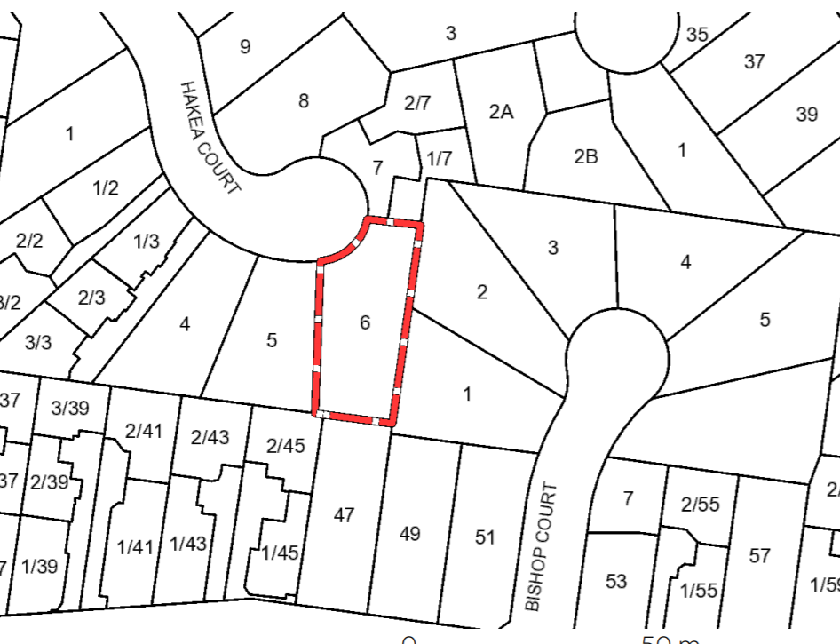

Remarks

Introduction
- This is an application to review one condition on permit TPA/51996 issued by the council on 24 February 2021.
- In dispute is condition 1(a) which requires the deletion of Bedroom 4 from the upper level of the rear of two units proposed on the site.
- The key issues in this case are whether deletion of this bedroom is necessary having regard to:
- overshadowing of SPOS associated with the host unit on its south side;
- overshadowing of the neighbouring dwelling to the west at No. 5 Hakea Court; and
- visual bulk impacts for neighbouring properties.
- Reasons for this decision were given orally at the conclusion of the hearing.

Mary-Anne Taranto
Member

