VICTORIAN CIVIL AND ADMINISTRATIVE TRIBUNAL
planning and environment DIVISION
planning and environment LIST | vcat reference No. P1963/2019  Permit Application no. TPA/25851/D

APPLICANT | Australian Leisure and Hospitality Group Pty Ltd
responsible authority | Monash City Council
SUBJECT LAND | 871 - 881 Ferntree Gully Road, Wheelers Hill
WHERE HELD | Melbourne
BEFORE | Jane Tait, Member
HEARING TYPE | Hearing
DATE OF HEARING | 31 August 2020
DATE OF ORDER | 2 October 2020
CITATION | Australian Leisure and Hospitality Group Pty Ltd v Monash CC [2020] VCAT 1093

Order

Permit granted
- In application P1963/2019 the decision of the responsible authority is set aside.
- In planning permit application TPA/25851/D an amended permit is directed to be issued for the land at 871 - 881 Ferntree Gully Road, Wheelers Hill. The permit is amended as follows:
  - Condition 32 is amended to read:
Unless otherwise agreed to in writing by the responsible authority, live entertainment and/or amplified music or other entertainment, other than background music, shall only be permitted during the following hours:
(a) Sunday - Between 12 midday and 10.30pm.
(b) Thursday - Between 12 midday and 10.30pm.
(c) Friday to Saturday - Between 12 midday and 11pm
  - Insert new Condition 34 as follows:
Prior to the use of the Level 1 deck area to the west building with background music, an acoustic report must be submitted to and approved by the Responsible Authority. The acoustic report must be generally in accordance with the Marshall Day Report dated 7 June 2019 endorsed pursuant to this permit but must be modified to:
        - Account for noise impacts at the approved residential development at 855 - 869 Ferntree Gully Road, Wheelers Hill;
        - Document a noise management level of LAeq 69 dB(A) 1 metre from any deck speaker, and noise management measures including use of a limiter, and sound meter for spot checks;
        - Document results of commissioning acoustic testing of the outdoor sound system, to confirm conformance with SEPP N-2 at all times;
to the satisfaction of the responsible authority. When approved the acoustic report shall form part of the permit.
(c) Condition 34 is renumbered as Condition 35 and amended to read:
No live entertainment or amplified music other than recorded background music in accordance with the approved acoustic report is permitted on the Level 1 deck area to the west building.
  - Condition 37 is renumbered as Condition 38 and amended to read:
The balcony must not be used after 10pm whilst any live and/or amplified music other than background music is being played within the subject premises.
- Conditions in the permit are renumbered accordingly.

Jane Tait
Member

Appearances
For Australian Leisure and Hospitality Group Pty Ltd | Ms Jane Sharp, Counsel for ALH, instructed by Mr Tim Landy, Tucker Partners. She called:  - Ms Bettina Kalt, acoustic consultant, Marshall Day Acoustics Pty Ltd  - Mr Paul Mulquiny, operations manager of ALH venues, including the Wheelers Hill Hotel
For Monash City Council | Mr David Vorcheimer, HWL Ebsworth Lawyers

Information
Description of proposal | To amend condition 34 and 37 of Permit TPA/25851/B to allow background music on the decking of the hotel.
Nature of proceeding | Application under section 77 of the Planning and Environment Act 1987 – to review the refusal to grant an amended permit.
Planning scheme | Monash Planning Scheme
Zone and overlays | General Residential Zone Schedule 5 (GRZ5)  Heritage Overlay Schedule 30 (HO30)  Design and Development Overlay Schedule 5 (DDO5)
Permit requirements | Clause 32.08-12 – Use as a hotel in a GRZ5
Land description | The subject site is located on the north-east corner of Ferntree Gully Road and Jells Road, Wheelers Hill. It is occupied by two buildings that form part of the Wheelers Hill Hotel.  The original weatherboard building is located in the south-west corner of the site and is occupied by Rogue Squire. The upper and lower levels contain seating and a bar.  Land uses to the north and north-east are dwellings within a Neighbourhood Residential Zone Schedule 4 (NRZ4). Directly south is the Monash Art Gallery and to the south-west is an aged care facility that is currently under construction.  To the west of the site is a former gym that is currently vacant but has a planning permit for the construction of 65 dwellings.
Tribunal inspection | The Tribunal conducted a site inspection of the subject and surrounding area prior to the hearing.

Reasons

What is this proceeding about?
- The Australian Leisure and Hospitality Group Pty Ltd (the ‘applicant’) operates Roque Squire and the Wheelers Hill Hotel at 871-881 Ferntree Gully Road, Wheelers Hill in accordance with Permit TPA/25851/B (the ‘planning permit’). It applied to Monash City Council (the ‘Council’) to amend the permit to allow background music on the building’s rear deck with the installation of four speakers.
- Council refused to amend the planning permit on grounds the proposal will lead to an unacceptable loss of amenity to neighbouring residential properties as a result of noise impacts. The applicant has lodged an application to review this decision.
- The applicant acknowledges the introduction of speakers on the outdoor deck for background music for diners may result in an incremental increase in noise to the surrounding area. It argues that no evidence has been presented by Council to indicate this proposal will lead to an unacceptable loss of amenity. It relies on the evidence of its acoustic consultant, Ms Kalk, who recommends the installation of noise limiters on the four speakers to ensure there will be negligible impact on the surrounding residential properties.
- The applicant argues there is no reasonable basis to find the future management of the premises will be inefficient or ineffective. It says the suite of conditions on the permit will ensure that noise impacts from the premises are acceptable. The applicant relies on the evidence of Mr Mulquiny who is the manager. He is confident the venue can continue to meet the conditions on the permit and the recommendations of the acoustic engineer.
- Statements of grounds were submitted from residents nearby that support Council’s ground of refusal. They say they are inconvenienced by patrons after weekend nights and question whether installation of a noise limiting system will be effective.

What is the context of the site?
- The subject site is located on the north-east corner of Ferntree Gully Road and Jells Road, Wheelers Hill. It contains two freestanding buildings that are occupied by the Wheelers Hill Hotel and Rogues Squire. The remainder of the land is used for car parking and landscaping.
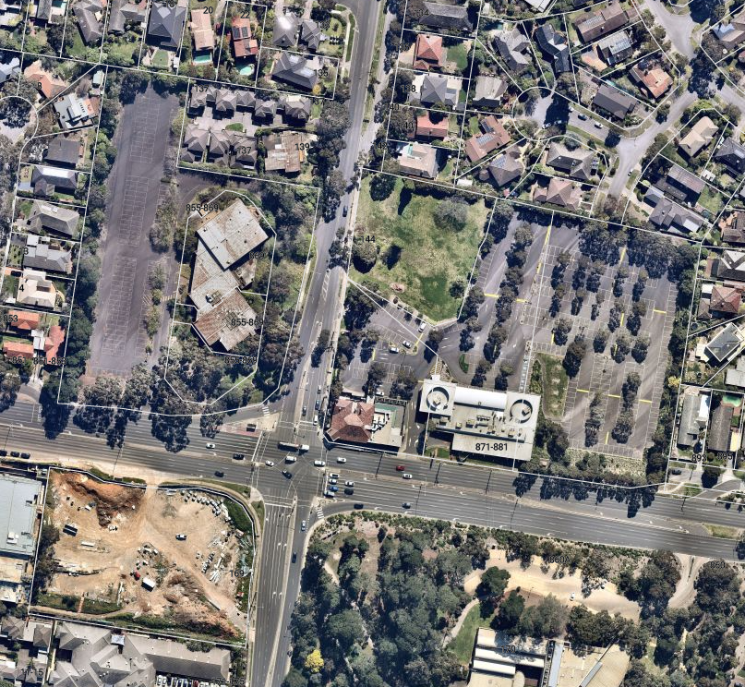
Wheelers Hill Hotel
Rogue Squire
855-869 Ferntree Gully Road
Source: Nearmap (7 Sept 2020)
- The Roque Squire is located in the south-west corner of the site. It is a two storey weatherboard building that contains ground and first floor dining and an outdoor deck abutting the north (rear) and south (front) elevation. The rear deck (as displayed below) is the area where the applicants are seeking to amend the permit to allow background music.
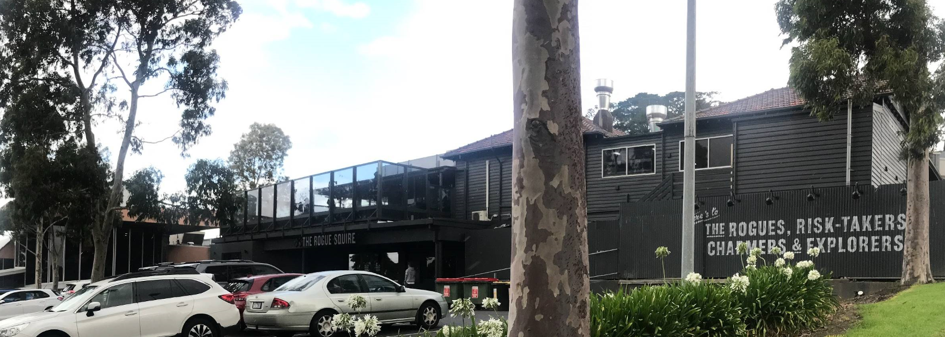
Source: Council site photos
- A feature of this site is the topography of the land. It has a moderate slope to the north that has been utilised for lower level dining with the rear deck above. This upper level deck contains acoustic glazing abutting the side elevations which was required in accordance with a condition on the planning permit.
- The aerial photograph illustrate the interfaces of the subject site. Land to the north and north-east are residential properties within a NRZ4 which are located a minimum of 115 metres from the rear deck. Land on the north-west corner at 855-869 Ferntree Gully Road of Jells Road and Ferntree Gully Road, is currently vacant but was formerly occupied by a gymnasium. A planning permit was issued in July 2019 for 65 dwellings that comprise two and three storey dwellings including some facing Jells Road. This site is located approximately 65 metres from the deck.
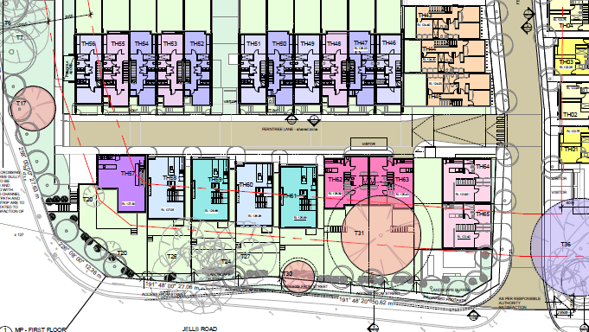
Source: First Floor Master Plan – 855-869 Ferntree Gully Road Council Tribunal Book – TP1.04 – CHT Architects Rev K
- The site also faces an art gallery to the south and an aged care centre to the south-west that is currently under construction that is approximately 85 metres from the deck.

Existing Planning Permit
- Permit TPA/25851/B was issued in June 1999 for redevelopment of the existing hotel. The conditions which are sought to be amended include:
34. No live entertainment or amplified music is permitted to be performed or played on any deck area. This includes any speaker system installed on any deck area directed at patrons outside the building, and all existing external speakers are to be removed from the premises.
37. The balcony must not be used after 10pm whilst any live and/or amplified music is being played within the subject premises.
- Other relevant conditions on the permit relating to the use include:
3. An appropriately calibrated noise limiting system must be installed and maintained on the site at all times. The maximum noise level emitted from the premises must not exceed levels specified in the State Environment Protection Policy (Control of Music Noise from Public Premises) No. N-2.
4. There must be no public address system installed on any deck area directed at patrons outside the buildings.
5. A transparent screen with improved acoustic properties to that located on the existing building must be erected on the new balcony proposed off the new Bistro area. The screen must be installed and maintained to the satisfaction of the Responsible Authority.
6. Unless with the prior written consent of the responsible authority, the provisions and restriction provided for in the current Liquor Licence No 31916034, must be complied with. The maximum number of patrons permitted on the premises must not exceed 1260.
32. Unless otherwise agreed to in writing by the responsible authority, live entertainment and/or amplified music or other entertainment, shall only be permitted during the following hours:
a) Sunday - Between 12 midday and 10.30pm.
b) Thursday - Between 12 midday and 10.30pm.
c) Friday to Saturday - Between 12 midday and 11pm
33. Two security guards, linked by radio, telephone or similar device, shall be provided on site during all amplified/live music events from 10pm until 30 minutes after the amplified music has ceased, to monitor and control the patrons leaving the car park.
35. Prior to the commencement of any live and/or amplified music form the subject premises, written confirmation must be received from Marshall Day Acoustics, confirming all necessary works have been satisfactorily completed/installed to achieve compliance with SEPP N-2 noise provisions.
36. The door to the balcony must be kept closed at all times except for people to access or leave the balcony and must not be propped open at any time, whilst any live and/or amplified music is being played within the subject premises.

Planning Permit History
- The permit was originally issued for redevelopment of the hotel with two conditions relating to music and noise:
Condition 3- No live entertainment or amplified music is permitted to be performed or played on the subject land;
Condition 4- There must be no public address system installed on any deck area directed at patrons outside the building.
- Amended Permit TPA/25851/A was issued in December 2007 to increase the capacity of the venue from 450 to 1260 persons (Condition 6). A second amendment TPA/25851/B was issued in May 2013 at the direction of the Tribunal in Australian Leisure and Hospitality Group v Monash CC [2013] VCAT 2102 (the ‘2013 Decision’). The application was to amend Condition 3 to allow live and/or amplified music on the premises. The Tribunal supported the amendment subject to inclusion of a raft of conditions regulating the use (Conditions 3-6 and 32-37). These conditions included no live or amplified music on Monday to Wednesday, no live or amplified music on the deck area and the door to the deck to remain closed. These conditions were based on the acoustic evidence presented at the hearing.
- A second application was made to amend Condition 32 of the permit to allow additional hours for live and/or amplified music on Thursday to Sunday until 1.00am and additional hours on other days of the week. This application was refused by Council and the decision affirmed by the Tribunal in AHL Property Group Holdings Pty Ltd v Monash CC in October 2015 (the ‘2015 Decision’). At the hearing, residents to the north-west of the subject site explained how there was a history of anti-social behaviour and noise when the site was operating as a nightclub. The Tribunal determined the applicant had not demonstrated that patron behaviour could be managed to protect the amenity of neighbouring dwellings.

How is the Rogue Squire currently used?
- Mr Mulquiny is the operations manager of the premises and says the business focuses primarily on the service of food and a limited bar menu. He says the premises has been converted from a nightclub/live entertainment venue to a restaurant through the removal of the stage, dance floor, speakers and lighting. He says the deck is used for seating, dining tables and booth seating.
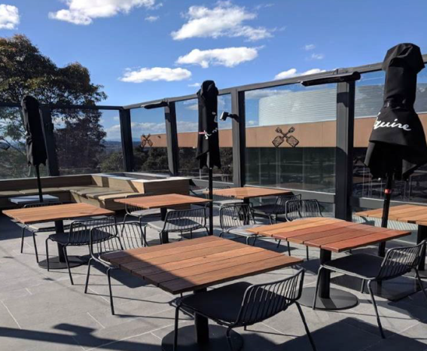
Source; Photograph from evidence statement by Paul Mulquiny – page 3
- Mr Mulquiny advises the venue offers a limited DJ service on Fridays and Saturdays from a playlist that operates during dining times and afterwards through the internal restaurant speakers. He acknowledges that there is sometimes live acoustic music which is played through the in-house speaker system within the building.
- He says the clientele are primarily families and groups of friends wanting to eat together and enjoy craft beer. He says the peak operating time is during lunch and dinner services and the kitchen closes at 10.30pm He says the use closes around 12.30pm when there is usually no more than 15 to 20 people in attendance.
- Two security guards are employed to patrol the car park and premises during the evening in accordance with Condition 33 of the permit.

Why is the Amendment Being Sought?
- Mr Mulquiny submits the sole purpose of the amendment to the permit is to create ambience and atmosphere on the deck whilst patrons are dining. There is no intention to use the premises as a nightclub.

What are the key issues?
- Having considered all submissions and evidence, I find the following key issues in this matter are:
- Does the amendment to the permit respond to its zoning and policy context?
- Will the background music cause unreasonable amenity impacts on neighbouring residential properties?
- Will patrons on the deck result in unacceptable noise impacts?
- The Tribunal must decide whether the proposal achieves an acceptable planning outcome. Clause 71.02-3 requires the decision maker to integrate a range of policies relevant to issues to be determined and balance conflicting objectives in favour of net community benefit and sustainable development.
- Having considered all submissions, evidence and assisted by my inspection, I have decided to set aside Council’s decision as the applicant has tabled evidence to demonstrate that noise levels can meet the required standard in State Environment Protection Policy (Control of Music Noise from Public Premises) No. N-2 (‘SEPP N-2’). I am also satisfied that patron noise can be satisfactorily addressed through the management of the premises, existing conditions on the permit and the implementation of acoustic measures recommended by the acoustic engineer. My reasons follow.

Does the amendment to the permit respond to its zoning and policy context?
- The subject site is located in a General Residential Zone Schedule 5 (GRZ5) that relates to the Wheelers Hill Activity Centre. The decision guidelines for non-residential uses require consideration of whether the use is compatible with residential uses.
- The Local Planning Policy Framework (LPPF) reiterates this theme in the objectives of Clause 22.06 – Wheelers Hill Activity Centre which seeks to enhance and protect the liveability and amenity of residential areas within Wheelers Hill from inappropriate development and land uses. Clause 22.09 – Non Residential Uses in Residential Areas Policy has objectives to ensure the amenity of the neighbourhood is not adversely affected by a business conducted in a residential area.
- Council argues the inclusion of the subject site in a GRZ5 in an activity centre anticipates increased, higher density development, including housing to the west. It says it is inevitable that there will be an increase in sensitive uses in close proximity to the subject site.
- I acknowledge the GRZ5 includes neighbourhood character objectives to promote an increased diversity of housing in the Wheelers Hill Activity Centre which may give rise to increased numbers of sensitive uses nearby. However, the hotel is part of the existing fabric of the activity centre that already has some amenity impacts on the surrounding area. I am satisfied that provided a range of acoustic measures are implemented on the deck, the music and patron noise can be effectively managed through permit conditions. My reasons follow.

Will the background music cause unreasonable amenity impacts on neighbouring residential properties?
- Council argues that Condition 37 on the permit was initially included on the permit as part of the 2013 Decision to reduce the noise levels on residents by preventing use of the balcony after 10pm whilst any live and/or amplified music is being played within the subject premises. It argues that amendment of Conditions 34 and 37 is likely to unreasonably increase noise levels offsite to sensitive residential uses, particularly late at night. It is also concerned the acoustic report does not adequately address the noise impacts on the approved residential development to the north-west at 855-869 Ferntree Gully Road (former gym site). It says this is higher density residential development that is in closer proximity to the deck than other residential properties nearby.
- Council says the existing permit conditions seek to contain noise sources to within the existing building and not extend to the outdoor areas. For example, Condition 36 of the permit requires the door to the balcony to be kept closed when live and/or amplified music is being played within the subject premises.
- Noise emissions from public premises are controlled and assessed in accordance with SEPP N-2. This policy has an objective of protecting people in their own properties and homes from unreasonable interference from music from indoor and outdoor venues, such as hotels.
- The applicant says Council has not provided any evidence that the proposal will lead to unacceptable loss of amenity to neighbouring properties. It argues that compliance with SEPP N-2 can be achieved and relies on the evidence of Ms Kalt. She considers background music on the deck can achieve the requirements of SEPP N-2 provided a music noise limiter is installed on the speakers.
- Her evidence included analysis of the impact of predicted noise levels on nearby sensitive uses, such as the proposed aged care centre, but failed to include the property to the north-west at 855-869 Ferntree Gully Road (former gym site). In submissions, she acknowledged no readings were taken at this site, but predicted maximum noise limit at night time would be approximately 40 Hz. This figure is based on background noise measurements taken at the aged care site in 2012. She said these measurements were used in preference to the 2019 measurements taken for the acoustic report tabled with the application as they were lower and thus were a more conservative approach to assessment.
- I am satisfied that background music on the deck can meet with SEPP N-2 requirements for night-time music noise limits. I have come to this conclusion based on Ms Kalt’s evidence this can be achieved through the implementation of her recommendation to install a music noise limiter as a condition of approval. I accept her opinion that this is a very effective means of controlling music as it limits the volume and it is contained within a tamper-proof enclosure. I acknowledge that her assessment fails to take into account the former gym site but her submissions lead me to the conclusion that these future dwellings will not be subject to music levels above the SEPP N-2 requirement.
- I also note there is an existing acoustic screen around the rear deck that is required in accordance with Condition 5 of the permit that also restricts sound from this area.

Will patrons on the deck result in unacceptable noise impacts?

Patron Noise
- Council argues the proposal may result in an unacceptable increase in patron noise levels that has not been adequately addressed by the applicant. It says that whilst noise limiting devices can be installed to address background music noise, careful management is required to protect the amenity of the surrounding residential area from patron noise. It submits the site has a history of noise related complaints and anti-social behaviour and therefore increased activity on the deck is inappropriate having regard to the zoning of the land and proximity to the adjoining residential properties.
- Council also submits that consumption of alcohol on the deck is likely to be associated with noise such as social chatter and the introduction of background music will exacerbate the tone and volume of chatter.
- The applicant relies on the evidence of Ms Kalt. She acknowledges that patron noise is not covered by any State Environment Protection Policy or general Victorian guideline. Therefore, her acoustic company has developed a set of design targets that are defined separately for day, evening and night periods on the basis of background noise levels. These targets and/or noise limit criteria have been accepted in other Tribunal decisions.
- Ms Kalt said a background music level is defined as a level that enables patrons to conduct a conversation at 600mm without having to raise their voice a substantial degree. This was defined in Whiting v Hosier Bar Pty Ltd (Occupational and Business) [2005] VCAT 814.
- Ms Kalt acknowledges that noise from patrons associated with dining and licensed venues is highly variable and includes a wide range of factors. These include type of venue: (i.e. dining or standing areas), numbers, demographics, weather, alcohol consumption, background noise levels and acoustic properties of the space. Her company has developed four broad categories of venue type: vertical drinking, taverns with significant food offerings, restaurant dining and small smoking areas.
- Ms Kalt says the target for patron noise is a maximum noise level of 65 dB for short term night noise levels and 45 dB for the night time period. Her assessment is based on a maximum of 146 patrons on the deck, including 93 seated and 40 standing patrons.
- Ms Kalt’s assessment of the predicted noise levels at nearby dwellings indicated all properties were below the maximum patron noise levels and short term maximum criteria based on a ‘vertical drinking’ patron category. However, she acknowledges patron noise may be marginally above the maximum 65 dB limit for some of the future town houses at the gym site (i.e. 67 dB). She says that she is not concerned about this level of exceedance as she has applied the worst case category of ‘vertical drinking’, which has the highest noise levels. She considers a more accurate description of the use would fall within the ‘restaurant dining’ category which will generate lower patron noise and thus comply with the short term maximum criteria.
- I am satisfied that patron noise from the deck will not cause unreasonable impacts on nearby residential uses, including the future townhouses at the gym site. I have come to this conclusion as Ms Kalt’s evidence shows the predicted noise generated by the patrons is likely to fall within ‘restaurant’ or ‘tavern with significant food offering’ categories which have lower noise levels than vertical drinking.
- From my site inspection and photographs submitted by the applicant, the deck appears to be primarily used for dining or seated consumption of alcohol which is different from ‘vertical drinking’. I also observed the deck has an existing glazed screen around the perimeter that is designed to reduce patron noise in accordance with a previous acoustic report for the 2013 Decision. I note that Ms Kalt’s assessment is based on a maximum of 146 patrons on the deck, which is highly conservative. The applicant says this deck can accommodate a maximum of 80 people which is set aside for tables, chairs and booth seating. I agree with the applicant that the deck is unlikely to be used for ‘vertical drinking’ given its primary use is dining with alcohol.
- In the absence of any evidence to the contrary, I accept Ms Kalt’s assessment that introduction of background music on the deck will not have any significant impact on the level of patron noise currently generated in this area and the impacts on neighbouring residential properties will be acceptable.

Venue Management
- Council submits that whilst the premises is now a brewhouse/restaurant, it still fits within the definition of a hotel. It notes Rogue Squire advertises the venue is available for events such as Christmas and birthdays and therefore caution should be applied to this amendment. This would be consistent with the approach taken by the Tribunal in the 2015 Decision given its past history of complaints.
- Council says that inclusion of background music will increase use of the deck after 10.00pm. It says that Condition 37 of the permit currently restricts use of the deck after 10.00pm whilst live or amplified music is playing within the premises. It says the amendments to the conditions may result in increased use of the deck until 1.00am which will increase patron noise late at night.
- The current liquor licence allows the service of alcohol until 1.00am on Thursdays to Sundays, 12 midnight on Mondays to Wednesdays and 11.00am on Sundays. I fail to see how the introduction of background music will increase use of the deck throughout the evening as it already contains seating that can be used by patrons until 1.00am on Thursdays to Sundays. Therefore, there is already potential for patron noise emanating from this deck during the late evening without background music. I also note this application is not seeking to change the hours of operation beyond those already permitted in the liquor licence.
- The applicant argues the site is no longer operating as a nightclub which was the source of complaints in the past. It says there has been no complaints since the restaurant commenced operation in 2018. The applicant submits the site is a well-managed venue and the history of past complaints should not be determinative in the current proposal. It submits there is no intention to reinstate the night club use, particularly given that Condition 32 on the permit restricts the hours of operation of live entertainment to 11.00pm on Fridays and Saturdays.
- The applicant relies on the evidence of Mr Mulquiny who is the operations manager of the facility. He has the responsibility for the day to day operation of the use, including staffing, security, and complaints management. He emphasised there have been no noise complaints lodged since the refurbishment of the venue in 2018. He explained the use operates in accordance with the conditions on the planning permit as it employs two security guards that patrol the car park, deck area and restaurant throughout the evening. He also says there is a complaint handling procedure implemented by the company that requires the operations manager to follow up on all negative feedback.
- Mr Mulquiny says the sole purpose of the music is for ambiance. He says the music will be specifically selected for this purpose to create a relaxing atmosphere for patrons. He submits that he understands the recommendations of the acoustic report and evidence and he is confident the recommendations will be met.
- I agree with Council that careful management is required to protect the amenity of the surrounding residential area. This was the basis of the 2013 decision that included a raft of conditions on the permit to address residential amenity. For example, the inclusion of the transparent screen on the deck (Condition 5), no public address system on the deck (Condition 4) and two security guards monitoring the car park (Condition 33). These conditions, in conjunction with compliance with SEPP N-2, have contributed to the operation of this use without compliant since Roque Squire converted the premises to a food based operation.
- I acknowledge there are existing use rights for a hotel on this site. However, I am satisfied the building is not likely to be converted back into a nightclub given the internal layout and lack of infrastructure for this purpose.
- I do not agree with the applicant that the use is primarily a restaurant. Given the business includes a brewhouse, Mr Mulquiny agreed that some patrons frequent the venue for the consumption of alcohol and not the food offerings. However, I am satisfied the venue is primarily geared for meals and that problems associated with the former use as a nightclub are unlikely to occur.
- I am satisfied management of the venue and the conditions on the permit will ensure noise from the deck by patrons can be adequately managed to prevent unreasonable amenity impacts on nearby residents.

What conditions are appropriate?
- Whilst this application is to amend Condition 34 and 37 of the permit, Council included amendments and additional conditions to address its concerns.
- Condition 32 relates to hours of operation of live entertainment and/or amplified music. This condition was amended to insert reference to ‘other than background music’ to allow background music on the deck in accordance with the liquor licence hours. The applicant agrees this clause should be inserted into the condition.
- Council included a new Condition 34 to reflect the recommendations of acoustic report submitted with the application (i.e. Marshall Day Report dated 7 June 2019) and included further recommendations that relate to the development at 855-869 Ferntree Gully Road (the gym site). The condition also requires documentation of the noise management levels of the speakers through use of a noise limiter, sound meter and spot checks. Another inclusion was the commissioning of acoustic testing of the outdoor system to confirm conformance with SEPP N-2 at all times.
- The applicant agrees to these additional requirements in Condition 34. However it queries the inclusion of a requirement for measures to manage patron noise to be consistent with a restaurant use. I consider this condition is vague and will be difficult to assess. I will delete it from the permit as the other clauses in the condition deal with noise associated with the speakers.
- Council also requested that a condition be included to restrict patron noise measures in accordance with the acoustic evidence. I am not prepared to include this condition as I am satisfied the existing conditions on the permit will effectively manage patron behaviour.

Conclusion
- For the reasons given above, the decision of the responsible authority is set aside and an amended permit is granted.

Jane Tait
Member

The submissions and evidence of the parties, any supporting exhibits given at the hearing and the statements of grounds filed have all been considered in the determination of the proceeding. In accordance with the practice of the Tribunal, not all of this material will be cited or referred to in these reasons.
Saint Kilda Pty Ltd v Yarra CC (Correction) [2014] VCAT 676, MacRiver Pty Ltd v Yarra CC [2017] VCAT 1123 and Buckingham Drive v Banyule CC [2018] VCAT 1285.

