VICTORIAN CIVIL AND ADMINISTRATIVE TRIBUNAL
planning and environment DIVISION
planning and environment LIST | vcat reference No. P1379/2019  Permit Application no. 49896
CATCHWORDS
Section 77 of the Planning & Environment Act 1987; Monash Planning Scheme; General Residential Zone Schedule 3; Vegetation Protection Overlay; Multiple dwellings; Policy; Neighbourhood Character; Amenity Impacts

APPLICANTS | Yunkai Sun and Li Ling
responsible authority | Monash City Council
Referral Authority | VicRoads
RESPONDENTS | Evangelia Michailidis and others
SUBJECT LAND | 531 Waverley Road, Glen Waverley
WHERE HELD | Melbourne
BEFORE | Katherine Paterson, Member
HEARING TYPE | Hearing
DATE OF HEARING | 24 January 2020
DATE OF ORDER | 10 February 2020
CITATION | Sun v Monash CC [2020] VCAT 144

Order
- Pursuant to clause 64 of Schedule 1 of the Victorian Civil & Administrative Tribunal Act 1998, the permit application is amended by substituting for the permit application plans, the following plans filed with the Tribunal:
- Prepared by: | Jesse Any Architects
- Drawing numbers: | TP00 to TP13
- Dated: | 6 December 2019
- In application P1379/2019 the decision of the responsible authority is set aside.
- In planning permit application 49896 a permit is granted and directed to be issued for the land at 531 Waverley Road, Glen Waverley in accordance with the endorsed plans and the conditions set out in Appendix A. The permit allows:
- The construction of three dwellings on a lot.
- The alteration of access to a road in a Road Zone Category 1.

Katherine Paterson
Member

Appearances
For applicants | Mr Andrew Clarke, Town Planner, Clarke Planning. He called the following expert witness:  - Mr Michael Rogers, Arborist, John Patrick and Associates
For responsible authority | Mr James Turner, Monash City Council
For referral authority | No appearance
For respondents | Ms Maria Pantelakakis

Information
Description of proposal | Construction of three dwellings. Two of the dwellings are proposed to be attached, and will be three stories in height, including a semi basement garage containing two spaces per dwelling. These dwellings will contain three bedrooms and include living areas over two levels. The third dwelling is located at the rear of the site and will contain four bedrooms over two levels. Vehicle access to all three dwellings is provided by a single crossover to Waverley Road. The architectural style of the dwellings incorporates pitched tiled roofs and rendered and coloured brickwork. All existing vegetation on site is to be removed to accommodate the development.
Nature of proceeding | Application under section 77 of the Planning and Environment Act 1987 – to review the refusal to grant a permit.
Planning scheme | Monash Planning Scheme
Zone and overlays | General Residential Zone Schedule 3, Vegetation Protection Overlay Schedule 1. Waverley Road is within a Road Zone Category 1.
Permit requirements | Clause 32.08-6 – Construct two or more dwellings on a lot.  Clause 52.29-2 – Alter access to a road in a Road Zone Category 1.
Land description | The subject site has an area of 653.8 square metres and contains a single storey brick dwelling, as well as some garden plantings, none of which are considered to be significant. The site has a fall of approximately 3 metres from the front to the rear.
Tribunal inspection | 3 February 2020
Cases referred to: | Bell v Monash CC [2019] VCAT 1782 (12 November 2019)

Reasons

What is this proceeding about?
- Yunkai Sun and Li Ling wish to construct three dwellings on land at 531 Waverley Road, Glen Waverley. Following Council’s decision to refuse to grant a planning permit, they have requested that the Tribunal review this matter.
- Council refused the application on a number of grounds, but a primary concern is that the proposal is inconsistent with the neighbourhood character of the area and the parking requirements of the Monash Planning Scheme. They are also concerned that the provision of balconies for the secluded private open space will provide a poor level of internal amenity and will not provide sufficient space for landscaping.
- A number of nearby residents share Council’s concerns but are also concerned that the development of three dwellings on this site is an overdevelopment of the site, and the setbacks of the proposal are insufficient, resulting in visual bulk when viewed from the adjoining properties. They are also concerned that the dwellings will overlook the adjoining properties.

What are the key issues?
- Having considered all the submissions and evidence and inspected the subject land and its locality, I consider the key issues in this proceeding are:
- Is the proposal to construct three dwellings on this site supported by planning policy?
- Is the proposal respectful of the neighbourhood character?
- Does the proposal create unacceptable amenity impacts?
- Will the proposal have an unreasonable impact on the neighbouring trees?
- Are the parking and access arrangements acceptable?
- Will the proposal provide an acceptable level of internal amenity?

Summary of findings
- I have decided to grant a permit for the following reasons:
- The proposal is consistent with policy expectations for development within this area;
- The proposal is an acceptable response to the preferred neighbourhood character, including landscaped character;
- With the changes I have made, I am satisfied that the proposal will not result in any unreasonable impacts on the amenity of adjoining properties;
- With the changes I have made, I am satisfied that the proposal will not have an unreasonable impact on the health and viability of the neighbouring trees;
- I am satisfied that the parking and access arrangements are acceptable, having regard to the requirements of Clause 52.06 and the Australian Standards; and
- The proposal will provide an acceptable level of amenity for the future occupants of the dwellings.
My reasons follow.

Is the proposal to construct three dwellings on this site supported by planning policy?
- It is state planning policy to create mixed-use neighbourhoods at varying densities, including through the development of urban-renewal precincts that offer more choice in housing, create jobs and opportunities for local businesses and deliver better access to services and facilities.
- Plan Melbourne, a reference document within the scheme, provides a map of land included within the Monash National Employment and Innovation Cluster (NEIC). The subject site is located on the outer edge of the NEIC, as shown in the extract from Plan Melbourne:
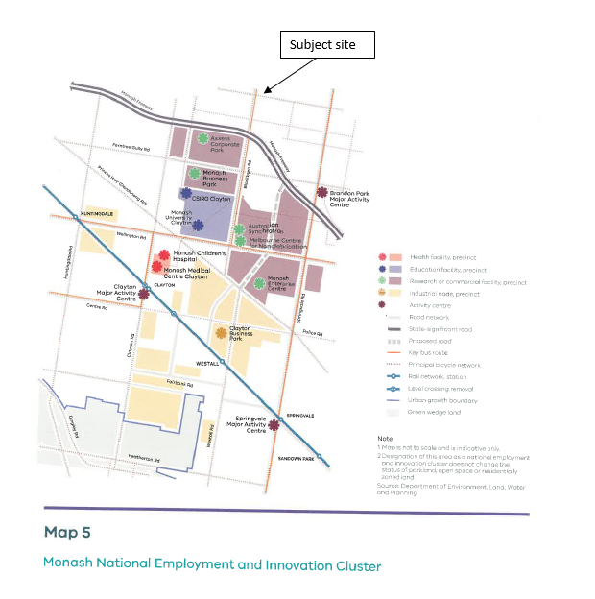
- Clause 11.01-1R states that Melbourne’s NEIC’s are to be a key focal point for investment and growth. This is complemented by the polices at Clause 16.01-2R of the scheme which seeks to facilitate increased housing in established areas to create a city of 20 minute neighbourhoods close to existing services, jobs and public transport.
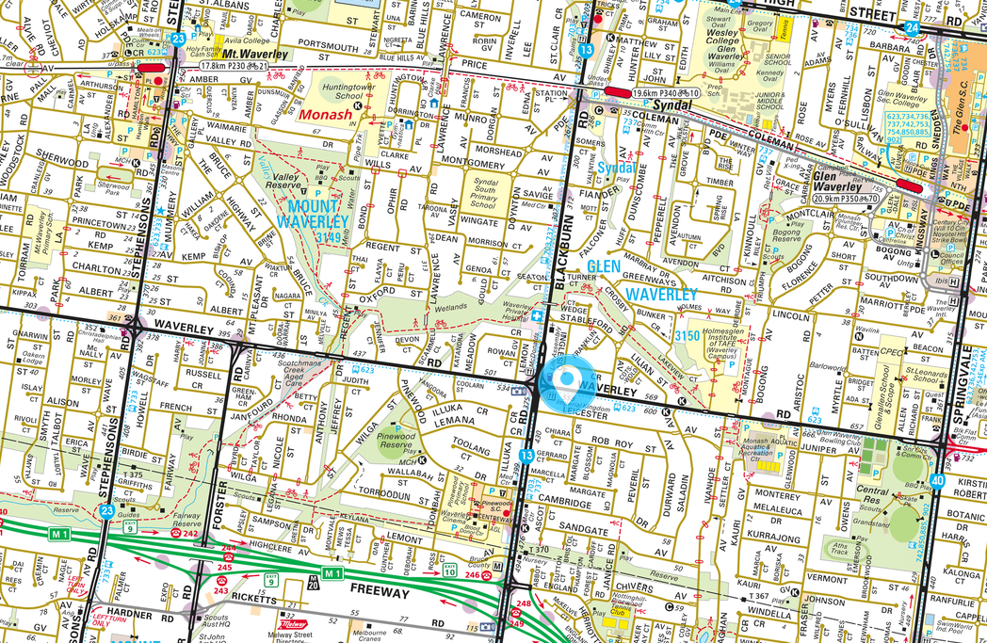
- The above extract from Melways Online, shows the number of services located in proximity to the subject site, which is located approximately 550 metres (or an 8 minute walk) from the Pinewood Shopping Centre, and a mere 14 metres from commercial uses are positioned on all four corners of the intersection of Waverley and Blackburn Road. Nearby public transport is in the form of buses, including a bus service that operates along Waverley Road linking the site with Glen Waverley and St Kilda, as well as Mount Waverley Train Station. The nearest train station is Syndal Train Station, which is located approximately 1.3 kilometres from the subject site, or a 16 minute walk. I find that due to its location, it is a site that is strongly encouraged by planning policy for more intensive housing forms.

Local Planning Policy
- Clause 21.01 -1 of the Monash Planning Scheme states that the population of Monash is expected to increase by over 26,000 to over 215,000 between 2016 and 2031, and this increase in population will drive demand for an additional 10,000 new dwellings for the municipality during this period. Clause 21.01-3 of the scheme directs new residential growth to neighbourhood and activity centres, the Monash NEIC and the boulevards (Springvale Road and Princes Highway). At the same time, a key focus of planning policy is to ensure that Monash’s Garden City Character is maintained and enhanced.
- Clause 21.04-1 states:
Monash is committed to managing residential growth to ensure it is directed to neighbourhood and activity centres that are well serviced by public transport, retailing, community facilities and employment opportunities. A significant opportunity exists to increase residential densities around the Monash National Employment Cluster to provide housing close to jobs. Some potential is also available to provide higher density development along the boulevards (Springvale Road and Princes Highway). This will reduce development pressure on less accessible locations allowing their garden city character to be preserved. Residential growth within those areas identified to be of special character, such as the heritage precincts and the creek environs will be further restricted, to ensure this character is protected and enhanced.
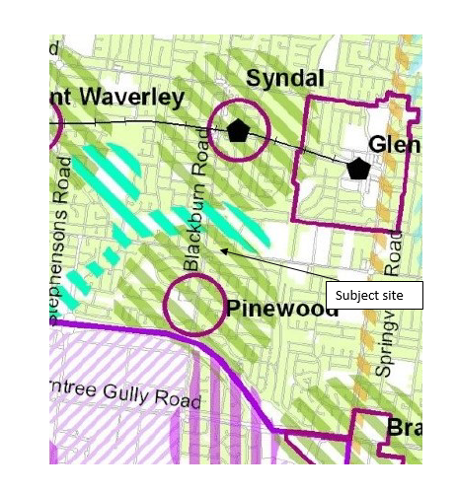
- As shown in the above extract from the housing strategy included at 21.04-1 of the scheme, the site is within an accessible area, due to its proximity to the Pinewood Activity Centre. The northern boundary of the NEIC is shown on the map to be the Monash Freeway, which is approximately 950 metres from the site.
- Housing strategies include:
- Direct more intensive, higher scale development to neighbourhood and activity centres that are well serviced by public transport, commercial, recreational, community and educational facilities.
- Support substantial residential growth within the Monash National Employment Cluster to provide housing closer to where people work and study.
- Allow some residential growth along those parts of the boulevards (Springvale Road and Princes Highway) that can support higher scale development in terms of neighbourhood character and accessibility.
- Provide an appropriate built form transition between activity centres and residential areas through innovative and high quality architectural design, appropriate setbacks and landscaping.
- Clause 21.04-1 is generally silent as to what development is anticipated for the accessible areas however, based on the above strategies it is clear that the greatest levels of development are expected within the neighbourhood and activity centres, NEIC and the boulevards, with the accessible areas serving as a transition in form to the residential areas shown as ‘garden city suburbs’ or creek environs.
- This approach is consistent with the Monash Housing Strategy 2014, which is listed as a background document at Clause 21.04-1, and includes the following in its description of the accessible areas:
Future Character: | The areas surrounding the centres will form a transition between the activity centres, which are intended to be areas of higher density development (residential and commercial), and the Garden City Suburbs (Category 7) which will continue to be occupied by more traditional forms of residential development.  These areas will provide for a diverse range of housing types while retaining key aspects of the existing built form and landscape character of the area. Improved building design and quality will be encouraged to maximise the comfort for future residents (and neighbours) as well as minimising running and maintenance costs.
Residential Outcomes: | Transition in residential density from the interface with surrounding residential areas to the boundary of the Activity Centre.  Lower density unit and townhouse style developments at the interface with surrounding residential areas.  Potential for apartment development in context with the scale of development of the Activity Centre, at the interface with the Activity Centre subject to careful design.  On larger sites, in suitable locations, increased density may be appropriate, subject to careful design and the provision of appropriate landscaped setbacks.
- I find that this proposal, for three townhouse style dwellings, two of which are in an attached form and three storeys in height, is generally consistent with the built form outcomes envisaged by planning policy for the accessible area.
- Clause 21.04-1 of the scheme was recently amended through part 2 of amendment C125 to the Monash Planning Scheme. This amendment had a long history but was finally gazetted on 14 November 2019. In my decision in Bell v Monash CC [2019] VCAT 1782 (12 November 2019), I outlined some of this history.
[15] Amendment C125 originally proposed to include the subject site within a General Residential Zone Schedule 4 (GRZ4). The planning panel for the amendment recommended that this zone be combined with the proposed General Residential Zone Schedule 3 (GRZ3), with a revised schedule.
[16] Council agreed with the combining of the GRZ3 and GRZ4 zones but did not agree with all of the Panel’s recommendations with respect to the content of the schedule. The adopted schedule, which is now before the Minister for Planning for final approval, has altered the Panel’s recommendations for front setbacks, landscaping, private open space and front fences.
[17] On the 25 February 2018 the Minister for Planning wrote to Monash City Council advising that Amendment C125 would be split into two parts. Part 1 has been approved and gazetted. Part 2, which included the revised General Residential Zone, required further work;
I consider Part 2 requires further strategic work on the council's application of the GRZ. The adopted GRZ features a 9-metre-high discretionary building height control. This approach is no longer possible due to changes to the Victoria Planning Provisions introduced by VC110. Consequently, the council should review the application of the zone. In locations where the council is trying to maintain lower-scale residential development and character, the NRZ may be more appropriate. In other locations, such as in and around activity and neighbourhood centres, accessible areas and along boulevards where the council's housing strategy is identifying the need for further growth, a GRZ or even a RGZ may be more appropriate. Therefore under Section 32 of the Act, I direct the council to give more notice of Amendment C125 (Part 2) where it seeks to change the zone from GRZ to NRZ or GRZ to RGZ and comply again with sections 21 to 31, which relate to all matters after the giving of notice.
[18] On 27 March 2018, Monash City Council requested that the Minister approve Part 2 of the amendment as previously adopted by Council. The Tribunal is unaware if there have been any further discussions between Council and the Minister for Planning as to the proposed amendment, and in particular the proposed GRZ3. Given the circumstances of the amendment, I find I cannot consider the proposal to rezone the land to GRZ3 as seriously entertained, and I have not given the proposed zoning any weight in my decision.
- Council advised at the hearing that when the amendment was gazetted on 14 November 2019 (two days following the Bell decision), it was done so on the basis that further strategic work would be undertaken for the accessible areas. In the meantime, the General Residential Zone Schedule 3 (GRZ3) was applied to the accessible areas. Council submitted that as the accessible areas will be subject to further strategic work, I should completely disregard the current policy provisions relating to the accessible areas. With respect, the Tribunal cannot take this approach. The Tribunal must consider the application based on the provisions of the scheme at the time the decision is made, which includes the policies at Clause 21.04-1.
- The site has been included within the General Residential Zone Schedule 3, the objectives of which include encouraging a diversity of housing types and housing growth particularly in locations offering good access to services and transport. Development outcomes therefore need to be considered in light of the site’s inclusion within an accessible area, which immediately lends itself to more intensive forms of housing. Even if this provision wasn’t in the scheme, the locational attributes of this site, particularly its proximity to the Pinewood Activity Centre and position on a main road near commercial uses and public transport would remain.
- The Tribunal notes that the amended schedule that has been included in the GRZ3 through Amendment C125 Pt 2 is generally consistent with the panel’s recommendations. In particular, the minister has included the use of balconies as secluded private open space for dwellings. As such, the development of ‘reverse living’ style dwellings, such as those proposed by the application, are anticipated to be established within the GRZ3 areas. Whether such dwellings are acceptable on a site, as always, will come down to an assessment of a development’s design response to its specific context, including neighbourhood character, impacts on the amenity of neighbouring properties and internal amenity. I consider each of these aspects in my decision.

Is the proposal respectful of the neighbourhood character?
- The objectives of the General Residential Zone Schedule 3 include:
To encourage development that respects the neighbourhood character of the area.
- Clause 55.02-1 of the scheme requires a development to ensure that the design respects the existing neighbourhood character or contributes to a preferred neighbourhood character. The schedule to the GRZ3 includes the following neighbourhood character objectives:
- To support new development that contributes to the preferred garden city character through well landscaped and spacious gardens that include canopy trees.
- To promote the preferred garden city character by minimising hard paving throughout the site by limiting the length and width of accessways and limiting paving within open space areas.
- To support new development that minimises building mass and visual bulk in the streetscape through generous front and side setbacks, landscaping in the front setback and breaks and recesses in the built form.
- To support new development that locates garages and carports behind the front walls of buildings.
- Clause 22.01 –Residential Development and Character Policy provides design guidelines for residential development and divides the municipality into various character types, with the subject site included within the Garden Suburban Northern Areas. The preferred character statement for this precinct is:
Although there will be changes to some of the houses within this area, including the development of well-designed and sensitive unit development and, on suitable sites, some apartment development, these will take place within a pleasant leafy framework of well-vegetated front and rear gardens and large canopy trees.
Setbacks will be generous and consistent within individual streets. Building heights will vary between neighbourhoods. Neighbourhoods with diverse topography and a well-developed mature tree canopy will have a larger proportion of two storey buildings. In the lower, less wooded areas, buildings will be mainly low rise unless existing vegetation or a gradation in height softens the scale contrast between buildings. New development will complement the established buildings through consistent siting, articulated facades and use of materials. New development will consider energy efficiency and sustainability principles. Long expanses of blank wall will be avoided, particularly when adjacent to public parks, reserves and other open space areas, where the building should address the public area.
Architecture, including new buildings and extensions, will usually be secondary in visual significance to the landscape of the area when viewed from the street. New development will be screened from the street and neighbouring properties by well planted gardens that will ensure the soft leafy nature of the street is retained.
Gardens will consist of open lawns, planted with a mix of native and exotic vegetation and trees.
Existing mature trees and shrubs will be retained and additional tree planting within streets and private gardens will add to the tree canopy of the area.
Buildings will be clearly visible through these low garden settings, and nonexistent or transparent front fences. Additional vehicle crossovers will be discouraged.
The built-form will be visually unified by well-planted front gardens that contain large trees and shrubs and street tree planting. Trees within lots to be redeveloped will be retained wherever possible to maintain the established leafy character.
Landscape elements such as remnant indigenous vegetation and the large old coniferous wind-rows will be retained until trees are no longer healthy or safe.
- It is clear that Clause 22.01 anticipates a level of change within the Garden Suburban Northern Areas, including the establishment of some apartment buildings. I find that the development of attached townhouses in this location is consistent with this direction.
- The front and rear setbacks meet the minimum standards of the schedule to the zone, and the landscape plan submitted with the application indicates that the resulting area is enough for the planting of seven canopy trees, four more than required by the schedule to the zone for this site. Four of the proposed trees are to have a mature height of at least 12 metres, considerably taller than the maximum building height of 8.3 metres. The result will be that the built form will be set within landscaped front and rear gardens, which I find will assist in achieving the garden city garden character desired by the scheme.
- The application proposes a maximum height of 8.35 metres above NGL in a three storey form or at 116.15AHD. The adjoining dwellings at 533 and 529 Waverley Road are shown on the plans to have a maximum height of 116.19 and 114.61AHD respectively. As such, the proposed height of the dwellings is consistent with the adjoining dwellings, despite the increase in the number of storeys from 2 to 3 to accommodate the semi-basement garage. I find a three storey proposal is acceptable on this site, given its main road context and location opposite commercial uses.
- With respect to design, the development does incorporate the use of almost sheer walls, however, this is consistent with the residential neighbourhood character of the area, as the many dwellings that front Waverley Road are large two storey brick dwellings that incorporate the use of sheer walls. It is also consistent with the style of the commercial buildings located within proximity to the site. The use of brick walls and tiled concrete pitched roofs will further ensure that the design of the proposed dwellings is generally consistent with those found in the area.
- Council was critical of the setbacks of the development from the side boundaries, which they submitted were insufficient to provide for landscaping to achieve the garden city character. Firstly, I note that the schedule to the GRZ3 emphasises the role of planting within the front setback, rather than on side boundaries, which is further supported by the variation to the front setback requirements of Clause 55. The schedule does not vary the side setback requirements of Standard B17 of Clause 55.04-1, which are comfortably complied with at ground level. The proposed side setbacks closely reflect the setbacks of dwellings in the area, the majority of which are constructed closely to side boundaries, with most dwellings constructed to at least one side boundary. The landscape plan indicates that the proposed side setbacks are enough for the provision of some landscaping along both side boundaries, including the planting of two eight metre Blueberry Ash trees adjacent to the accessway for dwellings one and two. I am satisfied that the side setbacks are consistent with the neighbourhood character of the area and will assist in achieving the garden city character desired by the scheme.
- A key concern of Council is the extent of hard paving shown on the site to provide access to the basements for dwellings one and two. To limit access to Waverley Road, which is a Category 1 road with mature canopy trees, the application provides only a single crossover for the development, with vehicles accessing the basement via the rear of the front two dwellings. This arrangement requires a significant amount of paving within the middle section of the site. Therefore, whilst there is a separation between the dwellings and the front and the rear, there is little ability for the centre of the site to be landscaped.
- On balance, I consider that this approach is an acceptable response to neighbourhood character, as it will enable the provision of a large relatively unencumbered front garden, the retention of canopy trees, and will not be apparent from the streetscape. I have required the endorsement, implementation and maintenance of a landscape plan as a condition of permit.

Does the proposal create unacceptable amenity impacts?
- Due to the height of the proposed development, the application has the potential to affect the amenity of the adjoining properties through visual bulk, loss of light to existing habitable room windows, overlooking and overshadowing. I will consider each in turn.

Visual Bulk
- During my site inspection, I was able to observe both the living and secluded private open space areas of both the adjoining properties. Both dwellings have been designed to take advantage of views towards Scotchmans Creek reserve and beyond. Due to the slope of the land, both dwellings have raised terraces, with lower ground level gardens, which are accessed via their living rooms. This arrangement is generally shown on the aerial image below:
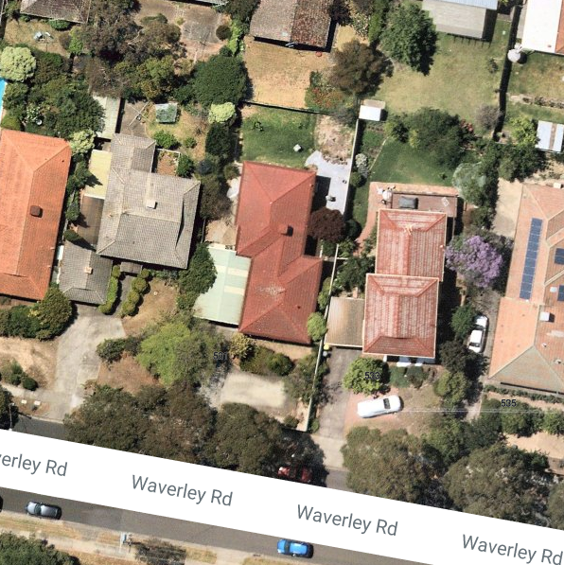
- Dwelling three, which is proposed to be a two storey dwelling, has the greatest potential to affect the amenity of the secluded private open space areas of the site, as the front two dwellings, whilst taller, are located generally in line with the adjoining dwellings.
- I am satisfied that the setbacks of the proposed development are enough to ensure that the proposed built form will not appear visually dominant when viewed from these spaces. Although the rear dwelling will clearly be seen from these spaces, I am satisfied that there is sufficient separation to reduce the visual impact of the development. I note that the proposed development will not obstruct views towards the creek, which are generally to the north.

Loss of light
- I am satisfied that due to the setbacks of the proposed building from the existing habitable room windows, which significantly exceed the setbacks required under Standard B19 of Clause 55.04-3, the development will not result in loss of light to neighbouring habitable room windows.

Overlooking
- Due to the slope of the land, several windows at ground and first floor are required to be treated to prevent overlooking of the adjoining properties. the plans indicate that overlooking is proposed to be prevented through the use of opaque glazing to a height of 1.7 metres above finished floor level or highlight windows. Whilst this meets the requirements of the standard, this method does significantly compromise the internal amenity of the dwellings.
- I find to improve the internal amenity of the dwellings, alternative methods should be used to prevent overlooking such as blades, fins, screens or raised boundary fences which prevent downward views whilst maintaining an outlook for the residents. I will require the provision of a sightline diagram to demonstrate that the method used will prevent downward views into neighbouring properties. I have required this as a condition of permit.

Overshadowing
- Based on the shadow diagrams submitted with the application, I am satisfied that whilst the development will cast additional shadow into the secluded private open space of 529 Waverley Road at 9am and 533 Waverley Road at 3pm, the level of shadow cast is significantly less than the amount allowed under Standard B21 of Clause 55.04-5. As such I am satisfied that the amenity of the adjoining properties will not unreasonably be affected through overshadowing.

Will the proposal have an unreasonable impact on the neighbouring trees?
- There are several trees on neighbouring properties which have the potential to be adversely affected by the proposed development, including two street trees located on Waverley Road.
- Arboricultural evidence was provided to the Tribunal by Mr Michael Rogers of John Patrick Landscape Architects. In his evidence, he assessed the level of encroachment of the works into these trees. All trees, with the notable exception of trees 14 and 20, are unlikely to be affected by the development as the level of encroachment into the Tree Protection Zone (TPZ) will not exceed 10%, which is consistent with the requirements of the Australian Standard AS4970-2009 Protection of trees on neighbouring properties (Australian Standards). I am satisfied that save for trees 14 and 20, the works are unlikely to have a significant impact on the health and viability of these trees, including the street trees located at the frontage of the site.
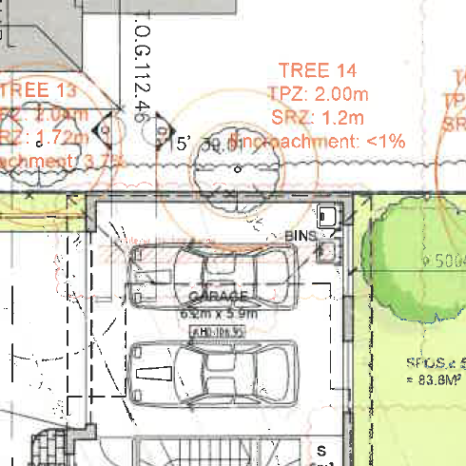
- The proposed garage will significantly encroach into the TPZ of tree 14, a Bay Tree located on the neighbouring property at 529 Waverley Road, as shown in the extract from the plans above.
- Mr Rogers calculated the amount on encroachment to be 34%, which is a major encroachment under the Australian Standards. Even more concerning, the proposed garage will encroach into the structural root zone of this tree, which may mean that the works will affect the trees stability.
- To resolve these concerns, Mr Rogers recommended the utilisation of root sensitive footings that minimise excavation and the potential for root damage, using a method involving pier and beam generally in accordance with the drawing below:
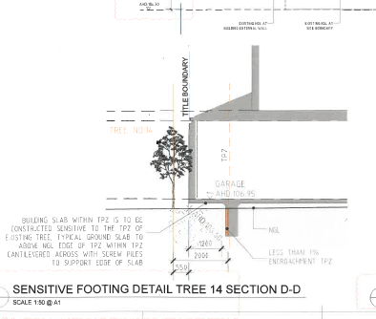
- If this method of construction is utilised, the piers will be sited to be outside the structural root zone and to less than 1% of the TPZ of the tree. Mr Rodgers submitted that Bay trees are very hardy and tolerant to dry conditions. Based on this evidence, I find that provided the works occur as shown in the diagram, the proposal should not have an adverse impact on the health and viability of the tree. I note that the tree will have considerable space within the secluded private open space of 529 Waverley Road as well as underneath the garage for root growth following construction.
- Mr Rogers calculated that the proposed driveway will encroach into the TPZ of tree 20 by 10.6%, as shown in the plan below:
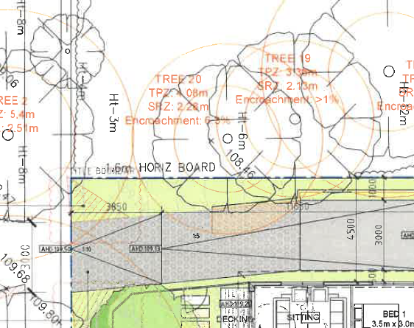
- The application proposes the construction of a low retaining wall between the eastern boundary and the driveway. Mr Roger’s evidence was that prior to the retaining wall, the works should have little impact on the health and viability of the tree as the driveway is being replaced at the existing level, devoid and excavations and should not damage roots.
- The construction of the retaining wall would require an approximate 300mm cut, which may result in the cutting of roots if they are present below the existing driveway. Mr Rogers submitted that it was likely that the majority of Tree 20’s roots are growing into the front garden of 529 Waverley Road, and as such are unlikely to be present below the driveway.
- Nonetheless, to ensure the tree roots are not adversely affected by the development, Mr Rogers discussed with the architect whether it was possible to raise the driveway within the TPZ of Tree 20, removing the need for the site cut and construction of a retaining wall in this location. Having ascertained that it was, he has recommended that this change be incorporated in the plan, together with a requirement that the driveway be constructed in a permeable material. I have required these changes as a condition of permit.
- To further protect the neighbouring trees during construction, Mr Rodgers recommended that the existing driveway and retaining walls be kept as long as possible, to minimise the overall impact of the development on the health and viability of the neighbouring trees. I have required the preparation of the Tree Management Plan, which includes this requirement.
- With these changes in place, I am satisfied based on the evidence that the works should not have an adverse impact on the neighbouring vegetation.

Are the parking and access arrangements acceptable?
- I have previously considered the parking and access arrangements from a neighbourhood character perspective but will now consider it from a traffic perspective.
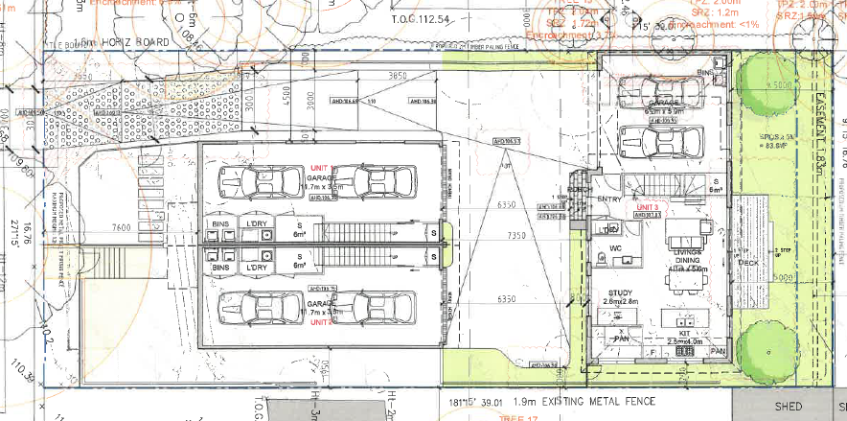
- As seen in the above plan, the application proposes the provision of two car spaces per dwelling, which is consistent with the requirements of Clause 52.06 of the Monash Planning Scheme. The spaces are proposed to be provided in tandem garages for dwellings one and two, and a more traditional double garage for dwelling three. All three garages are to be accessed via a single access way and crossover to Waverley Road and comply with the minimum length and width requirements of Clause 52.06.
- VicRoads originally objected to the application but withdrew their objection on the basis of the amended plans, subject to conditions including a requirement for all vehicles to enter and exit the site in a forward direction.
- Prior to the hearing, the permit applicant circulated advice the applicant had received from O’Brien traffic, which included a series of swept path diagrams. These diagrams indicate that up to a three-point turn (four vehicle movements) are required for vehicles to enter and exit the garage of dwelling two, with the vehicle overhanging the 800mm garden bed outside the front of dwelling three. The Australian Standards for Parking facilities AS/NZS 2890.1:2004 (Australian Standards) allows three point turns in domestic situations, as occupants of the dwellings are generally prepared to accept some inconvenience when entering or leaving the parking space and will become familiar with the arrangement overtime.
- The Australian Standards state that a ground clearance should be provided of 120mm for vehicles, which means that the parking arrangements will restrict the ability of the garden bed in front of dwelling three to be landscaped. The landscape plan currently shows the planting of a row of Snow Maiden Rahiolepis in the garden bed opposite the garage, which is a small shrub anticipated to reach a height of 800mm. I have therefore required the landscape plan to be amended showing the planting in this location to have a mature height of no more than 120mm. This will likely result in the planting of ground covers in this location.
- The diagrams use the B85 vehicle, which the Australian Standards based on the 2004 Ford Falcon, which had the dimensions of 4910mm length x 1870mm width. I am satisfied that there would be a considerable number of modern day vehicles which may comfortably enter and exit the garage in a forward direction, which are at these dimensions or smaller. I note that drivers of larger vehicles, such as the 2020 Ford Endura SUV, would have great difficulty in using the garage. However, this is not fatal to this application, as drivers of these vehicles are unlikely to choose to live in dwellings one or two.
- Ms Pantelakakis raised concern that drivers of vehicles leaving the garages of dwellings one and two would not be able to see an oncoming vehicle travelling down the accessway due to the layout of dwelling one. As this is an application for three dwellings, using a conservative estimate of 10 daily vehicle movements per dwelling there would be in the order of 30 vehicle movements per day, with three in the peak hours (or one approximately every 20 minutes). As such it would be on very rare occasion when there would be two vehicles travelling in opposite directions at the same time. Due to the low volume of traffic, the Australian Standards does not require a passing bay to be provided for this development, although I note that due to its width, the access way between the two groups of dwellings will serve this function. To improve the visibility for vehicles, I will require the provision of a mirror positioned so that vehicles exiting the garages of dwellings one and two may see a vehicle entering the site from Waverley Road.
- With the changes I have made I am satisfied that the parking and access arrangements are acceptable.

Will the proposal provide an acceptable level of internal amenity?
- Council submitted that the use of balconies as the secluded private open space for dwellings one and two was uncharacteristic of the area and would lead to a poor amenity outcome.
- The objective of Clause 55.05-4 is to provide adequate private open space for the reasonable recreation and service needs of residents. As mentioned above, the version of the schedule to the GRZ3 which was gazetted in the planning scheme via Amendment C125 allows 10 square metre balconies as an option for the provision of private open space for dwellings of medium density housing developments. The application before me proposes the use of 12 square metre balconies. Whilst south facing, these balconies will have a direct outlook to the street and will not require screening to prevent overlooking. These spaces will be complemented by front gardens, and a small service yard for dwelling two.
- I find that the provision of private open space for these dwellings will meet the reasonable recreation and service needs of the residents. There are a number of nearby public open space areas, including the Scotchman’s creek trail located 450 metres from the site (a five minute walk), the Monash Aquatic Centre (700 metres from the site), with playground and bbq facilities provided in Central Reserve located 1.2 kilometres from the site (14 minute walk), which will provide for any additional recreational needs of the residents.
- Whilst the application does propose a reverse living layout, with the changes I have made including the screening devices, I am satisfied that each dwelling will provide a comfortable home to their future occupants, whether they be a single, couple or family.

What conditions are appropriate?
- Draft conditions were discussed at the hearing, and any changes to those conditions reflect those discussions plus further consideration at the hearing.
- In addition to the changes discussed at the hearing and in my decision, I have required an amended landscape plan which includes the changes required under condition 1, including a revised planting scheme for the garden bed outside of dwelling three and included the Tribunal’s standard expiry condition. I have also deleted condition 12 of the permit, as the existing crossing is proposed to be widened.

Conclusion
- During the hearing, I was provided with a number of examples of unit developments that have been determined by the Tribunal for developments in Glen Waverley. Some were supported, others not, for the reasons given in those decisions. The Tribunal is not bound by precedent and each case must be considered on its merits. In this case, with the changes I have made, I find that the proposed development is an appropriate response to the requirements of the Monash Planning Scheme.
- For the reasons given above, the decision of the responsible authority is set aside. A permit is granted subject to conditions.

Katherine Paterson
Member

Appendix A – Permit Conditions

Permit Application No | 49896
Land | 531 Waverley Road Glen Waverley

What the permit allowS
In accordance with the endorsed plans:
- The construction of three dwellings on a lot.
- The alteration of access to a road in a Road Zone Category 1.

Conditions

Amended Plans
- Before the development starts, plans drawn to scale and dimensioned must be submitted to and approved by the Responsible Authority. When approved, the plans will be endorsed and will then form part of the permit. The plans must be generally in accordance with the plans prepared by Jesse Ant Architects dated 6 December 2019 and Landscape Plan prepared by Species Landscape Architects dated December 2019, but modified to show:
- Alternative treatments such as blades, fins, screens and fences used to prevent overlooking from the habitable room windows of the proposed dwellings within nine metres of the secluded private open space and habitable room windows of the adjoining properties. Sightline diagrams must be provided which demonstrate that the method used prevents downward views (within 9 metres) into the secluded private open space and habitable room windows of the adjoining properties, whilst maintaining an outlook for the dwelling. This requirement only applies to habitable room windows of rooms which have a finished floor level of 0.8 metres above ground level. A screening device may not be necessary for a window if a sightline demonstrates that a downwards view is prevented via existing fences or structures such as a carport.
- The sensitive footing detail for the construction of the garage for dwelling three generally in accordance with the plan TP11 prepared by Jesse Ant Architects dated 10 December 2019
- Within the Tree Protection Zone of Tree 20, the driveway raised to avoid site cut and the construction of a retaining wall in this location, generally in accordance with the plan TP11 prepared by Jesse Ant Architects dated 10 December 2019. The driveway is to be constructed of permeable materials in the Tree Protection Zone of Tree 20 to the satisfaction of the responsible authority.
- Detail of excavation and retaining walls as modified in the plans prepared by Jesse Ant Architects dated 10 December 2019 referenced TP06-TP11, except as altered by 1(c).
- The provision of a mirror positioned so that vehicles exiting the garages of dwellings one and two may see a vehicle entering the site from Waverley Road.
- The ramp gradients to be consistent between TP6 (Lower Ground Floor Plan) and TP7 (Ground Floor Plan). Ramp gradients must be in accordance with Clause 52.06-9.
- The location and design of any proposed electricity supply meter boxes. The electricity supply meter boxes must be located at or behind the setback alignment of buildings on the site. Alternatively it must be set back a minimum of 3 metres from the front title boundary, no greater than 1.4 metres in height and must be adjacent to side boundary fencing.
- Details (height and materials) of any proposed fencing located within the front setback of the site, dividing open space associated with Unit 1 and Unit 2. Any fencing must be no greater than 1.2m in height.
- Provide a corner splay or area at least 50% clear of visual obstructions (or with a height of less than 1.2 metres), which may include adjacent landscaping areas with a height of less than 0.9 metres, extending at least 2.0 metres long x 2.5 metres deep (within the property) on both sides of the vehicle crossing to provide a clear view of pedestrians on the footpath of the frontage road.
- A double door (minimum width 1.8 metres) is to be installed on the rear of the unit 3 garage to allow for drainage maintenance requests.
- A Tree Management Plan in accordance with Condition 5 of this Permit.
- A Sustainable Design Assessment (SDA) in accordance with Condition 6 of this Permit.

No Alteration or Changes
- The development as shown on the endorsed plans must not be altered without the prior written consent of the Responsible Authority.

Landscaping
- Prior to the commencement of buildings and works a landscape plan prepared by a suitably qualified person must be submitted to and approved by the responsible authority. The landscape plan must be generally in accordance with the plan prepared by Species (Drawing Number L1 dated December 2019) but modified to show:
- Any design changes required under condition 1 of this permit, including the location of retaining walls and driveway construction; and
- A revised planting scheme for the garden bed opposite the garage for dwelling three. The species chosen cannot exceed a mature height of 120mm.

Landscaping Prior to Occupation
- Before the occupation of the buildings allowed by this permit, landscaping works as shown on the endorsed plans must be completed to the satisfaction of the Responsible Authority and then maintained to the satisfaction of the Responsible Authority. Any dead, diseased or damaged plants must be replaced, to the satisfaction of the Responsible Authority.

Tree Management Plan
- Concurrent with the submission of amended plans required by Condition 1 and prior to any demolition or site works, a Tree Management Plan (TMP) must be submitted to and approved by the Responsible Authority. The TMP must be prepared by a suitably qualified and experienced Arborist and must set out recommendations and requirements in relation to the management and maintenance of Tree Nos. 1, 2, 13, 14, 18, 19 and 20 (as identified in the Arborist Report prepared by John Patrick Landscape Architects dated December 2019).
The TMP must be approved by the Responsible Authority prior to the commencement of any works, including demolition and/or levelling of the site. The TMP must make specific recommendations in accordance with the Australian Standard AS4970: 2009 - Protection of Trees on Development Sites and detail the following to the satisfaction of the Responsible Authority ensuring the trees to be retained remain healthy and viable during construction:
a) A Tree Protection Plan drawn to scale that shows:
- Tree protection zones and structural root zones of all trees to be retained,
- All tree protection fenced off areas and areas where ground protection systems will be used;
- The type of footings within any tree protection zones;
- Any services to be located within the tree protection zone and a notation stating all services will either be located outside of the tree protection zone, bored under the tree protection zone, or installed using hydro excavation under the supervision of the Project Arborist; and
- A notation to refer to the Tree Management Plan for specific detail on what actions are required within the tree protection zones.
- Any excavation within the Tree Protection Zone of Tree 1 is to be hand dug and not undertaken via heavy machinery.
- A supervision timetable and certification of tree management activities required by the Project Arborist to the satisfaction of the responsible authority. An arborist must be on site during any works within the Tree Protection Zone of the street trees, the construction of the driveway and the works to establish the location of the piers for the garage for dwelling three.
- Photographs of Tree 1 is to be taken prior to and after excavation to demonstrate compliance with the recommendations of the Tree Management Plan. These photographs must be provided at the request of the Responsible Authority.
- Any remedial pruning works required to be performed on tree canopies located within subject site. The pruning comments must reference Australian Standards 4373:2007, Pruning of Amenity Trees and a detailed photographic diagram specifying what pruning will occur.
- During construction, the existing driveway and retaining walls need to be kept as long as possible to minimise the impact of the construction on the health and viability of the neighbouring vegetation.
The recommendations contained in the approved tree management plan must be implemented to the satisfaction of the Responsible Authority.

Sustainable Design Assessment (SDA)
- Concurrent with the endorsement of any plans pursuant to Condition 1, a Sustainable Design Assessment (in accordance with Clause 22.13) to the satisfaction of the Responsible Authority must be submitted to and approved by the Responsible Authority. When approved, the Sustainable Design Assessment will be endorsed and will form part of this permit.
- The provisions, recommendations and requirements of the endorsed Sustainable Design Assessment must be implemented and complied with to the satisfaction of the Responsible Authority.

Boundary Walls
- The walls on the boundary of adjoining properties shall be cleaned and finished in a manner to the satisfaction of the Responsible Authority.

Stormwater
- All stormwater collected on the site from all hard surface areas must not be allowed to flow uncontrolled into adjoining properties or the road reserve.
- All stormwater collected on the site is to be detained on site to the predevelopment level of peak stormwater discharge. The design of any internal detention system is to be approved by Council’s Engineering Department prior to drainage works commencing.
- The nominated point of stormwater connection for the site is to the north-west corner of the property where the entire site's stormwater must be collected and free drained via a 150 mm pipe to the Council pit in the rear easement to be constructed to Council Standards. (A new pit is to be constructed to Council Standards if a pit does not exist, is in poor condition or is not a Council standard pit). Note: If the point of connection cannot be located then notify Council's Engineering Department immediately.

Road Infrastructure
- Any works within the road reserve must ensure the footpath and naturestrip are to be reinstated to Council standards.
- Engineering permits must be obtained for new or altered vehicle crossings and new connections to Council pits and these works are to be inspected by Council's Engineering Department. A refundable security deposit of $1,000 is to be paid prior to the drainage works commencing.

VicRoads Conditions
- Prior to the commencement of use or occupation, a sealed access crossover as at least 3 metres wide at the property boundary with the edges of the crossover angled at 60 degrees to the road reserve boundary, at least for the first 3 metres from the edge of the road must be constructed to the satisfaction the Responsible Authority (RA) and at no cost to VicRoads or the RA.
- Prior to the commencement of the use or the occupation of the buildings or works hereby approved, the access crossover and associated works must be provided and available for use.
- Vehicles must enter and exit the land in a forward direction at all times.
- The level of the footpath must not be lowered or altered in any way to facilitate access to the site.

Completion of Buildings and Works
- Once the development has started it must be continued and completed to the satisfaction of the Responsible Authority.

Permit Expiry
- This permit as it relates to development (buildings and works) will expire if one of the following circumstances applies:
- The development is not started within two (2) years of the issue date of this permit.
- The development is not completed within four (4) years of the issue date of this permit.
In accordance with section 69 of the Planning and Environment Act 1987, an application may be submitted to the responsible authority for an extension of the periods referred to in this condition.

– End of conditions –

The submissions and evidence of the parties, any supporting exhibits given at the hearing and the statements of grounds filed have all been considered in the determination of the proceeding. In accordance with the practice of the Tribunal, not all of this material will be cited or referred to in these reasons.
Clause 11.01-1R
Plan Melbourne 2017-2050 page 27
Melways Online https://online.melway.com.au/melway/ retrieved 10 February 2020
Identified as a small neighbourhood centre at Clause 21.01-1 of the scheme.
Nearmap Image dated 19 December 2020 http://maps.au.nearmap.com/ retrieved 6 February 2020.
Extract from plan prepared by Jesse Ant Architects, Drawing TP06 dated 6 December 2019
Extract from plan prepared by Jesse Any Architects, Drawning TP 11 dated 10 December 2019
Extract from plan prepared by Jesse Ant Architects, Drawing TP07 dated 6 December 2019
Extract from plan prepared by Jesse Ant Architects, Drawing TP06 dated 6 December 2019

