VICTORIAN CIVIL AND ADMINISTRATIVE TRIBUNAL
planning and environment DIVISION
planning and environment LIST | vcat reference No. P2300/2019  Permit Application no. TPA/50392
CATCHWORDS

Section 80 Planning and Environment Act 1987, Monash Planning Scheme, neighbourhood character, General Residential Zone – Schedule 3, side setback, boundary to boundary development, upper level setback.

APPLICANT | Dragan Jovanovic
responsible authority | Monash City Council
SUBJECT LAND | 16 Callander Street, Hughesdale
WHERE HELD | Melbourne
BEFORE | Alison Glynn, Member
HEARING TYPE | Hearing
DATE OF HEARING | 3 June 2020
DATE OF ORDER | 10 June 2020
CITATION | Jovanovic v Monash CC [2020] VCAT 628

Order

Conditions changed
- The decision of the responsible authority is varied.
- The Tribunal directs that planning permit TPA/50392 must contain the conditions set out in planning permit TPA/50392 issued by the responsible authority on 7 November 2019 with the following modifications:
  - Conditions 1a), 1c) and 1d) are deleted.
  - Conditions in the planning permit are renumbered accordingly.
- The responsible authority is directed to issue a modified planning permit in accordance with this order.

Alison Glynn
Member

Appearances
For Dragan Jovanovic | Mr Richard Umbers, Town Planner of Peninsula Planning Consultants Pty. Ltd.
For Monash City Council | James Turner, Town Planner.

Information
Description of proposal | Construction of two, double storey dwellings. One sits behind the other with a side drive on the west side of the lot to access the rear dwelling that has a garage on this west side boundary near the rear of the lot.  The front dwelling (dwelling 1) includes a bedroom wall set in 0.2 metres from eastern side boundary and a double garage also on this eastern side boundary.
Nature of proceeding | Application under section 80 of the Planning and Environment Act 1987 – to review the conditions contained in the permit. This includes conditions 1a), 1c) and 1d). The council submission states it no longer contests the deletion of condition 1d). The issues of merit relate to conditions 1a) and 1c) that require:  1a) increasing the ground floor side setback of a bedroom in Dwelling 1 from 0.2 metres to 1.0 metres.  1c) deleting an upper level bedroom of dwelling 1, to create a larger gap between the upper levels of dwelling 1 and 2.
Planning scheme | Monash Planning Scheme
Zone and overlays | General Residential Zone – Schedule 3 (GRZ3)
Permit requirements | Construction of two or more dwellings in GRZ3.
Key relevant scheme policies and provisions | Clauses 11, 15.01, 16, 21.04, 22.01, 32.08, 55 and 65.
Land description | The site has a 15.2 metre frontage to the south side of Callander Street and a depth of 40.2 metres. To the east and west are single storey dwellings.
Tribunal inspection | I inspected the site and surrounds, unaccompanied, before the hearing on 31 May 2020.

Reasons

What is this proceeding about?
- Monash City Council has issued a planning permit to construct two, double storey dwellings at 16 Callander Street, Hughesdale. The permit includes a number of conditions including condition 1 that requires application plans that formed the basis of the permit to be amended to show a number of changes. The permit applicant opposes three components of this condition being conditions 1a), 1c) and 1d).
- The written submission of the council, filed before the hearing, states that it does not contest the request of the review applicant to delete condition 1d). This condition therefore can be deleted with the consent of the parties.
- Conditions 1a) and 1c) of the permit that require the application plans to be amended to show:
Condition 1a): The setback of the ground floor guest room of Dwelling 1 to the eastern property boundary to be increased to 1 metre.
Condition 1c) The upper floor bedroom 2 area of Dwelling 1 deleted.
- The scope of this review is therefore to determine if the two conditions are necessary in order for the permit to adequately address the relevant policy and provisions of the Monash Planning Scheme as it relates to the permit being granted.

Is condition 1a) needed?
- The council submits this condition is necessary for the proposal to provide an appropriate response to the neighbourhood character provisions and policies of the Monash Planning Scheme. In particular this includes objectives of the GRZ3 applying to the land that include:
- To support new development that contributes to the preferred garden city character through well landscaped and spacious gardens that include canopy trees.
- To promote the preferred garden city character by minimising hard paving throughout the site by limiting the length and width of accessways and limiting paving within open space areas.
- To support new development that minimises building mass and visual bulk in the streetscape through generous front and side setbacks, landscaping in the front setback and breaks and recesses in the built form.

- To support new development that locates garages and carports behind the front walls of buildings
- A relevant decision guideline of the zone is also to consider whether the development provides an appropriate transition to built form on adjoining sites.
- As set out in the ground floor of the application plans in Figure 1 below, Dwelling 1 includes a guest bedroom that has a five metre long wall, set in 0.2 metres from its eastern boundary. This wall is approximately three metres high and allows for the side fence to the adjoining property to the east to remain in place.
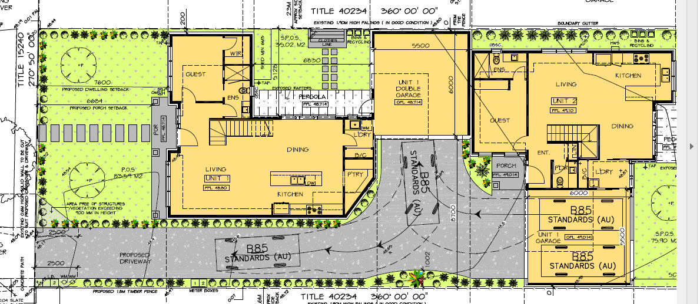
Figure 1 - ground floor layout of application plans (north is to the left of the page).
- The council submits the condition to require an additional 0.8 metres to this side setback is needed to ensure the development:
- is consistent with both the existing and preferred character of the area, and
- provides breathing space when viewed from the adjoining property.
- The council submits the character of the neighbourhood does not typically present as boundary to boundary development and that the proposed wall, close to the eastern boundary, will be inconsistent with the existing siting pattern in the neighbourhood.
- I agree that Callander Street does not typically display boundary to boundary development, but I consider the proposed layout will not view overtly as boundary to boundary development, or inconsistent with other dwellings in the street, some of which include building to one side boundary. This includes some dwellings, such as at 9 Callander Street that have quite prominent double garages to the side boundary as part of their façade.
- The ground floor layout includes generous landscape space and provides for pitched roof, recessed upper level form so that the overall concept, as approved can complement ‘the scale and siting of the original housing’ in the area as well as enhancing the area’s the ‘generous spacious, open, landscaped character’, as sought by the preferred character set out in clause 22.01.
- The preferred character statement in clause 22.01 seeks ‘the maintenance of setbacks from at least one boundary’. I assume from the council comments that the council interprets this policy reference as a need for a setback to at least one ‘side’ boundary although the policy does not explicitly state this. Dwelling 1 has a garage set to one side boundary and Dwelling 2 has a garage set to the other side boundary. The council conditions do not seek to amend either of these garage side setbacks. Condition 1a) simply seeks a currently 0.2 metre setback of the bedroom to be converted to a 1.0 metre setback. From the council submission I understand this is sought to protect amenity to the adjoining neighbour to the east and to maintain a greater perception of setback from this eastern side boundary.
- I am not convinced that the setback is necessary to address the existing and preferred neighbourhood character and accept the applicant’s submission that any such need is not balanced against the compromise needed to internal amenity resulting from the reduced internal floor area. This is because:
  - Some perception of a side setback is retained with the existing 0.2 metre setback as it allows the existing 1.9 metre side boundary fence to be retained with the bedroom wall protruding only 1.1 to 1.2 metres above.
  - The differing side setback sought will make no difference on the capacity to landscape the front setback. The landscaping will still be in this front setback. A 1.0 metre side setback does not allow for any meaningful additional landscape. In any event this is not the basis on which council says the setback is required.
  - Any view of a side setback along this eastern side boundary will continue to be restricted due to the garage to the side boundary some 6.8 metres further south of the bedroom wall.
  - As a general building concept, the setting of dwelling 1 to the east of the lot, with a side drive to the west is quite consistent with the street setting and retains a sense that there is a dwelling with a side driveway which is consistent with the rhythm of dwelling placements in the street. The eastern boundary form does not create a continuous façade, or a terrace formation across the width of the site.
- I am also satisfied there is no amenity need for the condition to be retained. The wall abuts an adjoining drive of 18 Callander Street. The perceived difference in visual bulk will be imperceptible to this neighbour with the fence and a small setback retained, also noting that the length and height of the wall is limited. I also note that this neighbour did not seek to become a party to the proceeding.
- I therefore will delete condition 1a) as not being necessary or warranted, based on the provisions of the Monash Planning Scheme.

is condition 1c) needed?
- This condition requires bedroom 2 of dwelling 1 to be deleted. This bedroom is circled in red in Figure 2 below.
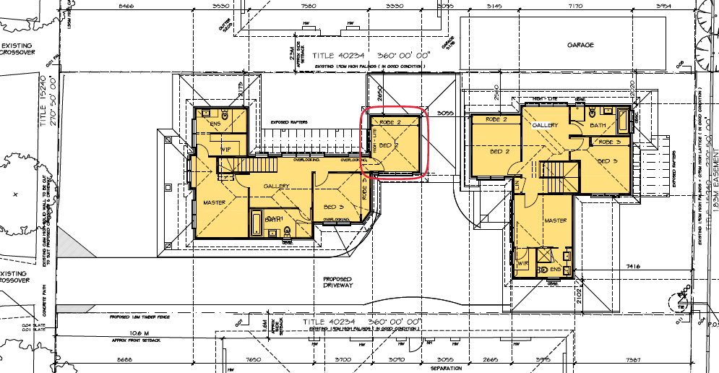
Figure 2 - First Floor plan. Bedroom 2 of dwelling 1 circled in red.
- The council submits that the proposed 3.05 metre separation between the upper floors of Dwellings 1 and 2 is inadequate and will result in an unacceptable bulk and mass of the built form when viewed from surrounding properties. It is on this basis that it has imposed condition 1c) to delete bedroom 2 of dwelling 1.
- The council maintains that this is consistent with general policy in 22.01 to ‘minimise the impact of the scale and massing of development’. It also relies on policy in clause 22.01-3 for side and rear setbacks to:
Minimise the impact of visual bulk to neighbouring properties, through suitable setbacks from adjacent secluded private open space to enable the provision of screening trees, and scaling down of building form to the adjoining properties
- Bedroom 2 of dwelling 1 sits mid-block in the site, set back at least 2.65 metres from the east boundary to 18 Callander Street where there is a side drive and the side of the house on this adjoining lot. It then sits over 7.5 metres from the western side boundary to 14 Callander Street where there is the side of a house. The bedroom is not directly adjacent to any secluded private open space and is well within the measurable standard for visual bulk set by clause 55.04-1.
- Based on the objectives and standards of clause 55.04-1 and the relevant policy of clause 22.01 I find the setting of bedroom 2 of dwelling 1 reasonable. It is not in a position or height to create unreasonable visual bulk to its neighbours, or indeed to dwelling 2. It is a bedroom that will not be easily seen from the street and therefore also has no perceptible impact on the streetscape.
- I also note that policy at clause 22.01 includes direction for upper levels to be recessed and/or articulated to minimise the impression of building scale. I am satisfied that the small footprint, its setback from all boundaries, and recession of the upper level from the lower, ground level meets this policy directive.
- I therefore find I cannot substantiate a reasonable rationale for this condition and will direct it be deleted.

Conclusion
- For the reasons given above, the decision of the responsible authority is varied. A permit is granted subject to amended conditions that delete conditions 1a), 1c) and 1d) for reasons set out above.

Alison Glynn
Member

By telephone
The submissions of the parties, any supporting exhibits given at and before the hearing, and the statements of grounds filed; have all been considered in the determination of the proceeding. In accordance with the practice of the Tribunal, not all of this material will be cited or referred to in these reasons.

