VICTORIAN CIVIL AND ADMINISTRATIVE TRIBUNAL
planning and environment DIVISION
planning and environment LIST | vcat reference No. P1668/2019  Permit Application no. TPA/49873

APPLICANT | Leo (Quan) Zhou
responsible authority | Monash City Council
SUBJECT LAND | 15 - 16 Kalonga Court  GLEN WAVERLEY VIC 3150
WHERE HELD | Melbourne
BEFORE | Judith Perlstein, Member
HEARING TYPE | Hearing
DATE OF HEARING | 20 February 2020
DATE OF ORDER | 27 February 2020
CITATION | Zhou v Monash CC [2020] VCAT 242

Order

Conditions changed
- The decision of the responsible authority is varied.
- The Tribunal directs that planning permit P1668/2019 must contain the conditions set out in planning permit TPA/49873 issued by the responsible authority on 26 July 2019 with the following modifications:
  - Condition 1(a), (b), (c), (d), (e) and (f) are deleted.
  - Conditions in the planning permit are renumbered accordingly.
- The responsible authority is directed to issue a modified planning permit in accordance with this order.

Judith Perlstein
Member

Appearances
For applicant | Mr Mark Waldon of St-Wise Pty Ltd.
For responsible authority | Mr Gerard Gilfedder of Currie and Brown.

Information
Description of proposal | Construction of six double-storey dwellings.
Nature of proceeding | Application under section 80 of the Planning and Environment Act 1987 – to review the conditions contained in the permit.
Planning scheme | Monash Planning Scheme
Zone and overlays | General Residential Zone, Schedule 3 (GRZ3).
Permit requirements | Clause 32.08-6 Construction of two or more dwellings on a lot in the GRZ3.
Relevant scheme policies and provisions | Clauses 11, 15, 16, 21.01, 21.04, 22.01, 22.05, 32.08, 55, 65.
Land description | An aerial image of the subject site and its surrounding context is included below.

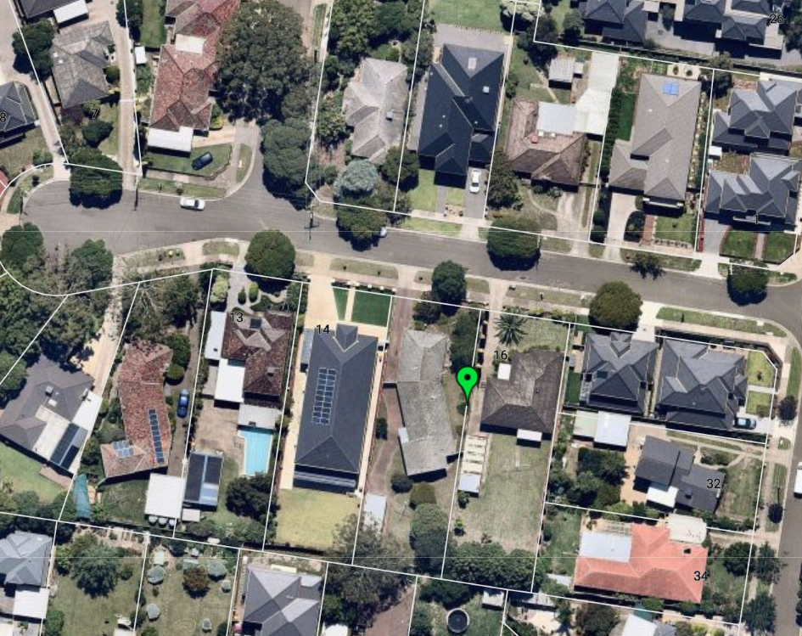
Reasons

what is this proceeding about?
- On 26 July 2019, the Monash City Council issued a planning permit for the construction of six double-storey dwellings on the subject site, which comprises two lots located on the southern side of Kalonga Court, Glen Waverley, with a combined frontage of 33.52 metres, a depth of 50.29 metres and a total site area of 1,686 square metres.
- Each dwelling is proposed to have four bedrooms, a double garage, and between 75 and 106 square metres of secluded private open space.
- The Council issued the planning permit with several conditions, including the following conditions concerning elements of the submitted plans required to be revised prior to endorsement by the Council:
- The northern Master bedroom wall of dwelling 3 be setback an additional 500mm or to the satisfaction of the Responsible Authority;
- The northern Master bedroom wall of dwelling 4 be setback an additional 500mm or to the satisfaction of the Responsible Authority;
- The northern Master bedroom wall of dwelling 5 be setback an additional 500mm with no further reduction to the southern and western setbacks to the satisfaction of the Responsible Authority;
- The northern Master bedroom wall of dwelling 6 be setback an additional 500mm with no further reductions to the southern or eastern setback to the satisfaction of the Responsible Authority;
- The eastern wall of Bedroom 4, Dwelling 5, to be setback an additional 700mm with no further reductions to the northern, southern and western setbacks to the satisfaction of the Responsible Authority; and
- The western wall of Bedroom 4, Dwelling 6, be setback an additional 700mm with no further reductions to northern, southern and western setbacks to the satisfaction of the Responsible Authority.
- The Council submits that these conditions are necessary to achieve a proper neighbourhood character outcome and to ensure the amenity external to the proposed development is protected. It submits that the conditions achieve a preferred design outcome that will provide greater articulation in the presentation of the dwellings to the rear of the site and adjoining properties, reduce bulk and massing of the dwellings and provide greater separation between the dwellings.
- The applicant submits that the conditions are not necessary to improve the development, or for the protection of neighbourhood character or to produce a more favourable amenity for neighbours.
- The Tribunal must determine whether the disputed conditions should be retained or deleted. The key issue, as identified by the parties, is whether the changes proposed by the Council are necessary to achieve an acceptable planning outcome with respect to this proposal.
- Having considered the submissions of both parties with respect to the applicable policies and provisions of the Monash Planning Scheme (Scheme), I have determined that the proposal is an acceptable one without the inclusion of the conditions in dispute, and that the permit should be amended to delete those conditions. My reasons follow.

tribunal consideration
- Between 2017 and 2019, the context within which the site is located underwent some change. As seen via aerial photography within nearmap, the dwellings at 1 and 18 Kalonga Court, 41 Botanic Drive and at 9 Ranfurlie Drive, to the south-west of the subject site, were all demolished and the properties were redeveloped with two double-storey dwellings. In addition, 14 Kalonga Court, directly abutting the subject site to its west, was redeveloped with one large double-storey dwelling.
- Since the planning permit has been issued, Amendment C125, Part 2, was gazetted and introduced into the Scheme. The zoning of the site has now changed to the General Residential Zone, Schedule 3 (GRZ3) – Garden City Suburbs, with the following neighbourhood character objectives:
To support new development that contributes to the preferred garden city character through well landscaped and spacious gardens that include canopy trees.
To promote the preferred garden city character by minimising hard paving throughout the site by limiting the length and width of accessways and limiting paving within open space areas.
To support new development that minimises building mass and visual bulk in the streetscape through generous front and side setbacks, landscaping in the front setback and breaks and recesses in the built form.
To support new development that locates garages and carports behind the front walls of buildings.
- Several variations to the clause 55 standards were introduced by the GRZ3, however, the proposal is generally compliant with those variations, and the elements that do not strictly comply are not the subject of this review.
- The parties also referred to the new clause 22.01 – residential development and character policy, which includes the subject site within the ‘Garden city suburbs (northern)’ area. The Council referred to several policy objectives of clause 22.01 with respect to built form and scale of development, which apply to the entire municipality, including:
- Respect the height, scale and massing of existing dwellings in the neighbourhood.
- Ensure taller buildings incorporate sufficient articulation, including recessed upper levels, to respect the prevailing scale of the adjoining dwellings and the neighbourhood.
- Incorporate higher degrees of articulation for double storey development in streetscapes where the prevailing built form is single storey.
- Retain human scale, and by the inclusion of significant breaks and recesses in building massing, avoid large block like structures dominating the streetscape.
- Ensure buildings respect the built form, rhythm and proportions of existing dwellings in the neighbourhood.
- Respect the roof forms and pitches of existing dwellings in the neighbourhood.
- Preserve backyard character by ensuring multi-storey development at the rear of properties incorporates generous articulation and setbacks including ground floor setbacks sufficient in width to support screening trees.
- The applicant submitted that, to some extent, the Council has accepted the desired future character would be achieved by supporting the development. The Council has approved the development of six dwellings on two lots with double-storey built form for each of the dwellings, including in rear yards.
- The Council referred to specific elements of the newly introduced policies and zone controls, including an additional decision guideline of the GRZ3, ‘whether the development provides an appropriate transition to built form on adjoining sites’, the reference in clause 22.01 to ‘the inclusion of significant breaks and recesses in building massing’, the reference in the GRZ3 objectives to ‘breaks and recesses in the built form’, and referred to consideration of ‘backyard-scape’.
- However, the first four conditions in dispute seek only to create a greater separation between the main bedrooms of the upper levels of the dwellings. Below is a site plan, marked up by the Council’s advocate, indicating the effect of the proposed conditions on the proposal.
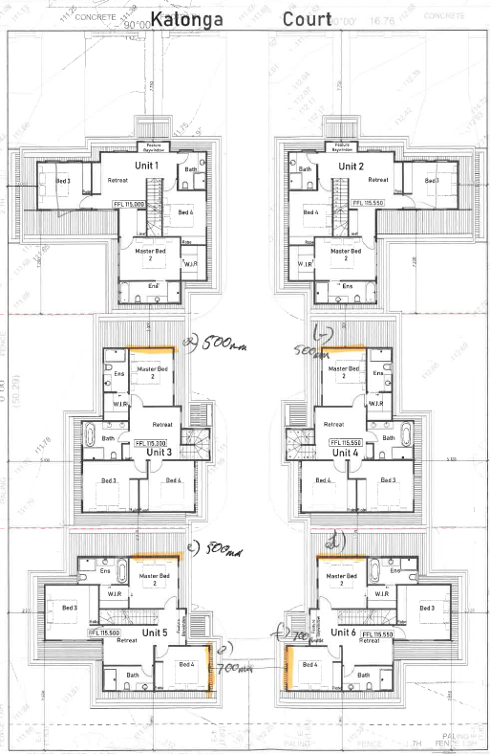
- The current separation at first floor level, between each block of two units, is 3 metres. Conditions 1(a) to (d) require an additional 500mm setback of the northern wall of the master bedroom of each of units 3, 4, 5 and 6. That will increase the separation between the master bedroom of those units and the first floor of the units opposite to 3.5 metres, but will retain the 3 metre separation for the remainder of the northern wall, which houses an ensuite. Given that the master bedroom is inset in all of these units, the increased separation will not be appreciated from the surrounding properties.
- The Council’s reasons for the conditions relate to neighbourhood character and to amenity of surrounding properties. It is not clear how these minor amendments at first floor level, internal to the development, will provide any benefit, or any change at all, to how the buildings are viewed or perceived in the neighbourhood or from surrounding properties external to the subject site. Issues of ‘backyard-scape’, transition to built form on adjoining sites and breaks and recesses in building massing are not resolved by the inclusion of these conditions.
- I agree with the submissions of the applicant that these are matters that the Council must have considered and resolved in its initial decision to grant a permit for the proposal. While I accept that the Council considers these changes would further improve the proposal, I do not consider they are justified on the basis of the reasons provided or that imposing the conditions would provide any appreciable change to the development.
- Further, the proposed changes will have a detrimental effect on the internal amenity of the dwellings within the development, requiring changes to internal layout that will either reduce the size of the master bedrooms or require reconfiguration of the first floor.
- For these reasons I do not consider that conditions 1(a) to (d) are required to reach an acceptable outcome for this development.
- Conditions 1(e) and (f) relate to the separation, at first floor, of the two rear units, and the visibility through the centre of the development. There is currently a 5.4 metre separation between units 5 and 6 at first floor level, with both units set back over 4 metres from the rear boundary. The proposed additional setback of 700mm to bedroom 4 of each unit would result in a separation of 6.8 metres between the two units. At ground floor, the separation is 4 metres, with sufficient room for planting of a large canopy tree between the two units.
- The Council submitted that the proposed conditions seek to retain a vista down the central driveway and to increase the separation between dwellings to reduce bulk and retain open view lines between the rear four buildings. As already noted, I do not consider that the first four conditions in dispute assist in achieving the outcomes of reducing bulk and retaining open view lines between the rear buildings. I also consider that the rear separation of 5.4 metres is sufficient to provide a vista down the central driveway and an appreciable separation between the dwellings from the properties to the rear. Given that the subject site comprises two lots, the development of two dwellings proximate to the single dwellings to the rear is not inconsistent with the neighbourhood character.

Conclusion
- For the reasons given above, the decision of the responsible authority is varied. The conditions the subject of this application for review are deleted from planning permit P1668/2019.

Judith Perlstein
Member

From www.nearmap.com.au, taken on 17 February 2020. The arrow is shown on the boundary between the two lots that comprise the subject site.
The submissions of the parties, any supporting exhibits given at the hearing, and the statements of grounds filed; have all been considered in the determination of the proceeding. In accordance with the practice of the Tribunal, not all of this material will be cited or referred to in these reasons.

