VICTORIAN CIVIL AND ADMINISTRATIVE TRIBUNAL

administrative DIVISION

|  |  |
| --- | --- |
| planning and environment LIST | vcat reference No. P1985/2018  Permit Application no. TPA/48840 |
| CATCHWORDS | |
| Application under section 77 of the *Planning and Environment Act 1987* to review the refusal to grant a permit; Monash Planning Scheme; General Residential Zone; six (6) triple storey dwellings; neighbourhood character; housing policy; Mount Waverley Activity Centre and access safety | |

|  |  |
| --- | --- |
| APPLICANT | Liang Zhao |
| responsible authority | Monash City Council |
| RESPONDENTs | Stephen Mackay, Paula Mackay and Wilma Carter and Ron and Eva Lorraine Cashin |
| SUBJECT LAND | 1 Arthurson Street, Mount Waverley |
| WHERE HELD | Melbourne |
| BEFORE | Christopher Harty, Member |
| HEARING TYPE | Hearing |
| DATE OF HEARING | 17 and 18 April 2019 |
| DATE OF ORDER | 14 June 2019 |
| CITATION | Zhao v Monash CC [2019] VCAT 869 |

# Order

1. Pursuant to section 127 and clause 64 of Schedule 1 of the *Victorian Civil and Administrative Tribunal Act 1998*, the permit application is amended by substituting for the permit application plans, the following plans filed with the Tribunal:

|  |  |
| --- | --- |
| Architectural plans prepared by: | Archimedium Australia Pty Ltd |
| Drawing numbers: | TP3, TP4, TP5, TP6 and TP7 |
| Revision: | B |
| Dated: | 28 February 2019 |

1. In application P1985/2018 the decision of the responsible authority is affirmed.
2. In planning permit application TPA/48840 no permit is granted.

|  |  |  |
| --- | --- | --- |
| **Christopher Harty**  **Member** |  |  |

# Appearances

|  |  |
| --- | --- |
| For Liang Zhao | Mr Simon Skinner, Town Planner from Planning Sense Town Planning Consultants. He called the following expert witnesses:  Mr David Beaton, Traffic Engineer from Quantum Traffic Pty Ltd  Mr Robert Thomson, Landscape Architect from Habitat Landscape and Environmental Design Consultants |
| For Monash City Council | Ms Sally Moser, Town Planner from Moser Planning Services Pty Ltd |
| For Stephen Mackay, Paula Mackay and Wilma Carter | Mr Stephen Mackay |
| For Ron and Eva Lorraine Cashin | No appearance |

# Information

|  |  |
| --- | --- |
| Description of proposal | Construction of six (6) triple storey dwellings. |
| Nature of proceeding | Application under section 77 of the *Planning and Environment Act 1987* – to review the refusal to grant a permit. |
| Planning scheme | Monash Planning Scheme |
| Zone and overlays | General Residential Zone Schedule 2 – Monash Residential Areas (GRZ2) |
| Permit requirements | Clause 32.08-6 to construct two or more dwellings on a lot |
| Relevant scheme policies and provisions | Clauses 11, 15, 16, 21.01, 21.04, 22.01, 22.05, 32.08, 52.06, 55, 65 and 71.02 |
| Land description | The land at 1 Arthurson Street, Mount Waverley (the site) is located on the north-east corner of Arthurson Street and Carmel Avenue, approximately 150 metres west of Alexander Street. The site is irregularly shaped with a frontage to Arthurson Street of 9.84 metres, a corner splay of 5 metres and boundary to Carmel Avenue of 45.67 metres with an overall area of 974 square metres.  The site has a slope towards the west of approximately 600mm. It is currently occupied by a single storey brick veneer dwelling and carport and outbuilding in the rear yard. There is a 1.83-metre-wide easement along the rear (north) and eastern side boundaries and two street trees on the Carmel Avenue frontage and one on the Arthurson Street frontage.  The surrounding area is predominantly modest single storey residential dwellings including multi-dwelling development and scattered newer two storey dwellings. The site is located directly south of the Mount Waverley Train Station car park and VicRail electrical substation. The site is also approximately 200 metres east of the Mount Waverley Activity Centre. |
| Tribunal inspection | 4 June 2019 unaccompanied |

# Reasons[1]

## What is this proceeding about?

1. Liang Zhao (the applicant) seeks to construct six (6) triple storey dwellings at 1 Arthurson Street, Mount Waverley (the site). Monash City Council (the Council) determined on 10 August 2018 to refuse to grant a permit. The applicant has lodged a review of Council's decision.
2. Council’s grounds for refusing the permit were primarily that:

* the proposed development was inconsistent with the residential policy (Clauses 21.04 and 22.01), 2014 Monash Housing Strategy and design outcomes regarding being respectful of neighbourhood character and was an overdevelopment;
* the proposal represents a poor design response to its immediate context with respect to site layout, building massing, setbacks, access, landscaping, amenity, private open space and detailed design; and
* the proposal does not adequately satisfy Clause 52.06 requirements regarding vehicle access and safety[2].

1. Despite the applicant substituting amended plans, Council maintains its lack of support for the proposal. It says the amended proposal remains bulky and out of character with the location and is too dramatic a departure from the established neighbourhood character of the area.
2. The respondents (objectors) support Council's position. They also are concerned with traffic safety issues associated with inadequate parking, additional traffic generated by the proposed development and poor safety with the proposed access to Dwelling 1 from Arthurson Street.
3. The applicant submits the proposal is a design response that satisfies the purposes of the General Residential Zone Schedule 2 (GRZ2) that affects the site and the provisions and policies of the Monash Planning Scheme. The applicant considers the proposal constitutes apartment style dwellings in a townhouse form and unashamedly is a contemporary design response to neighbourhood character. It provides respectful and well managed housing change given the location of the site close to the Mount Waverley Activity Centre. It also benefits from the site’s corner location, direct abuttal to the Mount Waverley Train Station car park and limited direct interface with sensitive residential development to the east.

## What are the key issues?

1. The issues raised within the context of this review relate generally to the proposal’s design responsiveness to the policy context of the area, neighbourhood character considerations and access safety. Having heard the submissions and evidence and inspected the site and locality, the key issues arising from this proposal are:

* Does the proposal appropriately respond to the policy context of the area?
* Does the proposal respond to and respect neighbourhood character?
* Will the proposal cause unreasonable amenity or landscape impacts?
* Is access safe?

1. I must decide whether the proposal will produce an acceptable outcome having regard to the relevant policies and provisions in the Monash Planning Scheme. Net community benefit is central in reaching a conclusion. Clause 71.02 - *Integrated Decision Making* of the planning scheme requires the decision-maker to integrate the range of policies relevant to the issues to be determined and balance conflicting objectives in favour of net community benefit and sustainable development.
2. With this proposed development I must decide whether a permit should be granted and, if so, what conditions should be applied.
3. Having considered all submissions presented with regards to the applicable policies and provisions of the Monash Planning Scheme, I find the proposal represents an unacceptable outcome.
4. The proposed access for Dwelling 1 fronting onto Arthurson Street fails to produce a safe outcome for future occupants of that dwelling. The proposed crossover to Arthurson Street is too close to the intersection with Carmel Avenue to allow it to be used in a safe manner. I find the combination of the sweeping bend of the intersection when travelling from Carmel Avenue into Arthurson Street and the proposed location of the crossover to Dwelling 1 beside that of 2/3 Arthurson Street culminates in an unsafe outcome which I consider fatal for this proposal.
5. Despite the satisfactory design response of other elements of the development, it is not possible to merely impose conditions to alter the layout to produce safer access without a more fundamental and potentially significant re-design. Hence, I have decided to affirm the decision of Council and that no permit is granted. My reasons follow.

## Does the proposal appropriately respond to the policy context of the area?

### What is proposed?

1. The proposal is to construct six (6) three storey dwellings in two blocks of attached built form. Dwelling 1 faces the site’s narrow frontage to Arthurson Street and its corner with Carmel Avenue. It has a separate single car garage and tandem car space and crossover onto Arthurson Street. Dwelling 1 is attached to Dwellings 2 and 3 located behind, and which front onto an internal driveway accessed off Carmel Avenue. Opposite and also facing the same internal driveway, are Dwellings 4, 5 and 6 at the wider rear or northern end of the site.
2. The design is for three storeys and with a building height of up to 9.5 metres at its highest. Under the GRZ (and noting Schedule 2 does not include any variation), the mandatory height limit is 11 metres or three storeys. The proposal satisfies the height limits of the zone.
3. The built form design is contemporary and a departure from the single and occasional double storey built form with hipped roof forms common in the neighbourhood. The neighbourhood could be described as post-war development up to the 1990s comprising predominantly single dwellings with some newer double storey forms. Where multi-unit development does exist, it is in the form of dual occupancy with dwellings in tandem. As an example, the property next door at 3 Arthurson Street comprises the original dwelling with a second dwelling behind and serviced by separate driveways and crossovers. The proposal would end up with a new crossover in conjunction with that of the rear dwelling at 2/3 Arthurson Street.

### What is the policy context?

1. The arguments about the merits of the departure of the proposal’s built form design response from the predominantly single storey dwelling character of the area revolves around what policy intends for future residential development in an area located within close proximity to both the Mount Waverley Train Station and Activity Centre.
2. The site directly abuts the western end of the Mount Waverley Train Station car park (to the north). Both the Mount Waverley Train Station and the Mount Waverley Activity Centre are within a 200 metre walk of the site. It therefore benefits from being close to jobs, community services and facilities including public transport and with creating a city of 20 minute neighbourhoods[3].
3. Reinforcing this, Mr Skinner submitted the site enjoys features and contextual attributes that are typically urban and makes the land highly appropriate for more intensive development. Some of these features and attributes include:

* A corner location with two road abuttals and only one sensitive interface to a residential property (to the east), which is primarily the driveway of 2/3 Arthurson Street, along the common side boundary.
* A large lot size of 974 square metres, capable of accommodating multi-dwelling development.
* Absence of vegetation including canopy trees of any landscape character note.
* Predominantly flat topography.

1. These features and attributes were recognised by both Council and the applicant as lending the site to having potential for multi-dwelling development[4].
2. However, despite what would usually be a clear case for supporting more intense residential development, there is uncertainty because of recent and proposed changes to the local policy setting of the Monash Planning Scheme with regards to future neighbourhood character[5].
3. The uncertainty is twofold. Firstly, there is confusion over what residential character policy should appropriately be considered. Secondly, there is uncertainty as to whether or not the site falls within the policy sphere of influence of the Mount Waverley Activity Centre area as defined under Council’s adopted Monash Housing Strategy, 2014, which is a reference document in the planning scheme, having been introduced under the auspices of Amendment C125 Part 1.
4. Currently, the Monash Planning Scheme identifies the site under Clause 21.04 – *Residential Development* and Clause 22.01 – *Residential Development and Character Policy* within the *Type C Character derived from Post-War to 1965 development, undulating topography with a dominant N-S, E-W grid with some diagonal distortion*.
5. The desired future character statement for Type C refers to development within a pleasant leafy framework of well-planted front gardens and large canopy trees. New buildings will be subservient to the landscape, although newer two storey housing will gradually become more dominant and be buffered from the street by a well planted front garden that will ensure the soft leafy nature of the street. Setbacks will be generous and consistent within individual streets.
6. Both policies emphasise the Garden City Character of Monash and the desirability of retaining neighbourhood character. However, there are two important caveats to this aspiration. The first is that these same policies support medium rise residential development in places such as the Mount Waverley Activity Centre. The other being the general agreement of Council and the applicant that the neighbourhood character policy statements currently in the planning scheme are out-dated, based on an Urban Character Study from 1997 and clearly superseded by the residential development framework outlined under the 2014 Monash Housing Strategy.
7. Mr Skinner drew my attention to a number of previous Tribunal decisions that have made similar findings in this regard[6].
8. It appears the 2014 Monash Housing Strategy provides the most relevant and helpful guidance regarding policy settings for residential development and neighbourhood character. This is particularly so given the reference in the Monash Housing Strategy to Plan Melbourne, recognition of the Mount Waverley Activity Centre and the influence of the new reformed residential zones, including the current GRZ2 that applies to the site.
9. The 2014 Monash Housing Strategy identifies the site within possibly both *Category 1 – Activity and Neighbourhood Centres* and *Category 2 – Accessible Areas*.
10. The Residential Development Framework Map (Figure 6A from the Monash Housing Strategy, 2014) is shown in Figure 1. Ms Moser argued the site does not fall within the Mount Waverley Activity Centre area and is in the Accessible Areas category, whereas, Mr Skinner tabled an enlargement of the Residential Development Framework Map (Figure 2) showing the site was identifiable within the Activity Centres category.



Figure 1: Residential Development Framework Map, Figure 6A from the Monash Housing Strategy, 2014.

1. The relevant objectives for these residential development categories are:

* For Activity Centres, housing change and diversification, unless qualified by a Structure Plan.
* For Accessible Areas, moderate housing change and diversification serving as a transition between commercial and residential areas. Development will be respectful of neighbourhood character and amenity, with greater emphasis placed on these objectives in proportion to the distance from commercial zones and transport nodes.

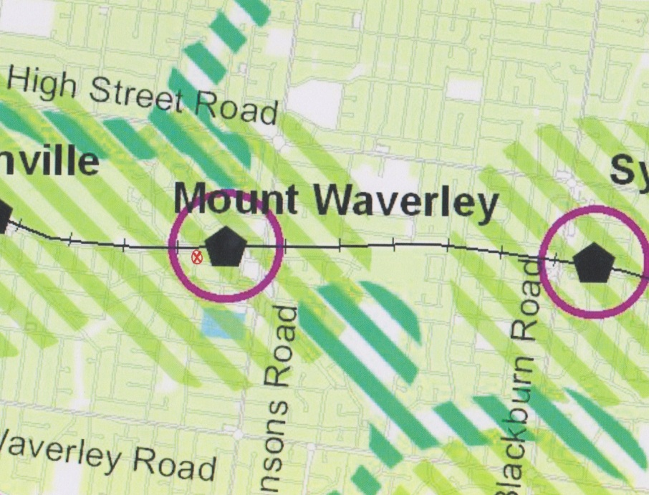

Figure 2: Enlargement of the Residential Development Framework Map showing the location of the site.

1. Medium density residential development will be directed to the Mount Waverley Activity Centre in accordance with relevant structure planning. A structure plan has only just commenced for the Mount Waverley Activity Centre, hence detailed planning direction and outcomes are yet to be formalised. However, Council has produced a discussion paper which does identify the site as one with capacity for additional housing in the residential area surrounding the Mount Waverley Activity Centre with an area greater than 700 square metres, that is in the GRZ2, and which supports some residential intensification to a maximum building height of 11 metres (3 storeys).
2. Ms Moser submitted that despite details lacking over more intense outcomes for the site, its location near the Mount Waverley Activity Centre is recognised and multi-dwelling development of the site is supported. However, site designs and layouts still have to respond to their context and provide a suitable living standard for their occupants.
3. To reconcile the confusion with policy, I have taken a first principles view. I consider the site specific characteristics of the site and its close proximity to both the Mount Waverley Activity Centre and Mount Waverley Train Station provides sufficient support for multi-dwelling development of up to 11 metres or three storeys to occur. The test is whether the design is respectful of neighbourhood character and amenity considerations.

## Does the proposal respond to and respect neighbourhood character?

1. Protection of Monash’s Garden City Character is pre-eminent in the planning scheme. Ms Moser argued that supporting a development that was completely at odds with the surrounding area is *jumping the gun* and inappropriate for the area. Ms Moser provided the following description of the existing neighbourhood character of the area within which the site is located:

* The subject site is in the neighbourhood located south of the Glen Waverley Railway line at the intersection of Arthurson Street, Carmel Avenue and Windsor Avenue. The railway and carpark are north.
* The neighbourhood is established and primarily comprises single storey post World War II dwellings.
* Some redevelopment of sites has occurred with single replacement dwellings and multi units comprising the original home with a second dwelling at the rear. This is the case with the property to the east at 3 Arthurson. Forms are often single storey and present often with modulated forms. New multi-unit developments have also occurred and these are well-articulated and present to the street/s with established gardens. Designs reflect the original housing and while contemporary, provide a strong link with the housing stock. What we do not see are large bulky flat roofed box like structures with little landscaping dominating properties.
* The Post World War II houses and subsequent redevelopments have a constant spacing and rhythm of side setbacks with one setback being larger at 3 metres with one off the other.
* Rooflines are pitched.
* Sites present with low fencing and single crossovers with modest forms.
* The majority of properties have established gardens with trees, lawn and shrubs. Houses and sites are well maintained.
* Street trees add to the landscaping theme of the neighbourhood.
* Front fences are generally low and are of a style and design that complements the area.

1. The proposal is a stark contrast to surrounding built form in the neighbourhood. The box like nature of design combined with minimal variation of upper floor level setbacks, lack of articulation and modulation and straight wall finishes with use of highlight window designs combine to create a built form outcome that Ms Moser described as over-powering. Not only did she consider this would be an issue for the residents to the east, but it becomes more critical due to the highly exposed nature and location of the site.
2. The site is relatively exposed to the public realm given its corner setting. When travelling east along Windsor Avenue towards the site, it is highly exposed visually, and the three-storey built form will be visually prominent.
3. The west elevation in this instance presents as a gateway entry into Carmel Avenue/Arthurson Street and to both the Mount Waverley Train Station area and the Mount Waverley Activity Centre precinct. The design will present as the long side of the property with minimal side boundary setbacks from the side street (Carmel Avenue) at around 3 to 3.5 metres, and creating a contrasting design to the more modest built form of surrounding properties.
4. Contributing to this contrast, is the presence of cantilevered sections of the design with balconies extending out from the building for Dwellings 2 to 6 and for part of the east façade of the first and second floor levels for Dwelling 3, appearing to produce an abrupt interface to the two residential dwellings and communal areas at 3 Arthurson Street.
5. Ms Moser submitted the proposed design ignores the guidance offered in the planning scheme, with a design that is not able to be ignored simply by reference to the location of the site in close proximity to the Mount Waverley Activity Centre and Train Station.
6. In contrast, Ms Skinner pointed out that the site is not affected by any overlays that would otherwise identify the site as having any particular constraints or features of value to have regards to with any design. Removal of the existing dwelling results in a blank canvas for a design that best capitalises on the proximity of the site to transport and other services.
7. The site is largely devoid of any significant vegetation or landscape character. Any landscape value is offered by existing vegetation on abutting land to the rear in the car park of the train station or along the shared boundary with the driveway to the east. Hence, Garden City Character is not threatened by the proposal.
8. Mr Skinner considers:

The design response is the “first cab off the rank” in terms of higher density, three (3) storey development to the west of the Mount Waverley Major Activity Centre, however this intensity and form of housing will be become more common place in this neighbourhood over the next five (5) years, let along 10-20 years.

1. In considering how the proposal respects neighbourhood character, I would note that where single storey built form dominates, a respectful design might be an additional storey transitioning in height with a similar built form (such as pitched roofing and/or materials and finishes etc…. However, given the features and attributes of this site, there is some merit is capitalising on these and benefiting from its location.
2. I understand that where sites are located distant, or on the fringe of an activity centre area, there should be a transition or buffer in any design response to adjoining residential areas where the garden city policy plays a stronger role with urban character. I am satisfied that some lee-way is acceptable, recognising that respect does not mean mimic, but fitting in.
3. In terms of site layout, I am satisfied the proposal provides an appropriate response. It avoids walls on boundaries, and hence with setbacks of 7.6 metres from Arthurson Street and generally 3 to 4 metres from the eastern, northern and western boundaries, an area becomes available for landscaping and planting of canopy trees. I find this can provide a reasonable response to the Garden City Character of the planning scheme.
4. Although building heights are three storeys, the built form height achieves a maximum of around 9.5 metres. Generally, I find this height is reasonable and often is reached with large single dwellings and double-storey development involving pitched rooflines. The key built form issue is a lack of realistic recession of upper storey levels sufficient to make a greater impression on those aspects of the design that are open to views from the public realm.
5. Generally, I am satisfied that the design can be more intense with a departure of built form from that found in the neighbourhood. I agree that the location of the site close to the Mount Waverley Train Station and the Mount Waverley Activity Centre does open the door for a more intense and contemporary built-form design to be pursued. However, I consider a more responsive design would include greater upper floor level recession, avoidance of cantilevering and better integration of balconies within the facades of the dwellings.
6. Within the context of the site’s location abutting the train station car park and corner location, I am satisfied with the reverse living design, where views of the public realm may be available for future occupants of the dwellings is acceptable.
7. I also consider the design would benefit from greater provision of two bedroom dwellings to support housing diversity.
8. Generally, I do not consider the proposed development fails on grounds of neighbourhood character.

## Will the proposal cause unreasonable amenity and landscape impacts?

1. Generally, I am satisfied the proposal will not cause unreasonable amenity or landscape impacts.
2. Overlooking is appropriately managed and overshadowing impacts will not begin to have an effect on land to the east until the afternoon, which is acceptable. Impacts are not considered to be significant given the location of boundary fencing, the driveway leading to the rear dwelling at 2/3 Arthurson Street and the presence of vegetation.
3. Other design issues concerning entries and surveillance are not considered detrimental. The dwelling entries are sufficiently identifiable from Arthurson Street, Carmel Avenue or the internal driveway off Carmel Avenue.
4. Signs of overdevelopment are not present with compliant site coverage, and permeability[7].
5. Generally, amenity and detailed design is appropriate.
6. Landscaping is proposed which will enhance the proposal. The evidence of Mr Thomson demonstrated that the design of the development provides appropriate space for landscaping around the site including canopy trees. He identified that the proposed landscaping includes the planting of 15 canopy trees above 7 metres in height and over 200 shrubs and tussocks, which will create effective landscape buffers to side and rear boundaries and a garden setting for the proposed dwellings.
7. Adjoining trees located to the east and north can be safeguarded with appropriate Tree Protection Zones and should be capable of being retained. I would envisage that setbacks not be decreased with any future development proposals in order to ensure adjoining trees are protected and retained.
8. The street tree in Arthurson Street is proposed to be removed to accommodate the proposed crossover. Given my comments on this proposed access, the tree should be retained.

## Is access safe?

1. The key reason for not granting a permit is the unsafe access that is proposed from Arthurson Street. I consider the proposed driveway access from Carmel Avenue is satisfactory. It is located sufficiently distant from Arthurson Street and within sightlines of traffic movement from both Windsor Avenue and the train station car park entrance to minimise safety issues.
2. The driveway and crossover for Dwelling 1 is proposed to be located east along the Arthurson Street frontage. The section of the site plan in Figure 3 shows this requires a vehicle entering the garage or tandem space of Dwelling 1 to drive into the site and immediately angle the vehicle to access the garage. The tandem space also has to be parked on an angle.

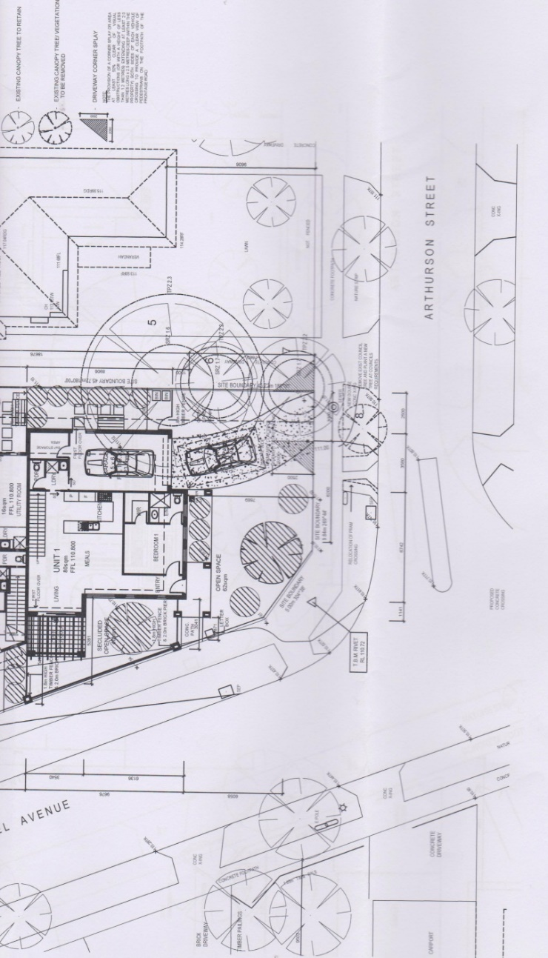

Figure 3: section of the site plan showing the proposed access to Dwelling 1 from Arthurson Street.

1. Abutting the proposed crossover is the existing crossover that provides access to the rear dwelling at 2/3 Arthurson Street. A median strip, pram-crossing and drainage pit are all located close together. The introduction of the crossover will result in relocating (slightly according to Mr Beaton) the pram-crossing with possible implications for the drainage pit. Ms Moser considered the combination of these works will contribute to a further hardening of this road frontage, including the need to remove the existing street tree (Plum tree – *Prunus domestica*). She reiterated Council does not support the removal of this tree.
2. From the perspective of access, the provision of a dual access point for an additional two vehicles further compounds the safety issue in my view.
3. I find the proposed crossover is too close to the intersection of Arthurson Street with Carmel Avenue.
4. A vehicle attempting to reverse out of the driveway and crossover from Dwelling 1 onto Arthurson Street will find it challenging due to the curved design of the driveway, shown in the substituted plans, which result from an increased setback of the single car garage off the eastern side boundary. In addition, the separation distance of 6.2 metres from the intersection tangent with Carmel Avenue, in combination with the sweeping nature of the bend of this intersection, as distinct from a more usual 90 degree intersection configuration, where vehicle the speed is reduced, means that a vehicle could approach, at speed, and potentially clash with any vehicle attempting to reverse out of the site onto Arthurson Street. I consider this too dangerous.
5. The *Planning and Environment Act 1987* (the Act) establishes one of the objectives for planning is to create a safe living environment for all Victorians[8].
6. Similarly, Clause 52.06 – Car Parking has one of its purposes *to ensure that the design and location of car parking is of a high standard, creates a safe environment for users and enables easy and efficient use*. Decision guidelines under Clause 52.06-10 also require consideration of *the role and function of nearby roads and the ease and safety with which vehicles gain access to the site* and *the ease and safety with which vehicles access and circulate within the parking area*. The proposal fails to achieve these in my view.
7. I note the evidence of Mr Beaton that the crossover location for Dwelling 1 is not within the prohibited area as outlined under Australian Standard AS2890.1:2004 (being setback 6.2 metres, and beyond the 6 metres limit from the tangent point on the intersection between Arthurson Street and Carmel Avenue).
8. I also note his evidence that the location of the crossover is satisfactory from a traffic engineering perspective. He also considers that with co-location with the existing crossover to the east, no safety impacts are expected, with residents able to arrive and depart in either direction, which ensures convenient access.
9. Mr Beaton also considered a similar arrangement is in place at the eastern end of Arthurson Street where it intersects with Alexander Street (at No. 16 Arthurson Street), where no casualty crashes have been reported and which represents a real world example of a dual crossover treatment that works safely. Hence, the proposal is also safe and acceptable.
10. I do not agree and accordingly, I am not prepared to grant a permit.
11. The intersection design of Arthurson and Alexander Streets is a 90 degree configuration, different from the more sweeping bend present with Arthurson Street and Carmel Avenue. I do not consider it represents good orderly planning to allow for a sub-standard access arrangement merely because it may already exist elsewhere.
12. Although Mr Beaton considered sightlines will be improved following the removal of front fencing on this intersection from approximately 22 to 30 metres, I am not convinced that introducing a new access to Arthurson Street, at this location is appropriate.
13. I agree with the comment of Mr Mackay that, the combination of curved driveway, co-location of crossovers to the east and close proximity to a sweeping bend of a road intersection carrying traffic, including buses from the train station car park, all leads to a dangerous design proposal that, *just doesn’t fit*.
14. A more satisfactory arrangement for vehicular access would be for any future redevelopment of the site to provide access only from Carmel Avenue and be sited to ensure adequate sight lines and visibility to traffic movement and designed to ensure access movement can occur in a forward direction.
15. Despite many aspects of the proposal achieving acceptable outcomes, I find it is not possible to merely impose conditions that would allow for changes to the design to avoid the crossover onto Arthurson Street without a significant re-design and potentially other changes to the overall layout of the development.

## Conclusion

1. For the reasons given above, the decision of the responsible authority is affirmed. No permit is granted.

|  |  |  |
| --- | --- | --- |
| **Christopher Harty**  **Member** |  |  |

1. The submissions and evidence of the parties, any supporting exhibits given at the hearing and the statements of grounds filed have all been considered in the determination of the proceeding. In accordance with the practice of the Tribunal, not all of this material will be cited or referred to in these reasons.
2. There was an issue about whether the location of the proposed crossover for Dwelling 1 onto Arthurson Street was compliant with the Australian Standard AS2890.1:2004 – *Parking Facilities - off-street parking*, however, it was established in Mr Beaton’s evidence that it technically was.
3. Refer to Clauses 15.01-4R and 16.01-2S.
4. Such a view is also supported by State policy under Clause 11.03-1S.
5. Amendment C125 Parts 1 (approved) and 2 (not approved).
6. *IPIA Pty Ltd v Monash CC* [2018] VCAT 1290, *Makhmalbaf v Monash CC* (Red Dot) [2018] VCAT 1641 and *Liu v Monash CC* [2018] VCAT 1704.
7. Site coverage is 40% compared to the standard of 60%. Site permeability is 44.5% compared to the standard of 20%.
8. Section 4(1)(c).